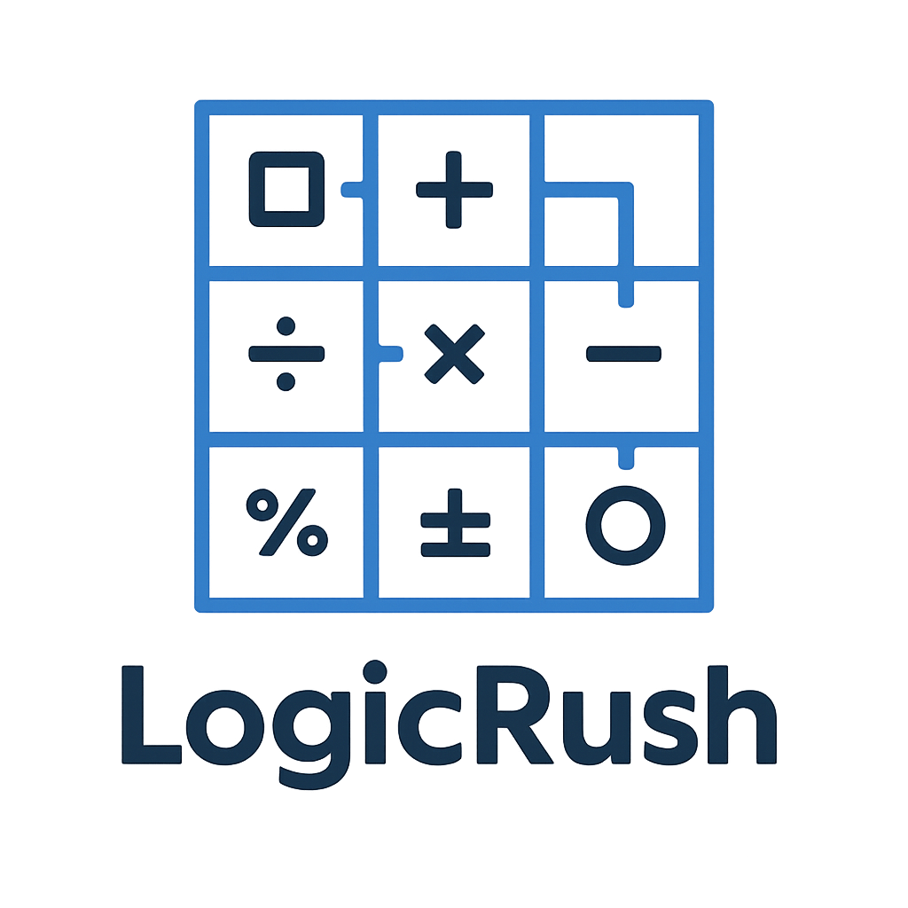

Contents
Assignment 3
Our Team: Logic Legends 4
Stages of development 5
Project description 6

Assignment

The topic is “Game of Words & Math Games.” Our task was to create a C++ game connected to either word puzzles or mathematical challenges for the 2025/2026 school year. The project had to follow specific requirements: clear code structure, clear variables, optional use of external libraries, and an active GitHub repository showing commits, task planning, and collaboration.
We worked in a team of four, each with a defined role such as Scrum Trainer, Front-End Developer, Back-End Developer, or Designer. Everyone contributed to the development of the final product.
The project duration was from 17.11.2025 to 07.12.2025. During this time, we built the game, organized the project files, prepared documentation, and created a presentation. Each member also described their technical work in the documentation.
This project reflects our teamwork, coding abilities, and understanding of how to build and document a complete C++ game.

Our Team: Logic Legends

№ | Name and class | Role
№1 | Martin Zhelev - 9V | Scrum trainer
№2 | Dimitar Nyagalov – 9B | Front-End  Developer
№3 | Georgi Nikolov – 9A | Back-End Developer
№4 | Plamen Rusev - 9G | Designer

Stages of development

№ | Stage
1 | Planning  Choosing the topic, forming the team, assigning roles.
2 | Design  Structuring the gameplay, rules, and difficulty levels.
3 | Implementation  Writing the C++ code and building all game features.
4 | Collaboration  Using GitHub for commits, tasks, and version control.
5 | Finalization  Finishing documentation, presentation, and publishing the project.

Project description
This project is a C++ console game developed for the theme “Math Games.” The goal was to create a logical and mathematical challenge where players solve problems while navigating through a grid. Each move requires answering a math question, and different difficulty levels introduce larger grids, harder operations, traps, bonuses, and limited lives.
Our team collaborated using modern tools to plan, build, and document the project. The development was done in Visual Studio, with version control and teamwork managed through Git and GitHub. Microsoft Word and PowerPoint were used to create the documentation and presentation. Communication and task coordination were handled through Microsoft Teams.
The project follows a clear code structure with separate modules for the game logic, problem generation, and shared types. This ensures readability, easier debugging, and better teamwork across the different roles. The final result meets the requirements of the assignment and represents a complete, well-organized team effort.

