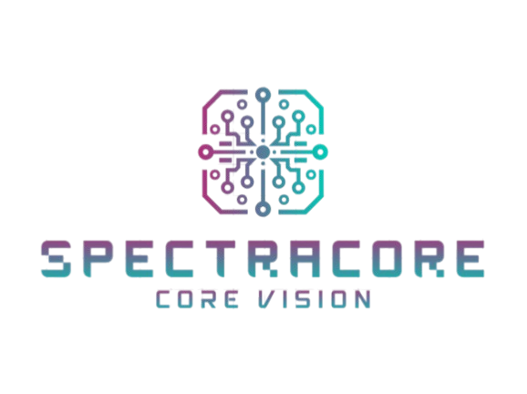

SpectraCore

Table of contents
Project description: 3
Team information: 3
Project information: 4
Technologies used: 4
Ways of realization: 5

Project description:
- SpectraCore is a console-based implementation of the popular Wordle game, developed entirely in C++. The player must guess a hidden 5-letter word within a limited number of attempts, receiving feedback after each guess.

Team information:
Name: Role:
1 Antonio Ivanov Scrum Trainer
2 Ivan Lapchev Backend Developer
3 Georgi Georgiev Frontend Developer
4 Stoyan Savakov Designer

Project information:
№ Information
- Description:
This project is a C++ console version of Wordle, where the player tries to guess a randomly selected 5-letter word before running out of attempts. The game features multiple difficulty modes (Easy, Normal, Hard, Extreme), each offering different numbers of guesses. It includes language selection for English and German, randomized word lists, and clear in-console feedback indicating letters in the correct position, letters present in the word, and letters that do not appear at all. The program is structured into multiple .cpp and .h files for clarity and maintainability.
- Communication:
For communication we used Microsoft Teams and Instagram. We also used GitHub for collaborative work. It all made it easier to work.

Technologies used:
№ Technology Usage
1 Visual Studio Used as IDE
2 GitHub For collaboration
3 C++ For creating the project
4 Word For creating the documentation
5 Powerpoint For creating the presentation
6 Microsoft Teams For communication

Ways of realization:
№ Issue
- Task distribution
Solution: We discussed the skills of each team member and divided up who would do what. Then we created issues in GitHub and assigned milestones which helped us to organize our time.
- Task Completion:
Solution: We met in Teams every day to discuss the project status and we all gave ideas that we could add in the game. We also used GitHub to track our progress. We also set deadlines for each task given.

