Documentation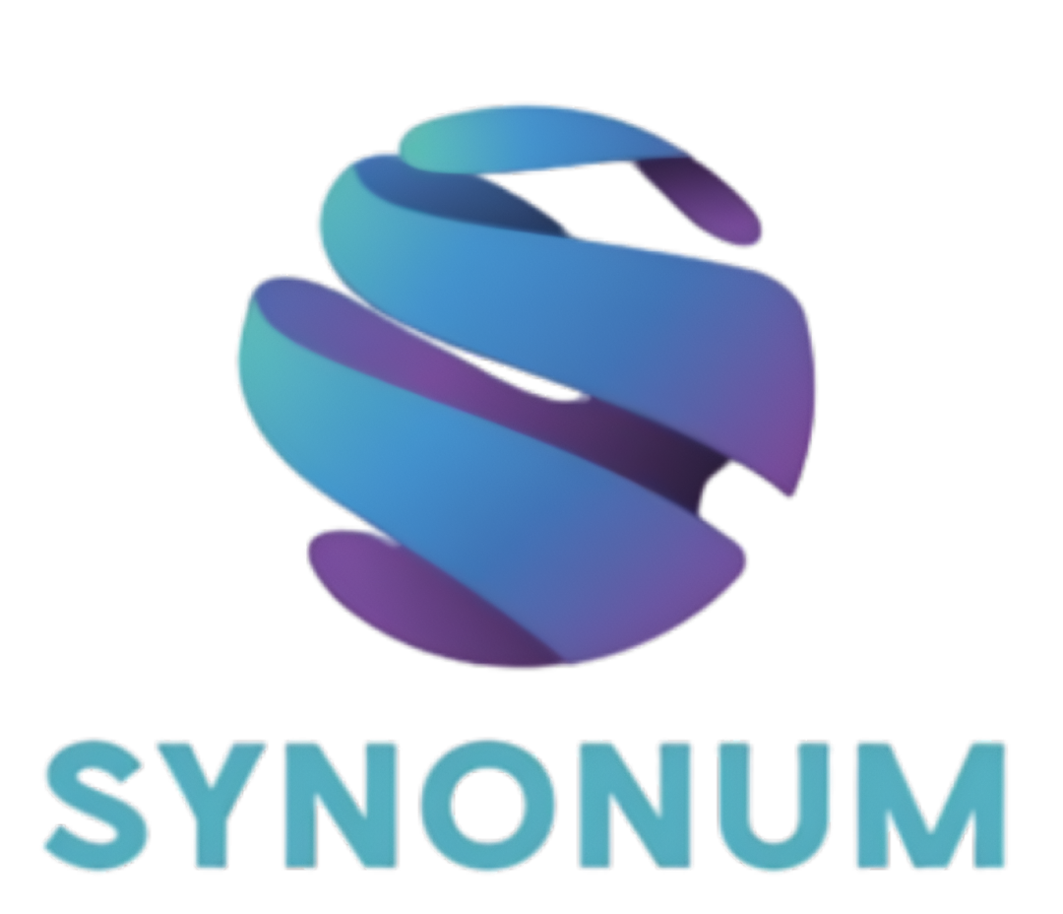

Content
- About us
- The purpose of the project
- Progress
- Used softwares and programmes
- Languages used

- About us

Person | Job | Class
Radostin Dimkirichev | Back-end Developer | 9 “A”
Mariela Apostolova | Front-end Developer | 9 “B”
Vsevolod Bolotov | Front-end Developer | 9 “V”
Dimana Foteva | Scrum trainer | 9 “G”

- Purpose of the project
- This project is a Hangman × Math game that gives players the opportunity to choose what game they would like to play. The game encourages both critical thinking and problem-solving while keeping the gameplay fun and engaging.
- It is designed to be simple, interactive, and easy for players.
- Progress
1st Week | Team assembling.  The first week focused on forming the development team and assigning roles (design, frontend, project management etc.). We discussed the goals and vision for the Fusion Express platform. Tools, communication channels, and workflows were also established.
2nd Week | Project developing  This project was developed through a cycle of planning, coding, and testing. By refining each component of the C++ program as it was created, We ensured the final result was both reliable and efficient.
3rd Week | Finalization  We finished the project, presentation and documentation, fixed some bugs. The platform was tested across devices
4th Week | Presenting  After finishing the project and weeks of hard working, the project is ready to be presented.

- Programmes and softwares

- MS Teams – For commication with our teammates.
- Visual Studio – For the development of the project.
- Github - For storing and sharing code, allowing our other teammates to track changes using Git.
- MS Word – For creating the documentation of the project.
- MS Powerpoint - For creating the presentation of the project.
5. Languages used


