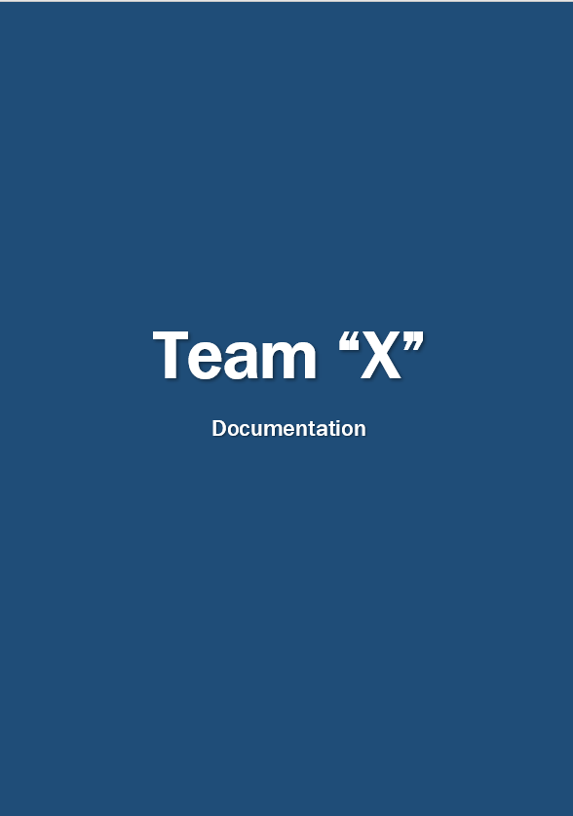

**Contents**

Project idea 3

Team information 3

Project information 4

Technologies used 5

Work plan 5

# **Project idea**

* Our team decided to recreate a simple yet entertaining game named Wordle. It is a game where you get five empty gaps that you should fulfill with letters and guess the word.

# **Team information**

|  |  |
| --- | --- |
| **Name** | **Role** |
| Roberta Hristova | Front-End Developer |
| Leya Susova | Back-End Developer |
| Nia Georgieva | Designer |
| Ekaterina Zalinskaya | Scrum Trainer |

# **Project information**

Information

1. **Description**

A simple yet entertaining game named Wordle. It is a game where you get five empty gaps that you should fulfill with letters and guess the word. It was written with C++.

1. **Installation**

To install the project, you can open our GitHub repository and follow the instruction in the README.md file.

1. **Communication**

Our team used Teams for communication and file sharing.

# **Technologies used**

1. Visual Studio 2022
2. GitHub
3. Word
4. PowerPoint
5. Teams

For writing the main code

For collaboration

For the documentation

For the presentation

For communication

# **Work plan**

1. Make up a feasible idea
2. Separating the tasks
3. Start writing the code

3.1. Main menu

3.2. The rest of the structure

1. Create a documentation
2. Create a presentation