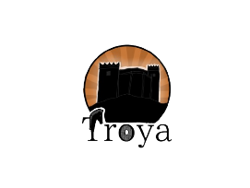TroyaTable of contents

Team 3

★ Objectives 4

★ Main stages in the development 4

★ Alice’s solving adventures’ block scheme 6

Functions 6

Conclusion 8

# Team

Scrum Trainer

Ulvie Mustafa Mustafa (9g)

Created working environment then she did the backend of level 1 and 2. Finally she did the presentation.

Backend Developer

Sheniz Idris Ali (9b)

Made main menu basics then she made backend of level 3 and 4. Finally she did the documentation.

Backend Developer

Martin Nikolaev Dimarov (9v)

Made main menu details then he made the frontend of level 1 and 3 and also helped for backend level 3.

Designer

Ameliia Oleksandrivna Dorosh (9g)

Made the design of all the levels and frontend of level 2 and 4 then she made the logos.

Summary

## **Objectives**

* Create an engaging educational game with four levels that combine math and language challenges.
* Enhance players’ problem-solving and critical thinking skills.
* Provide a fun and interactive learning experience through diverse gameplay mechanics.

## **Main stages in the development**

1. **Exploration**

In the initial phase, our team gathered regularly to brainstorm and explore various ideas and solutions applicable to the project’s design and purpose.

1. **Design**

Ameliia Dorosh made the design of all the levels in the game.

1. **Development**

Step by step, week by week and task by task our application was gradually materialising. Development involved a process of collaborative and focused work and despite encountering obstacles along the way, we always found solutions, ensuring the project’s advancement continued. Everyone in the team worked and did everything they can.

* **Implementation**
* **Software for programming our project is** [**Visual Studio 2022**](https://visualstudio.microsoft.com/)

**ur collaboration tools are** [**GitHub**](https://github.com/) **and** [**Git**](https://git-scm.com/)**.**

**Programming language we have programmed in is C++**



**Software used for the presentation of the project are** [**Microsoft Word**](https://www.microsoft.com/en-us/microsoft-365/word) **and** [**Microsoft PowerPoint**](https://www.microsoft.com/en-us/microsoft-365/powerpoint)



# **Alice’s solving adventures’ block scheme**

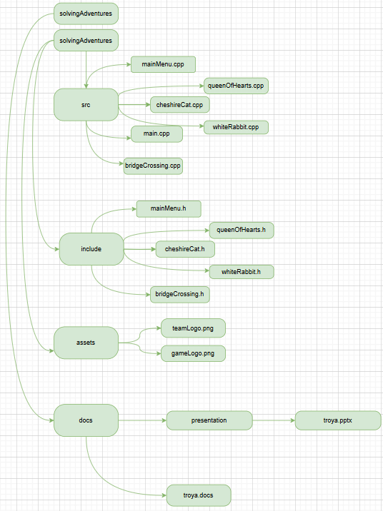

|  |  |
| --- | --- |
| Functions | |
| Types | Name |
| int | main() |
| void | mainMenu() |
| void | functionMenu() |
| void | whiteRabbit () |
| void | levelOne() |
| void | displayMathProblem() |
| void | displayHint() |
| void | mathFunction () |
| void | appearance() |
| void | cheshireCat() |
| void | bridge() |
| void | queenOfHearts() |
| void | doorsOneAndTwo() |
| void | doorsThreeAndFour() |
| void | doorsFiveAndSix() |

# Conclusion

**Solving Adventures in wonderland is designed to be a dynamic and engaging educational game that blends the challenges of math and language in a fun and interactive format.**

**With its well-balanced levels combining math equations and word games, the game not only tests the players' skills but also encourages critical thinking and problem-solving. With its systematic development and focus on educational value, Alice’s Solving Adventures is well-positioned to offer a meaningful and enjoyable learning experience that aligns with its core goals of fostering skills and encouraging intellectual growth.**