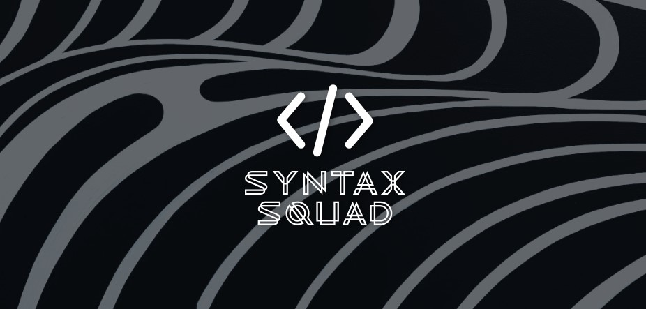

Syntax

Squad

Contents

1. Members…………………………………………………………………………………………………………
2. Idea of the project…………………………………………………………………………………………….
3. Realization steps……………………………………………………………………………………………..
4. Used technologies……………………………………………………………………………………………
5. Project block-scheme……………………………………………………………………………………….

1. Members

|  |  |
| --- | --- |
| **Name** | **Role** |
| Stilian Solinkov | Scrum Trainer |
| Alexander Petrov | Back-end Developer |
| **Doni Dimitrov** | Back-end Developer |
| **Kaloyan Koev** | Designer |

2. Idea of the project

The main target of the project is to create an application which is a fun way to learn some words. The game is fun, relaxing and helpful.

In our game the main goal is to guess the word. get the highest score and have fun of course.

3.Stages of realization

1. Idea
2. GitHub Setup
3. Organization
4. Desing
5. Coding
6. Execution of presentation & documentation

4.Used tachnologies

1. Main language – C++
2. IDE – Visual Studio 2023
3. Documentation – Word, Power Point
4. Communication – Teams
5. Repo – GitHub, Git

5.Project Block-Scheme