Atari Joyport Parallel BT/ WIFI Interface
An DIY- parallel interface which connects to the two Joystick- ports of an Atari 600/ 800 XL which exchanges data over a Bluetooth or WIFI- connection with a modern computer or an hand- held device.
Hardware Part is build with PJRC's Tensy 2.0 (Arduino), some wires and two D- SUB 9 Pin connectors .
Software part's are 6502- Core routines which provide basic functionality to open and close a communication channel and to send data. On the receiving side (Tensy 2.0) a C++ firmware handles communication with the parallel interface and receives data from the Atari Machine. Received data is send to the COM- Port via a physical USB connection between Tensy 2.0 and PC and via Tensy's RX/TX- pins to a connected Bluetooth or WiFi- Module.
Tools for the Atari are a Serial Debugger to test the Interface and a Disk- Copy Program which reads a whole disk and sends it via the parallel interface.
For the time being Atari can only send. Receiving data on the Atari is not possible.

ToDo:
- Build Disk Copy Program
- Build a simple terminal to send Text messages

Serial Data Transfer
USB- connection works like a charm! RXTX- Java Library is the way to go for a command line interface!
Binary data is transferred 1:1. Ascii decoding works

BT Data Transfer
Works, sort of... To Do:
Write BT- receiver for android which receieves bytes in the right order....
Firmware for Tensy and 6502 are working when connected via USB to the serial monitor, Android part which receives via BT does not work!

Tensy, Pin Assignments

All Links: 30.4.2019

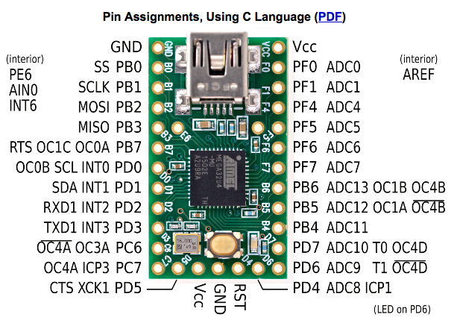 | 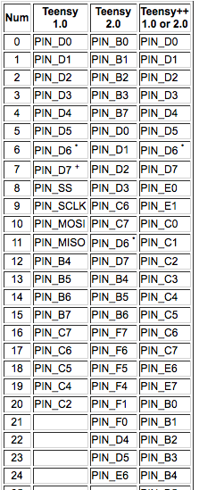
https://www.pjrc.com/teensy/td_digital.html | Tensy: Digital I/O Pins  https://www.pjrc.com/teensy/td_digital.html

