Cassandra Morales

Lab section: 0017

**Portion of Preliminary Design**

Objective

The objective of this project is to construct a water resistant, floating, and moving boat that can travel a minimum distance of 10 yards. While designing and building the boat we must remain under the budget of $85. The main constraints for this project is that the boat must not exceed 1m x 1m x 1m and cannot be self-guided or self-propelled.

Product Options

Option 1: Pontoon Boat

My first option for this project is building a pontoon boat. I like the idea of this boat due to the simplicity of the design of the vessel. I plan on forming the shape of the boat with Styrofoam and hot glue. To make the boat move the minimum distance of 10 yards I plan on recycling some materials such as the wheels, battery, and protective case from an old robot and adding them to the vessel. I believe that if I can attach the wheels to the left and the right side of the boat, and add horizontal flaps made of old window blinds to the wheels, then the boat should move at a slow but steady pace.

Option 2: Sailboat

My second option for this project is building a sailboat. This option I am a little more skeptical about because of how I plan on making the boat move regardless of the weather conditions outside. First, I will use Styrofoam to build a kayak shaped base, then I will cut an old bed sheet to form the sail and likely buy a couple wooden sticks to attach the sail to the base of the boat. To make the boat move the minimum distance of 10 yards, I plan on buying a miniature fan and placing it at the back of the boat to create the wind needed to push it forward. In order to balance the boats weight, as I’m sure the fans weight will tilt the boat backwards, I will place a Ziplock bag of dirt at the front of the boat to prevent the boat from tilting/sinking.

Option 3: Walkaround boat

My third and final option for my boat project design is building a walkaround boat. This is my last option since it would likely take up a large portion of the $85 budget. Like my first two options I will use Styrofoam to build the base of the boat, then I would need to find a motor for the boat that does not require a remote control and does not cost more than $60 as I do not know what other extra materials, I will need to buy to attach the motor to the base. Some of the extra materials that I will probably use are duct tape, hot glue, batteries etc. not including the initial cost of the Styrofoam.

Equation 1: Score Calculation

**Score = Cost+Time+Difficulty+Visual appeal+Performance**

Conclusions

After further review of my three options from their scores, I will be moving forward with the Sailboat despite the fact that it has the biggest risk factor for not working properly in certain weather conditions. I have come to this conclusion since its score is much higher than my two other options. Even if the Sailboat does not move as quickly, or as straight as the other two probably would, its scores in factors such as budget, appearance, and difficulty outweigh the performance risks.

**Final Gantt Chart**

Table 1

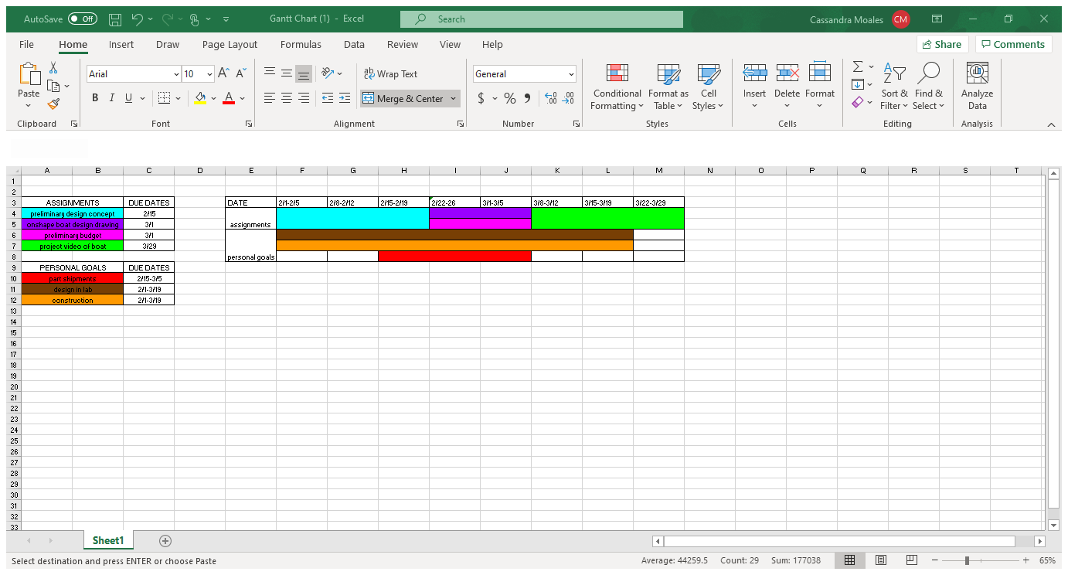

**CAD Model of Final Design**

Figure 1

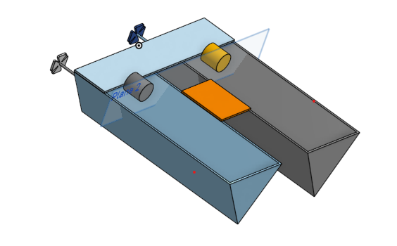<https://cad.onshape.com/documents/512f768fd371d90a08441a2c/w/989434ee2fd5e9cc874e0ef3/e/69b49945f4d377e41d1685ab>

**Pictures of Completed Boat**

Figure 2

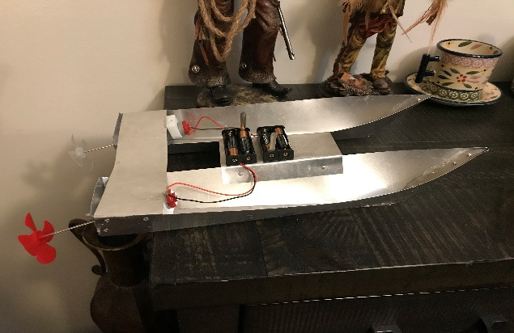

Figure 3

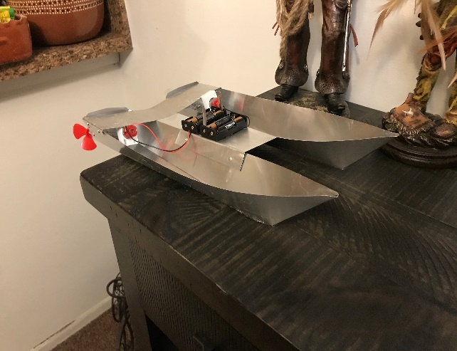

Figure 4

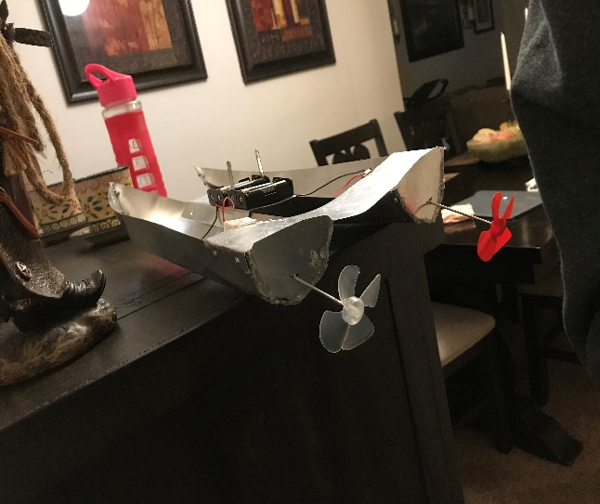

**Explanation of Final Design**

While reviewing my three design ideas from my preliminary design, I realized that my boat would be functional, but it would not meet my visual expectations. I wanted to design and build a boat that was aesthetically pleasing while still capable of meeting the requirements of moving a minimum of 10 yards and being less than a meter cubed in sized. I wanted an elegant yacht look that would not be tricky or time consuming and that would allow the final product to maintain functional and in good condition after many years.

In my preliminary design I described making a sailboat made mostly with Styrofoam. I could have stuck with that as my main material, but then I thought about what a boat looks like in real life. Because of this I chose to replace the Styrofoam with metal sheets in order to give it a clean appearance. Although traditional boats are made out of wood due to its buoyancy, I wanted my design to have shiny modern appeal. My next thought was to find a shape that would work for both the speed of the boat and the flexibility of the metal. From this I chose to go for a traditional boat shape of a pointed nose and sharp, curved bottom. I also did not want to risk the minimal chance of my boat tipping over, to prevent this I made a replica of my improved idea and connected the two boats together for better balance. In other words, I made two speed boats and placed a sheet of metal over the top and sealed them together with hot glue. I left the top of the speed boats open since I would need the extra water-proof space to incorporate the propellers, cables and batteries that would allow the boat to move without the need for a string or any other guiding sources. I cut two holes in the middle of the back of each speed boat that would hold the stick attachment holding the motor and propellers together and finally glued the batteries and motors down to the back to stop them from shifting all over while the boat was in motion.

Once my boat had come to life I began testing straight away as I knew that I would have to make many adjustments. My first dilemma was that when aligning both sides of the boat I glued one side higher than the other making the boat turn to the left. My first attempt at trying to fix this was adding weight to the right side of the boat since it would even out the alignment of both sides. I soon realized that water started leaking in from the holes I had made for the propellers since I did not predict the water to reach an inch over the bottom of the boat. This caused way more issues than I had anticipated and required that I remade both holes about three centimeters higher than they were before just to be sure that I would not have to make the holes a third time. After no more water was reaching the inside of the boat, I began placing the propellers, but remembered that I still needed to fix the direction in which the boat was moving. To cancel out the curve in the way the boat moved I added a flap to the bottom of both sides angled in a way that would guide the boat to the right to balance the boats direction and hopefully making it move straight forward. Adding the flaps did work, however, the only way that the boat moved straight was if it was going backwards. Despite what seemed to be hours of rewiring and trying a variety of cables, switches, batteries I was not able to make the move in a straight line without it moving in reverse. Regardless of its direction, not a single part of my boat broke during the testing processes and I was finally able record my boat moving 10 yards across a pool.

**Final Budget**

Table 2

|  |  |  |  |  |
| --- | --- | --- | --- | --- |
| Material | Price | Location | Quantity Needed | Total |
| Metal sheet roll | 10.16 | Home depot | 1 | 10.16 |
| Hot glue | 3.97 | Amazon | 1 pack | 3.97 |
| Hot glue gun | Recycled | Home | 1 | 0 |
| Rivet tool kit | 27.97 | Home depot | 1 | 27.97 |
| Motor kit | 13.99 | Amazon | 1 | 13.99 |
| Budget Total |  | Given: $85 | Used: 56.19 | Total Left: $28.81 |

**Appendix**

Inspiration

<https://www.coxmarine.com/3-of-the-worlds-fastest-speed-boats/#:~:text=Spirit%20of%20Australia%20is%20currently,an%20eye%2Dwatering%20317.6%20MPH>.

Materials

(rivet tool kit)

<https://www.homedepot.com/p/Arrow-1-Handed-Swivel-Riveter-Kit-RT187SHK/304679379>

(boat motor kit)

<https://www.amazon.com/EUDAX-Rectangular-Electric-Electronic-Propeller/dp/B077WWS63B/ref=sr_1_14?dchild=1&keywords=boat+motor+kit&qid=1618025778&sr=8-14>

(hot glue sticks)

<https://www.amazon.com/Adtech-220-3824-Mini-Glue-Stick/dp/B01N0ON9G2/ref=sxin_9_ac_d_rm?ac_md=2-2-bWluaSBob3QgZ2x1ZSBzdGlja3M%3D-ac_d_rm&cv_ct_cx=hot+glue+sticks&dchild=1&keywords=hot+glue+sticks&pd_rd_i=B01N0ON9G2&pd_rd_r=e7632414-16ab-4f07-874d-8f7463d3f61c&pd_rd_w=IAtis&pd_rd_wg=gbDFF&pf_rd_p=b0625ac1-ea22-4a1c-8206-57129b08e075&pf_rd_r=C4XSRDSE5CPWVZD42M1D&psc=1&qid=1618025859&sr=1-3-12d4272d-8adb-4121-8624-135149aa9081>

(metal sheet roll)

<https://www.homedepot.com/p/Amerimax-Home-Products-14-in-x-10-ft-Galvanized-Steel-Roll-Valley-Flashing-70414/100096067>