Analysis of Bias Factors

Table of Contents

## Regression Tables

parnames <- c("betaO0", "betaO1", "betaO2", "betaS0", "betaS1", "betaS2", "betaS3")  
res0 <- list()  
for (i in 1:(length(parnames))) {  
 res0[[i]] <- f_reg(data=dfreg, parname=parnames[[i]], trimpct=0.003)  
}

## ANOVA & Interaction Plots

### betaO0 : intercept in outcome equation

ANOVA : Logit - Logit Specification

|  | num Df | den Df | MSE | F | ges | Pr(>F) |
| --- | --- | --- | --- | --- | --- | --- |
| dependence | 3 | 14226 | 0.27 | 1018.86 | 0.18 | 0.00 |
| selectivity | 2 | 14226 | 0.27 | 790.77 | 0.10 | 0.00 |
| x_dist | 3 | 14226 | 0.27 | 162.12 | 0.03 | 0.00 |
| dependence:selectivity | 6 | 14226 | 0.27 | 62.42 | 0.03 | 0.00 |
| dependence:x_dist | 9 | 14226 | 0.27 | 6.37 | 0.00 | 0.00 |
| selectivity:x_dist | 6 | 14226 | 0.27 | 2.98 | 0.00 | 0.01 |
| dependence:selectivity:x_dist | 18 | 14226 | 0.27 | 1.11 | 0.00 | 0.33 |

The ANOVA suggests that:

* The main effect of dependence is statistically significant and large (F(3) = 1018.86, p < .001; Eta2 (partial) = 0.18, 95% CI [0.17, 1.00])
* The main effect of selectivity is statistically significant and medium (F(2) = 790.77, p < .001; Eta2 (partial) = 0.10, 95% CI [0.09, 1.00])
* The main effect of x_dist is statistically significant and small (F(3) = 162.12, p < .001; Eta2 (partial) = 0.03, 95% CI [0.03, 1.00])
* The interaction between dependence and selectivity is statistically significant and small (F(6) = 62.42, p < .001; Eta2 (partial) = 0.03, 95% CI [0.02, 1.00])
* The interaction between dependence and x_dist is statistically significant and very small (F(9) = 6.37, p < .001; Eta2 (partial) = 4.01e-03, 95% CI [1.97e-03, 1.00])
* The interaction between selectivity and x_dist is statistically significant and very small (F(6) = 2.98, p = 0.007; Eta2 (partial) = 1.25e-03, 95% CI [1.96e-04, 1.00])
* The interaction between dependence, selectivity and x_dist is statistically not significant and very small (F(18) = 1.11, p = 0.331; Eta2 (partial) = 1.41e-03, 95% CI [0.00, 1.00])

Effect sizes were labelled following Field’s (2013) recommendations.

##### Two-way Interaction Plots

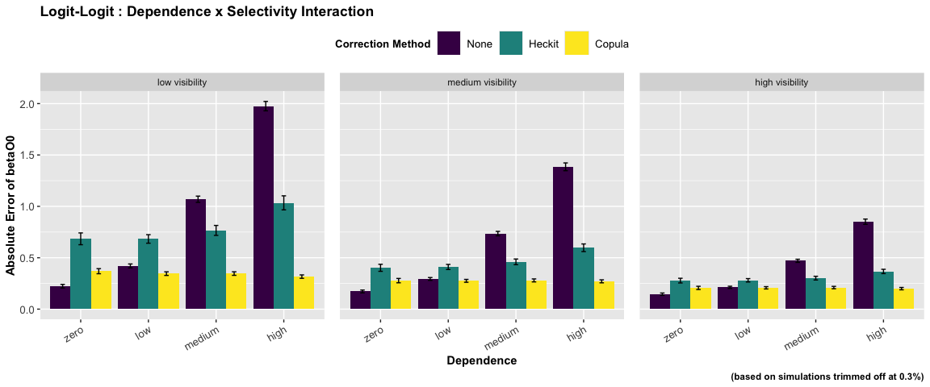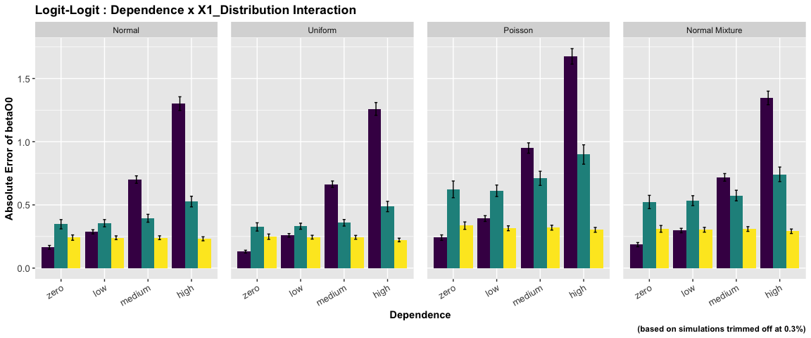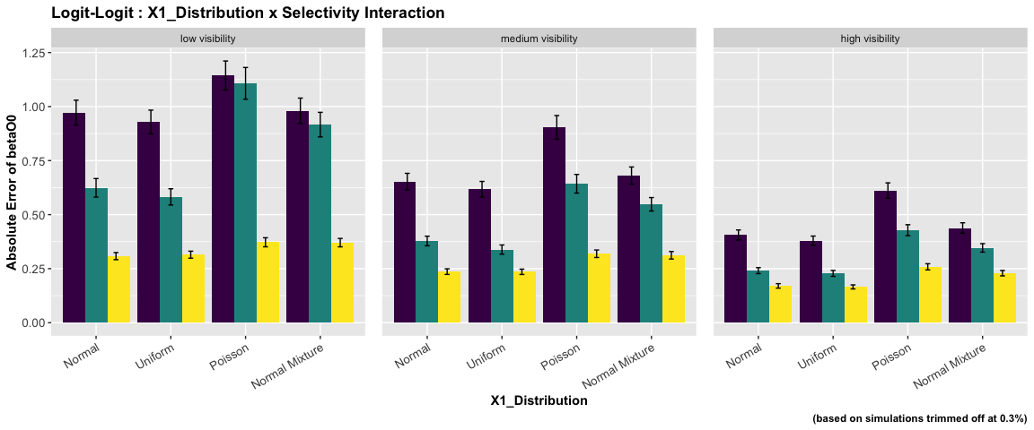

ANOVA : Logit - Normal Specification

|  | num Df | den Df | MSE | F | ges | Pr(>F) |
| --- | --- | --- | --- | --- | --- | --- |
| dependence | 3 | 14352 | 0.03 | 762.28 | 0.14 | 0.00 |
| selectivity | 2 | 14352 | 0.03 | 724.62 | 0.09 | 0.00 |
| x_dist | 3 | 14352 | 0.03 | 146.20 | 0.03 | 0.00 |
| dependence:selectivity | 6 | 14352 | 0.03 | 33.89 | 0.01 | 0.00 |
| dependence:x_dist | 9 | 14352 | 0.03 | 5.04 | 0.00 | 0.00 |
| selectivity:x_dist | 6 | 14352 | 0.03 | 1.87 | 0.00 | 0.08 |
| dependence:selectivity:x_dist | 18 | 14352 | 0.03 | 0.24 | 0.00 | 1.00 |

The ANOVA suggests that:

* The main effect of dependence is statistically significant and medium (F(3) = 762.28, p < .001; Eta2 (partial) = 0.14, 95% CI [0.13, 1.00])
* The main effect of selectivity is statistically significant and medium (F(2) = 724.62, p < .001; Eta2 (partial) = 0.09, 95% CI [0.08, 1.00])
* The main effect of x_dist is statistically significant and small (F(3) = 146.20, p < .001; Eta2 (partial) = 0.03, 95% CI [0.03, 1.00])
* The interaction between dependence and selectivity is statistically significant and small (F(6) = 33.89, p < .001; Eta2 (partial) = 0.01, 95% CI [0.01, 1.00])
* The interaction between dependence and x_dist is statistically significant and very small (F(9) = 5.04, p < .001; Eta2 (partial) = 3.15e-03, 95% CI [1.32e-03, 1.00])
* The interaction between selectivity and x_dist is statistically not significant and very small (F(6) = 1.87, p = 0.082; Eta2 (partial) = 7.82e-04, 95% CI [0.00, 1.00])
* The interaction between dependence, selectivity and x_dist is statistically not significant and very small (F(18) = 0.24, p > .999; Eta2 (partial) = 2.97e-04, 95% CI [0.00, 1.00])

Effect sizes were labelled following Field’s (2013) recommendations.

##### Two-way Interaction Plots

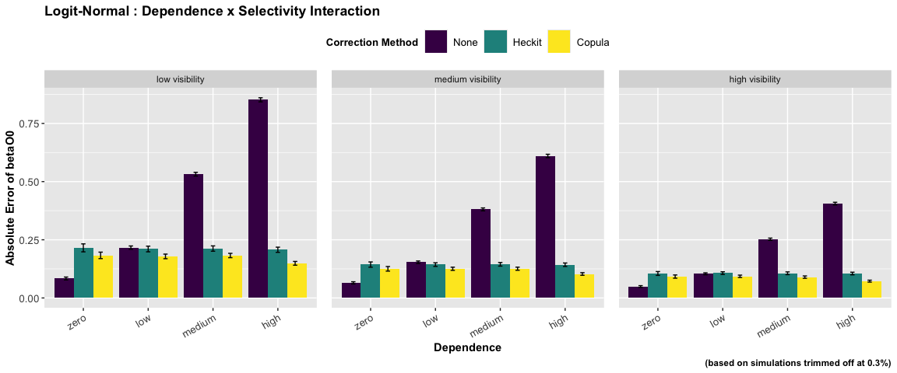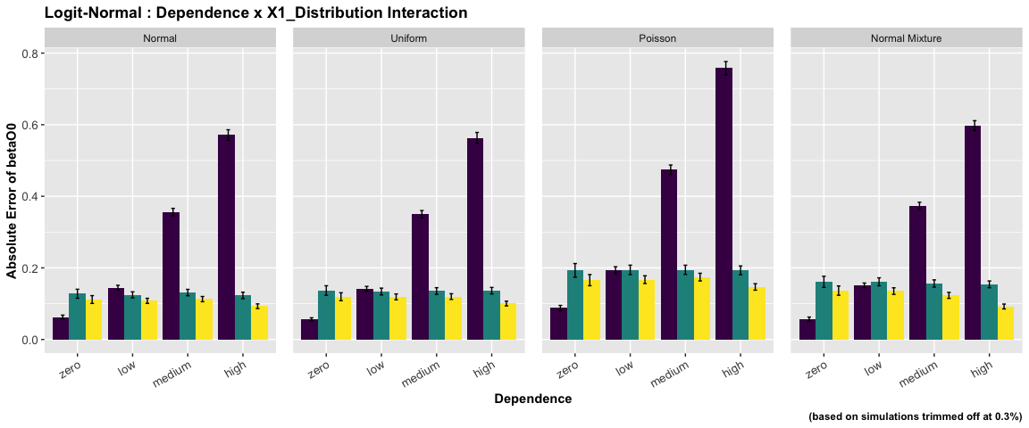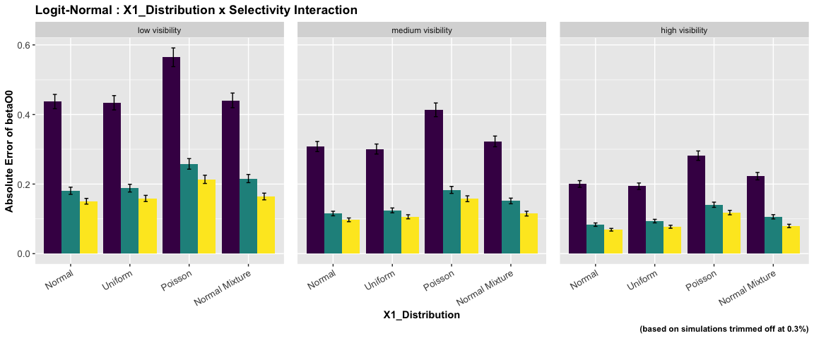

ANOVA : Logit - Poisson Specification

|  | num Df | den Df | MSE | F | ges | Pr(>F) |
| --- | --- | --- | --- | --- | --- | --- |
| dependence | 3 | 14352 | 0 | 756.27 | 0.14 | 0 |
| selectivity | 2 | 14352 | 0 | 582.14 | 0.08 | 0 |
| x_dist | 3 | 14352 | 0 | 661.75 | 0.12 | 0 |
| dependence:selectivity | 6 | 14352 | 0 | 34.57 | 0.01 | 0 |
| dependence:x_dist | 9 | 14352 | 0 | 29.74 | 0.02 | 0 |
| selectivity:x_dist | 6 | 14352 | 0 | 45.81 | 0.02 | 0 |
| dependence:selectivity:x_dist | 18 | 14352 | 0 | 2.13 | 0.00 | 0 |

The ANOVA suggests that:

* The main effect of dependence is statistically significant and medium (F(3) = 756.27, p < .001; Eta2 (partial) = 0.14, 95% CI [0.13, 1.00])
* The main effect of selectivity is statistically significant and medium (F(2) = 582.14, p < .001; Eta2 (partial) = 0.08, 95% CI [0.07, 1.00])
* The main effect of x_dist is statistically significant and medium (F(3) = 661.75, p < .001; Eta2 (partial) = 0.12, 95% CI [0.11, 1.00])
* The interaction between dependence and selectivity is statistically significant and small (F(6) = 34.57, p < .001; Eta2 (partial) = 0.01, 95% CI [0.01, 1.00])
* The interaction between dependence and x_dist is statistically significant and small (F(9) = 29.74, p < .001; Eta2 (partial) = 0.02, 95% CI [0.01, 1.00])
* The interaction between selectivity and x_dist is statistically significant and small (F(6) = 45.81, p < .001; Eta2 (partial) = 0.02, 95% CI [0.01, 1.00])
* The interaction between dependence, selectivity and x_dist is statistically significant and very small (F(18) = 2.13, p = 0.003; Eta2 (partial) = 2.67e-03, 95% CI [4.38e-04, 1.00])

Effect sizes were labelled following Field’s (2013) recommendations.

##### Two-way Interaction Plots

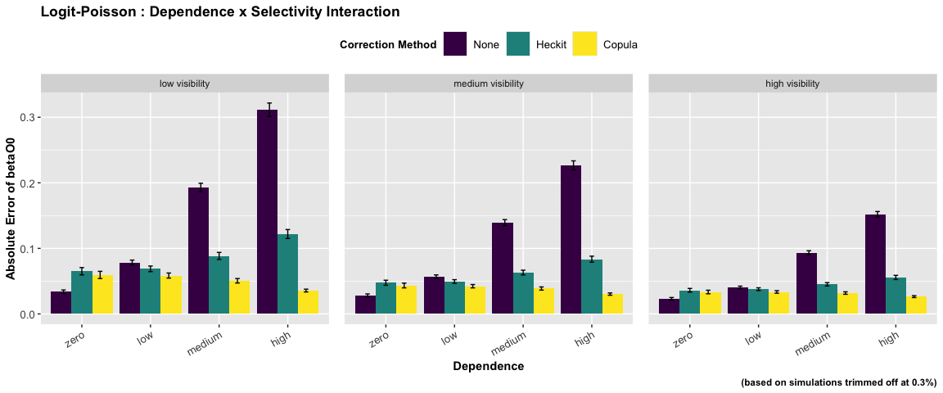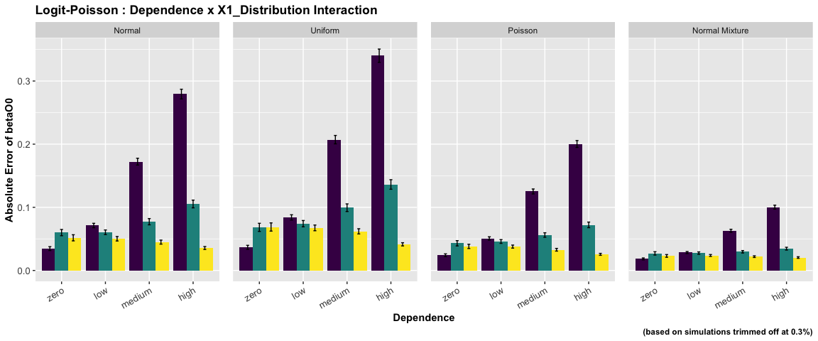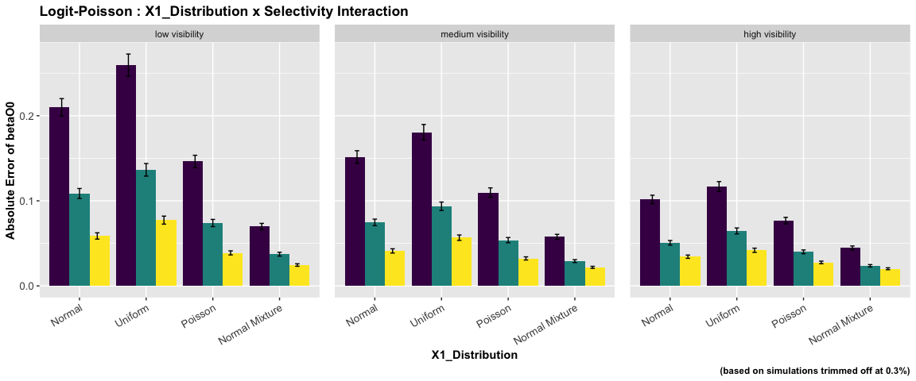

ANOVA : Logit - Probit Specification

|  | num Df | den Df | MSE | F | ges | Pr(>F) |
| --- | --- | --- | --- | --- | --- | --- |
| dependence | 3 | 14228 | 0.15 | 899.38 | 0.16 | 0 |
| selectivity | 2 | 14228 | 0.15 | 737.50 | 0.09 | 0 |
| x_dist | 3 | 14228 | 0.15 | 156.67 | 0.03 | 0 |
| dependence:selectivity | 6 | 14228 | 0.15 | 48.50 | 0.02 | 0 |
| dependence:x_dist | 9 | 14228 | 0.15 | 8.34 | 0.01 | 0 |
| selectivity:x_dist | 6 | 14228 | 0.15 | 6.33 | 0.00 | 0 |
| dependence:selectivity:x_dist | 18 | 14228 | 0.15 | 3.16 | 0.00 | 0 |

The ANOVA suggests that:

* The main effect of dependence is statistically significant and large (F(3) = 899.38, p < .001; Eta2 (partial) = 0.16, 95% CI [0.15, 1.00])
* The main effect of selectivity is statistically significant and medium (F(2) = 737.50, p < .001; Eta2 (partial) = 0.09, 95% CI [0.09, 1.00])
* The main effect of x_dist is statistically significant and small (F(3) = 156.67, p < .001; Eta2 (partial) = 0.03, 95% CI [0.03, 1.00])
* The interaction between dependence and selectivity is statistically significant and small (F(6) = 48.50, p < .001; Eta2 (partial) = 0.02, 95% CI [0.02, 1.00])
* The interaction between dependence and x_dist is statistically significant and very small (F(9) = 8.34, p < .001; Eta2 (partial) = 5.25e-03, 95% CI [2.94e-03, 1.00])
* The interaction between selectivity and x_dist is statistically significant and very small (F(6) = 6.33, p < .001; Eta2 (partial) = 2.66e-03, 95% CI [1.13e-03, 1.00])
* The interaction between dependence, selectivity and x_dist is statistically significant and very small (F(18) = 3.16, p < .001; Eta2 (partial) = 3.98e-03, 95% CI [1.39e-03, 1.00])

Effect sizes were labelled following Field’s (2013) recommendations.

##### Two-way Interaction Plots

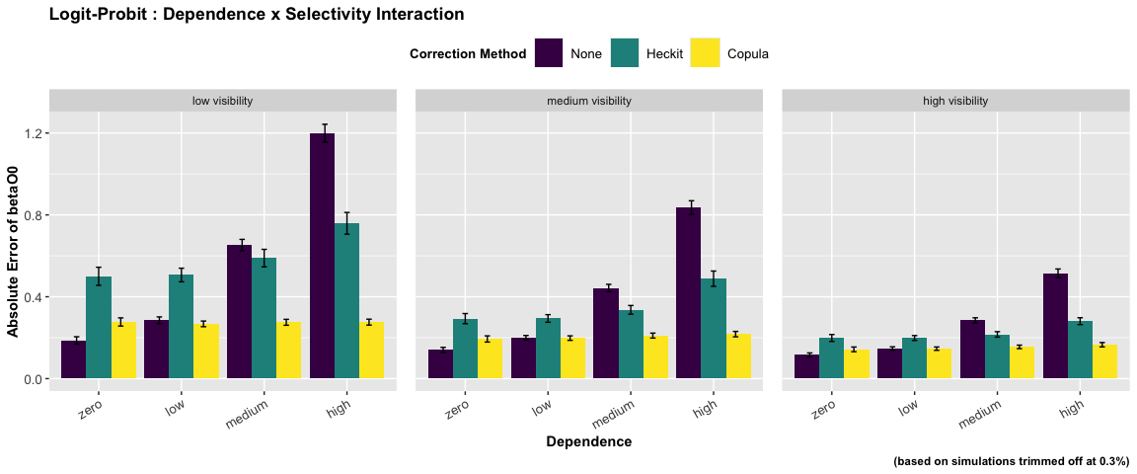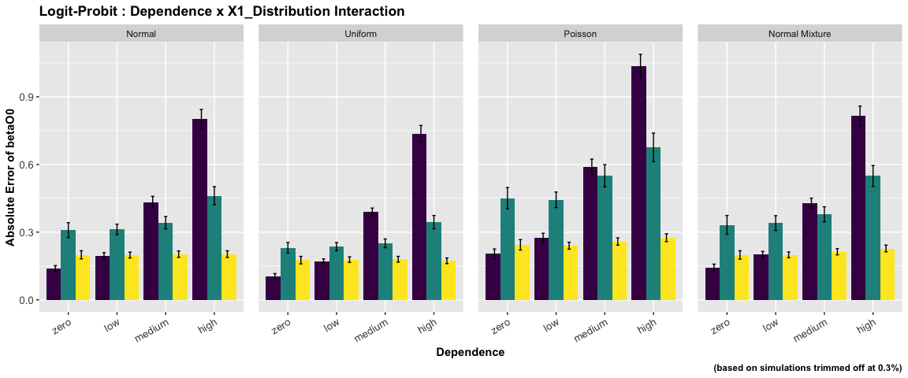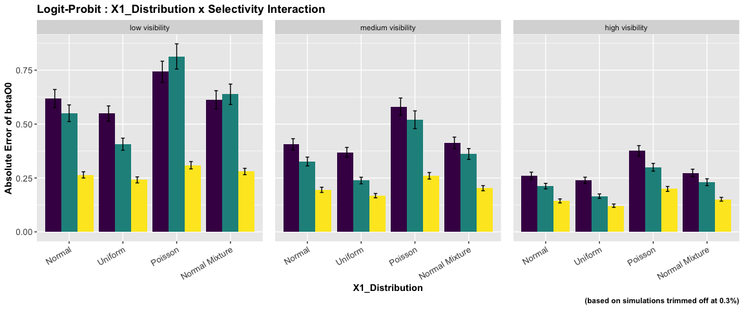

ANOVA : Probit - Logit Specification

|  | num Df | den Df | MSE | F | ges | Pr(>F) |
| --- | --- | --- | --- | --- | --- | --- |
| dependence | 3 | 14275 | 0.19 | 797.31 | 0.14 | 0.00 |
| selectivity | 2 | 14275 | 0.19 | 1214.85 | 0.15 | 0.00 |
| x_dist | 3 | 14275 | 0.19 | 216.51 | 0.04 | 0.00 |
| dependence:selectivity | 6 | 14275 | 0.19 | 89.29 | 0.04 | 0.00 |
| dependence:x_dist | 9 | 14275 | 0.19 | 7.68 | 0.00 | 0.00 |
| selectivity:x_dist | 6 | 14275 | 0.19 | 7.58 | 0.00 | 0.00 |
| dependence:selectivity:x_dist | 18 | 14275 | 0.19 | 0.73 | 0.00 | 0.79 |

The ANOVA suggests that:

* The main effect of dependence is statistically significant and large (F(3) = 797.31, p < .001; Eta2 (partial) = 0.14, 95% CI [0.13, 1.00])
* The main effect of selectivity is statistically significant and large (F(2) = 1214.85, p < .001; Eta2 (partial) = 0.15, 95% CI [0.14, 1.00])
* The main effect of x_dist is statistically significant and small (F(3) = 216.51, p < .001; Eta2 (partial) = 0.04, 95% CI [0.04, 1.00])
* The interaction between dependence and selectivity is statistically significant and small (F(6) = 89.29, p < .001; Eta2 (partial) = 0.04, 95% CI [0.03, 1.00])
* The interaction between dependence and x_dist is statistically significant and very small (F(9) = 7.68, p < .001; Eta2 (partial) = 4.82e-03, 95% CI [2.60e-03, 1.00])
* The interaction between selectivity and x_dist is statistically significant and very small (F(6) = 7.58, p < .001; Eta2 (partial) = 3.18e-03, 95% CI [1.51e-03, 1.00])
* The interaction between dependence, selectivity and x_dist is statistically not significant and very small (F(18) = 0.73, p = 0.787; Eta2 (partial) = 9.15e-04, 95% CI [0.00, 1.00])

Effect sizes were labelled following Field’s (2013) recommendations.

##### Two-way Interaction Plots

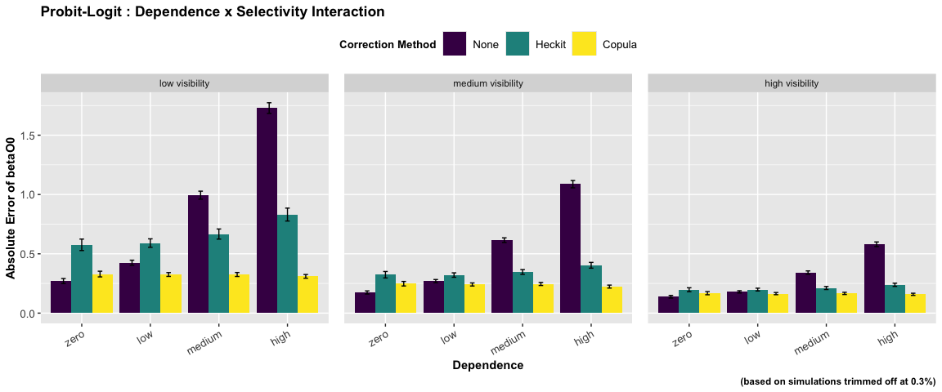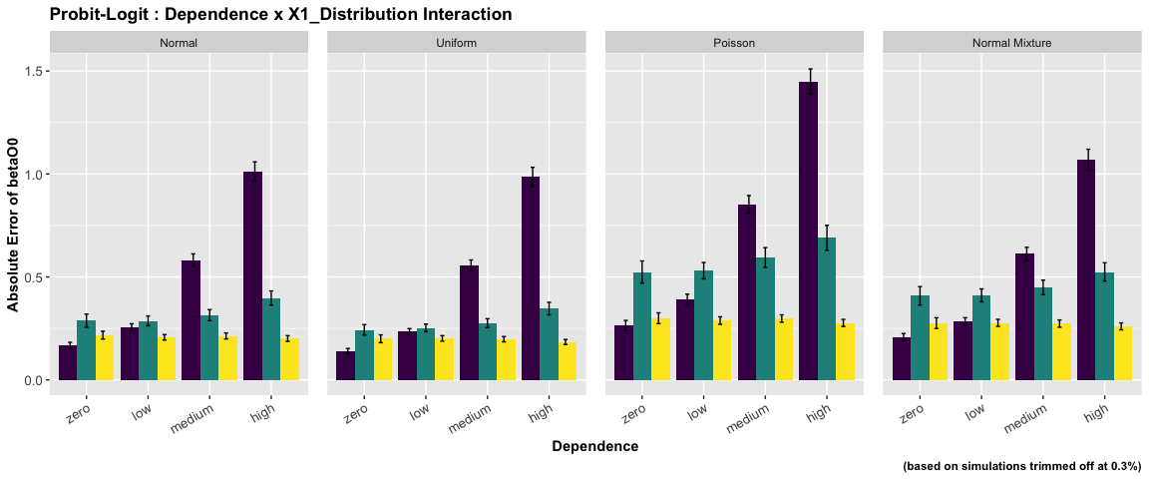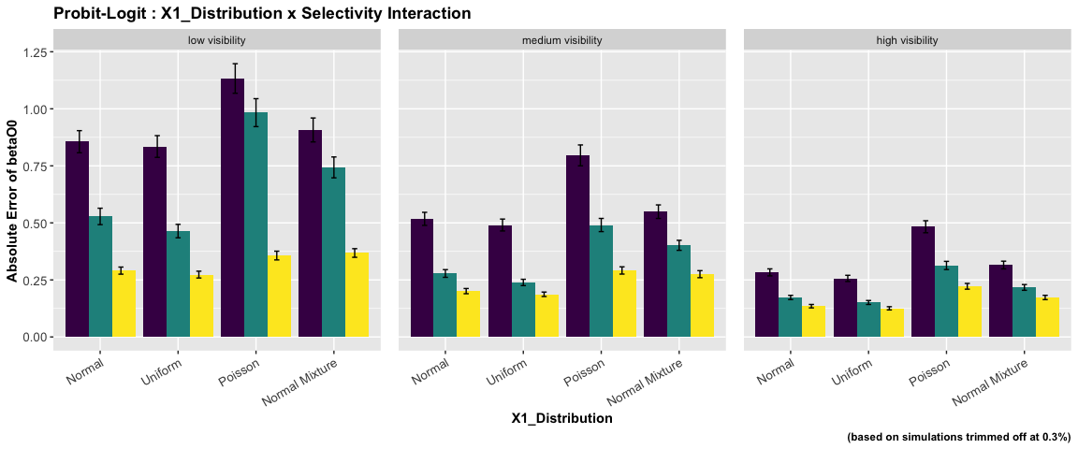

ANOVA : Probit - Normal Specification

|  | num Df | den Df | MSE | F | ges | Pr(>F) |
| --- | --- | --- | --- | --- | --- | --- |
| dependence | 3 | 14352 | 0.02 | 688.91 | 0.13 | 0.00 |
| selectivity | 2 | 14352 | 0.02 | 1022.26 | 0.12 | 0.00 |
| x_dist | 3 | 14352 | 0.02 | 177.48 | 0.04 | 0.00 |
| dependence:selectivity | 6 | 14352 | 0.02 | 53.06 | 0.02 | 0.00 |
| dependence:x_dist | 9 | 14352 | 0.02 | 7.28 | 0.00 | 0.00 |
| selectivity:x_dist | 6 | 14352 | 0.02 | 3.31 | 0.00 | 0.00 |
| dependence:selectivity:x_dist | 18 | 14352 | 0.02 | 0.94 | 0.00 | 0.53 |

The ANOVA suggests that:

* The main effect of dependence is statistically significant and medium (F(3) = 688.91, p < .001; Eta2 (partial) = 0.13, 95% CI [0.12, 1.00])
* The main effect of selectivity is statistically significant and medium (F(2) = 1022.26, p < .001; Eta2 (partial) = 0.12, 95% CI [0.12, 1.00])
* The main effect of x_dist is statistically significant and small (F(3) = 177.48, p < .001; Eta2 (partial) = 0.04, 95% CI [0.03, 1.00])
* The interaction between dependence and selectivity is statistically significant and small (F(6) = 53.06, p < .001; Eta2 (partial) = 0.02, 95% CI [0.02, 1.00])
* The interaction between dependence and x_dist is statistically significant and very small (F(9) = 7.28, p < .001; Eta2 (partial) = 4.55e-03, 95% CI [2.40e-03, 1.00])
* The interaction between selectivity and x_dist is statistically significant and very small (F(6) = 3.31, p = 0.003; Eta2 (partial) = 1.38e-03, 95% CI [2.76e-04, 1.00])
* The interaction between dependence, selectivity and x_dist is statistically not significant and very small (F(18) = 0.94, p = 0.531; Eta2 (partial) = 1.18e-03, 95% CI [0.00, 1.00])

Effect sizes were labelled following Field’s (2013) recommendations.

##### Two-way Interaction Plots

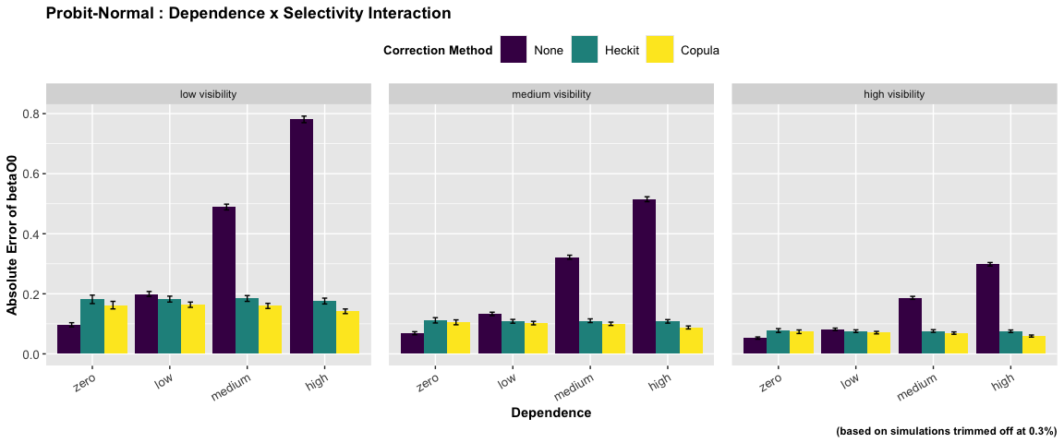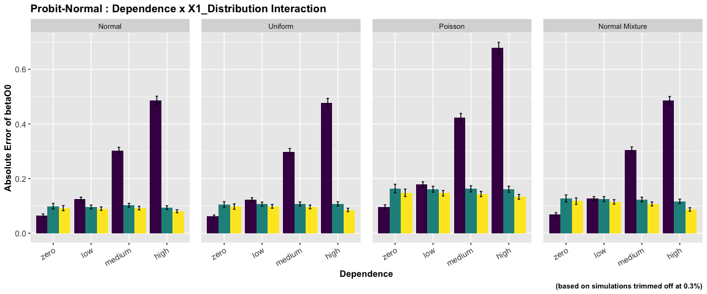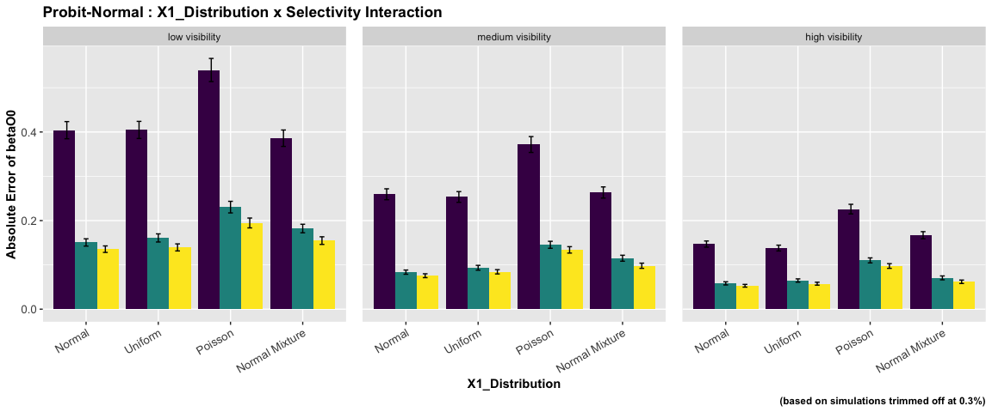

ANOVA : Probit - Poisson Specification

|  | num Df | den Df | MSE | F | ges | Pr(>F) |
| --- | --- | --- | --- | --- | --- | --- |
| dependence | 3 | 14352 | 0 | 625.26 | 0.12 | 0 |
| selectivity | 2 | 14352 | 0 | 812.60 | 0.10 | 0 |
| x_dist | 3 | 14352 | 0 | 765.94 | 0.14 | 0 |
| dependence:selectivity | 6 | 14352 | 0 | 49.85 | 0.02 | 0 |
| dependence:x_dist | 9 | 14352 | 0 | 39.58 | 0.02 | 0 |
| selectivity:x_dist | 6 | 14352 | 0 | 83.68 | 0.03 | 0 |
| dependence:selectivity:x_dist | 18 | 14352 | 0 | 4.48 | 0.01 | 0 |

The ANOVA suggests that:

* The main effect of dependence is statistically significant and medium (F(3) = 625.26, p < .001; Eta2 (partial) = 0.12, 95% CI [0.11, 1.00])
* The main effect of selectivity is statistically significant and medium (F(2) = 812.60, p < .001; Eta2 (partial) = 0.10, 95% CI [0.09, 1.00])
* The main effect of x_dist is statistically significant and medium (F(3) = 765.94, p < .001; Eta2 (partial) = 0.14, 95% CI [0.13, 1.00])
* The interaction between dependence and selectivity is statistically significant and small (F(6) = 49.85, p < .001; Eta2 (partial) = 0.02, 95% CI [0.02, 1.00])
* The interaction between dependence and x_dist is statistically significant and small (F(9) = 39.58, p < .001; Eta2 (partial) = 0.02, 95% CI [0.02, 1.00])
* The interaction between selectivity and x_dist is statistically significant and small (F(6) = 83.68, p < .001; Eta2 (partial) = 0.03, 95% CI [0.03, 1.00])
* The interaction between dependence, selectivity and x_dist is statistically significant and very small (F(18) = 4.48, p < .001; Eta2 (partial) = 5.59e-03, 95% CI [2.67e-03, 1.00])

Effect sizes were labelled following Field’s (2013) recommendations.

##### Two-way Interaction Plots

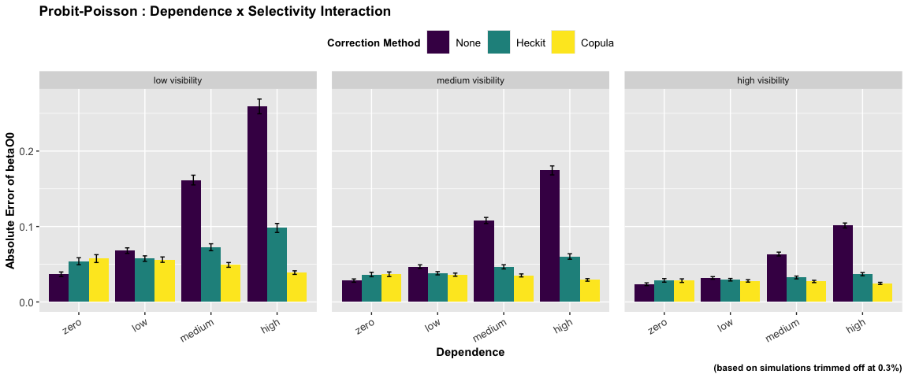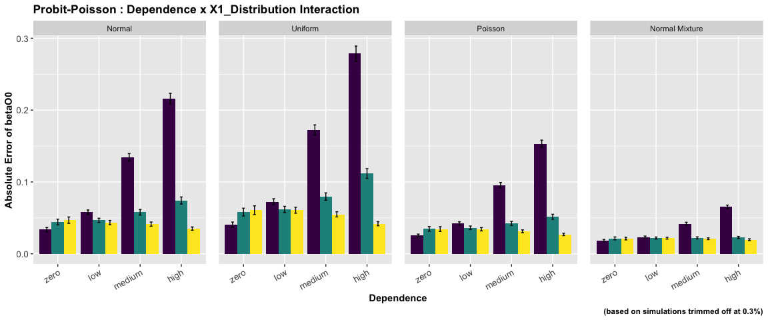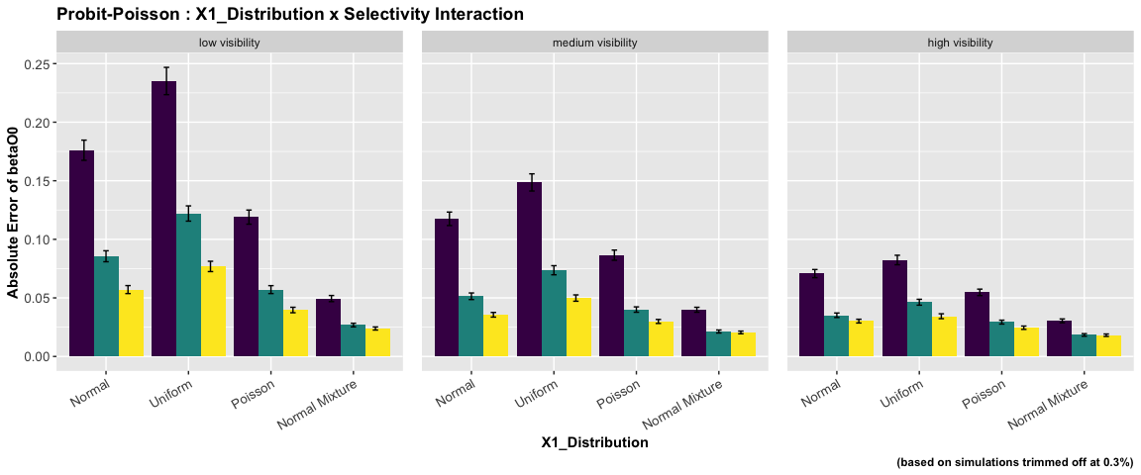

ANOVA : Probit - Probit Specification

|  | num Df | den Df | MSE | F | ges | Pr(>F) |
| --- | --- | --- | --- | --- | --- | --- |
| dependence | 3 | 14181 | 0.13 | 529.72 | 0.10 | 0.00 |
| selectivity | 2 | 14181 | 0.13 | 1162.93 | 0.14 | 0.00 |
| x_dist | 3 | 14181 | 0.13 | 204.53 | 0.04 | 0.00 |
| dependence:selectivity | 6 | 14181 | 0.13 | 59.24 | 0.02 | 0.00 |
| dependence:x_dist | 9 | 14181 | 0.13 | 4.51 | 0.00 | 0.00 |
| selectivity:x_dist | 6 | 14181 | 0.13 | 20.52 | 0.01 | 0.00 |
| dependence:selectivity:x_dist | 18 | 14181 | 0.13 | 1.53 | 0.00 | 0.07 |

The ANOVA suggests that:

* The main effect of dependence is statistically significant and medium (F(3) = 529.72, p < .001; Eta2 (partial) = 0.10, 95% CI [0.09, 1.00])
* The main effect of selectivity is statistically significant and large (F(2) = 1162.93, p < .001; Eta2 (partial) = 0.14, 95% CI [0.13, 1.00])
* The main effect of x_dist is statistically significant and small (F(3) = 204.53, p < .001; Eta2 (partial) = 0.04, 95% CI [0.04, 1.00])
* The interaction between dependence and selectivity is statistically significant and small (F(6) = 59.24, p < .001; Eta2 (partial) = 0.02, 95% CI [0.02, 1.00])
* The interaction between dependence and x_dist is statistically significant and very small (F(9) = 4.51, p < .001; Eta2 (partial) = 2.85e-03, 95% CI [1.09e-03, 1.00])
* The interaction between selectivity and x_dist is statistically significant and very small (F(6) = 20.52, p < .001; Eta2 (partial) = 8.61e-03, 95% CI [5.93e-03, 1.00])
* The interaction between dependence, selectivity and x_dist is statistically not significant and very small (F(18) = 1.53, p = 0.070; Eta2 (partial) = 1.94e-03, 95% CI [0.00, 1.00])

Effect sizes were labelled following Field’s (2013) recommendations.

##### Two-way Interaction Plots

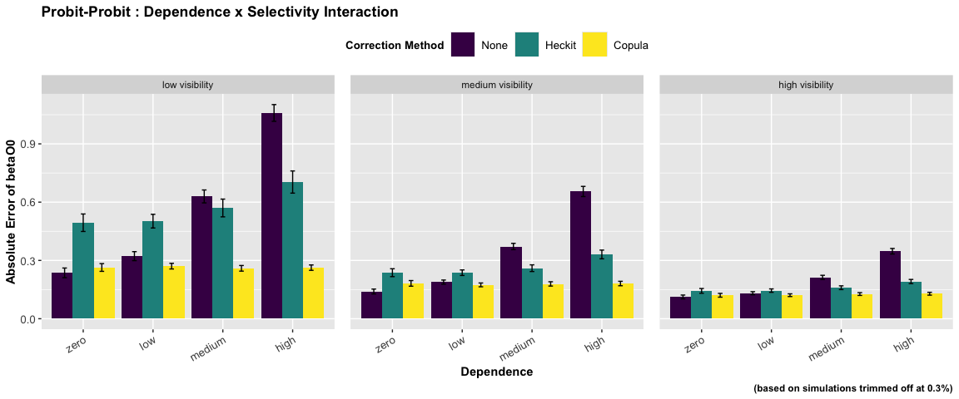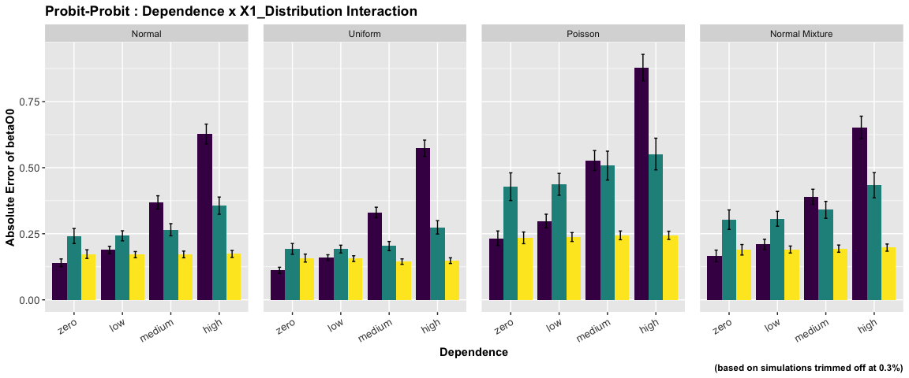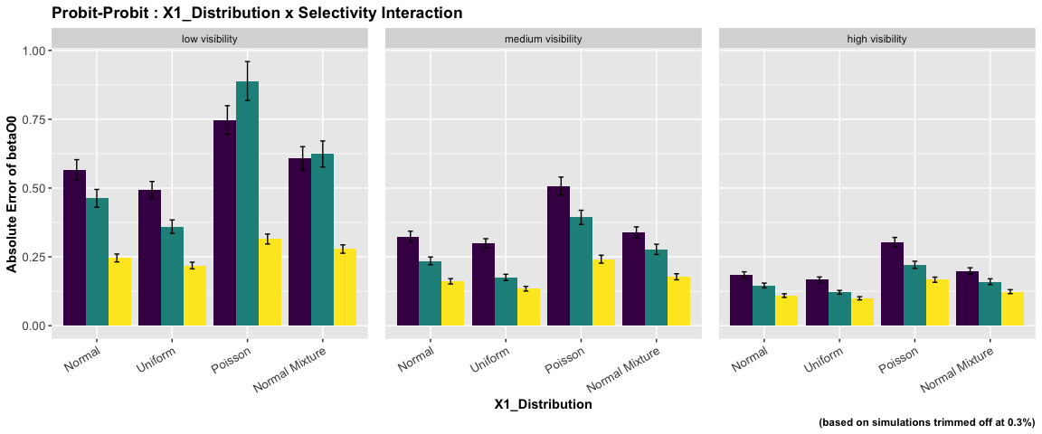

### betaO1 : coefficient on endogenous variable X1

ANOVA : Logit - Logit Specification

|  | num Df | den Df | MSE | F | ges | Pr(>F) |
| --- | --- | --- | --- | --- | --- | --- |
| dependence | 3 | 14280 | 0.07 | 394.47 | 0.08 | 0.00 |
| selectivity | 2 | 14280 | 0.07 | 440.23 | 0.06 | 0.00 |
| x_dist | 3 | 14280 | 0.07 | 84.73 | 0.02 | 0.00 |
| dependence:selectivity | 6 | 14280 | 0.07 | 44.35 | 0.02 | 0.00 |
| dependence:x_dist | 9 | 14280 | 0.07 | 4.47 | 0.00 | 0.00 |
| selectivity:x_dist | 6 | 14280 | 0.07 | 3.05 | 0.00 | 0.01 |
| dependence:selectivity:x_dist | 18 | 14280 | 0.07 | 1.10 | 0.00 | 0.34 |

The ANOVA suggests that:

* The main effect of dependence is statistically significant and medium (F(3) = 394.47, p < .001; Eta2 (partial) = 0.08, 95% CI [0.07, 1.00])
* The main effect of selectivity is statistically significant and small (F(2) = 440.23, p < .001; Eta2 (partial) = 0.06, 95% CI [0.05, 1.00])
* The main effect of x_dist is statistically significant and small (F(3) = 84.73, p < .001; Eta2 (partial) = 0.02, 95% CI [0.01, 1.00])
* The interaction between dependence and selectivity is statistically significant and small (F(6) = 44.35, p < .001; Eta2 (partial) = 0.02, 95% CI [0.01, 1.00])
* The interaction between dependence and x_dist is statistically significant and very small (F(9) = 4.47, p < .001; Eta2 (partial) = 2.81e-03, 95% CI [1.06e-03, 1.00])
* The interaction between selectivity and x_dist is statistically significant and very small (F(6) = 3.05, p = 0.005; Eta2 (partial) = 1.28e-03, 95% CI [2.14e-04, 1.00])
* The interaction between dependence, selectivity and x_dist is statistically not significant and very small (F(18) = 1.10, p = 0.342; Eta2 (partial) = 1.39e-03, 95% CI [0.00, 1.00])

Effect sizes were labelled following Field’s (2013) recommendations.

##### Two-way Interaction Plots

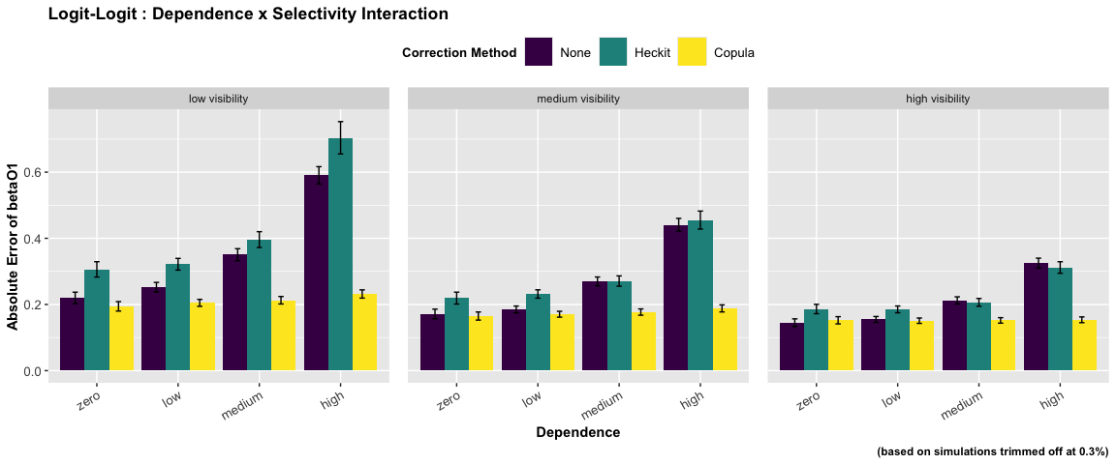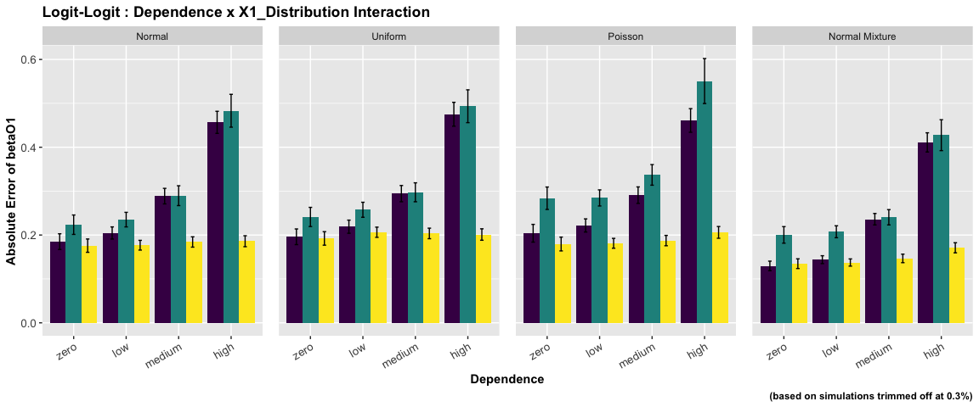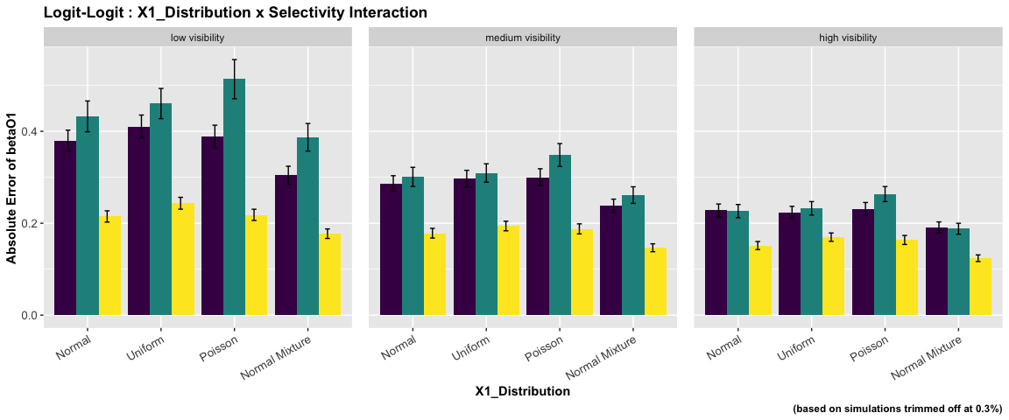

ANOVA : Logit - Normal Specification

|  | num Df | den Df | MSE | F | ges | Pr(>F) |
| --- | --- | --- | --- | --- | --- | --- |
| dependence | 3 | 14352 | 0 | 315.79 | 0.06 | 0.00 |
| selectivity | 2 | 14352 | 0 | 316.79 | 0.04 | 0.00 |
| x_dist | 3 | 14352 | 0 | 555.38 | 0.10 | 0.00 |
| dependence:selectivity | 6 | 14352 | 0 | 4.60 | 0.00 | 0.00 |
| dependence:x_dist | 9 | 14352 | 0 | 0.92 | 0.00 | 0.51 |
| selectivity:x_dist | 6 | 14352 | 0 | 12.90 | 0.01 | 0.00 |
| dependence:selectivity:x_dist | 18 | 14352 | 0 | 0.44 | 0.00 | 0.98 |

The ANOVA suggests that:

* The main effect of dependence is statistically significant and medium (F(3) = 315.79, p < .001; Eta2 (partial) = 0.06, 95% CI [0.06, 1.00])
* The main effect of selectivity is statistically significant and small (F(2) = 316.79, p < .001; Eta2 (partial) = 0.04, 95% CI [0.04, 1.00])
* The main effect of x_dist is statistically significant and medium (F(3) = 555.38, p < .001; Eta2 (partial) = 0.10, 95% CI [0.10, 1.00])
* The interaction between dependence and selectivity is statistically significant and very small (F(6) = 4.60, p < .001; Eta2 (partial) = 1.92e-03, 95% CI [6.18e-04, 1.00])
* The interaction between dependence and x_dist is statistically not significant and very small (F(9) = 0.92, p = 0.511; Eta2 (partial) = 5.73e-04, 95% CI [0.00, 1.00])
* The interaction between selectivity and x_dist is statistically significant and very small (F(6) = 12.90, p < .001; Eta2 (partial) = 5.36e-03, 95% CI [3.24e-03, 1.00])
* The interaction between dependence, selectivity and x_dist is statistically not significant and very small (F(18) = 0.44, p = 0.980; Eta2 (partial) = 5.49e-04, 95% CI [0.00, 1.00])

Effect sizes were labelled following Field’s (2013) recommendations.

##### Two-way Interaction Plots

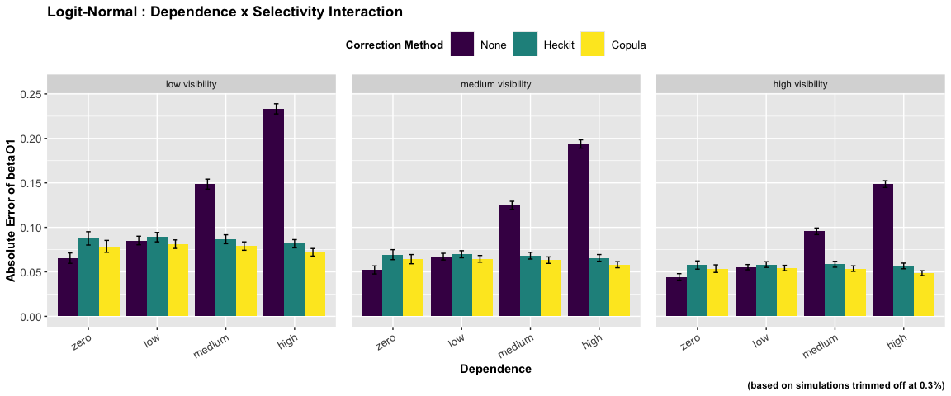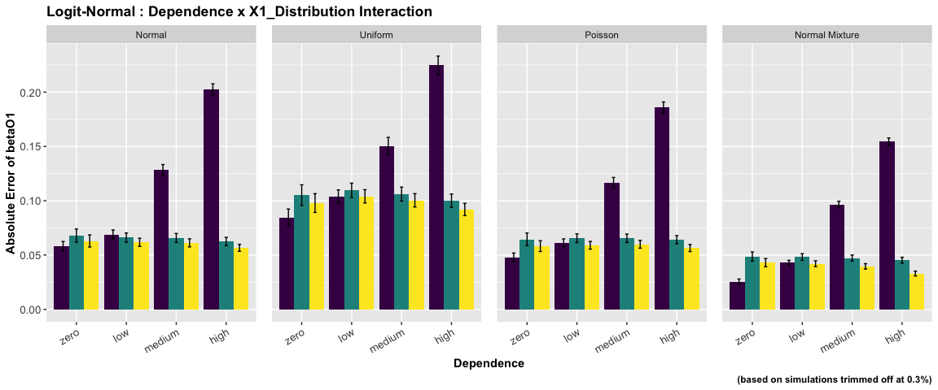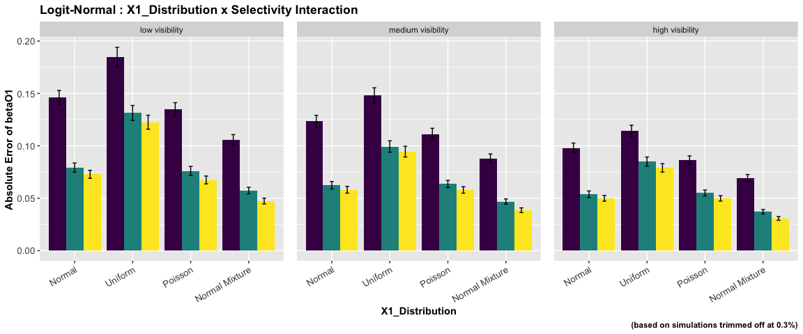

ANOVA : Logit - Poisson Specification

|  | num Df | den Df | MSE | F | ges | Pr(>F) |
| --- | --- | --- | --- | --- | --- | --- |
| dependence | 3 | 14352 | 0 | 522.76 | 0.10 | 0 |
| selectivity | 2 | 14352 | 0 | 377.30 | 0.05 | 0 |
| x_dist | 3 | 14352 | 0 | 3330.50 | 0.41 | 0 |
| dependence:selectivity | 6 | 14352 | 0 | 25.37 | 0.01 | 0 |
| dependence:x_dist | 9 | 14352 | 0 | 82.43 | 0.05 | 0 |
| selectivity:x_dist | 6 | 14352 | 0 | 85.96 | 0.03 | 0 |
| dependence:selectivity:x_dist | 18 | 14352 | 0 | 5.43 | 0.01 | 0 |

The ANOVA suggests that:

* The main effect of dependence is statistically significant and medium (F(3) = 522.76, p < .001; Eta2 (partial) = 0.10, 95% CI [0.09, 1.00])
* The main effect of selectivity is statistically significant and small (F(2) = 377.30, p < .001; Eta2 (partial) = 0.05, 95% CI [0.04, 1.00])
* The main effect of x_dist is statistically significant and large (F(3) = 3330.50, p < .001; Eta2 (partial) = 0.41, 95% CI [0.40, 1.00])
* The interaction between dependence and selectivity is statistically significant and small (F(6) = 25.37, p < .001; Eta2 (partial) = 0.01, 95% CI [7.58e-03, 1.00])
* The interaction between dependence and x_dist is statistically significant and small (F(9) = 82.43, p < .001; Eta2 (partial) = 0.05, 95% CI [0.04, 1.00])
* The interaction between selectivity and x_dist is statistically significant and small (F(6) = 85.96, p < .001; Eta2 (partial) = 0.03, 95% CI [0.03, 1.00])
* The interaction between dependence, selectivity and x_dist is statistically significant and very small (F(18) = 5.43, p < .001; Eta2 (partial) = 6.76e-03, 95% CI [3.63e-03, 1.00])

Effect sizes were labelled following Field’s (2013) recommendations.

##### Two-way Interaction Plots

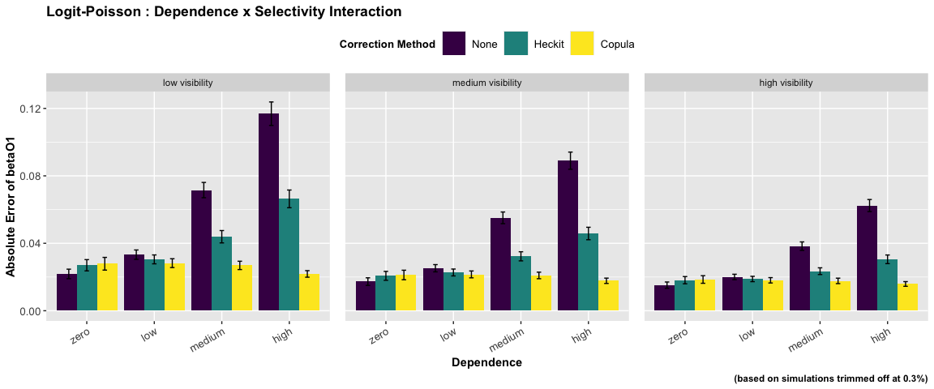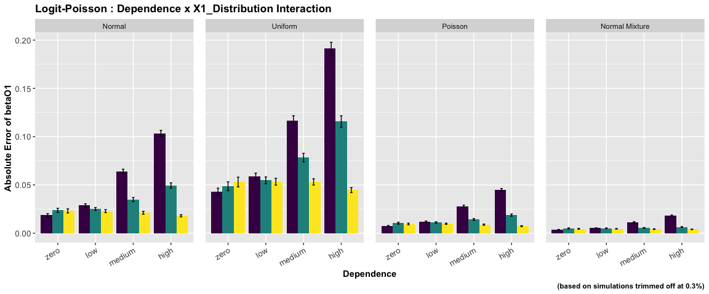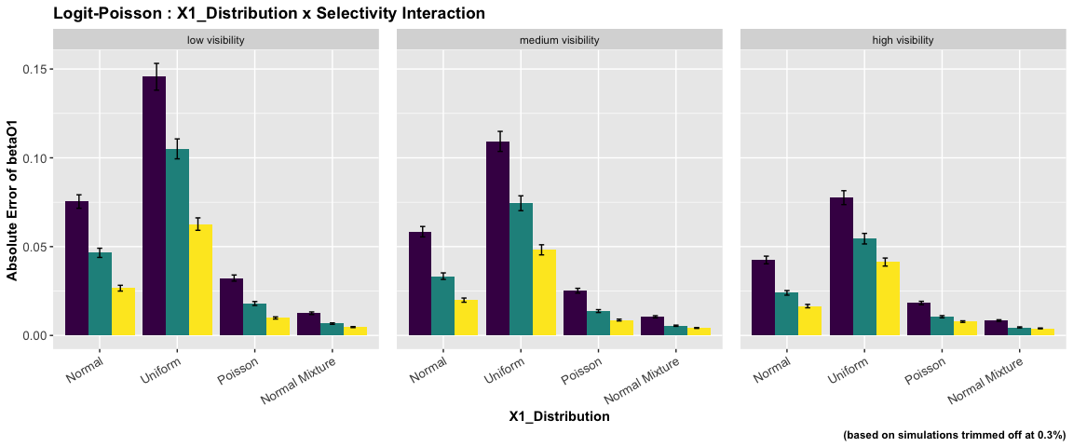

ANOVA : Logit - Probit Specification

|  | num Df | den Df | MSE | F | ges | Pr(>F) |
| --- | --- | --- | --- | --- | --- | --- |
| dependence | 3 | 14209 | 0.07 | 277.01 | 0.06 | 0.00 |
| selectivity | 2 | 14209 | 0.07 | 359.94 | 0.05 | 0.00 |
| x_dist | 3 | 14209 | 0.07 | 115.35 | 0.02 | 0.00 |
| dependence:selectivity | 6 | 14209 | 0.07 | 24.38 | 0.01 | 0.00 |
| dependence:x_dist | 9 | 14209 | 0.07 | 2.87 | 0.00 | 0.00 |
| selectivity:x_dist | 6 | 14209 | 0.07 | 3.55 | 0.00 | 0.00 |
| dependence:selectivity:x_dist | 18 | 14209 | 0.07 | 1.66 | 0.00 | 0.04 |

The ANOVA suggests that:

* The main effect of dependence is statistically significant and small (F(3) = 277.01, p < .001; Eta2 (partial) = 0.06, 95% CI [0.05, 1.00])
* The main effect of selectivity is statistically significant and small (F(2) = 359.94, p < .001; Eta2 (partial) = 0.05, 95% CI [0.04, 1.00])
* The main effect of x_dist is statistically significant and small (F(3) = 115.35, p < .001; Eta2 (partial) = 0.02, 95% CI [0.02, 1.00])
* The interaction between dependence and selectivity is statistically significant and small (F(6) = 24.38, p < .001; Eta2 (partial) = 0.01, 95% CI [7.30e-03, 1.00])
* The interaction between dependence and x_dist is statistically significant and very small (F(9) = 2.87, p = 0.002; Eta2 (partial) = 1.81e-03, 95% CI [3.70e-04, 1.00])
* The interaction between selectivity and x_dist is statistically significant and very small (F(6) = 3.55, p = 0.002; Eta2 (partial) = 1.50e-03, 95% CI [3.39e-04, 1.00])
* The interaction between dependence, selectivity and x_dist is statistically significant and very small (F(18) = 1.66, p = 0.039; Eta2 (partial) = 2.09e-03, 95% CI [4.15e-05, 1.00])

Effect sizes were labelled following Field’s (2013) recommendations.

##### Two-way Interaction Plots

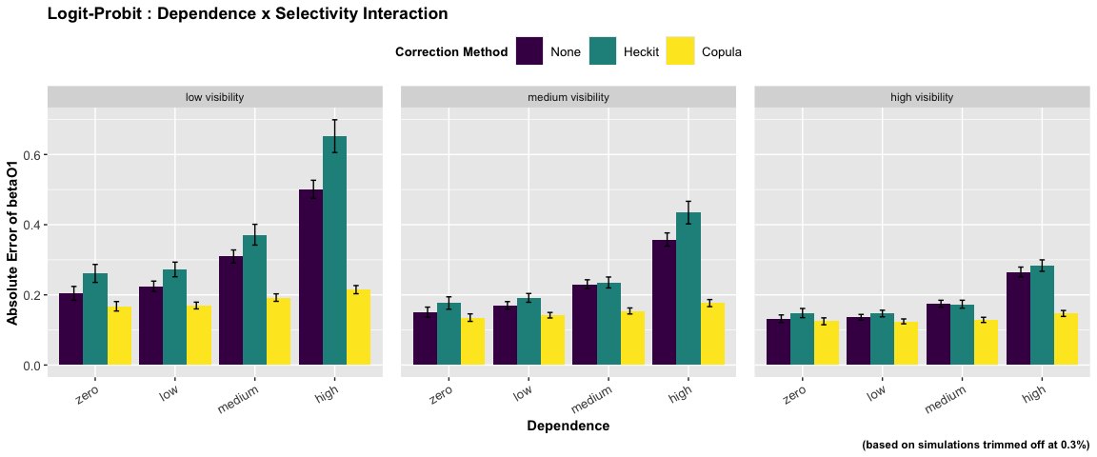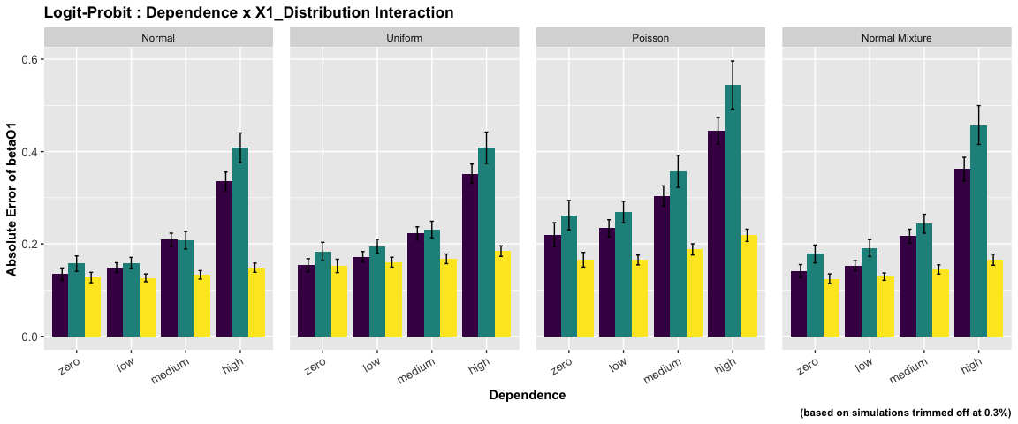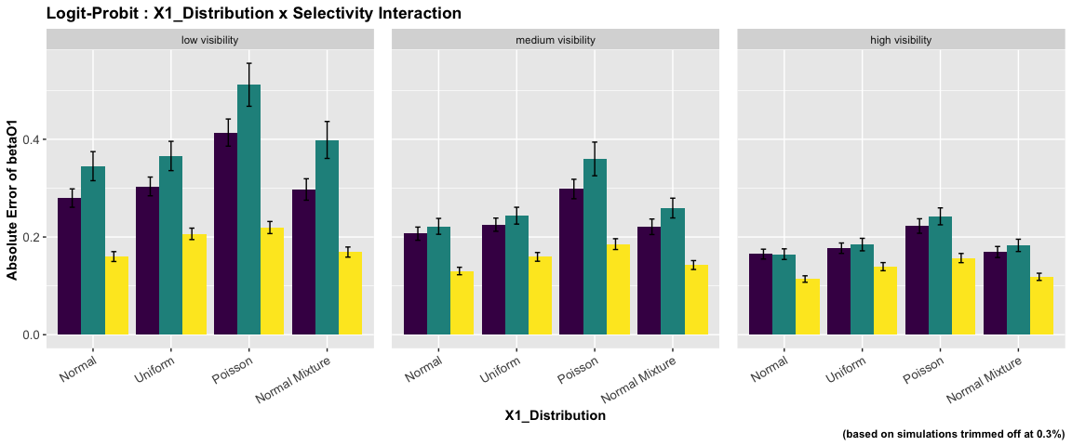

ANOVA : Probit - Logit Specification

|  | num Df | den Df | MSE | F | ges | Pr(>F) |
| --- | --- | --- | --- | --- | --- | --- |
| dependence | 3 | 14269 | 0.06 | 265.27 | 0.05 | 0.00 |
| selectivity | 2 | 14269 | 0.06 | 654.42 | 0.08 | 0.00 |
| x_dist | 3 | 14269 | 0.06 | 87.82 | 0.02 | 0.00 |
| dependence:selectivity | 6 | 14269 | 0.06 | 36.54 | 0.02 | 0.00 |
| dependence:x_dist | 9 | 14269 | 0.06 | 1.97 | 0.00 | 0.04 |
| selectivity:x_dist | 6 | 14269 | 0.06 | 7.34 | 0.00 | 0.00 |
| dependence:selectivity:x_dist | 18 | 14269 | 0.06 | 0.90 | 0.00 | 0.58 |

The ANOVA suggests that:

* The main effect of dependence is statistically significant and small (F(3) = 265.27, p < .001; Eta2 (partial) = 0.05, 95% CI [0.05, 1.00])
* The main effect of selectivity is statistically significant and medium (F(2) = 654.42, p < .001; Eta2 (partial) = 0.08, 95% CI [0.08, 1.00])
* The main effect of x_dist is statistically significant and small (F(3) = 87.82, p < .001; Eta2 (partial) = 0.02, 95% CI [0.01, 1.00])
* The interaction between dependence and selectivity is statistically significant and small (F(6) = 36.54, p < .001; Eta2 (partial) = 0.02, 95% CI [0.01, 1.00])
* The interaction between dependence and x_dist is statistically significant and very small (F(9) = 1.97, p = 0.038; Eta2 (partial) = 1.24e-03, 95% CI [3.17e-05, 1.00])
* The interaction between selectivity and x_dist is statistically significant and very small (F(6) = 7.34, p < .001; Eta2 (partial) = 3.08e-03, 95% CI [1.44e-03, 1.00])
* The interaction between dependence, selectivity and x_dist is statistically not significant and very small (F(18) = 0.90, p = 0.581; Eta2 (partial) = 1.13e-03, 95% CI [0.00, 1.00])

Effect sizes were labelled following Field’s (2013) recommendations.

##### Two-way Interaction Plots

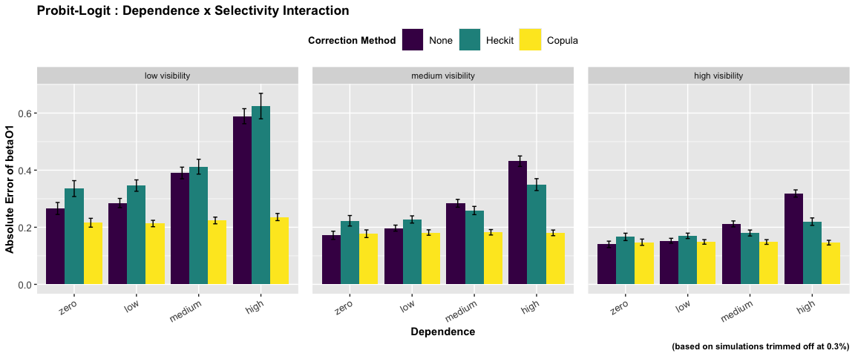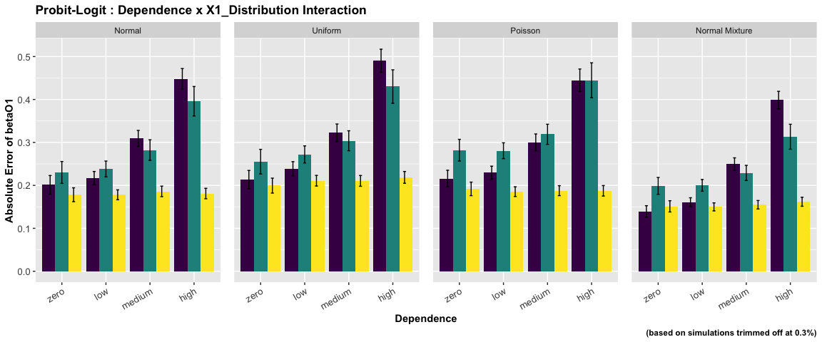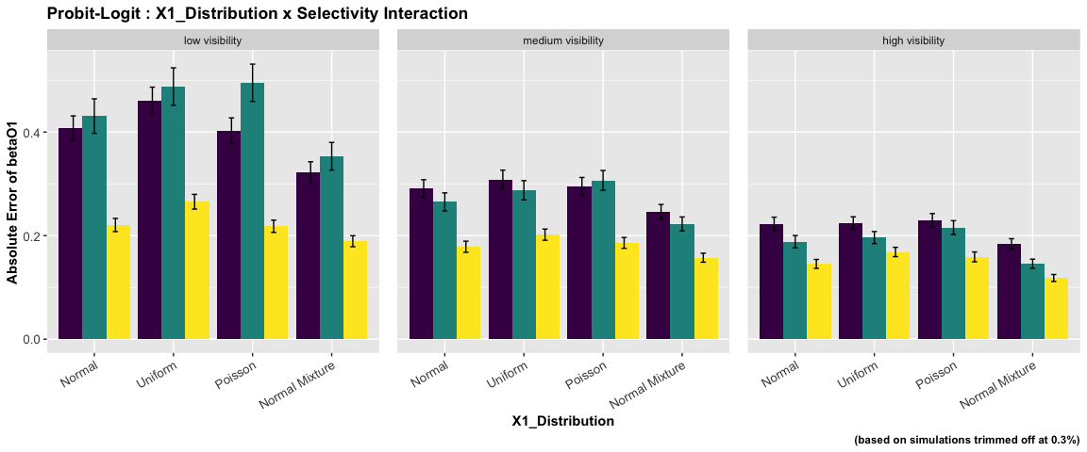

ANOVA : Probit - Normal Specification

|  | num Df | den Df | MSE | F | ges | Pr(>F) |
| --- | --- | --- | --- | --- | --- | --- |
| dependence | 3 | 14352 | 0 | 325.28 | 0.06 | 0.00 |
| selectivity | 2 | 14352 | 0 | 434.24 | 0.06 | 0.00 |
| x_dist | 3 | 14352 | 0 | 656.60 | 0.12 | 0.00 |
| dependence:selectivity | 6 | 14352 | 0 | 8.35 | 0.00 | 0.00 |
| dependence:x_dist | 9 | 14352 | 0 | 2.30 | 0.00 | 0.01 |
| selectivity:x_dist | 6 | 14352 | 0 | 21.90 | 0.01 | 0.00 |
| dependence:selectivity:x_dist | 18 | 14352 | 0 | 0.39 | 0.00 | 0.99 |

The ANOVA suggests that:

* The main effect of dependence is statistically significant and medium (F(3) = 325.28, p < .001; Eta2 (partial) = 0.06, 95% CI [0.06, 1.00])
* The main effect of selectivity is statistically significant and small (F(2) = 434.24, p < .001; Eta2 (partial) = 0.06, 95% CI [0.05, 1.00])
* The main effect of x_dist is statistically significant and medium (F(3) = 656.60, p < .001; Eta2 (partial) = 0.12, 95% CI [0.11, 1.00])
* The interaction between dependence and selectivity is statistically significant and very small (F(6) = 8.35, p < .001; Eta2 (partial) = 3.48e-03, 95% CI [1.75e-03, 1.00])
* The interaction between dependence and x_dist is statistically significant and very small (F(9) = 2.30, p = 0.014; Eta2 (partial) = 1.44e-03, 95% CI [1.47e-04, 1.00])
* The interaction between selectivity and x_dist is statistically significant and very small (F(6) = 21.90, p < .001; Eta2 (partial) = 9.07e-03, 95% CI [6.35e-03, 1.00])
* The interaction between dependence, selectivity and x_dist is statistically not significant and very small (F(18) = 0.39, p = 0.990; Eta2 (partial) = 4.91e-04, 95% CI [0.00, 1.00])

Effect sizes were labelled following Field’s (2013) recommendations.

##### Two-way Interaction Plots

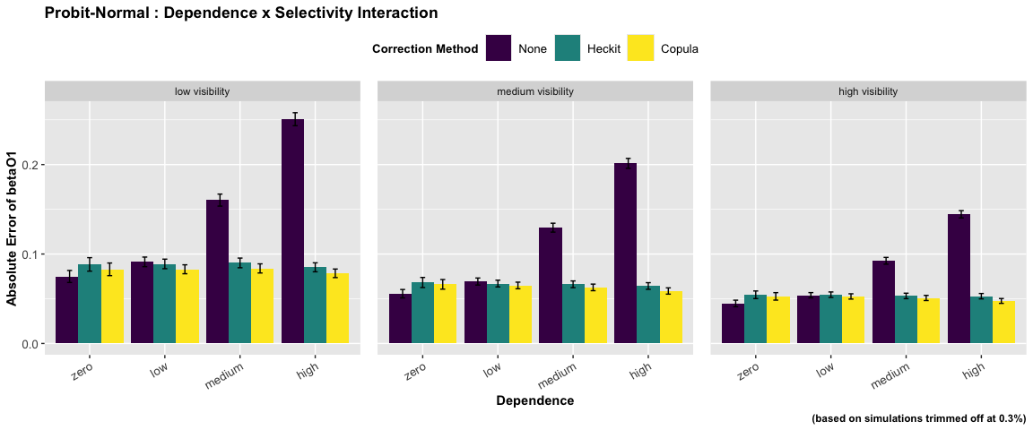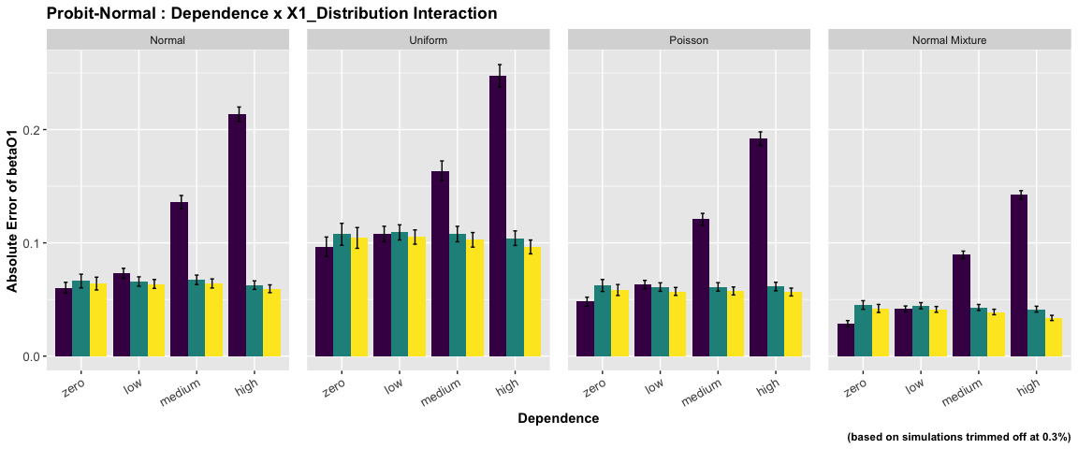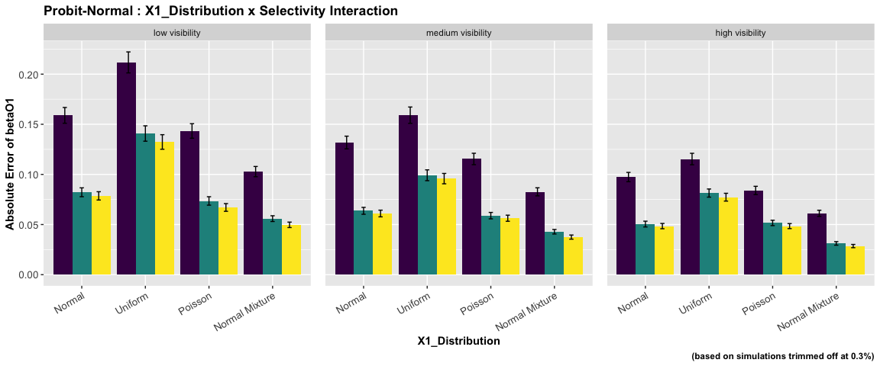

ANOVA : Probit - Poisson Specification

|  | num Df | den Df | MSE | F | ges | Pr(>F) |
| --- | --- | --- | --- | --- | --- | --- |
| dependence | 3 | 14352 | 0 | 343.08 | 0.07 | 0 |
| selectivity | 2 | 14352 | 0 | 449.31 | 0.06 | 0 |
| x_dist | 3 | 14352 | 0 | 3407.51 | 0.42 | 0 |
| dependence:selectivity | 6 | 14352 | 0 | 22.22 | 0.01 | 0 |
| dependence:x_dist | 9 | 14352 | 0 | 67.29 | 0.04 | 0 |
| selectivity:x_dist | 6 | 14352 | 0 | 129.05 | 0.05 | 0 |
| dependence:selectivity:x_dist | 18 | 14352 | 0 | 5.39 | 0.01 | 0 |

The ANOVA suggests that:

* The main effect of dependence is statistically significant and medium (F(3) = 343.08, p < .001; Eta2 (partial) = 0.07, 95% CI [0.06, 1.00])
* The main effect of selectivity is statistically significant and small (F(2) = 449.31, p < .001; Eta2 (partial) = 0.06, 95% CI [0.05, 1.00])
* The main effect of x_dist is statistically significant and large (F(3) = 3407.51, p < .001; Eta2 (partial) = 0.42, 95% CI [0.41, 1.00])
* The interaction between dependence and selectivity is statistically significant and very small (F(6) = 22.22, p < .001; Eta2 (partial) = 9.20e-03, 95% CI [6.46e-03, 1.00])
* The interaction between dependence and x_dist is statistically significant and small (F(9) = 67.29, p < .001; Eta2 (partial) = 0.04, 95% CI [0.03, 1.00])
* The interaction between selectivity and x_dist is statistically significant and small (F(6) = 129.05, p < .001; Eta2 (partial) = 0.05, 95% CI [0.05, 1.00])
* The interaction between dependence, selectivity and x_dist is statistically significant and very small (F(18) = 5.39, p < .001; Eta2 (partial) = 6.72e-03, 95% CI [3.60e-03, 1.00])

Effect sizes were labelled following Field’s (2013) recommendations.

##### Two-way Interaction Plots

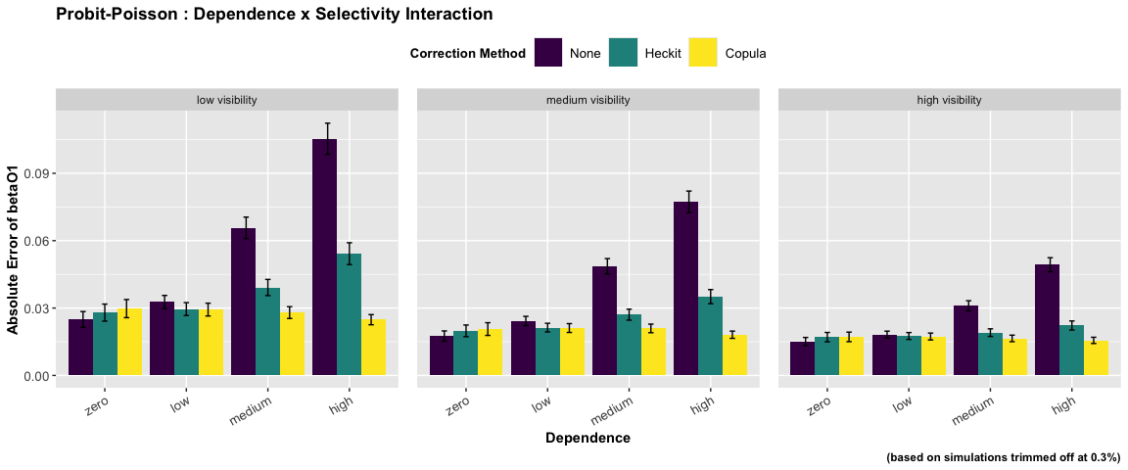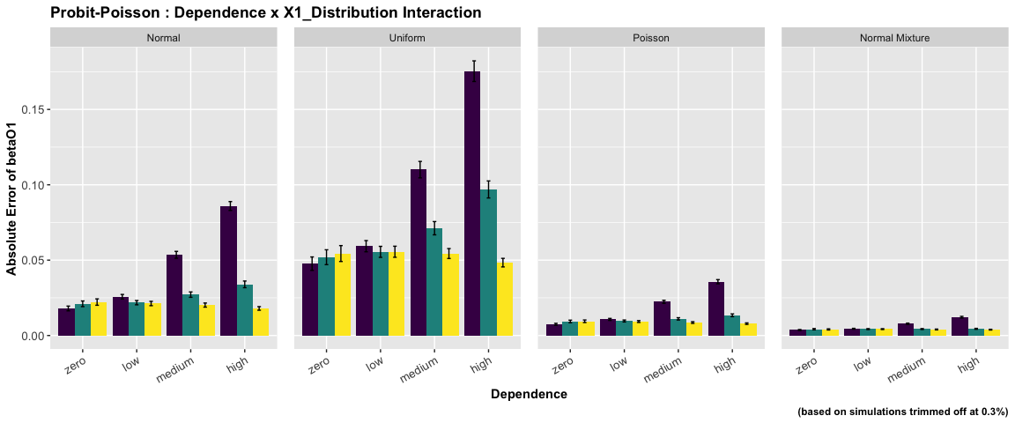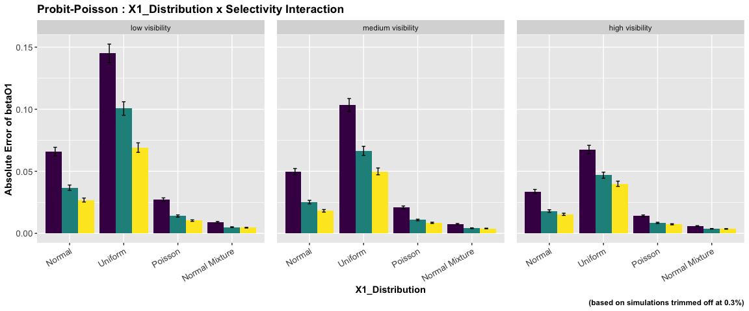

ANOVA : Probit - Probit Specification

|  | num Df | den Df | MSE | F | ges | Pr(>F) |
| --- | --- | --- | --- | --- | --- | --- |
| dependence | 3 | 14172 | 0.07 | 144.21 | 0.03 | 0.00 |
| selectivity | 2 | 14172 | 0.07 | 665.08 | 0.09 | 0.00 |
| x_dist | 3 | 14172 | 0.07 | 103.26 | 0.02 | 0.00 |
| dependence:selectivity | 6 | 14172 | 0.07 | 23.09 | 0.01 | 0.00 |
| dependence:x_dist | 9 | 14172 | 0.07 | 0.63 | 0.00 | 0.77 |
| selectivity:x_dist | 6 | 14172 | 0.07 | 6.80 | 0.00 | 0.00 |
| dependence:selectivity:x_dist | 18 | 14172 | 0.07 | 1.71 | 0.00 | 0.03 |

The ANOVA suggests that:

* The main effect of dependence is statistically significant and small (F(3) = 144.21, p < .001; Eta2 (partial) = 0.03, 95% CI [0.03, 1.00])
* The main effect of selectivity is statistically significant and medium (F(2) = 665.08, p < .001; Eta2 (partial) = 0.09, 95% CI [0.08, 1.00])
* The main effect of x_dist is statistically significant and small (F(3) = 103.26, p < .001; Eta2 (partial) = 0.02, 95% CI [0.02, 1.00])
* The interaction between dependence and selectivity is statistically significant and very small (F(6) = 23.09, p < .001; Eta2 (partial) = 9.68e-03, 95% CI [6.85e-03, 1.00])
* The interaction between dependence and x_dist is statistically not significant and very small (F(9) = 0.63, p = 0.769; Eta2 (partial) = 4.02e-04, 95% CI [0.00, 1.00])
* The interaction between selectivity and x_dist is statistically significant and very small (F(6) = 6.80, p < .001; Eta2 (partial) = 2.87e-03, 95% CI [1.28e-03, 1.00])
* The interaction between dependence, selectivity and x_dist is statistically significant and very small (F(18) = 1.71, p = 0.031; Eta2 (partial) = 2.17e-03, 95% CI [8.33e-05, 1.00])

Effect sizes were labelled following Field’s (2013) recommendations.

##### Two-way Interaction Plots

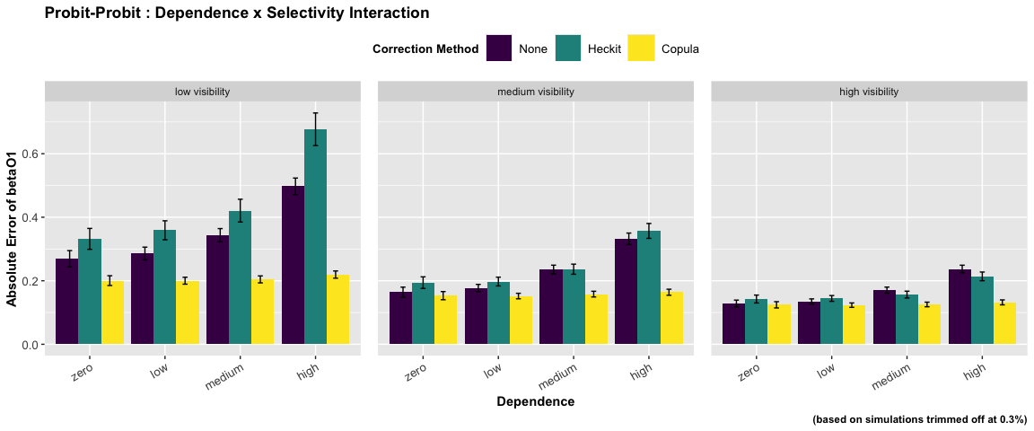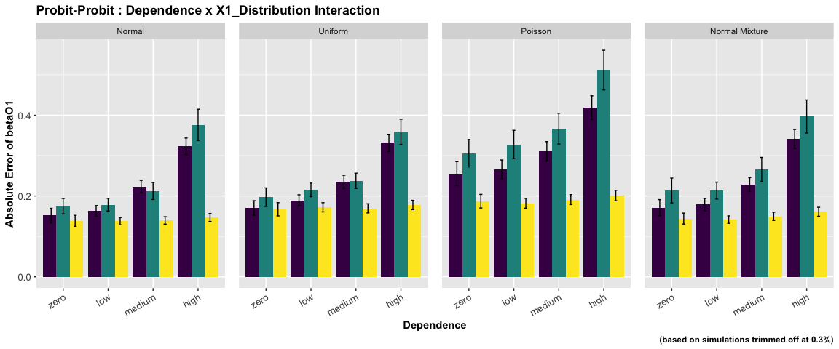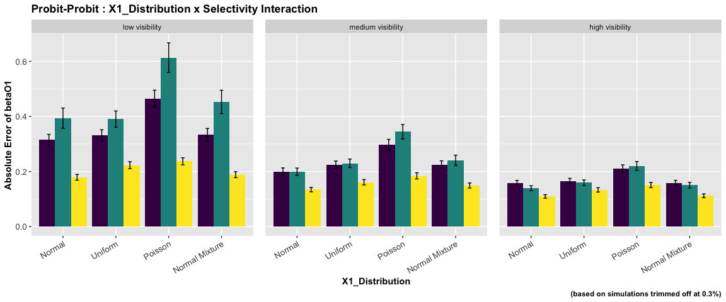

### betaO2 : coefficient on exogenous variable X2

ANOVA : Logit - Logit Specification

|  | num Df | den Df | MSE | F | ges | Pr(>F) |
| --- | --- | --- | --- | --- | --- | --- |
| dependence | 3 | 14249 | 0.06 | 851.09 | 0.15 | 0.0 |
| selectivity | 2 | 14249 | 0.06 | 447.67 | 0.06 | 0.0 |
| x_dist | 3 | 14249 | 0.06 | 51.06 | 0.01 | 0.0 |
| dependence:selectivity | 6 | 14249 | 0.06 | 53.40 | 0.02 | 0.0 |
| dependence:x_dist | 9 | 14249 | 0.06 | 11.31 | 0.01 | 0.0 |
| selectivity:x_dist | 6 | 14249 | 0.06 | 3.92 | 0.00 | 0.0 |
| dependence:selectivity:x_dist | 18 | 14249 | 0.06 | 0.80 | 0.00 | 0.7 |

The ANOVA suggests that:

* The main effect of dependence is statistically significant and large (F(3) = 851.09, p < .001; Eta2 (partial) = 0.15, 95% CI [0.14, 1.00])
* The main effect of selectivity is statistically significant and small (F(2) = 447.67, p < .001; Eta2 (partial) = 0.06, 95% CI [0.05, 1.00])
* The main effect of x_dist is statistically significant and small (F(3) = 51.06, p < .001; Eta2 (partial) = 0.01, 95% CI [7.88e-03, 1.00])
* The interaction between dependence and selectivity is statistically significant and small (F(6) = 53.40, p < .001; Eta2 (partial) = 0.02, 95% CI [0.02, 1.00])
* The interaction between dependence and x_dist is statistically significant and very small (F(9) = 11.31, p < .001; Eta2 (partial) = 7.09e-03, 95% CI [4.46e-03, 1.00])
* The interaction between selectivity and x_dist is statistically significant and very small (F(6) = 3.92, p < .001; Eta2 (partial) = 1.65e-03, 95% CI [4.37e-04, 1.00])
* The interaction between dependence, selectivity and x_dist is statistically not significant and very small (F(18) = 0.80, p = 0.698; Eta2 (partial) = 1.01e-03, 95% CI [0.00, 1.00])

Effect sizes were labelled following Field’s (2013) recommendations.

##### Two-way Interaction Plots

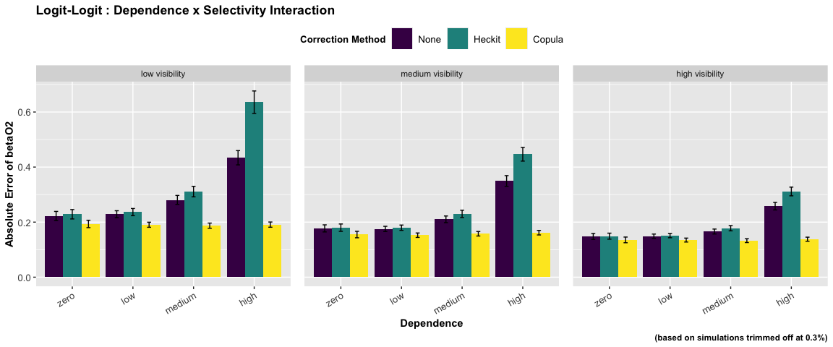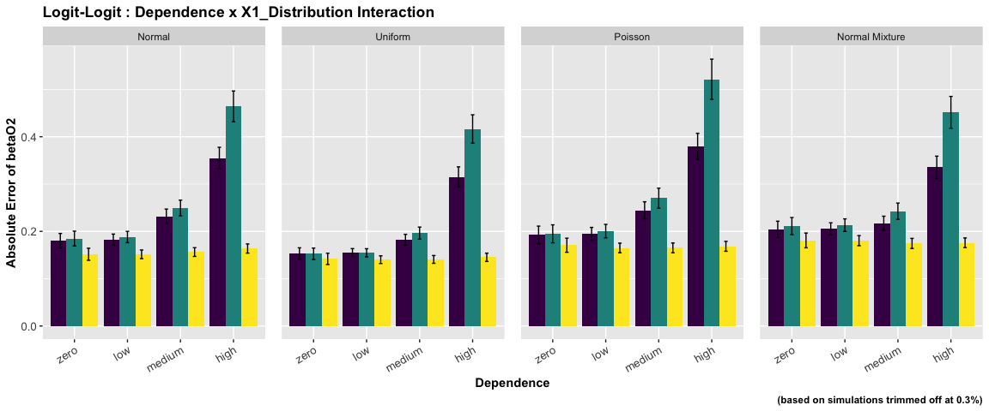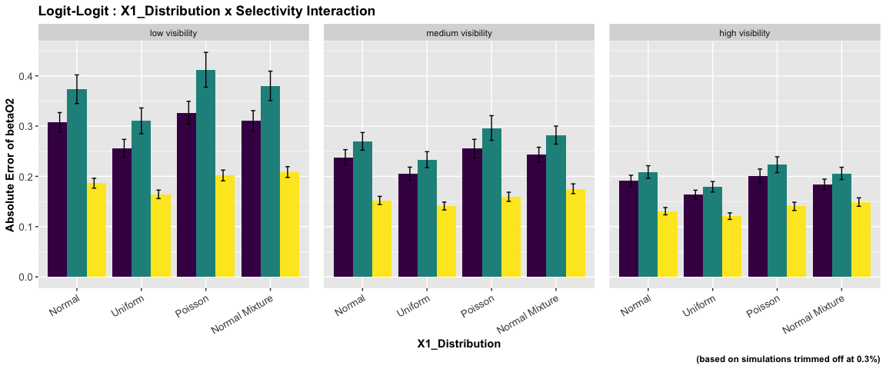

ANOVA : Logit - Normal Specification

|  | num Df | den Df | MSE | F | ges | Pr(>F) |
| --- | --- | --- | --- | --- | --- | --- |
| dependence | 3 | 14352 | 0 | 5.78 | 0.00 | 0.00 |
| selectivity | 2 | 14352 | 0 | 207.08 | 0.03 | 0.00 |
| x_dist | 3 | 14352 | 0 | 10.24 | 0.00 | 0.00 |
| dependence:selectivity | 6 | 14352 | 0 | 1.42 | 0.00 | 0.20 |
| dependence:x_dist | 9 | 14352 | 0 | 0.81 | 0.00 | 0.61 |
| selectivity:x_dist | 6 | 14352 | 0 | 1.98 | 0.00 | 0.06 |
| dependence:selectivity:x_dist | 18 | 14352 | 0 | 0.97 | 0.00 | 0.49 |

The ANOVA suggests that:

* The main effect of dependence is statistically significant and very small (F(3) = 5.78, p < .001; Eta2 (partial) = 1.21e-03, 95% CI [3.34e-04, 1.00])
* The main effect of selectivity is statistically significant and small (F(2) = 207.08, p < .001; Eta2 (partial) = 0.03, 95% CI [0.02, 1.00])
* The main effect of x_dist is statistically significant and very small (F(3) = 10.24, p < .001; Eta2 (partial) = 2.14e-03, 95% CI [9.40e-04, 1.00])
* The interaction between dependence and selectivity is statistically not significant and very small (F(6) = 1.42, p = 0.204; Eta2 (partial) = 5.92e-04, 95% CI [0.00, 1.00])
* The interaction between dependence and x_dist is statistically not significant and very small (F(9) = 0.81, p = 0.609; Eta2 (partial) = 5.06e-04, 95% CI [0.00, 1.00])
* The interaction between selectivity and x_dist is statistically not significant and very small (F(6) = 1.98, p = 0.065; Eta2 (partial) = 8.27e-04, 95% CI [0.00, 1.00])
* The interaction between dependence, selectivity and x_dist is statistically not significant and very small (F(18) = 0.97, p = 0.492; Eta2 (partial) = 1.22e-03, 95% CI [0.00, 1.00])

Effect sizes were labelled following Field’s (2013) recommendations.

##### Two-way Interaction Plots

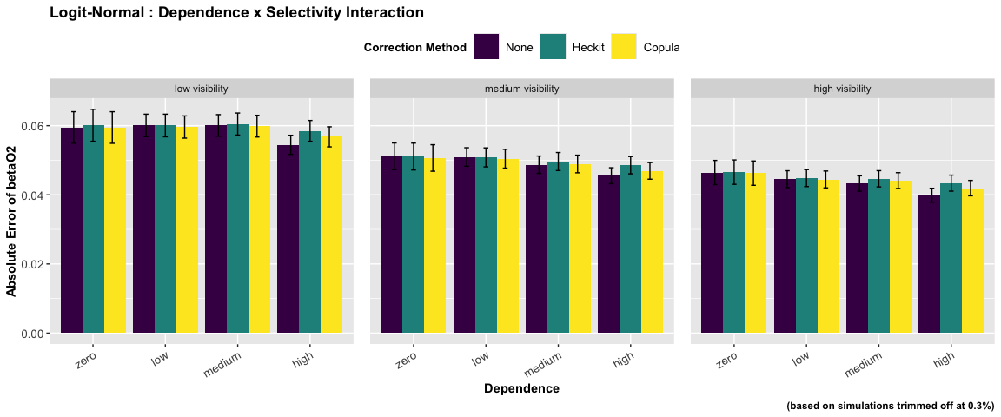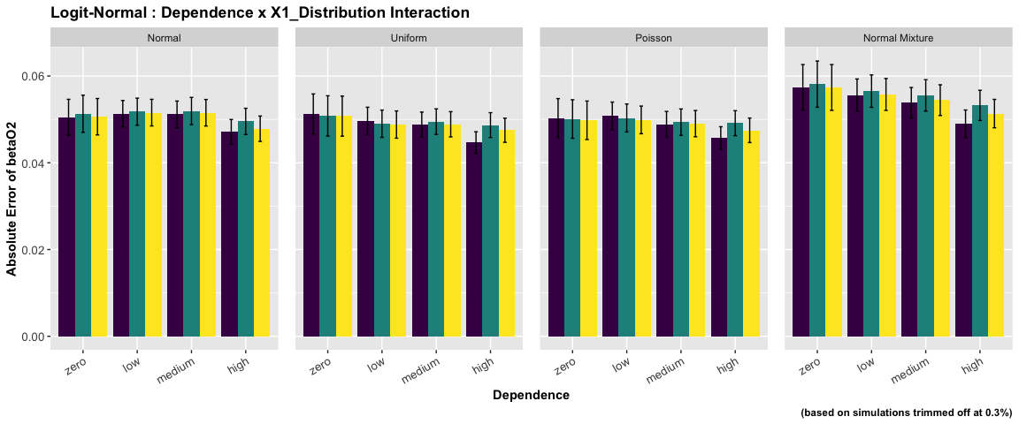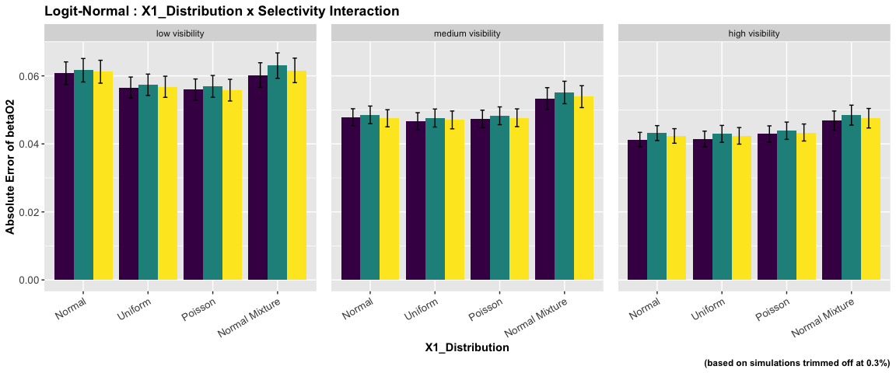

ANOVA : Logit - Poisson Specification

|  | num Df | den Df | MSE | F | ges | Pr(>F) |
| --- | --- | --- | --- | --- | --- | --- |
| dependence | 3 | 14352 | 0 | 610.20 | 0.11 | 0 |
| selectivity | 2 | 14352 | 0 | 530.21 | 0.07 | 0 |
| x_dist | 3 | 14352 | 0 | 1873.89 | 0.28 | 0 |
| dependence:selectivity | 6 | 14352 | 0 | 43.51 | 0.02 | 0 |
| dependence:x_dist | 9 | 14352 | 0 | 80.01 | 0.05 | 0 |
| selectivity:x_dist | 6 | 14352 | 0 | 94.18 | 0.04 | 0 |
| dependence:selectivity:x_dist | 18 | 14352 | 0 | 5.64 | 0.01 | 0 |

The ANOVA suggests that:

* The main effect of dependence is statistically significant and medium (F(3) = 610.20, p < .001; Eta2 (partial) = 0.11, 95% CI [0.11, 1.00])
* The main effect of selectivity is statistically significant and medium (F(2) = 530.21, p < .001; Eta2 (partial) = 0.07, 95% CI [0.06, 1.00])
* The main effect of x_dist is statistically significant and large (F(3) = 1873.89, p < .001; Eta2 (partial) = 0.28, 95% CI [0.27, 1.00])
* The interaction between dependence and selectivity is statistically significant and small (F(6) = 43.51, p < .001; Eta2 (partial) = 0.02, 95% CI [0.01, 1.00])
* The interaction between dependence and x_dist is statistically significant and small (F(9) = 80.01, p < .001; Eta2 (partial) = 0.05, 95% CI [0.04, 1.00])
* The interaction between selectivity and x_dist is statistically significant and small (F(6) = 94.18, p < .001; Eta2 (partial) = 0.04, 95% CI [0.03, 1.00])
* The interaction between dependence, selectivity and x_dist is statistically significant and very small (F(18) = 5.64, p < .001; Eta2 (partial) = 7.03e-03, 95% CI [3.85e-03, 1.00])

Effect sizes were labelled following Field’s (2013) recommendations.

##### Two-way Interaction Plots

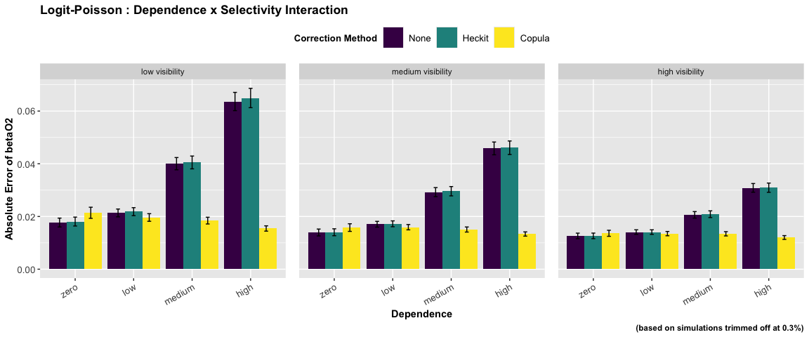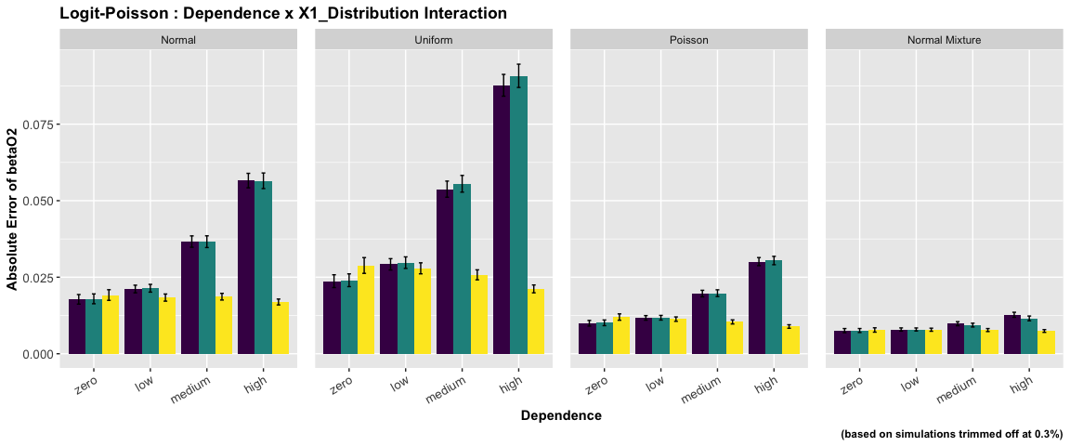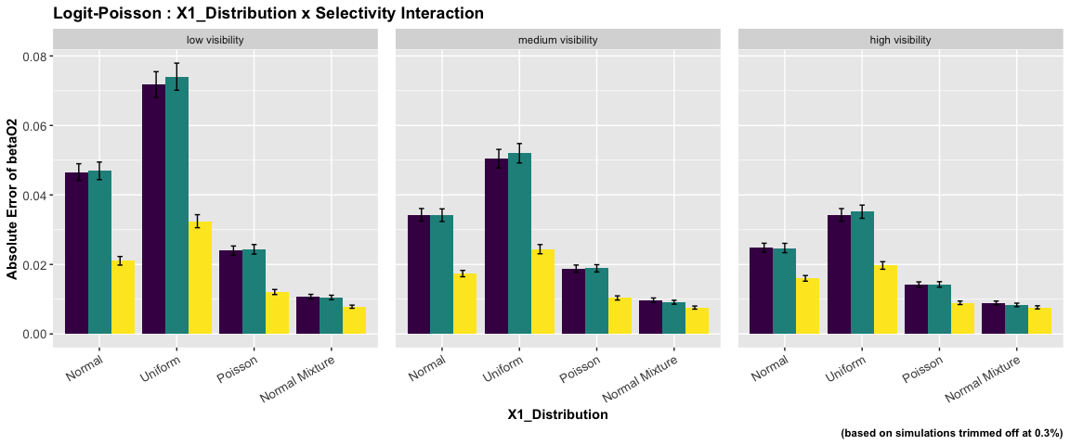

ANOVA : Logit - Probit Specification

|  | num Df | den Df | MSE | F | ges | Pr(>F) |
| --- | --- | --- | --- | --- | --- | --- |
| dependence | 3 | 14212 | 0.05 | 596.38 | 0.11 | 0 |
| selectivity | 2 | 14212 | 0.05 | 387.59 | 0.05 | 0 |
| x_dist | 3 | 14212 | 0.05 | 63.01 | 0.01 | 0 |
| dependence:selectivity | 6 | 14212 | 0.05 | 32.25 | 0.01 | 0 |
| dependence:x_dist | 9 | 14212 | 0.05 | 3.00 | 0.00 | 0 |
| selectivity:x_dist | 6 | 14212 | 0.05 | 4.55 | 0.00 | 0 |
| dependence:selectivity:x_dist | 18 | 14212 | 0.05 | 2.27 | 0.00 | 0 |

The ANOVA suggests that:

* The main effect of dependence is statistically significant and medium (F(3) = 596.38, p < .001; Eta2 (partial) = 0.11, 95% CI [0.10, 1.00])
* The main effect of selectivity is statistically significant and small (F(2) = 387.59, p < .001; Eta2 (partial) = 0.05, 95% CI [0.05, 1.00])
* The main effect of x_dist is statistically significant and small (F(3) = 63.01, p < .001; Eta2 (partial) = 0.01, 95% CI [0.01, 1.00])
* The interaction between dependence and selectivity is statistically significant and small (F(6) = 32.25, p < .001; Eta2 (partial) = 0.01, 95% CI [0.01, 1.00])
* The interaction between dependence and x_dist is statistically significant and very small (F(9) = 3.00, p = 0.001; Eta2 (partial) = 1.90e-03, 95% CI [4.25e-04, 1.00])
* The interaction between selectivity and x_dist is statistically significant and very small (F(6) = 4.55, p < .001; Eta2 (partial) = 1.92e-03, 95% CI [6.12e-04, 1.00])
* The interaction between dependence, selectivity and x_dist is statistically significant and very small (F(18) = 2.27, p = 0.002; Eta2 (partial) = 2.87e-03, 95% CI [5.62e-04, 1.00])

Effect sizes were labelled following Field’s (2013) recommendations.

##### Two-way Interaction Plots

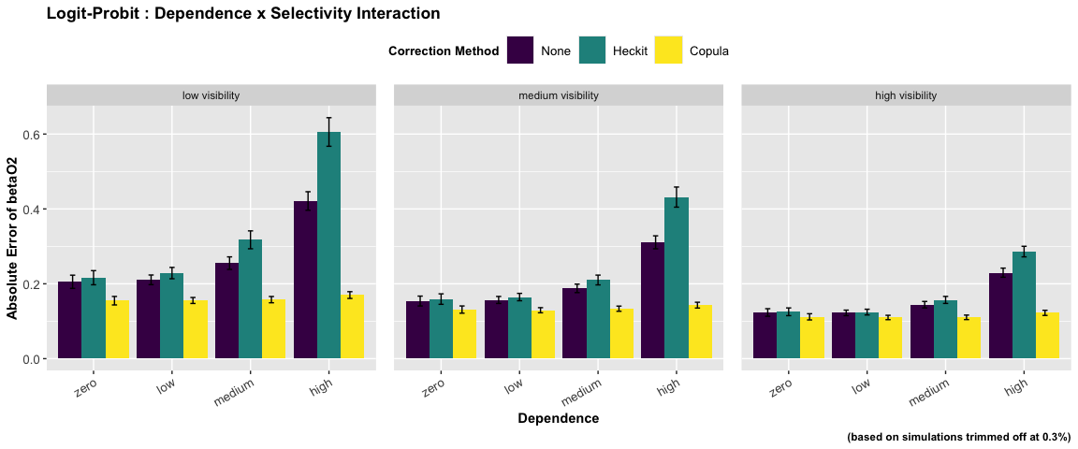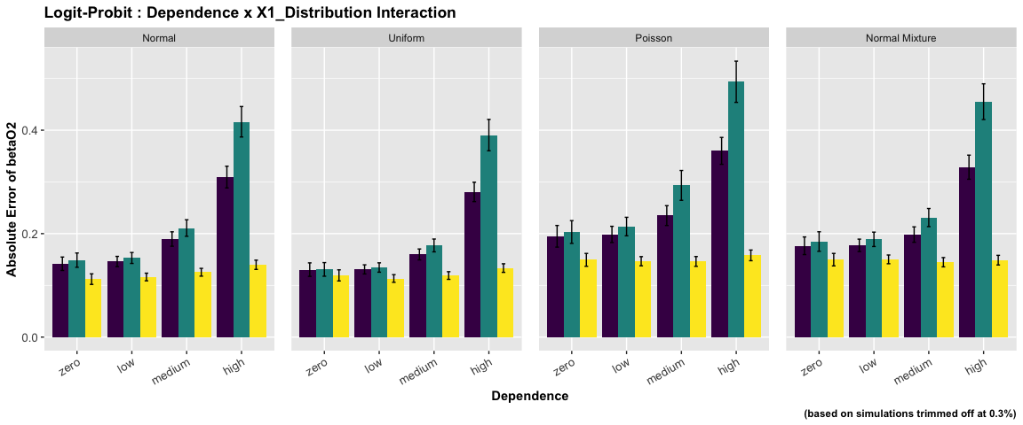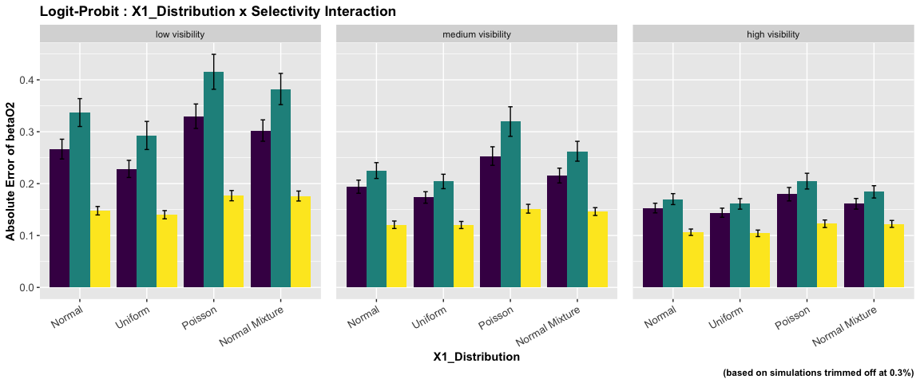

ANOVA : Probit - Logit Specification

|  | num Df | den Df | MSE | F | ges | Pr(>F) |
| --- | --- | --- | --- | --- | --- | --- |
| dependence | 3 | 14250 | 0.05 | 336.45 | 0.07 | 0.00 |
| selectivity | 2 | 14250 | 0.05 | 732.11 | 0.09 | 0.00 |
| x_dist | 3 | 14250 | 0.05 | 63.66 | 0.01 | 0.00 |
| dependence:selectivity | 6 | 14250 | 0.05 | 37.17 | 0.02 | 0.00 |
| dependence:x_dist | 9 | 14250 | 0.05 | 4.81 | 0.00 | 0.00 |
| selectivity:x_dist | 6 | 14250 | 0.05 | 6.02 | 0.00 | 0.00 |
| dependence:selectivity:x_dist | 18 | 14250 | 0.05 | 1.10 | 0.00 | 0.34 |

The ANOVA suggests that:

* The main effect of dependence is statistically significant and medium (F(3) = 336.45, p < .001; Eta2 (partial) = 0.07, 95% CI [0.06, 1.00])
* The main effect of selectivity is statistically significant and medium (F(2) = 732.11, p < .001; Eta2 (partial) = 0.09, 95% CI [0.09, 1.00])
* The main effect of x_dist is statistically significant and small (F(3) = 63.66, p < .001; Eta2 (partial) = 0.01, 95% CI [0.01, 1.00])
* The interaction between dependence and selectivity is statistically significant and small (F(6) = 37.17, p < .001; Eta2 (partial) = 0.02, 95% CI [0.01, 1.00])
* The interaction between dependence and x_dist is statistically significant and very small (F(9) = 4.81, p < .001; Eta2 (partial) = 3.03e-03, 95% CI [1.22e-03, 1.00])
* The interaction between selectivity and x_dist is statistically significant and very small (F(6) = 6.02, p < .001; Eta2 (partial) = 2.53e-03, 95% CI [1.04e-03, 1.00])
* The interaction between dependence, selectivity and x_dist is statistically not significant and very small (F(18) = 1.10, p = 0.341; Eta2 (partial) = 1.39e-03, 95% CI [0.00, 1.00])

Effect sizes were labelled following Field’s (2013) recommendations.

##### Two-way Interaction Plots

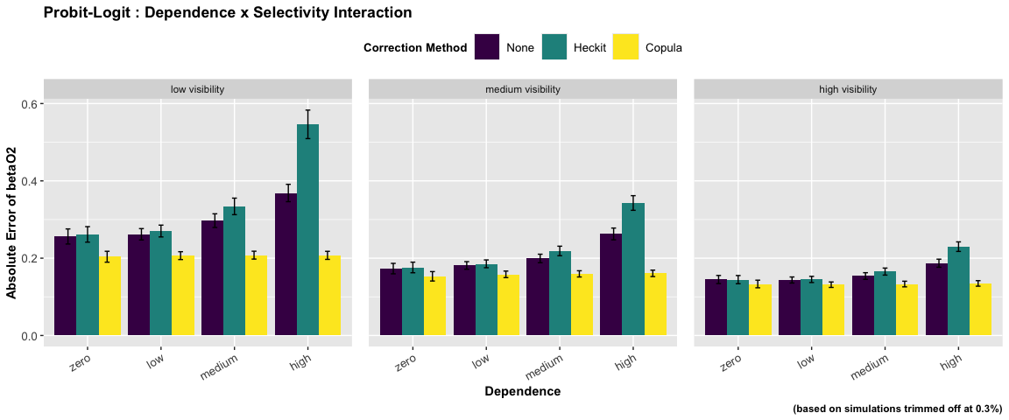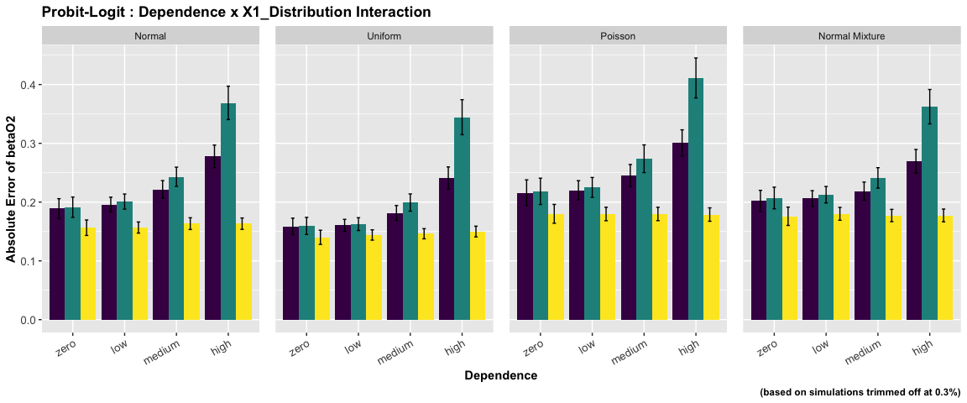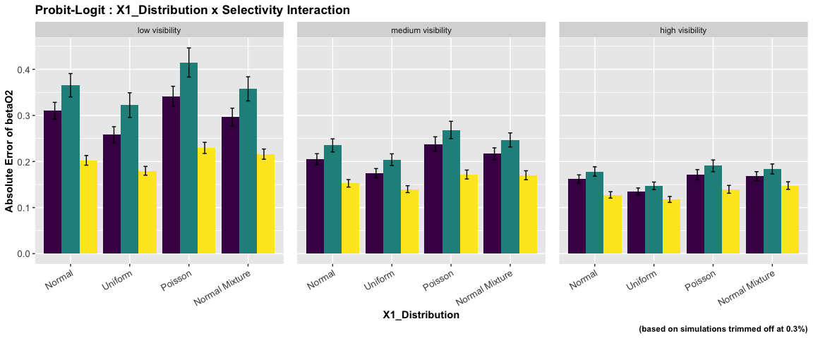

ANOVA : Probit - Normal Specification

|  | num Df | den Df | MSE | F | ges | Pr(>F) |
| --- | --- | --- | --- | --- | --- | --- |
| dependence | 3 | 14352 | 0 | 3.83 | 0.00 | 0.01 |
| selectivity | 2 | 14352 | 0 | 443.47 | 0.06 | 0.00 |
| x_dist | 3 | 14352 | 0 | 6.25 | 0.00 | 0.00 |
| dependence:selectivity | 6 | 14352 | 0 | 1.95 | 0.00 | 0.07 |
| dependence:x_dist | 9 | 14352 | 0 | 0.74 | 0.00 | 0.67 |
| selectivity:x_dist | 6 | 14352 | 0 | 5.45 | 0.00 | 0.00 |
| dependence:selectivity:x_dist | 18 | 14352 | 0 | 0.76 | 0.00 | 0.75 |

The ANOVA suggests that:

* The main effect of dependence is statistically significant and very small (F(3) = 3.83, p = 0.009; Eta2 (partial) = 8.00e-04, 95% CI [1.12e-04, 1.00])
* The main effect of selectivity is statistically significant and small (F(2) = 443.47, p < .001; Eta2 (partial) = 0.06, 95% CI [0.05, 1.00])
* The main effect of x_dist is statistically significant and very small (F(3) = 6.25, p < .001; Eta2 (partial) = 1.31e-03, 95% CI [3.93e-04, 1.00])
* The interaction between dependence and selectivity is statistically not significant and very small (F(6) = 1.95, p = 0.069; Eta2 (partial) = 8.16e-04, 95% CI [0.00, 1.00])
* The interaction between dependence and x_dist is statistically not significant and very small (F(9) = 0.74, p = 0.670; Eta2 (partial) = 4.66e-04, 95% CI [0.00, 1.00])
* The interaction between selectivity and x_dist is statistically significant and very small (F(6) = 5.45, p < .001; Eta2 (partial) = 2.27e-03, 95% CI [8.61e-04, 1.00])
* The interaction between dependence, selectivity and x_dist is statistically not significant and very small (F(18) = 0.76, p = 0.751; Eta2 (partial) = 9.51e-04, 95% CI [0.00, 1.00])

Effect sizes were labelled following Field’s (2013) recommendations.

##### Two-way Interaction Plots

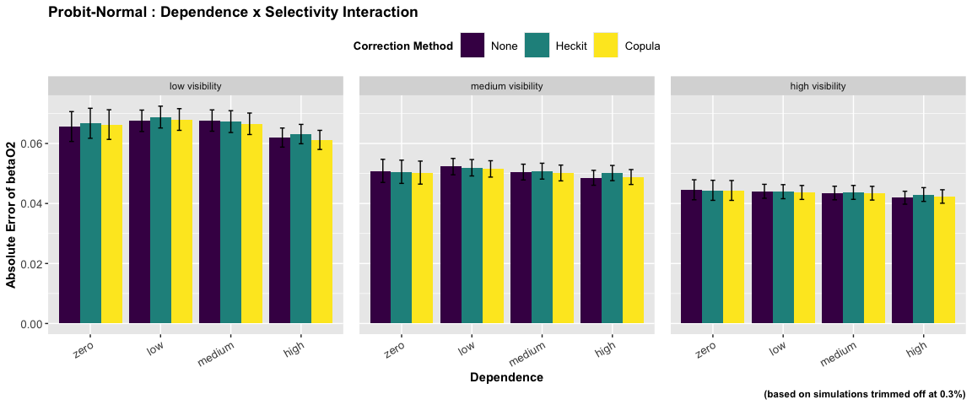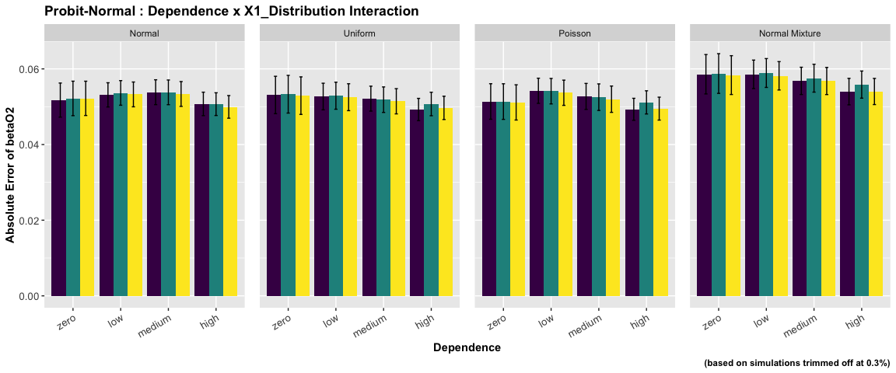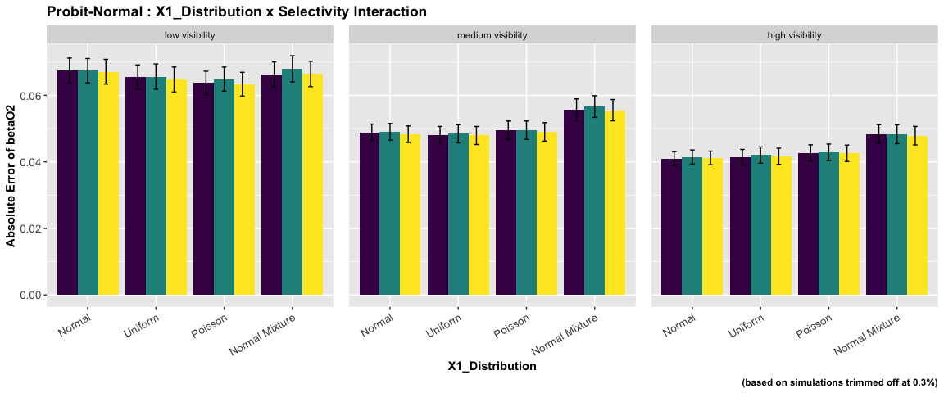

ANOVA : Probit - Poisson Specification

|  | num Df | den Df | MSE | F | ges | Pr(>F) |
| --- | --- | --- | --- | --- | --- | --- |
| dependence | 3 | 14352 | 0 | 322.28 | 0.06 | 0 |
| selectivity | 2 | 14352 | 0 | 550.20 | 0.07 | 0 |
| x_dist | 3 | 14352 | 0 | 1701.07 | 0.26 | 0 |
| dependence:selectivity | 6 | 14352 | 0 | 51.86 | 0.02 | 0 |
| dependence:x_dist | 9 | 14352 | 0 | 57.41 | 0.03 | 0 |
| selectivity:x_dist | 6 | 14352 | 0 | 127.70 | 0.05 | 0 |
| dependence:selectivity:x_dist | 18 | 14352 | 0 | 10.38 | 0.01 | 0 |

The ANOVA suggests that:

* The main effect of dependence is statistically significant and medium (F(3) = 322.28, p < .001; Eta2 (partial) = 0.06, 95% CI [0.06, 1.00])
* The main effect of selectivity is statistically significant and medium (F(2) = 550.20, p < .001; Eta2 (partial) = 0.07, 95% CI [0.06, 1.00])
* The main effect of x_dist is statistically significant and large (F(3) = 1701.07, p < .001; Eta2 (partial) = 0.26, 95% CI [0.25, 1.00])
* The interaction between dependence and selectivity is statistically significant and small (F(6) = 51.86, p < .001; Eta2 (partial) = 0.02, 95% CI [0.02, 1.00])
* The interaction between dependence and x_dist is statistically significant and small (F(9) = 57.41, p < .001; Eta2 (partial) = 0.03, 95% CI [0.03, 1.00])
* The interaction between selectivity and x_dist is statistically significant and small (F(6) = 127.70, p < .001; Eta2 (partial) = 0.05, 95% CI [0.04, 1.00])
* The interaction between dependence, selectivity and x_dist is statistically significant and small (F(18) = 10.38, p < .001; Eta2 (partial) = 0.01, 95% CI [8.87e-03, 1.00])

Effect sizes were labelled following Field’s (2013) recommendations.

##### Two-way Interaction Plots

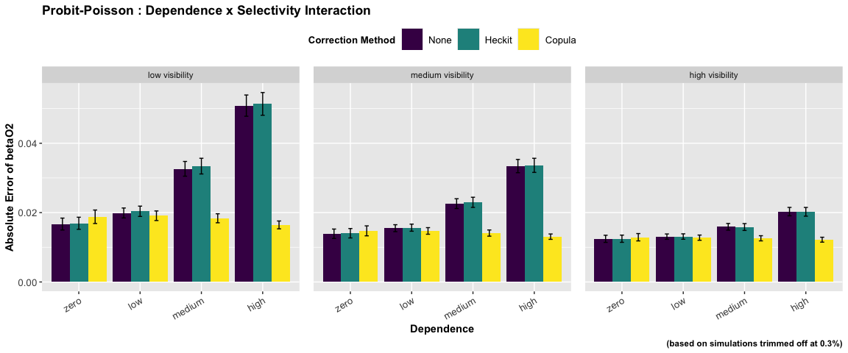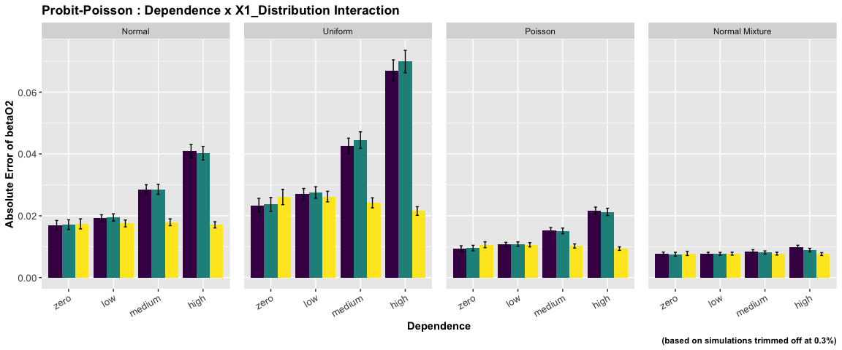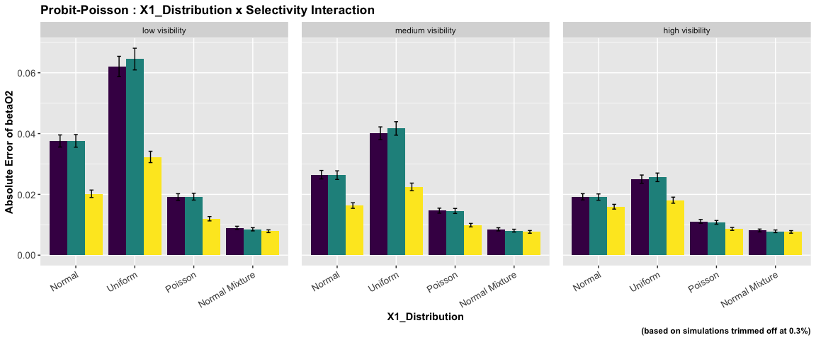

ANOVA : Probit - Probit Specification

|  | num Df | den Df | MSE | F | ges | Pr(>F) |
| --- | --- | --- | --- | --- | --- | --- |
| dependence | 3 | 14152 | 0.06 | 253.44 | 0.05 | 0.00 |
| selectivity | 2 | 14152 | 0.06 | 764.38 | 0.10 | 0.00 |
| x_dist | 3 | 14152 | 0.06 | 111.30 | 0.02 | 0.00 |
| dependence:selectivity | 6 | 14152 | 0.06 | 32.64 | 0.01 | 0.00 |
| dependence:x_dist | 9 | 14152 | 0.06 | 2.84 | 0.00 | 0.00 |
| selectivity:x_dist | 6 | 14152 | 0.06 | 12.24 | 0.01 | 0.00 |
| dependence:selectivity:x_dist | 18 | 14152 | 0.06 | 0.78 | 0.00 | 0.73 |

The ANOVA suggests that:

* The main effect of dependence is statistically significant and small (F(3) = 253.44, p < .001; Eta2 (partial) = 0.05, 95% CI [0.05, 1.00])
* The main effect of selectivity is statistically significant and medium (F(2) = 764.38, p < .001; Eta2 (partial) = 0.10, 95% CI [0.09, 1.00])
* The main effect of x_dist is statistically significant and small (F(3) = 111.30, p < .001; Eta2 (partial) = 0.02, 95% CI [0.02, 1.00])
* The interaction between dependence and selectivity is statistically significant and small (F(6) = 32.64, p < .001; Eta2 (partial) = 0.01, 95% CI [0.01, 1.00])
* The interaction between dependence and x_dist is statistically significant and very small (F(9) = 2.84, p = 0.002; Eta2 (partial) = 1.80e-03, 95% CI [3.59e-04, 1.00])
* The interaction between selectivity and x_dist is statistically significant and very small (F(6) = 12.24, p < .001; Eta2 (partial) = 5.16e-03, 95% CI [3.06e-03, 1.00])
* The interaction between dependence, selectivity and x_dist is statistically not significant and very small (F(18) = 0.78, p = 0.730; Eta2 (partial) = 9.87e-04, 95% CI [0.00, 1.00])

Effect sizes were labelled following Field’s (2013) recommendations.

##### Two-way Interaction Plots

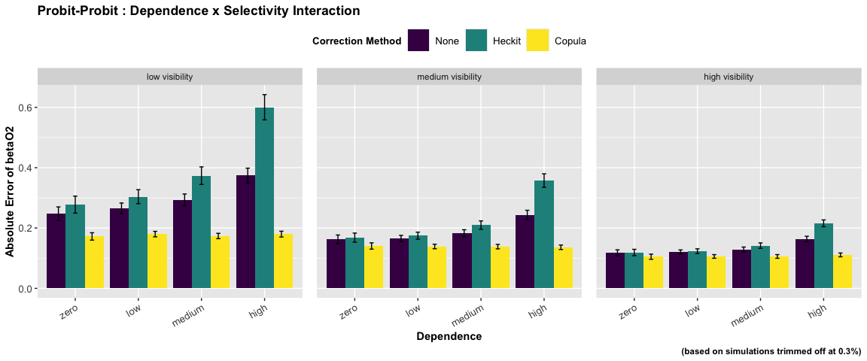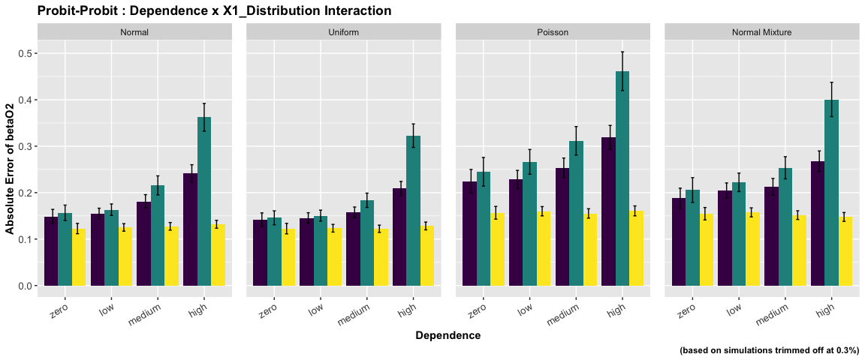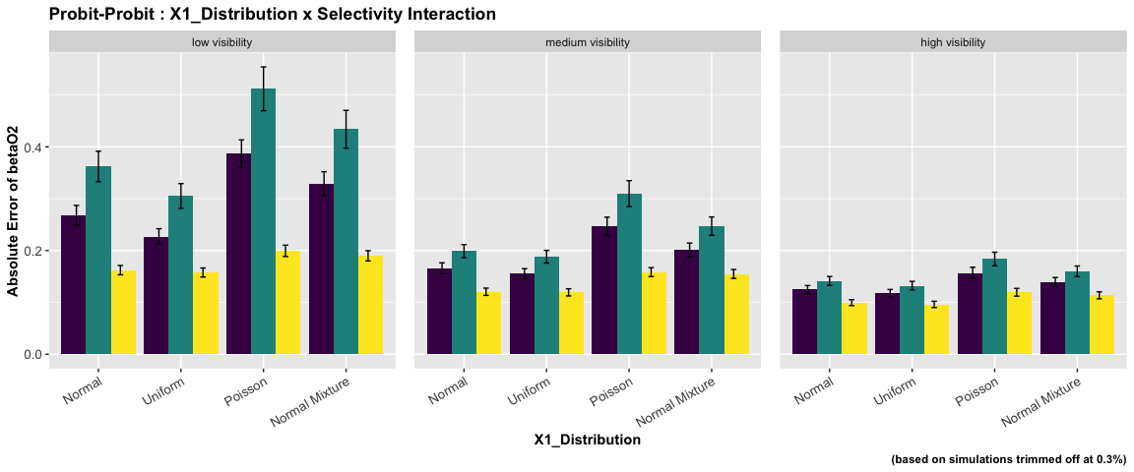

### method wise

| select_dist | outcome_dist | par | num.Df | den.Df | MSE | F | ges | Pr..F. |
| --- | --- | --- | --- | --- | --- | --- | --- | --- |
| Logit | Logit | betaO0 | 1 | 9527 | 0.22 | 958.26 | 0.09 | 0.00 |
| Logit | Logit | betaO1 | 1 | 9547 | 0.09 | 1033.69 | 0.10 | 0.00 |
| Logit | Logit | betaO2 | 1 | 9531 | 0.07 | 869.25 | 0.08 | 0.00 |
| Logit | Logit | betaS0 | 1 | 9541 | 0.03 | 4186.04 | 0.30 | 0.00 |
| Logit | Logit | betaS1 | 1 | 9536 | 0.01 | 39981.61 | 0.81 | 0.00 |
| Logit | Logit | betaS2 | 1 | 9572 | 0.00 | 1012.83 | 0.10 | 0.00 |
| Logit | Logit | betaS3 | 1 | 9549 | 0.01 | 33630.75 | 0.78 | 0.00 |
| Logit | Normal | betaO0 | 1 | 9598 | 0.01 | 171.07 | 0.02 | 0.00 |
| Logit | Normal | betaO1 | 1 | 9598 | 0.00 | 25.54 | 0.00 | 0.00 |
| Logit | Normal | betaO2 | 1 | 9598 | 0.00 | 0.66 | 0.00 | 0.42 |
| Logit | Normal | betaS0 | 1 | 9543 | 0.03 | 4204.91 | 0.31 | 0.00 |
| Logit | Normal | betaS1 | 1 | 9533 | 0.01 | 40577.89 | 0.81 | 0.00 |
| Logit | Normal | betaS2 | 1 | 9572 | 0.00 | 997.62 | 0.09 | 0.00 |
| Logit | Normal | betaS3 | 1 | 9548 | 0.01 | 34390.24 | 0.78 | 0.00 |
| Logit | Poisson | betaO0 | 1 | 9598 | 0.00 | 444.99 | 0.04 | 0.00 |
| Logit | Poisson | betaO1 | 1 | 9598 | 0.00 | 160.14 | 0.02 | 0.00 |
| Logit | Poisson | betaO2 | 1 | 9598 | 0.00 | 498.51 | 0.05 | 0.00 |
| Logit | Poisson | betaS0 | 1 | 9545 | 0.03 | 4221.17 | 0.31 | 0.00 |
| Logit | Poisson | betaS1 | 1 | 9538 | 0.01 | 41548.25 | 0.81 | 0.00 |
| Logit | Poisson | betaS2 | 1 | 9574 | 0.00 | 913.64 | 0.09 | 0.00 |
| Logit | Poisson | betaS3 | 1 | 9550 | 0.01 | 35127.12 | 0.79 | 0.00 |
| Logit | Probit | betaO0 | 1 | 9529 | 0.14 | 610.77 | 0.06 | 0.00 |
| Logit | Probit | betaO1 | 1 | 9525 | 0.09 | 720.55 | 0.07 | 0.00 |
| Logit | Probit | betaO2 | 1 | 9520 | 0.06 | 734.35 | 0.07 | 0.00 |
| Logit | Probit | betaS0 | 1 | 9540 | 0.03 | 4185.33 | 0.30 | 0.00 |
| Logit | Probit | betaS1 | 1 | 9538 | 0.01 | 39861.75 | 0.81 | 0.00 |
| Logit | Probit | betaS2 | 1 | 9570 | 0.00 | 1016.67 | 0.10 | 0.00 |
| Logit | Probit | betaS3 | 1 | 9550 | 0.01 | 33410.56 | 0.78 | 0.00 |
| Probit | Logit | betaO0 | 1 | 9546 | 0.15 | 636.91 | 0.06 | 0.00 |
| Probit | Logit | betaO1 | 1 | 9535 | 0.08 | 677.97 | 0.07 | 0.00 |
| Probit | Logit | betaO2 | 1 | 9517 | 0.06 | 610.92 | 0.06 | 0.00 |
| Probit | Logit | betaS0 | 1 | 9595 | 0.00 | 5.55 | 0.00 | 0.02 |
| Probit | Logit | betaS1 | 1 | 9595 | 0.00 | 5.73 | 0.00 | 0.02 |
| Probit | Logit | betaS2 | 1 | 9573 | 0.00 | 0.01 | 0.00 | 0.91 |
| Probit | Logit | betaS3 | 1 | 9589 | 0.00 | 10.56 | 0.00 | 0.00 |
| Probit | Normal | betaO0 | 1 | 9598 | 0.01 | 66.18 | 0.01 | 0.00 |
| Probit | Normal | betaO1 | 1 | 9598 | 0.00 | 10.01 | 0.00 | 0.00 |
| Probit | Normal | betaO2 | 1 | 9598 | 0.00 | 0.40 | 0.00 | 0.53 |
| Probit | Normal | betaS0 | 1 | 9596 | 0.00 | 8.20 | 0.00 | 0.00 |
| Probit | Normal | betaS1 | 1 | 9594 | 0.00 | 11.23 | 0.00 | 0.00 |
| Probit | Normal | betaS2 | 1 | 9573 | 0.00 | 0.07 | 0.00 | 0.79 |
| Probit | Normal | betaS3 | 1 | 9587 | 0.00 | 19.24 | 0.00 | 0.00 |
| Probit | Poisson | betaO0 | 1 | 9598 | 0.00 | 149.14 | 0.02 | 0.00 |
| Probit | Poisson | betaO1 | 1 | 9598 | 0.00 | 48.44 | 0.01 | 0.00 |
| Probit | Poisson | betaO2 | 1 | 9598 | 0.00 | 236.14 | 0.02 | 0.00 |
| Probit | Poisson | betaS0 | 1 | 9597 | 0.00 | 9.17 | 0.00 | 0.00 |
| Probit | Poisson | betaS1 | 1 | 9594 | 0.00 | 16.71 | 0.00 | 0.00 |
| Probit | Poisson | betaS2 | 1 | 9573 | 0.00 | 2.56 | 0.00 | 0.11 |
| Probit | Poisson | betaS3 | 1 | 9587 | 0.00 | 27.19 | 0.00 | 0.00 |
| Probit | Probit | betaO0 | 1 | 9494 | 0.13 | 409.61 | 0.04 | 0.00 |
| Probit | Probit | betaO1 | 1 | 9487 | 0.10 | 597.81 | 0.06 | 0.00 |
| Probit | Probit | betaO2 | 1 | 9467 | 0.07 | 622.41 | 0.06 | 0.00 |
| Probit | Probit | betaS0 | 1 | 9597 | 0.00 | 4.69 | 0.00 | 0.03 |
| Probit | Probit | betaS1 | 1 | 9594 | 0.00 | 6.70 | 0.00 | 0.01 |
| Probit | Probit | betaS2 | 1 | 9573 | 0.00 | 0.14 | 0.00 | 0.71 |
| Probit | Probit | betaS3 | 1 | 9588 | 0.00 | 10.17 | 0.00 | 0.00 |