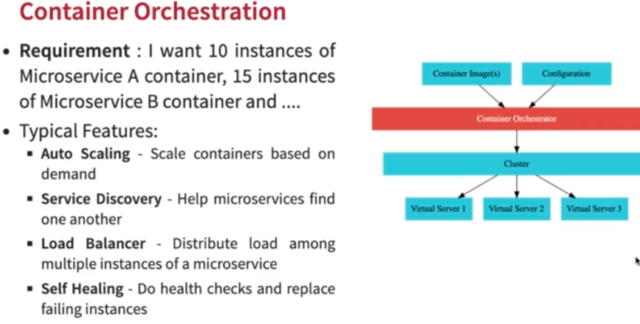
Various container orchestration Options

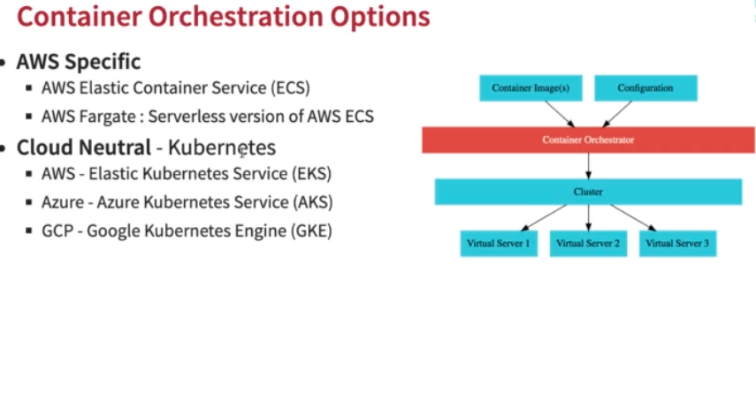
Introduction to Kubernetes:

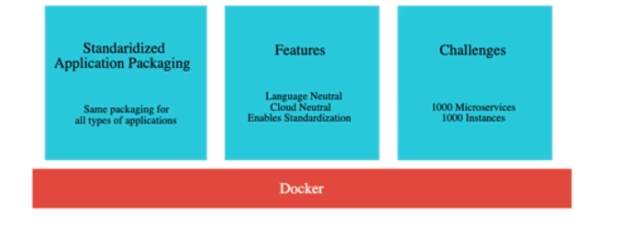
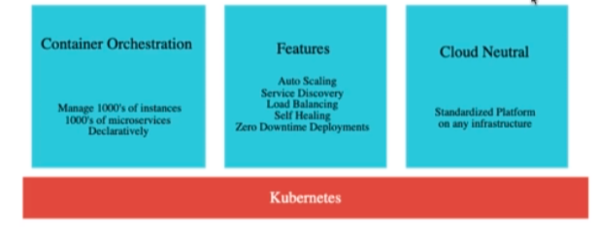
Kubernetes Architecture

Basically it is a resource manager which manages the virtual servers on the cloud.

Different cloud providers have different name names eg AWS EC2, Azure call them virtual machines, google cloud call them compute engines. Kuberenetes call them nodes. Kub can manages 1000s of such nodes. We have a few master nodes to manage such 1000s nodes.

Cluster: It is a combination of such master nodes and worker nodes.

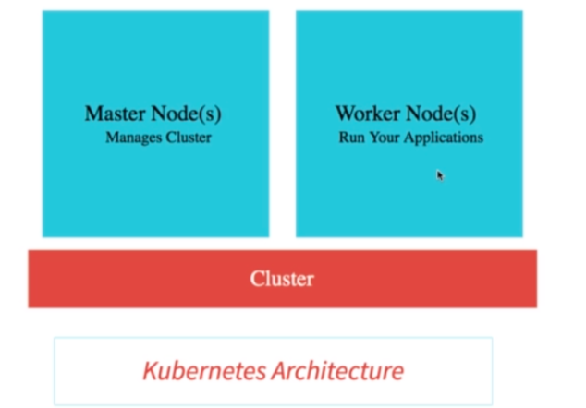

Master node make sure other nodes are working well.

Deploy your first spring boot app to Kubernetes

1. Create k8s cluster.
2. Open cloud shell.
3. Connect to the k8s cluster:

gcloud container clusters get-credentials “cluster-name” --zone us-central1-a --project “project-name”

4. Now for executing cmds we will be using kubectl ie Kube Controller. Kubectl is used for executing commands against any cluster.
> kubectl version

5. Create deployment with kubectl
> kubectl create deployment hello-world-rest-api –image=in28min/hello-world-rest-api:0.0.1.RELEASE

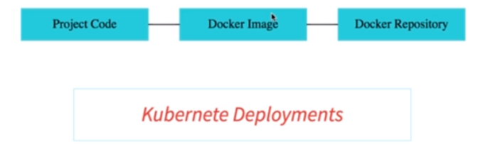
Above command will create a deployment in the cluster and will return us a deployment id.

6. Expose above deployment to the outside world as a load balancer and want to expose on port 8080.

kubectl expose deployment hello-world-rest-api --type=LoadBalancer –port=8080

7. To see if the above deployment is exposed successfully check the status from here:

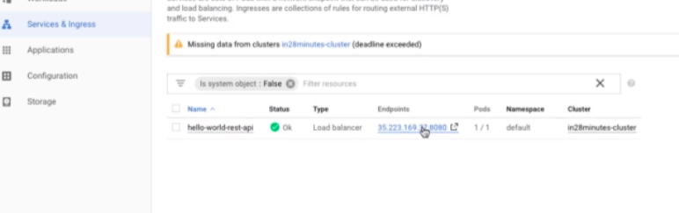
8. Click on the endpoint to open the real endpoint in the browser like this:

http://.........../hello-world or hello-world-bean

9. Print events which have occured in the backend:

> kubectl get events –sort-by=.metadata.creationTimestamp

> kubectl get pods
> kubectl get services
> kubectl get deployment

Kubernetes uses SINGLE RESPONSIBILITY PRINCIPLE. Which means one concept one responsibility.

K8S PODS

PODS are the most imp concept in k8s. PODS are the wrappers for containers. It is the smallest deploy-able unit in K8s.

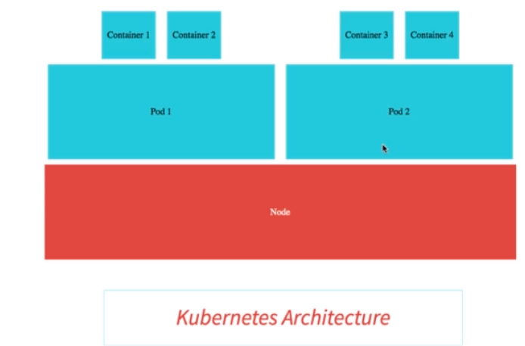

>kubectl get pods -o wide

The above command will return high level information about a pod. Each pod has a unique IP address.

A pod can have no. Of containers. Within each pod, containers share resources, they can talk to each other using localhost.

> kubectl explain pods.

To know the in depth information about a pod we can execute the below command:

> kubectl describe pod hello-world-rest-api-58ff5dd898-9trh2

POD runs on a specific node.

Namespace: it provides separation from dev to QA environments.

Annotations: it is the meta info about a pod.

K8S REPLICASET

> kubectl get rs or replicaset will return the below:

Replicaset ensures a specific no. of pods are always running every time.

How to delete a pod:

> kubectl delete pods “pod-name”

Now run again >kubectl get replicaset

it will again return the pod.

Why is this happening: Bcz of the replicaset. RS always watches the pods and it no. Of pods goes down the desired no. Of nodes, it will again spin up (create) another pod.

How to tell RS to have more no. Of pods (In case we need to scale the app we always increase the RS):

> kubectl scale deployment hello-world-rest-api –replicas=3

> kubeclt get pods
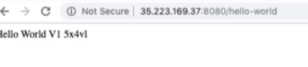

The above ids are changing which shows our application is running on more than 2 instances with load .

To view the complete event list:

>kubectl get events –sort.by=.metadata.creationTimestamp

>kubectl explain replicaset

K8S DEPLOYMENTS

A deployment ensures that a release upgrade, a switch from V1 to V2 happens without a hitch. It ensures that we do not have downtime when we release a new version of an application. There are different strategies for deployments such as i might want to actually send 50% of traffic to v1 and 50% to v2. Default strategy is rolling update which we are going to see in upcoming example.

> kubectl get rs -o wide

The above command shows this RS is tied to an image name as given above.
What are deployments:

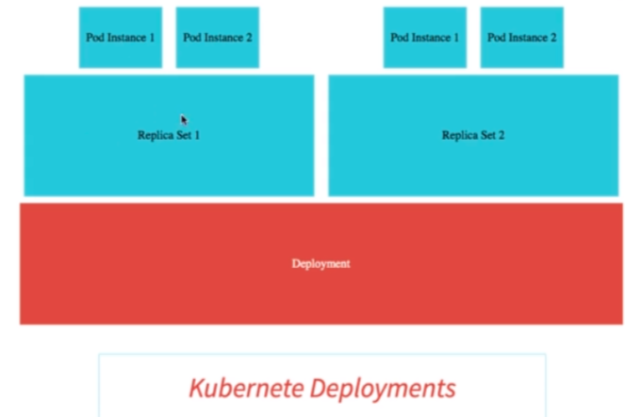

kubectl get rs
kubectl get rs -o wide

To deploy a new version hello-world-rest-api, run the following command:

kubectl set image deployment “name-of-the-deployment” “name-of-the-container=image_name”

kubectl set image deployment hello-world-rest-api hello-world-rest-api=DUMMY_IMAGE:TEST

In above command, we are passing an erroneous image.

Now run the below command which will show 2 replicas one of them is not ready:

kubectl get rs -o wide:

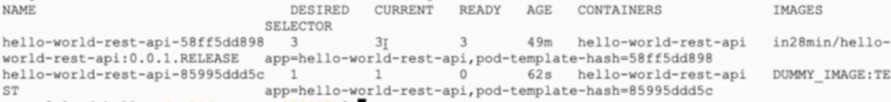

>kubectl get pods: it will return us the 4th pod with invalid image.

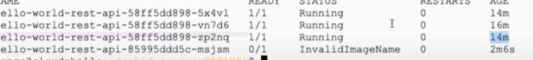

>kubectl describe pod hello-world-rest-api-85995ddd5c-msjsm

kubectl get events –sort-by=.metadata.creationTimestamp

Deploy a new version v2 through the following command:

>kubectl set image deployment hello-world-rest-api hello-world-rest-api=in28min/hello-world-rest-api:0.0.2.RELEASE

kubectl get events --sort-by=.metadata.creationTimestamp
kubectl get pods -o wide
kubectl delete pod hello-world-rest-api-67c79fd44f-n6c7l
kubectl get pods -o wide
kubectl delete pod hello-world-rest-api-67c79fd44f-8bhdt

OVERVIEW OF PODS, RS and DEPLOYMENTS

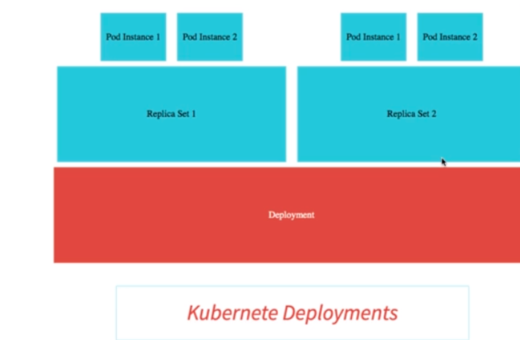

What is a Kubernetes Service?
Even if we delete a pod, a new pod is created by RS but the url for the services is never changed. We do not want consumer side of things get affected. We do not want user to use a different url in case a pod is deleted. That is the role of a service is to provide an always-available external interface to the app which are running inside the pods.
>kubectl get pods -o wide
>kubectl delete pod hello-world-rest-api-67c79fd44f-n6c7l
When the service is created: Services was created when we executed following command with an IP address. And this IP address is present in the endpoint of the rest api. Services also do load balancing between pods.

kubectl expose deployment hello-world-rest-api --type=LoadBalancer –port=8080

The idea of a Service is to group a set of Pod endpoints into a single resource. You can configure various ways to access the grouping. By default, you get a stable cluster IP address that clients inside the cluster can use to contact Pods in the Service. A client sends a request to the stable IP address, and the request is routed to one of the Pods in the Service.
A Service identifies its member Pods with a selector. For a Pod to be a member of the Service, the Pod must have all of the labels specified in the selector. A label is an arbitrary key/value pair that is attached to an object.

Why use a Kubernetes Service?
1. In a Kubernetes cluster, each Pod has an internal IP address. But the Pods in a Deployment come and go, and their IP addresses change. So it doesn't make sense to use Pod IP addresses directly. With a Service, you get a stable IP address that lasts for the life of the Service, even as the IP addresses of the member Pods change.
2. A Service also provides load balancing. Clients call a single, stable IP address, and their requests are balanced across the Pods that are members of the Service.
>kubectl get services
GKE USER INTERFACE INTERACTION
DEPLOY 2 APPS ON K8S
First, push images to docker using buildImage gradle task. Then execute the following commands.
kubectl create deployment currency-exchange --image=khushwinderdocker/microservices-currency-exchange-service-kubernetes:0.0.11-SNAPSHOT
kubectl expose deployment currency-exchange --type=LoadBalancer --port=8000

kubectl create deployment currency-conversion --image=khushwinderdocker/microservices-currency-conversion-service-kubernetes:0.0.11-SNAPSHOT
kubectl expose deployment currency-conversion --type=LoadBalancer --port=8100

AUTOSCALLING
kubectl autoscale deployment currency-exchange --min=1 --max=3 --cpu-percent=5
kubectl get hpa
kubectl get pods will return the newly created pods based on above auto scaling configuration.
kubectl top pod
kubectl top nodes
kubectl get hpa
kubectl delete hpa currency-exchange
Rolling out a deployment
kubectl rollout history deployment currency-conversion
kubectl rollout history deployment currency-exchange
kubectl rollout undo deployment currency-exchange --to-revision=1
Configuring Liveness and Readiness Probes for Microservices with K8S
Configuring above probes ensures that only when containers are ready to accept traffic, they will be receiving a traffic. When they are starting up and not ready to receive traffic they will not be receiving a traffic.
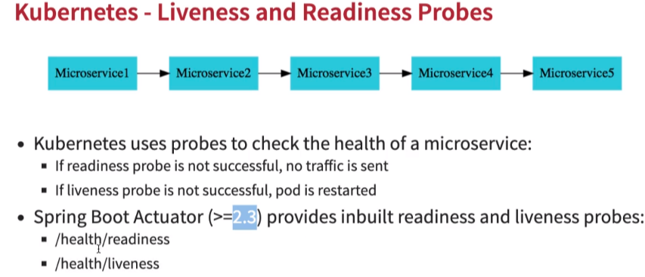
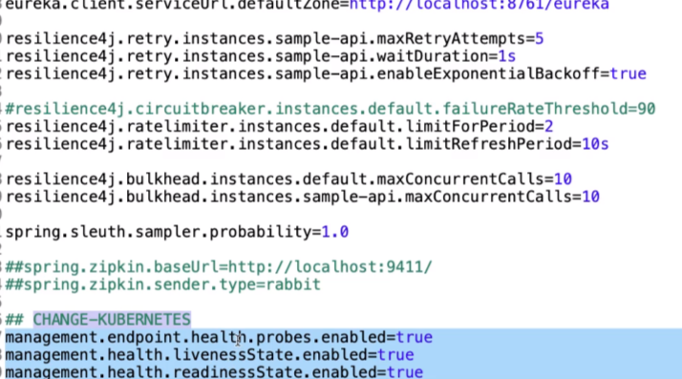
Make changes in the application.properties file:
After making above changes run the following url and see the actuator properties:
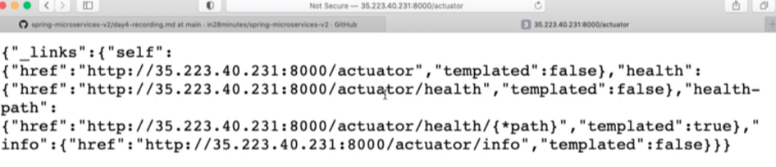
http://ipaddress:8000/actuator/health/readiness or liveness
Add the following to deployment.yaml fiel:
spec:
containers:
- image: khushwinderdocker/microservices-currency-exchange-service-kubernetes:0.0.11-SNAPSHOT
imagePullPolicy: IfNotPresent
name: microservices-currency-exchange-service-kubernetes
#
readinessProbe:
httpGet:
port: 8000
path: /actuator/health/readiness
livenessProbe:
httpGet:
port: 8000
path: /actuator/health/liveness
restartPolicy: Always
>kubectl get pods will return 2 instances of currency-conversion services are running:
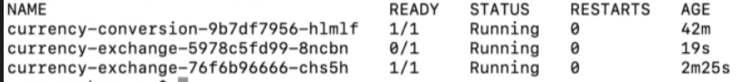
3rd one will only be terminated when 2nd one is ready not before that.

Exploring Centralized Logging and Monitoring in GKE
To view the logs, click on the view logs option under cluster:

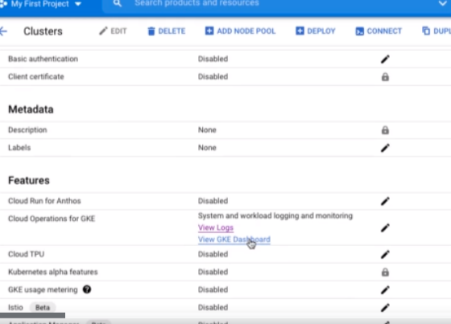

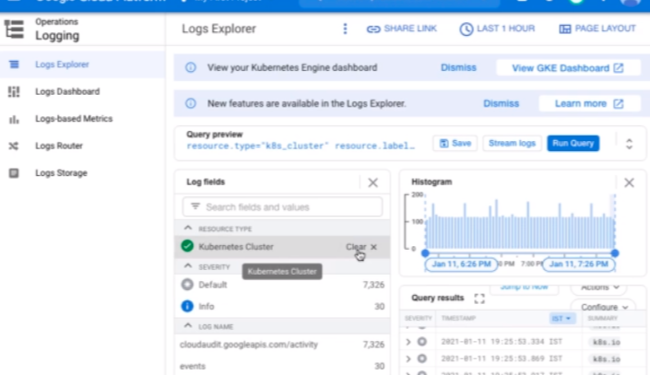

Enable Logging and Tracing APIs in Google Cloud Platform
1. Enabling APIs:
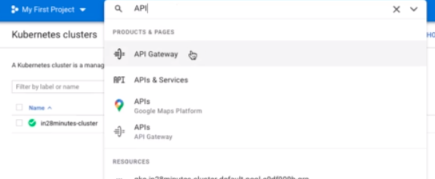

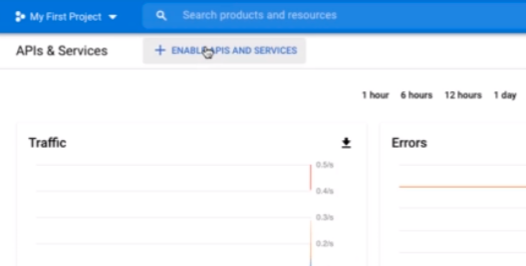

Click on Cloud logging APIs and enable it:

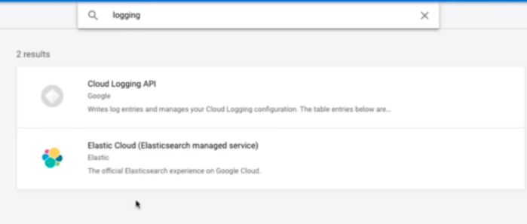
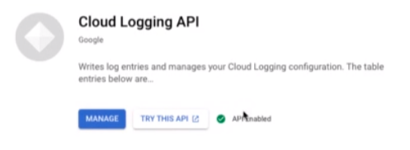

Enable StackDriver APIs: Enable all the 5 apis related to stackdriver:
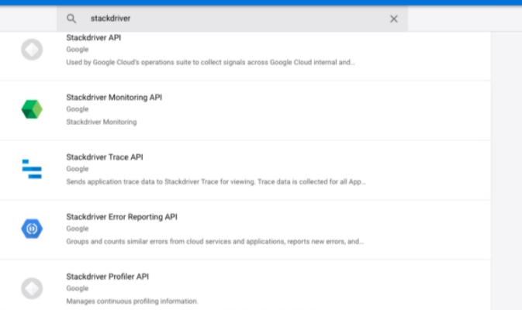

CREATE YAML FILE FROM DEPLOYMENTS

kubectl get deployments

kubectl get deployment currency-exchange -o yaml >> deployment.yaml
kubectl get service currency-exchange -o yaml >> service.yaml

