MONGODB TERMINOLOGIES

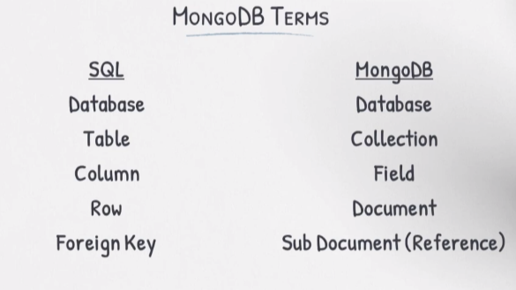

MONGO DB JSON STORAGE

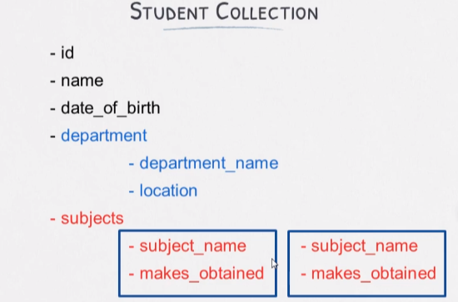

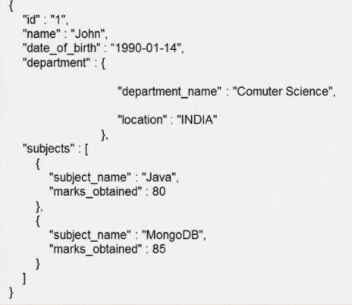

WRITING QUERIES

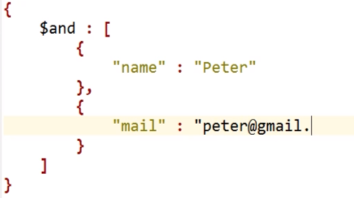

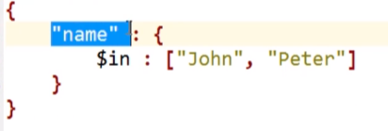

UPDATE QUERIES IN MONGOSHELL

>use springbootcourse  
  
>db.student.updateOne( {  
 name: "Robert"  
},  
{  
$set: {  
mail: "Robert@gmail.com"  
}  
})

<https://www.mongodb.com/docs/mongodb-shell/crud/insert/>

Remove Query

Following query will remove all the records:

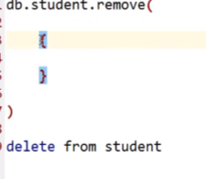

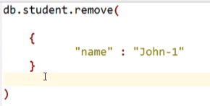

Find Query

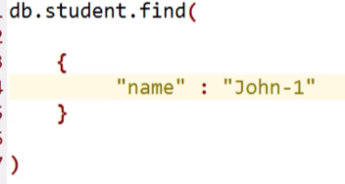

PAGINATION

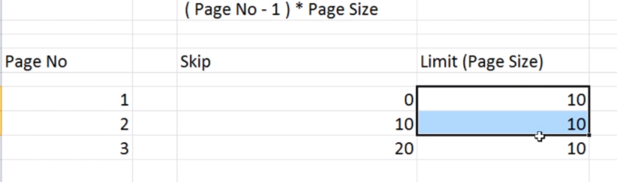

SORTING

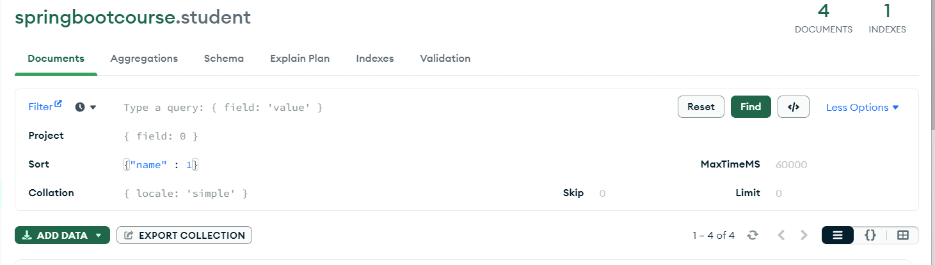

1 means ascending and –1 descending order.

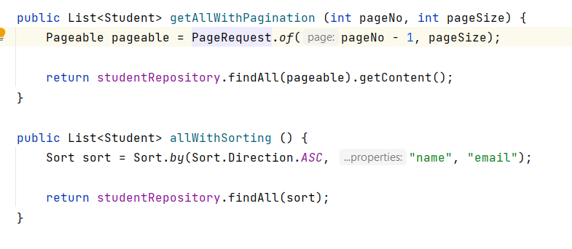

Fetch Record by SubDocument Field

{"department.location":"Ca"}

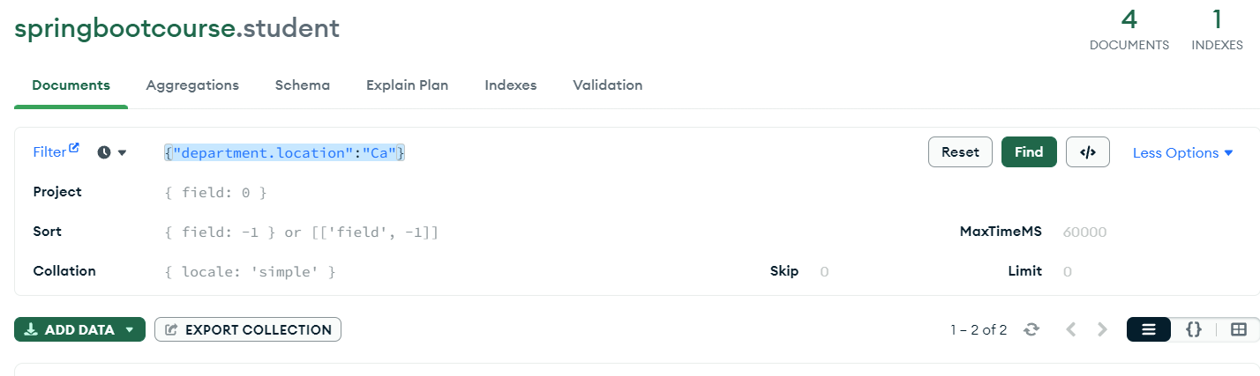

Fetch Record by Array Value

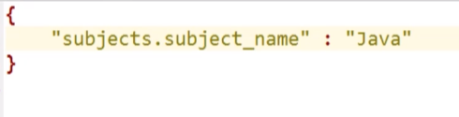

LIKE QUERY

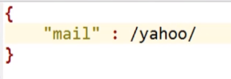

We need to replae % keyword with / in mongodb.

List<Student> findByEmailIsLike (String email);

STARTS WITH QUERY

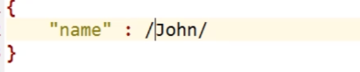

Add ^ before /

List<Student> findByNameStartsWith (String name);

TRANSIENT KEYWORD

We do not want to store this field into your document. Rather just want to have some login in our class to populate that field. This field will be returned in the response.

@Transient  
private double percentage;

PCF

