Unit Testing

We want to create a unit test for StudentController which is a Rest Controller. StudentController exposes two service methods - one Get and one Post. We will write unit tests for both these service methods.
In the unit test
- We will mock out the StudentService using Mockito
- We will use Mock MVC framework to launch only StudentController.
A key part of unit testing is to restrict the scope to a minimum. In this unit test, we want to test only the methods in StudentController.

Executing the Http Get Operation Using Postman
We will fire a request to http://localhost:8080/students/Student1/courses/Course1 to test the service. Response is as shown below.
{
"id": "Course1",
"name": "Spring",
"description": "10Steps",
"steps": [
"Learn Maven",
"Import Project",
"First Example",
"Second Example"
]
}

Add spring-security-test for disabling security in unit tests
<dependency>
<groupId>org.springframework.security</groupId>
<artifactId>spring-security-test</artifactId>
<scope>test</scope>
</dependency>

Unit Testing Http Get Operation
When we are unit testing a rest service, we would want to launch only the specific controller and the related MVC Components. WebMvcTest annotation is used for unit testing Spring MVC application. This can be used when a test focuses only Spring MVC components. Using this annotation will disable full auto-configuration and only apply configuration relevant to MVC tests.
- @ExtendWith(SpringExtension.class) : @ExtendWith is a repeatable annotation that is used to register extensions for the annotated test class, test interface/method/parameter/field. Annotated parameters are supported in test class constructors, in test methods, and in @BeforeAll, @BeforeEach, @AfterAll, and @AfterEach. SpringExtension integrates the Spring TestContext Framework into JUnit 5’s Jupiter programming model.
- @WebMvcTest(value = StudentController.class): WebMvcTest annotation is used for unit testing Spring MVC application. This can be used when a test focuses only Spring MVC components. In this test, we want to launch only StudentController. All other controllers and mappings will not be launched when this unit test is executed.
- @Autowired private MockMvc mockMvc: MockMvc is the main entry point for server-side Spring MVC test support. It allows us to execute requests against the test context.
- @MockBean private StudentService studentService: MockBean is used to add mocks to a Spring ApplicationContext. A mock of studentService is created and auto-wired into the StudentController.
- Mockito.when(studentService.retrieveCourse(Mockito.anyString(),Mockito.anyString())).thenReturn(mockCourse): Mocking the method retrieveCourse to return the specific mockCourse when invoked.
- MockMvcRequestBuilders.get("/students/Student1/courses/Course1").accept(MediaType.APPLICATION_JSON): Creating a Request builder to be able to execute a get request to uri “/students/Student1/courses/Course1” with accept header as “application/json”
- mockMvc.perform(requestBuilder).andReturn(): mockMvc is used to perform the request and return the response back.
- JSONAssert.assertEquals(expected, result.getResponse().getContentAsString(), false): We are using org.skyscreamer.jsonassert.JSONAssert. This allows us to do partial asserts against a JSON String. We are passing strict as false since we do not want to check for all fields in the response.

Adding Http POST Operation
A Http POST Operation should return a status of created (201) when the resource creation is successful.
@PostMapping("/students/{studentId}/courses"): Mapping a url for the POST Request @RequestBody Course newCourse: Using Binding to bind the body of the request to Course object. ResponseEntity.created(location).build(): Return a status of created. Also return the location of created resource as a Response Header.

Executing the Http POST Operation
Example request is shown below. It contains all the details to register a course to a student.
{
"name": "Microservices",
"description": "10Steps",
"steps": [
"Learn How to Break Things Up",
"Automate the hell out of everything",
"Have fun"
]
}
The below picture shows how we can execute this Http POST Operation from Postman . Make sure you go to the Body tab an select raw. Select JSON from the dropdown. Copy above request into body.
The URL we use is http://localhost:8080/students/Student1/courses.

Writing Unit Test for the Http POST Operation
In the unit test, we would want to post the request body to the url /students/Student1/courses. In the response, we check for HttpStatus of Created and that the location header contains the url of the created resource.
- MockMvcRequestBuilders.post("/students/Student1/courses").accept(MediaType.APPLICATION_JSON): Create a post request with an accept header for application\json
- content(exampleCourseJson).contentType(MediaType.APPLICATION_JSON): Use the specified content as body of the request and set content type header.
- assertEquals(HttpStatus.CREATED.value(), response.getStatus()): Assert that the return status is CREATED.
- response.getHeader(HttpHeaders.LOCATION): Get the location from response header and later assert that it contains the URI of the created resource.

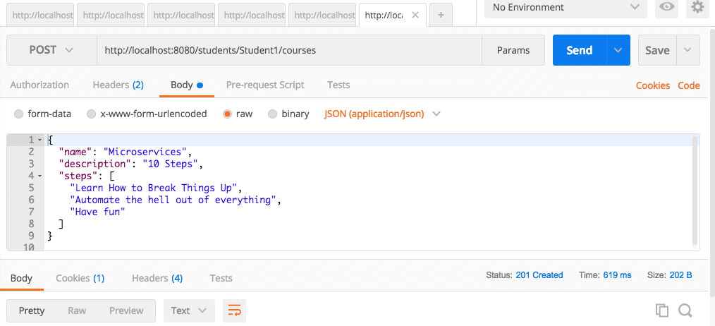

Integration Testing
We want to create a integration test for StudentController which is a Rest Controller. StudentController exposes two service methods - one Get and one Post. We will write integration tests for both these service methods.
In the integration test
- We will launch the complete Spring Boot application using @SpringBootTest
- We will invoke the service methods using TestRestTemplate
- We will assert the results using a great JSON assert framework - org.skyscreamer.jsonassert.JSONAssert
A key part of integration testing is testing all the layers in the application.

Integration Testing with the Http Get Operation
When we are writing an integration test for a rest service, we would want to launch the entire spring context.
- @SpringBootTest(classes = StudentServicesApplication.class, webEnvironment = SpringBootTest.WebEnvironment.RANDOM_PORT) : Launch the entire Spring Boot Application on a Random Port
- @LocalServerPort private int port;: Autowire the random port into the variable so that we can use it create the url.
- createURLWithPort(String uri) : Utility method to create the url given an uri. It appends the port.
- HttpEntity<String> entity = new HttpEntity<String>(null, headers);: We use entity so that we have the flexibility of adding in request headers in future.
- restTemplate.exchange(createURLWithPort("/students/Student1/courses/Course1"),HttpMethod.GET, entity, String.class): Fire a GET request to the specify uri and get the response as a String.
- JSONAssert.assertEquals(expected, response.getBody(), false) : Assert that the response contains expected fields.

Writing Integration Test for the Http POST Operation
When writing an integration test for a POST service we would want to check if the location header contains the uri of the created resource.
- String actual = response.getHeaders().get(HttpHeaders.LOCATION).get(0); : Get the Location header from the response.
- assertTrue(actual.contains("/students/Student1/courses/")) : Assert that the header contains the uri of the newly created resource.

Different Annotations

1. The @SpringBootTest annotation is useful when we need to bootstrap the entire container. The annotation works by creating the ApplicationContext that will be utilized in our tests.
@RunWith(SpringRunner.class)
@SpringBootTest( SpringBootTest.WebEnvironment.MOCK, classes = Application.class) @AutoConfigureMockMvc @TestPropertySource( locations = "classpath:application-integrationtest.properties")
public class EmployeeRestControllerIntegrationTest {
@Autowired private MockMvc mvc;
@Autowired private EmployeeRepository repository;
// write test cases here
}
We can use the webEnvironment attribute of @SpringBootTest to configure our runtime environment; we're using WebEnvironment.MOCK here so that the container will operate in a mock servlet environment.
Next, the @TestPropertySource annotation helps configure the locations of properties files specific to our tests. Note that the property file loaded with @TestPropertySource will override the existing application.properties file.
A test annotated with @SpringBootTest will bootstrap the full application context, which means we can @Autowire any bean that's picked up by component scanning into our test eg:
@SpringBootTest
public class EmployeeServiceImplIntegrationTest {
@Autowired private EmployeeService employeeService; // class code ...
}

@RunWith(SpringRunner.class) provides a bridge between Spring Boot test features and JUnit. Whenever we are using any Spring Boot testing features in our JUnit tests, this annotation will be required.

To test the Controllers, we can use @WebMvcTest. It will auto-configure the Spring MVC infrastructure for our unit tests.
In most cases, @WebMvcTest will be limited to bootstrap a single controller. We can also use it along with @MockBean to provide mock implementations for any required dependencies.
@WebMvcTest also auto-configures MockMvc, which offers a powerful way of easy testing MVC controllers without starting a full HTTP server.
@RunWith(SpringRunner.class) @WebMvcTest(EmployeeRestController.class)
public class EmployeeRestControllerIntegrationTest {
@Autowired private MockMvc mvc;
@MockBean private EmployeeService service;
// write test cases here
}

Diff between below 2 annotations:

@RunWith(SpringRunner.class) : You need this annotation to just enable spring boot features like @Autowire, @MockBean etc.. during junit testing
is used to provide a bridge between Spring Boot test features and JUnit. Whenever we are using any Spring Boot testing features in our JUnit tests, this annotation will be required.
@SpringBootTest : This annotation is used to load complete application context for end to end integration testing
The @SpringBootTest annotation can be used when we need to bootstrap the entire container. The annotation works by creating the ApplicationContext that will be utilized in our tests.

