Docker’s Need

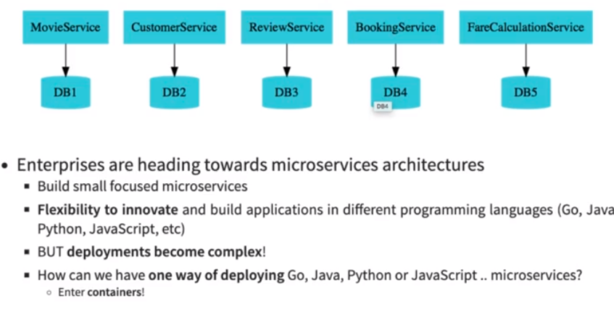

Docker’s Working
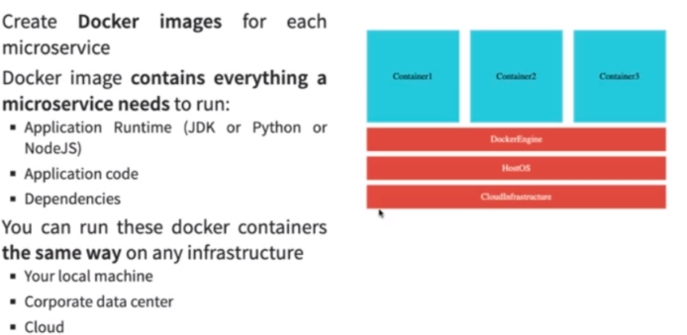

Docker’s Installation

https://docs.docker.com/desktop/install/windows-install/

RECOMMENDATION : Use PowerShell in Windows!
Recommendation 1
If you are using Windows, make sure that you use PowerShell instead of Command Prompt.

Recommendation 2
If you are using Window 10 and are using docker toolbox
=> Use 192.168.99.100 instead of localhost.
Note: If 192.168.99.100 does not work, you can find the IP by using the command docker-machine ip

Reason
In Window 10 when using docker toolbox, docker is configured to use the default machine with IP 192.168.99.100

Docker’s Installation Verification

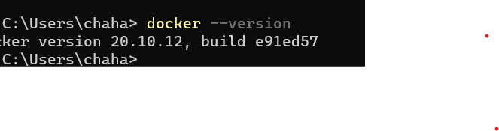
Few Important Docker Concepts

1. Docker Registry: https://hub.docker.com/ is known as docker registry. This contains a lot of repositories (different apps with different versions). This is a public repo so anyone can access it.

2. Docker repositories : Inside docker registry we can have many docker registries. A given repository can have multiple versions of an application. These versions are known as Docker images.

3. Docker Image: This contains all the components which an application needs to run.

We can download the images and run them as applications. A running image is known as container.

4. Docker Container: A download and running images is known as docket container.

Image is a static version and docker is a running app.

5. Container port and host port.

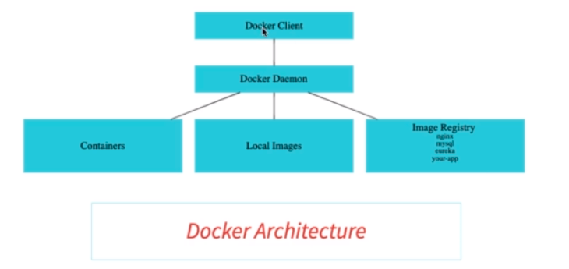
Docker daemon will download an image if it is not present locally. Docker client is the representation of our docker commands.

Using Docker on Cloud

