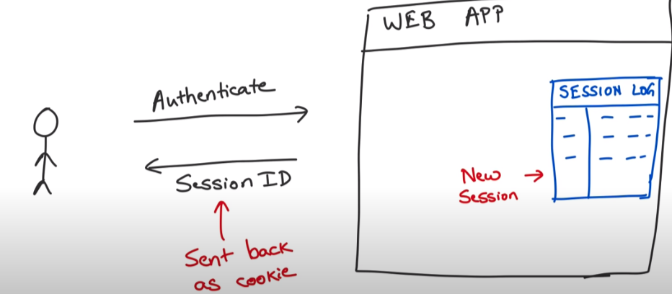

Above diagram shows the security in normal web apps. This type of security assumes that we have only single monolithic server in the back end eg:

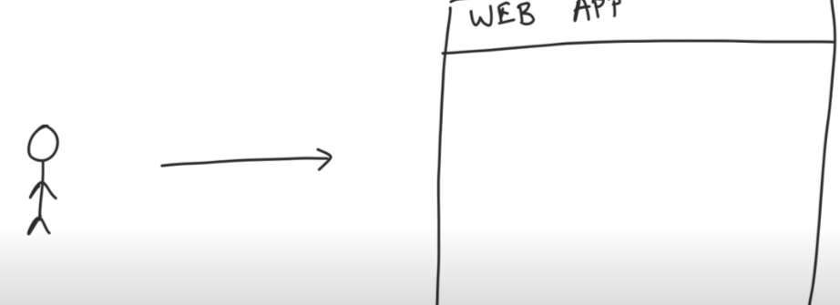

But these days modern web apps have multiple servers in the back end and request is routed through load balancer eg:

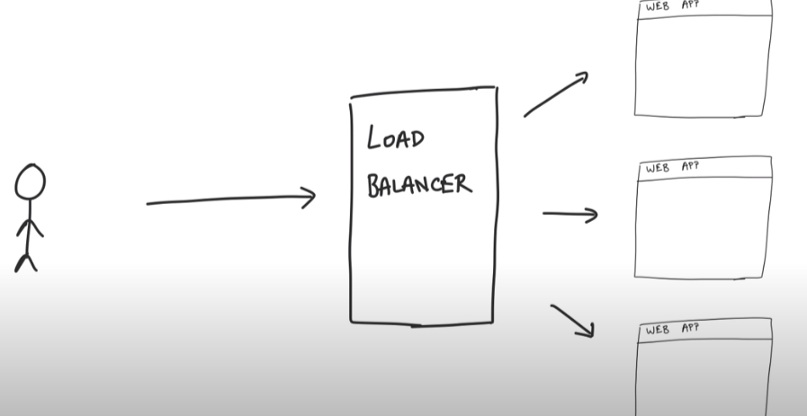

Then the problem arises that how we can maintain the session on all the servers? Answer is to have a shared session cache like Redis.:

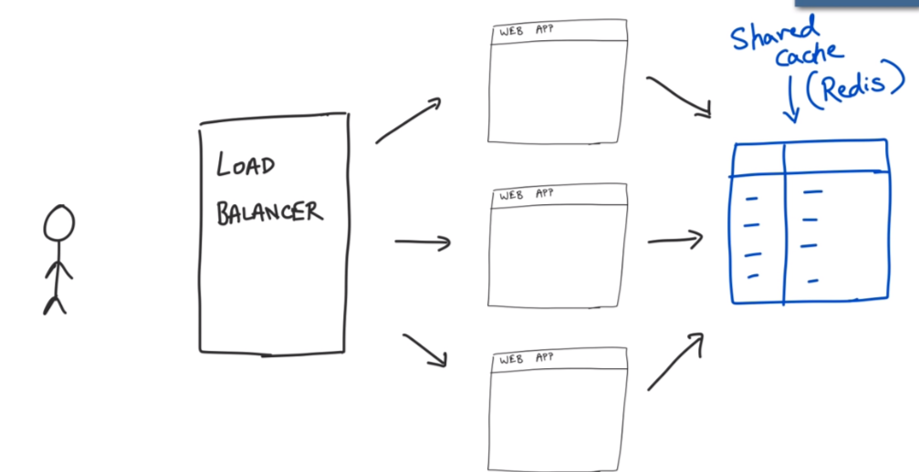

The drawback of above is if Redis server goes down, every request would fail. Or we can have another solution that is known as Sticky session. Here, load balancer remembers the previous request from a user and always redirect the same user request to same server:

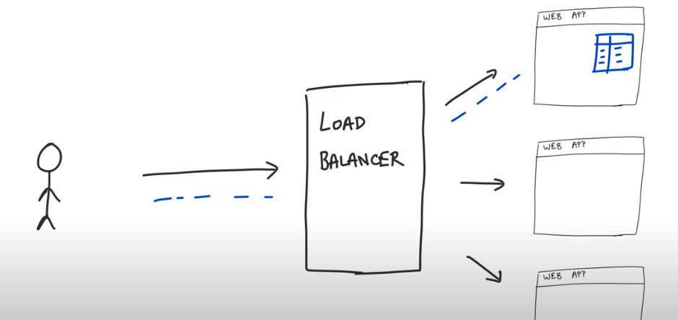
But this solution is not scaleable.

JWT as Solution:
Here servers does not save or remembers anything at their end but send the json payload or token to client. So in every subsequent requests, client sends the whole json token back to server. Server does not save anything but only validate this json token.

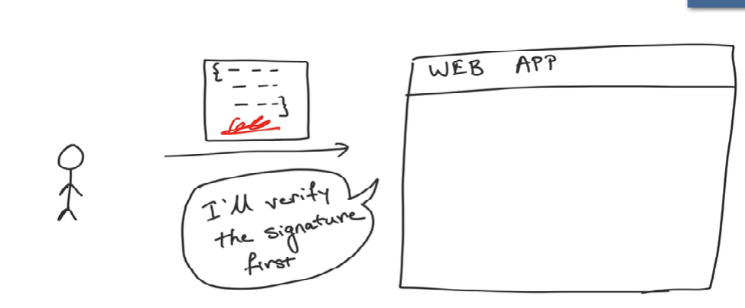

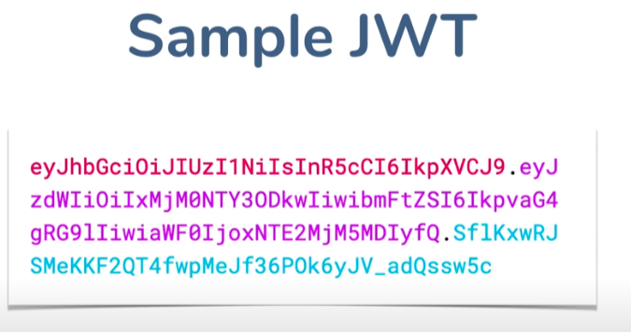
Structure of JWT (jwt.io): JWT is a value token (encoded in base64). The value here is the payload.

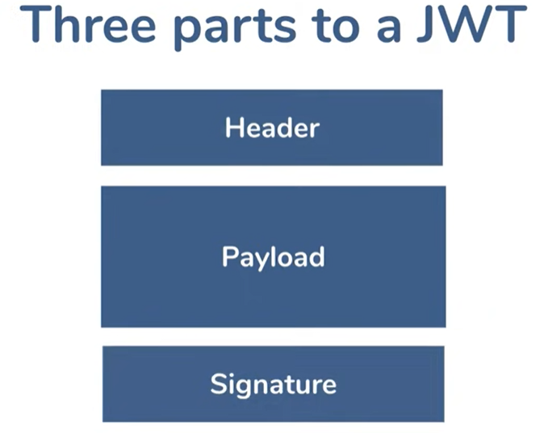
The whole jwt is encoded not because of security as anyone can decode these values. We encoded only for convenience purpose for sending it. The whole security part belongs to the Signature section.

Signature: This part purpose is not to encrypt or decrypt but for server to validate if this is actually a valid user (). This part only server can calculate. If any malicious client changes any value in header or payload, then the signature which is computed with the original value will no longer be same for the malicious or changed values.
The sign is created with same algorithm as in header. But if algor is in open does not it mean that anyone can use the same algorithm and generate the same sign. Well no, it is not possible because this algorithm requires a 256 bit secret key to create signature. So that is why only server can decrypt this.

So both header and payload are signed with secret key

The full flow with jwt

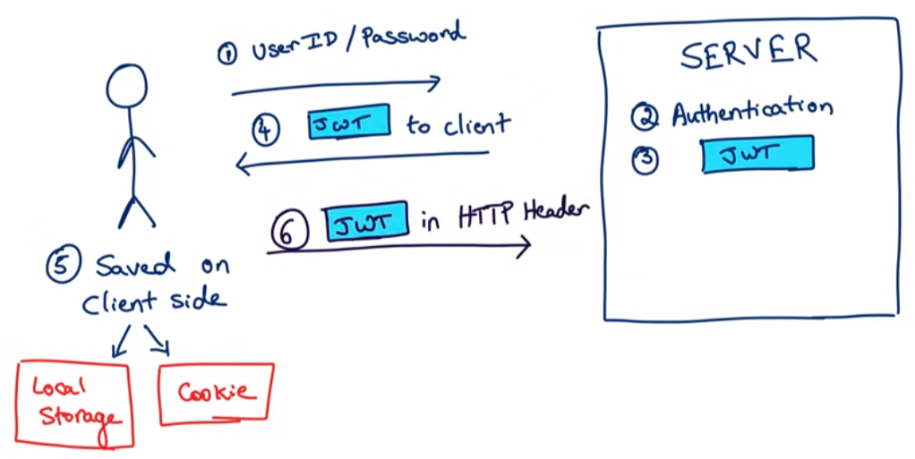
Remember, in above diagram, authentication is happening before jwt creation. Jwt is only used for authorization purpose.

Question: Why cannot we only include Signature in the jwt token:
Ans: So if you only sent the signature, that would work as a plain old session id, and the server would still have to store state, negating any benefit of a jwt.

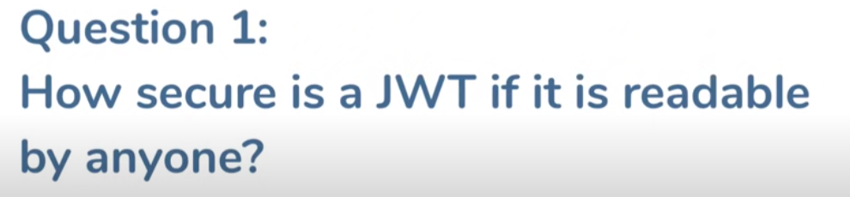
1. Do not store any confidential information inside jwt such as password or sin number. Just save enough information for the server to know who the user is.
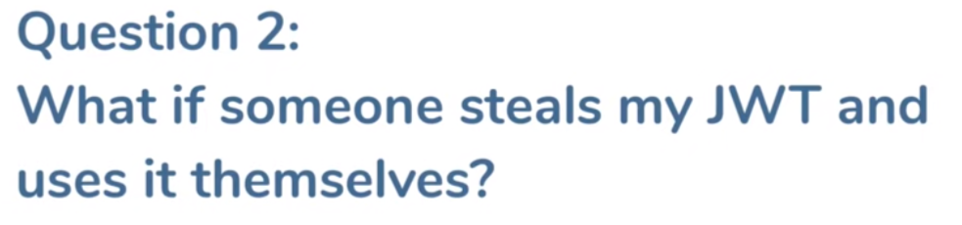
Although jwt cannot be tempered but what if someone steals it? Server just verifies if jwt is correct, it does not know who sent it.
Ans. Use https or OAUTH (established authentication and authorization mechanism.)

Problem 3: If session id is stole then one can log off to invalidate the session id but same is not true with jwt, as jwt cannot be expired.
Ans: Use blacklisted jwt. If a jwt is among blacklisted list then it will be rejected.

OAuth MECHANISM

OAuth 2.0 is an open authorization protocol which enables applications to access each others data. OAuth 2.0 covers different ways a client application can obtain authorization to access the resources stored on the resource server.

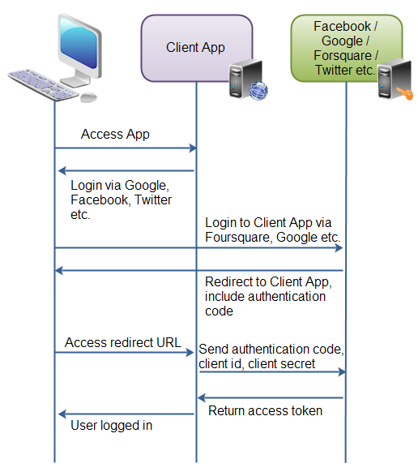

First the user accesses the client web application. In this web app is button saying "Login via Facebook" (or some other system like Google or Twitter).
Second, when the user clicks the login button, the user is redirected to the authenticating application (e.g. Facebook). The user then logs into the authenticating application, and is asked if she wants to grant access to her data in the authenticating application, to the client application. The user accepts.
Third, the authenticating application redirects the user to a redirect URI, which the client app has provided to the authenticating app. Providing this redirect URI is normally done by registering the client application with the authenticating application. During this registration the owner of the client application registers the redirect URI. It is also during this registration that the authenticating application gives the client application a client id and a client password. To the URI is appended an authentication code. This code represents the authentication.
Fourth, the user accesses the page located at the redirect URI in the client application. In the background the client application contacts the authenticating application and sends client id, client password and the authentication code received in the redirect request parameters. The authenticating application sends back an access token.
Once the client application has obtained an access token, this access token can be sent to the Facebook, Google, Twitter etc. to access resources in these systems, related to the user who logged in.
OAuth 2.0 defines the following roles of users and applications:
- Resource Owner
- Resource Server
- Client Application
- Authorization Server
These roles are illustrated in this diagram:

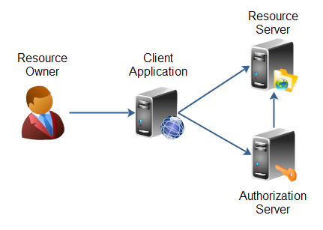

The resource owner is the person or application that owns the data that is to be shared. For instance, a user on Facebook or Google could be a resource owner. The resource they own is their data. The resource owner is depicted in the diagram as a person, which is probably the most common situation. The resource owner could also be an application. The OAuth 2.0 specification mentions both possibilities.
The resource server is the server hosting the resources. For instance, Facebook or Google is a resource server (or has a resource server).
The client application is the application requesting access to the resources stored on the resource server. The resources, which are owned by the resource owner. A client application could be a game requesting access to a users Facebook account.
The authorization server is the server authorizing the client app to access the resources of the resource owner. The authorization server and the resource server can be the same server, but it doesn't have to. The OAuth 2.0 specification does not say anything about how these two servers should communicate, if they are separate. This is an internal design decision to be made by the resource server + authorization server developers.
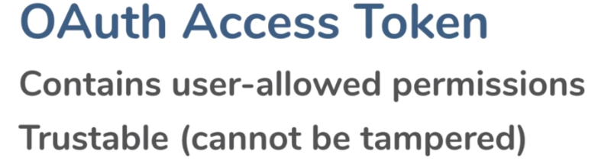
This token format is called JWT.

Why Oauth is only used for Authorization not authentication:
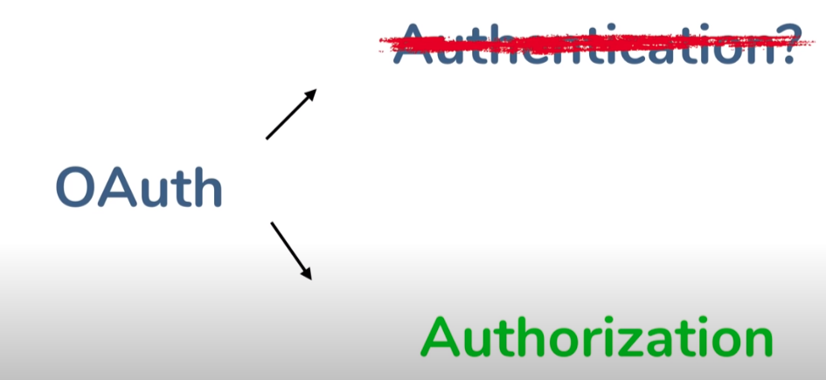

Bcz user is already authenticated with both the applications ie facebook and client app.

Security in Micro-services:

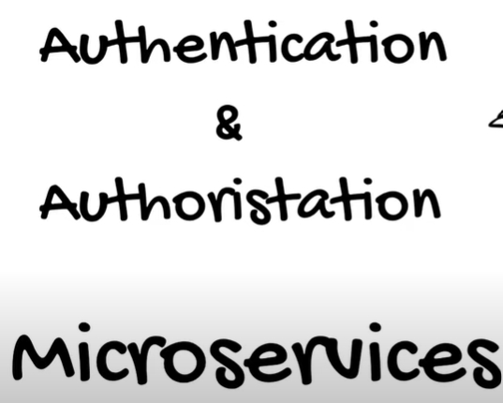

Authentication is Validating the user.
Authorization is Permission to access a resource.
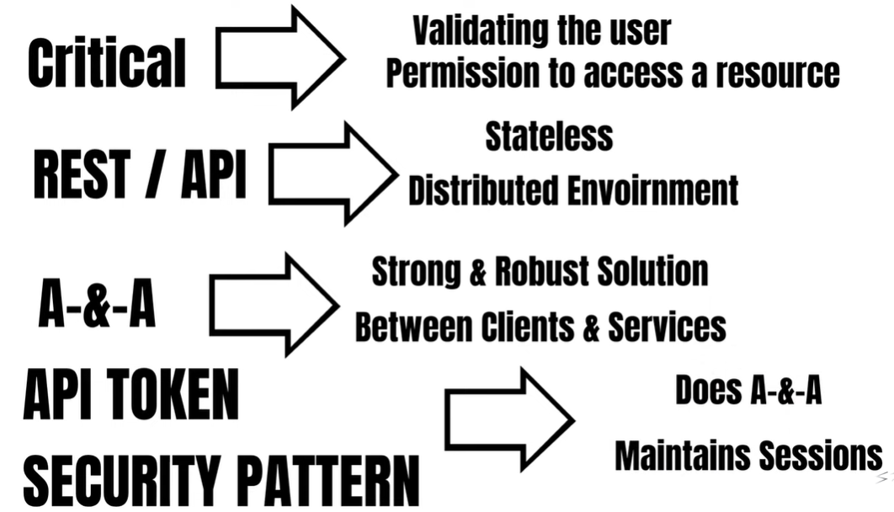

How Does whole process works

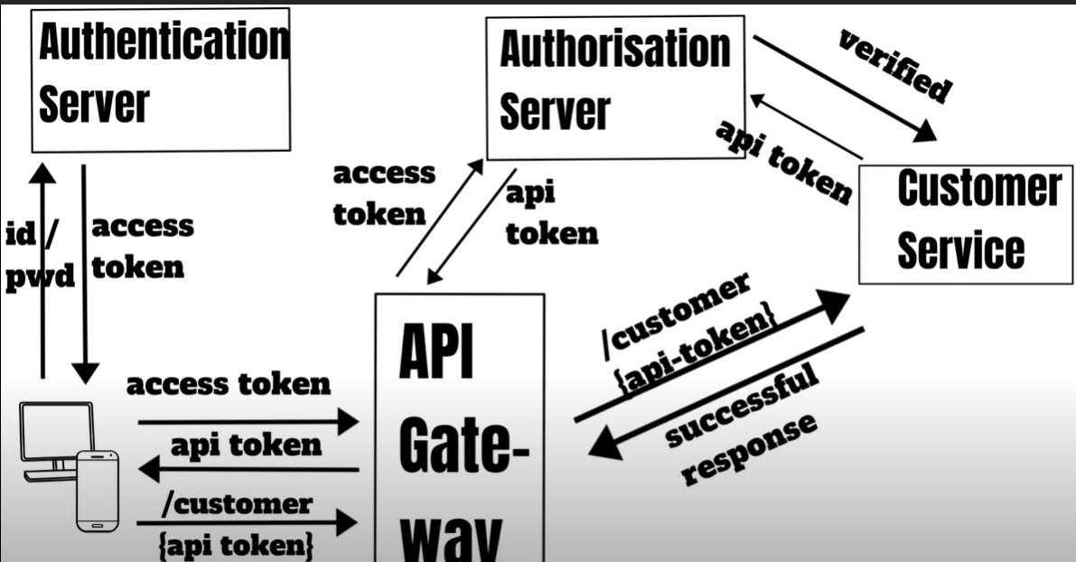

1. If a client wants to access a microservice, first it gets authenticated by calling the authentication server by passing the user name and password and it gets the access token in returns. This is where the client is authenticated.
2. Now client needs to get authorized for the microservice. For this, it will call the API gateway and pass the access token.
3. API Gateway then calls the authorization server with the access token passed in 2nd step.
4. Authorization server then based on the access token passed, checks the authorizations this particular client has and returns api token back to API gateway. API gateway again send back this api token to the client.
5. Now client will pass this api token as a part of the request header along with the address of the resource (/customer) to customer service through API gateway.
6. Now customer service needs to assure if this user is an authorized user or not. For that it passes the api token to authorization server. Once the authorization server verifies this api token, then client send backs the response back to client.

Question: Why customer service has to call auth server to confirm the token is valid? if it is a signed token, based on the roles and claims it can trust the access token right?

Ans: Because the logic to verify the JWT token doesn't live on the customer service, it lives on the auth server, in other words, the customer service doesn't know how to use the token, so it calls the auth service to verify the token against the keys and claims.

Question: Token will have all the details like who signed the token, and it will have hash of the details. If u have public key of the token u can just verify the signature whether it is correct or not. If the token is tampered u will reject. For this you dont need to call other service right?
Ans: Let's imagine a scenario where user just got banned right?, and the client side still has the token which contains this information, now if they send a request to the customer service, and the customer service just performs the check of integrity, this is not enough to allow the user to use the requested resource, because they might have just got banned in the auth service, but the customer service doesn't know, which means the customer service needs to check with the auth service each time for it verify the token

Authorization between multiple services

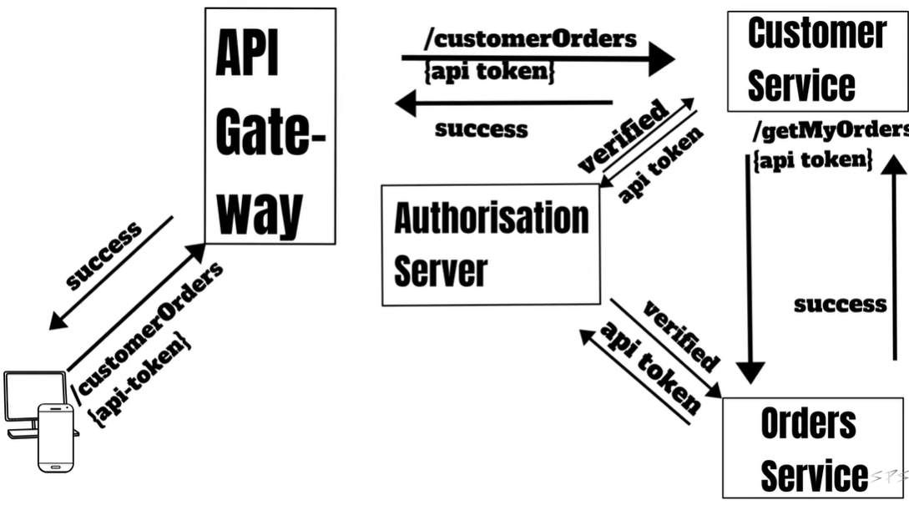
Here, the api-token will be passed and verified in every step of calling between microservices.

Question:

