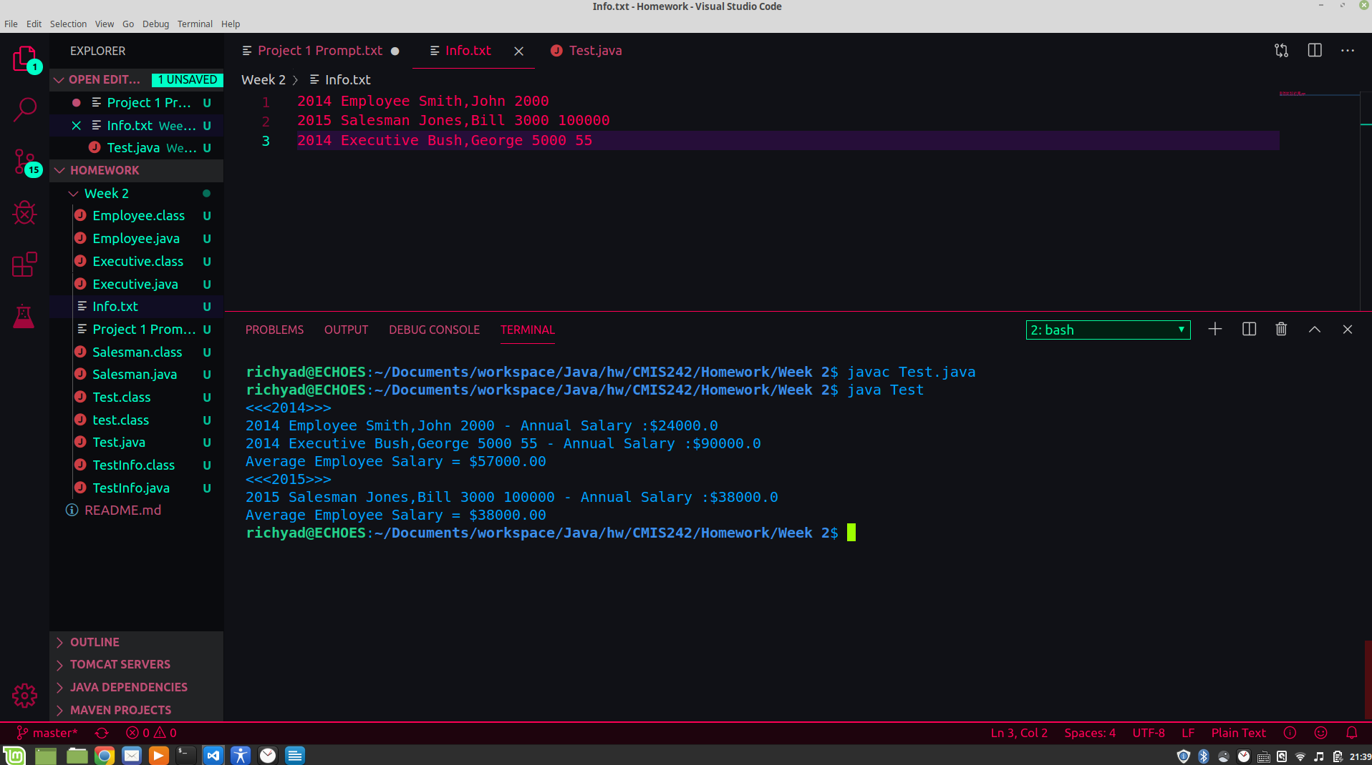Screen 1 displays output using the sample information provided.

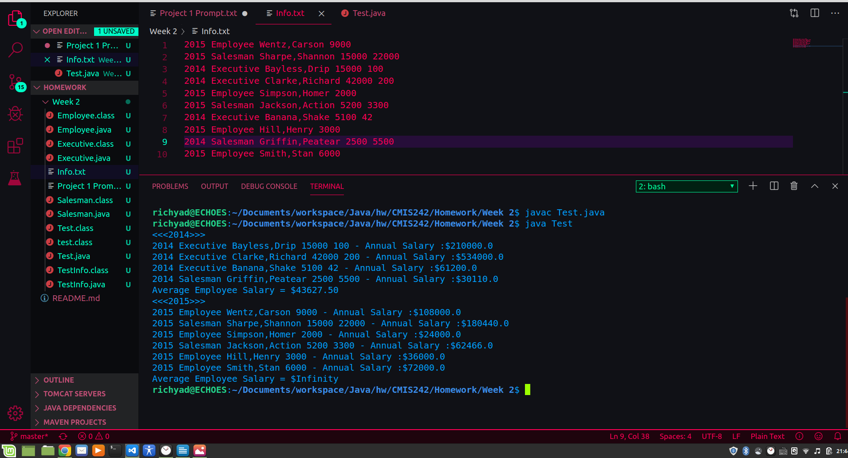Screen 2 uses sample data containing 10 different Employees where four are from 2014 and six are from 2015

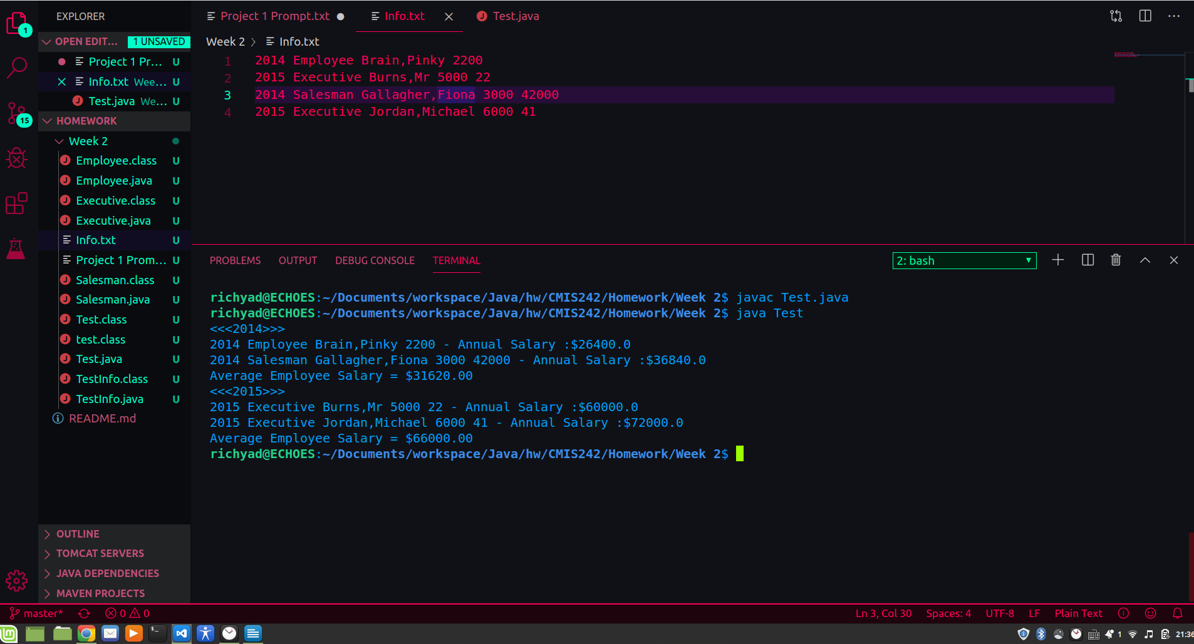Screen 3 uses sample data containing two Employees in 2014 and two in 2015.