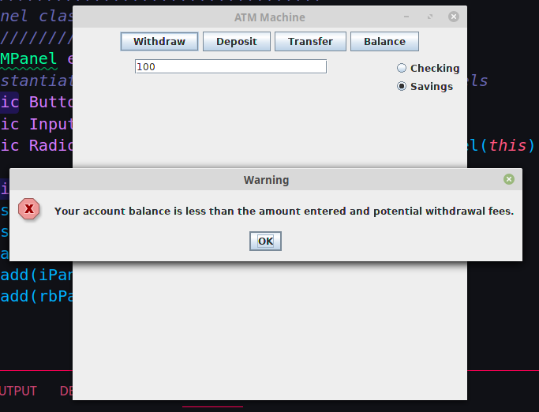  
  
TEST 1: Deposit $500 into the savings, withdraw $100 four times, transfer $100 into checking, and attempt to withdraw $100. It should fail since the total transaction will be $101.50 and the account only has $100 remaining.

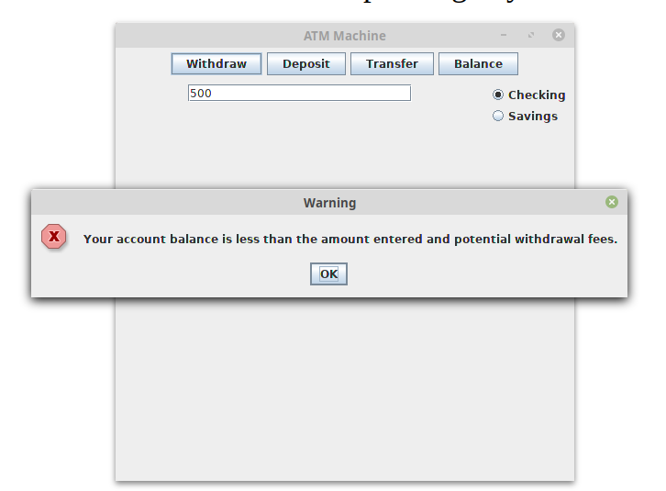  
TEST 2: Withdraw $500 from either account without depositing any funds first. It should fail since they start with $0 in the account.

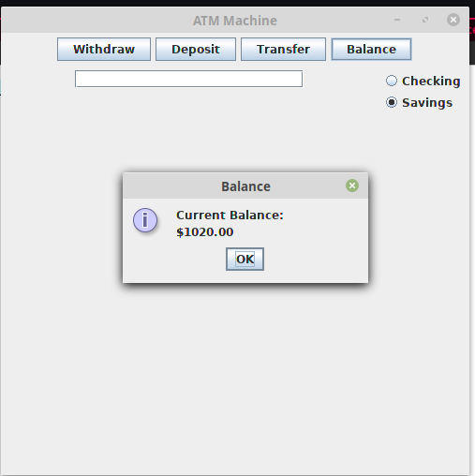  
  
TEST 3: Deposit $1020 into the Savings account and display the balance. It should pass since it displays the amount in the account.

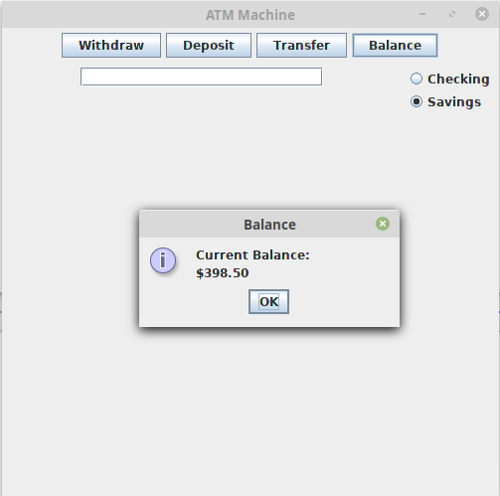  
TEST 4: Deposit $800 into the Checking account, deposit $500 into the Savings account, withdraw $200 from the Checking account four times, and withdraw $100 from the Savings account and display the balance. It should display $398.50 since the initial four withdrawals now force a $1.50 fee on all subsequent withdrawals.