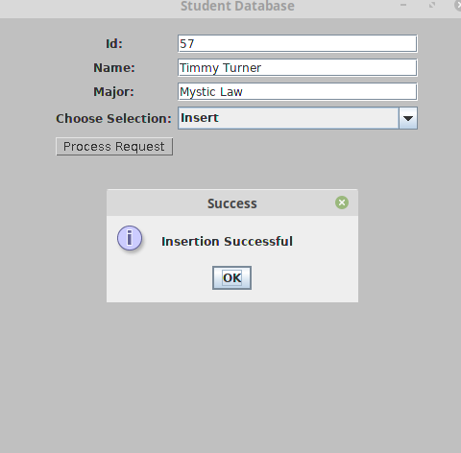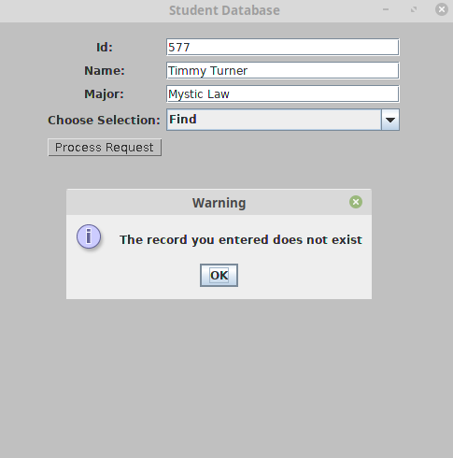

TEST 1: Add a student with the id 57, “Timmy Turner”, “Mystic Law”. Attempt to find the student using the id 577. (Warning should display saying the record does not exist).

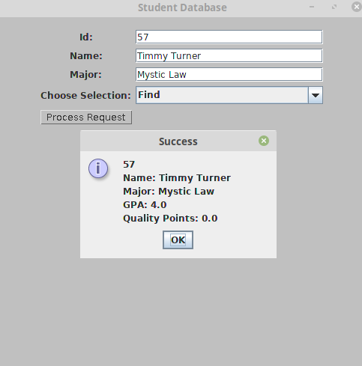

TEST 2: Add a student with the id 57, “Timmy Turner”, “Mystic Law”. Attempt to find the student using the id 57. (Timmy Turner’s info should appear with the GPA set to 4.0 and Quality Points set to 0).

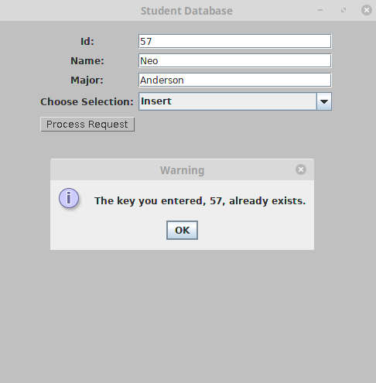

TEST 3: Add a new student with id 57, “Neo Anderson”, “Matrix”. (Warning should display saying the key already exists)

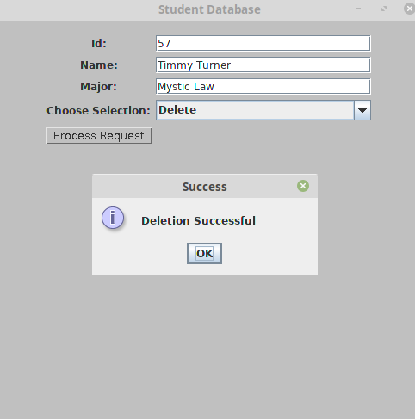

TEST 4: Delete the record for student id 57, “Timmy Turner”, “Mystic Law”. A prompt should appear saying the deletion was successful.

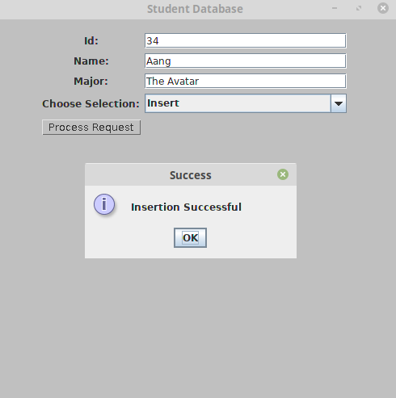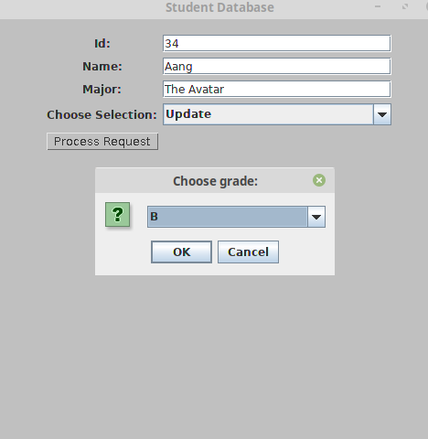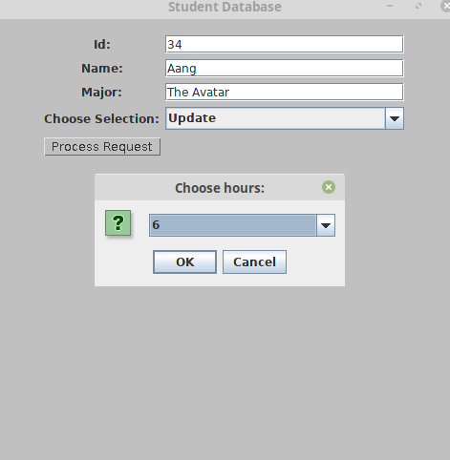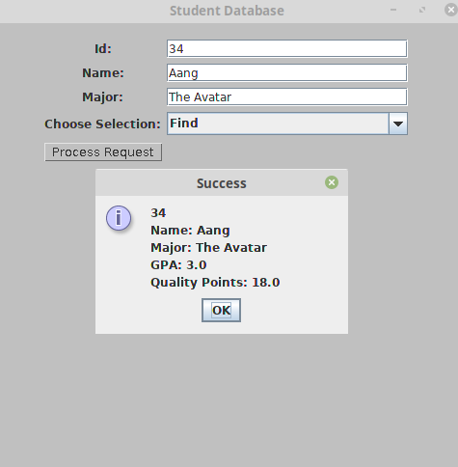

TEST 5: Insert the record id 34, “Aang”, “The Avatar”. Update with a B and 6 credit hours. Find the student with these same records and the display should read:  
34  
Name: Aang

Major: The Avatar

GPA: 3.0

Quality Points: 18