LCD Interface Module
Instructions on how to use the lcdif_cxx modules and their performance characteristics on selected microcontroller platforms

Forward
The LCD Interface Modules are designed to allow the user to connect the HD44780 Module to the chosen HD44780 based alphanumeric LCD display via the hardware interface of their choice, on the microcontroller of their choice. All of the different versions of this module offer essentially the same user API, but the underlying functionality is tuned to a specific microcontroller and its hardware. This module can be considered a „Hardware Abstraction Layer (HAL)“ for the HD44780 Module. The basic hardware interface supported is the GPIO peripheral, a peripheral support by almost all controllers. The GPIO pins of the target controller are then „bit-banged“ to implement the parallel interface as described in the datasheet of the HD44780 LCD controllers. When available, the Parallel Master Port peripheral is also supported (PMP). This is to be found on some 16- and 32-bit controllers from Microchip.
This module supports both the 8- and 4-bit bus mode of the HD44780 transparently from the upper software layers. If desired, this module could be modified to support any microcontroller so that the upper HD44780 Module can be used without modification.

Version Number
This document pertains to version V0.1 of the lcdif_module software.

Authors
Stuart Cording aka CODINGHEAD – wrote original code and port for bit-banged GPIO interface for PIC18 – codinghead@gmail.com
Contents
Forward 1
Version Number 1
Authors 1
File Organisation 2
Brief feature list of the LCDIF Module 2
Important Terminology and the HD44780 Controller 3
Using the LCD Interface Module 6
Further hints on LCDIF Module Usage 11
Porting the LCDIF Module to other microcontrollers or peripherals 12
Testing signal speed and timing of an LCDIF port 13
What to do if signal timings are too short or speeds are too high 13
Memory and Stack Usage for Selected MCUs and DSPs 13
Performance Measurements for Selected MCUs and DSPs 13
Known Issues 14
Future Improvements 14

File Organisation
The files for this module are organised as described here:
- HD44780 – Main directory for the HD44780 module and the associated LCD Interface module
  - HD44780_module – Source code for the HD44780 module
  - lcdif_module – Source code for the LCD Interface module described in this document
  - HD44780Test – Test bench code for the HD44780 module used during development
  - lcdifTest – Test bench code for the LCD Interface module used during development
  - HD44780_Examples – Examples of how to use the HD44780 and LCD Interfaces together on different controller platforms
  - CHM – Doc-O-Matic Express documentation as compiled HTML Help file
  - Doc-O-Matic – Code documentation generation files for use with Doc-O- Matic Express
  - DOM – Documentation generated by Doc-O-Matic Express
  - Documentation – Location of this and other documentation generated by hand
  - ChangeHistory – Change history on the module, listing changes since previous version
  - License – Licensing information and other relevant documents

Brief feature list of the LCDIF Module
The LCDIF Module supports:
- A single alphanumeric HD44780 controller based LCD display connected to a single parallel bus interface
- Multiple alphanumeric HD44780 controller based LCD displays connected to a common parallel bus
- LCD displays which contain multiple HD44780 controllers
- Multiple alphanumeric HD44780 controller based LCD displays connected to different parallel buses
- An abstracted parallel bus layer, allowing the physical hardware interface to be ported to different microcontrollers or physical interfaces
- A mutex scheme in the parallel bus layer ensuring that, in a multi-threaded system, that only one thread can use the common parallel bus resource

Important Terminology and the HD44780 Controller
Firstly some terminology:
HD44780 Controller - The controller chip found on almost all parallel interface based alphanumeric LCD displays supporting 4 x 40 characters or less. This refers additionally to all HD44780 „clones“ from other semiconductor manufacturers who use the same interface, registers and instructions.
LCD Module - A PCB or glass based alphanumeric LCD product where the HD44780 (or clone) is used as the LCD controller. Typically not manufactured by the HD44780 controller semiconductor vendor.
LCDIF Module - The LCD InterFace Module software discussed in this document
PBIF - Abbreviation for Parallel Bus InterFace, the software layer in the LCDIF Module providing the physical hardware interface to the LCD Module connected to the target microcontroller
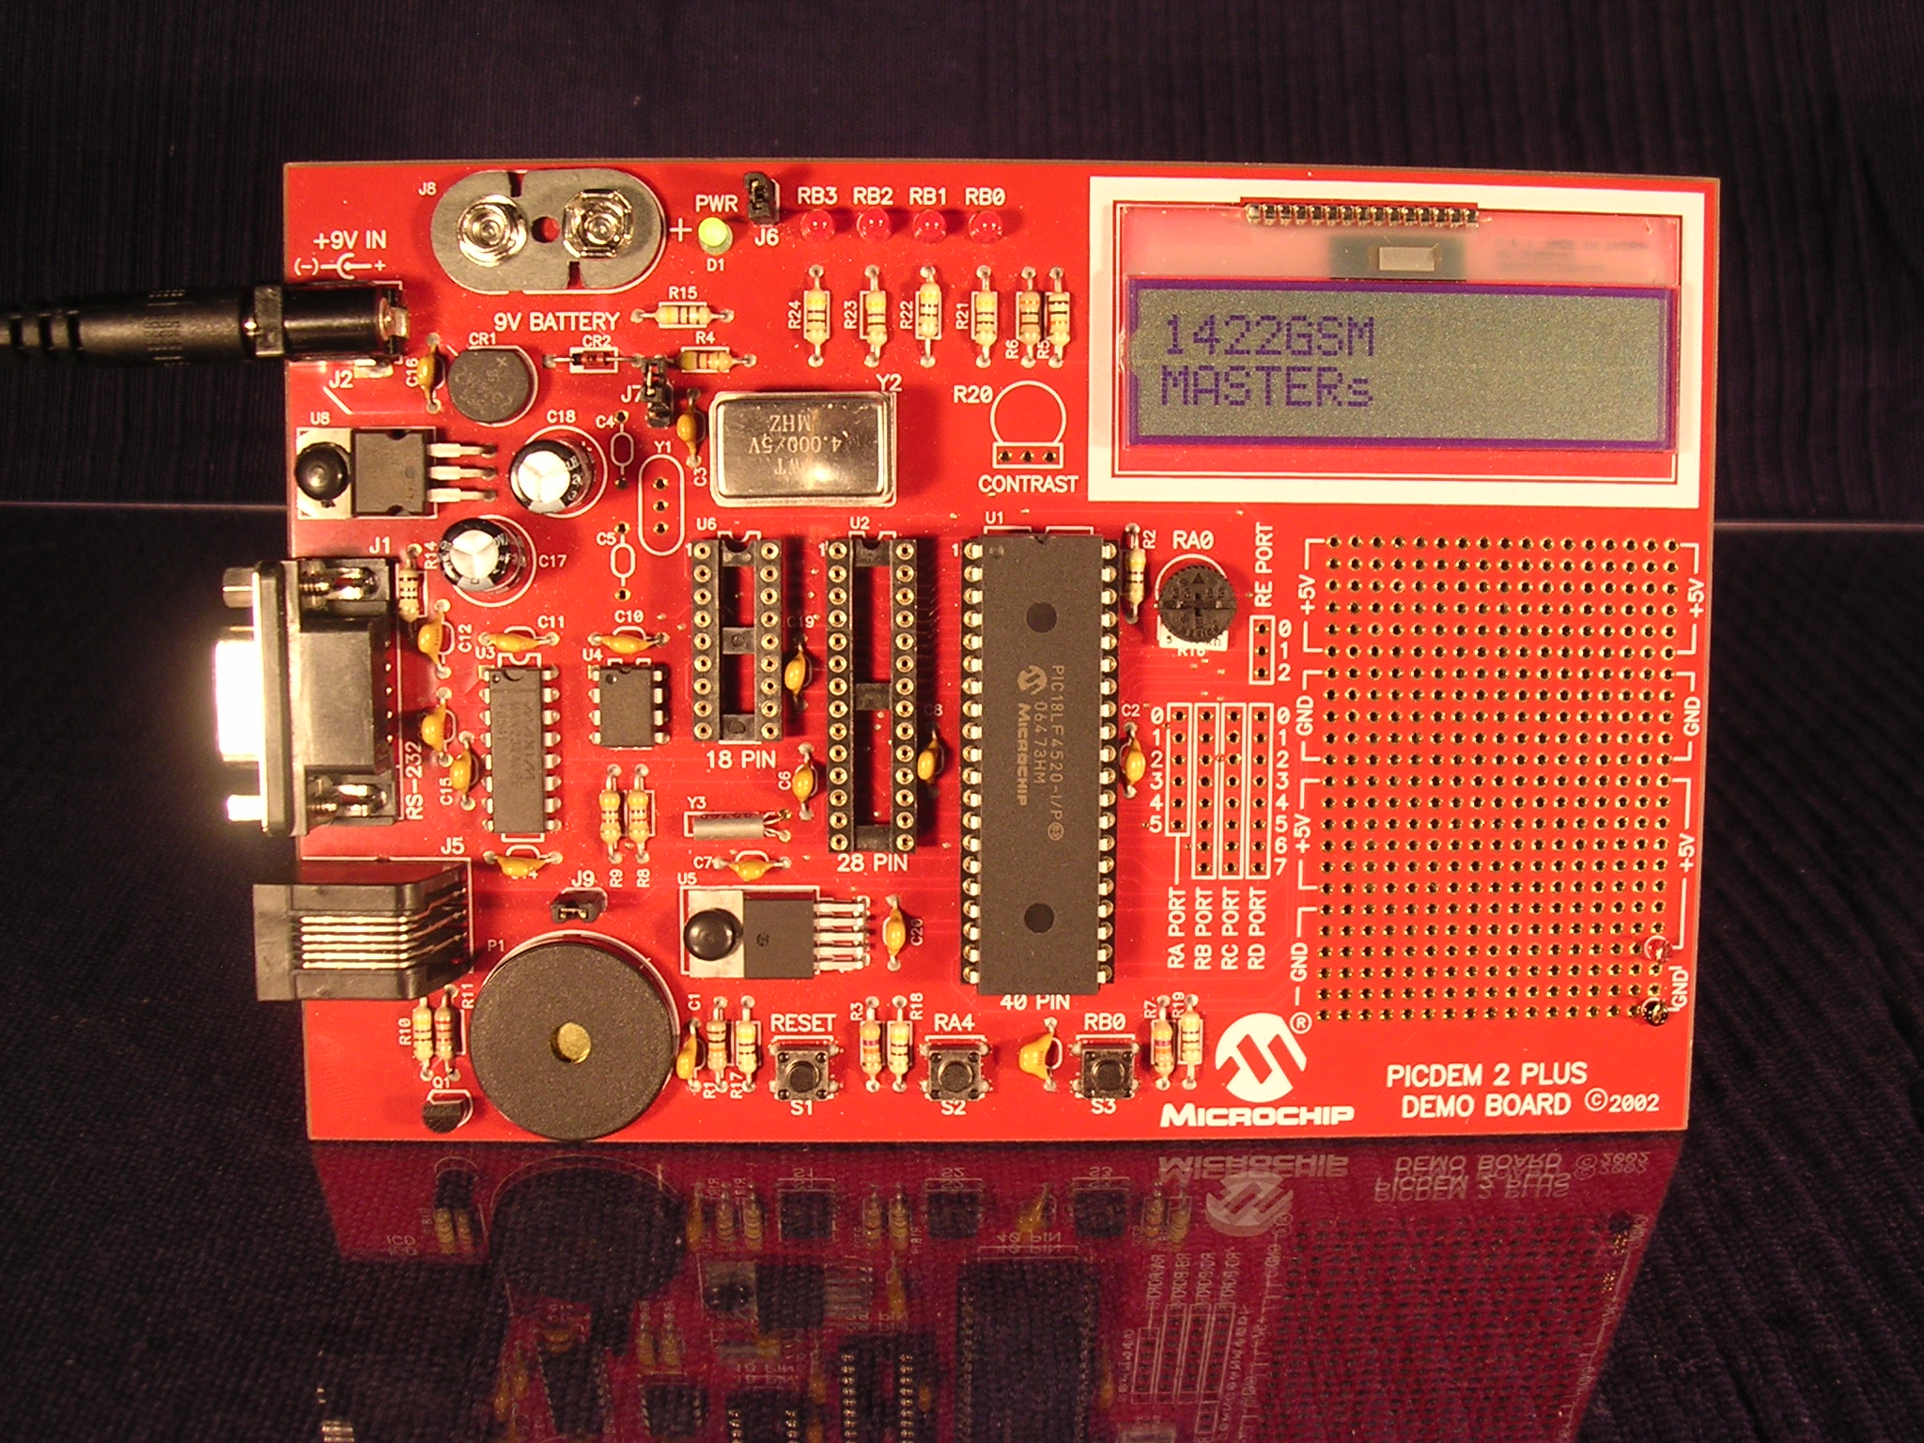
Figure 1: An HD44780 based alphanumeric LCD Chip-On-Glass (COG) display fitted to a Microchip PICDEM 2 Plus development board
The HD44780 Alphanumeric LCD Controller is a semiconductor product from Hitachi for controlling alphanumeric LCD displays. The controller consists of; a parallel control interface for control via a microcontroller or similar; a series of multiplexed pins for direct attachment to an LCD display; and a voltage generator to generate the voltages needed to control the segments of the LCD glass. Internally the controller offers four simple operations:
- Instruction Write – allows instructions to be written to the HD44780 controller in order to configure it in the desired operating mode
- Data Write – allows data, normally in the form of characters or numbers, to be written to the LCD display at the current cursor position. If the CGRAM (character graphics RAM) has been selected, the data written defines a horizontal line of one of the eight self-definable characters
- Data Read – allows the character or number being displayed at the current cursor position to be read. If the CGRAM has been selected, the data read is that defining a horizontal line of one of the eight self-defined characters.
- Address Counter and Busy Flag Read – allows the current position of the cursor to be read. If the CGRAM is selected, the currently selected CGRAM address will be read. The most significant bit is the Busy Bit. If set (i.e. '1') the HD44780 controller is still busy processing the most recent command.
There are many different manufacturers of HD44780 compatible LCD controllers although there are often minor differences in the interface or instruction timings. Most confusingly, the „Initialisation by Software“ process whereby the LCD module can be reset if the power-on-reset circuitry did not successfully reset the controller is often significantly different from manufacturer to manufacturer requiring that the process is customised for each chip set .
One of the main challenges for engineers and programmers when working with these controllers is that the data sheets are written for both the LCD module developer who wishes to interface the controller with their LCD glass and for the person who wishes to interface the controller to a microcontroller. This often leads to a confusing document where it is unclear which elements are necessary for the microcontroller developer. The LCD module manufacturers tend only to characterise their module with respect to voltages and current draw and simply refer the user to the data sheet of the chosen LCD controller that was used.
The HD44780 controllers can support up to 40 characters over two lines. Once more than 80 characters need to be supported, two or more HD44780 are fitted to the LCD module and the two controllers are selected via separate E (enable) lines with a common R/W and RS lines and data bus.
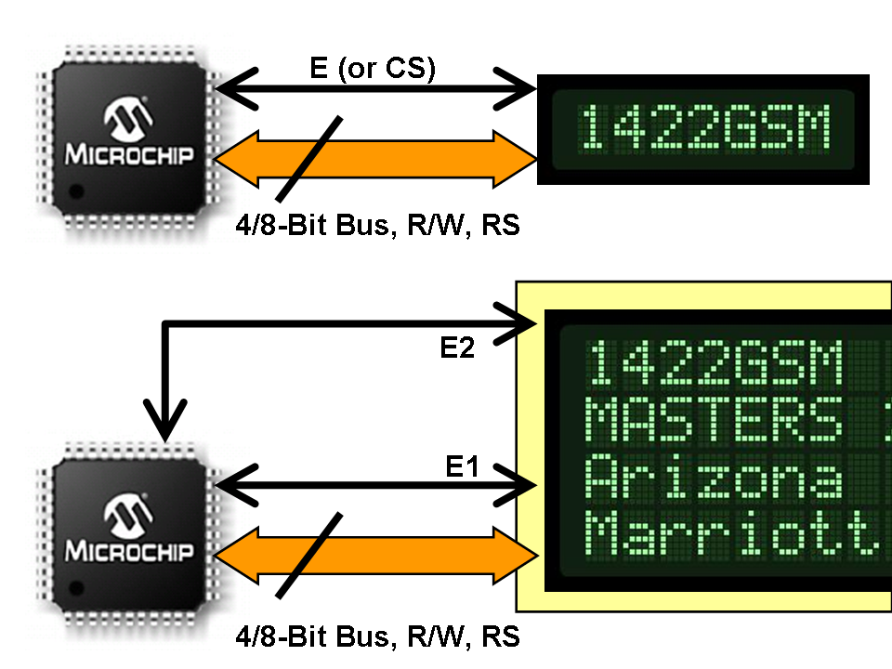
Figure 2: The HD44780 is controlled by a parallel bus with R/W (read/write) and RS (register select) control lines. LCD modules are enabled via an E (enable) signal, or in cases where more than one HD44780 is fitted, several E signals.
With this generic HD44780 and LCD Interface implementation there is no assumption about the target processor where the module is to be used or the hardware interface to which the LCD module is connected. This module (LCD interface) abstracts the hardware interface from the functionality of the HD44780 module so that only this module needs to be modified when porting the code to a new microcontroller. This module is also split into two elements; an LCD interface element offering the API to the HD44780 module and providing control of the E pin of the LCD module; and a „parallel bus“ element which is used to describe the common elements of the bus (parallel bus, R/W and RS lines) to which one or more HD44780s may be connected. This is shown in figure 3 below.
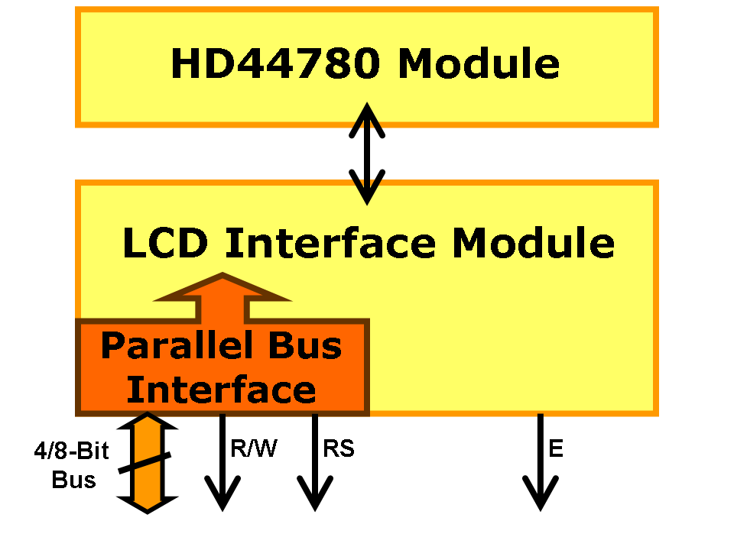
Figure 3: Relationship between HD44780 Module and the LCD Interface Module, and the Parallel Bus Interface which describes the common control lines for the hardware bus
The Parallel Bus Interface can be used by several instantiations of the LCD Interface module at the same time, with each instantiation merely defining the enable line for the LCD Module to be controlled. This helps to minimise code footprint by defining what is likely to be a common interface in a single place.

Using the LCD Interface Module
Typically the LCD Interface is not used alone but in conjunction with the HD44780 Module. If, however, you wish to use this module alone, or intend to write an optimised HD44780 layer on top of the LCD Interface Module, this section describes the step required.
To use the LCD Interface Module you will first need to create a single, common Parallel Bus Interface object which describes the parallel bus hardware to which the LCD Module will be connected to on the target microcontroller. The second step is to create an LCD Interface object for each LCD Module connected to that Parallel Bus Interface object. If necessary, several Parallel Bus Interface objects can be used if different LCD Modules are connected to different parallel buses on the target microcontroller. The following figures show some examples of how the LCD Interface Module, in conjunction with the Parallel Bus Interface, can be used with one or more hardware LCD modules. These are merely examples and not an exhaustive list of possible usage permutations.

1. Single LCD Module; Single LCD Interface Object; Single Parallel Bus Object
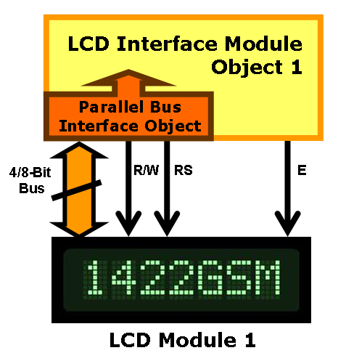
2. Two LCD Modules; Two LCD Interface Objects; Single common Parallel Bus Object
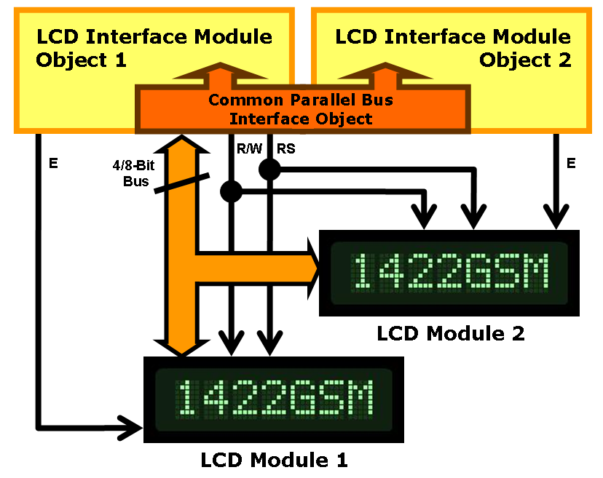
3. Two LCD Modules; Two LCD Interface Objects; Two separate Parallel Bus Objects describing two different hardware parallel buses
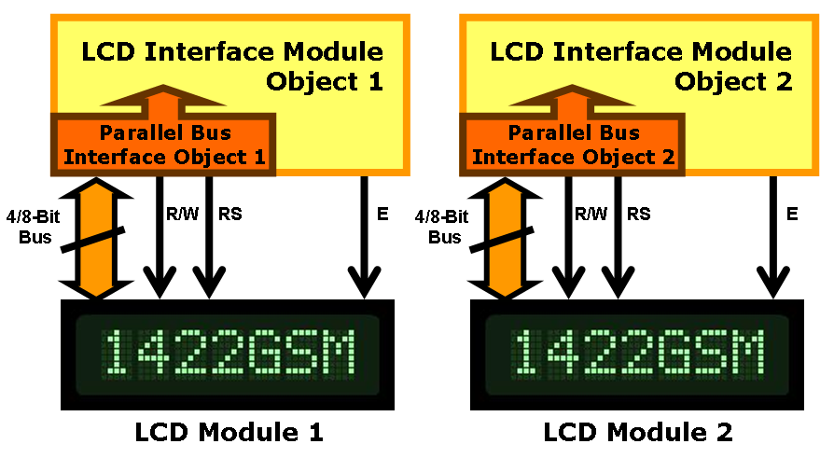
In order to create one single LCD Interface Object with a single Parallel Bus Interface object, please follow the following steps, referring when necessary to the code documentation in the /DOM directory. For further clarification, use the example code in the /hd44780Examples directory.
This example assumes that the parallel bus itself is a bit-banged GPIO port on a Microchip microcontroller.
- Define which GPIO pins will be used for each of the following signals; R/W output, E output; RS register select output; 4 or 8 bi-directional pins for the data bus
IMPORTANT! :- The 4 or 8 signals used for the data bus must be consecutive, with the LSb (least significant bit) on the lowest numbered pin. Examples using a Microchip microcontroller using a 4-bit data bus would be (for GPIO peripheral PORTB) RB0, RB1, RB2 and RB3, or RB3, RB4, RB5 and RB6.
- Declare one variable each of the following data types:
PBIFOBJ – the Parallel Bus Interface object
LCDIFOBJ – the LCD Interface Object
HLCDIF – the handle to an LCD Interface Object
LCDIFNUM – the LCD Interface number (can be a temporary variable)
- Set up the chosen GPIO peripheral so that the pins used as the R/W, E and RS signals are outputs and, where necessary, that any analogue capability on those pins is switched off.
IMPORTANT! :- The PBIF and LCDIF modules, in order to minimise code footprint and MIPS usage, only control the direction of the data bus pins since the other signals are always outputs.
- Assign the GPIO peripheral register addresses and pins in the PBIFOBJ variable you defined in step 2 for the LCD module signals R/W, RS and the parallel bus. This includes:
- The address of the LATx register where the R/W signal is connected
- The pin number of the GPIO peripheral assigned to the R/W signal
- The address of the LATx register where the RS signal is connected
- The pin number of the GPIO peripheral assigned to the RS signal
- The address of the LATx register to be used for the data bus
- The address of the PORTx register to be used for the data bus
- The address of the TRISx register to be used for the data bus
- A bit mask of the 4 or 8 consecutive pins being used as the parallel interface
In making the last assignment (the pins for the parallel bus) you have also defined if the bus is four or eight bits wide.
- Assign the GPIO peripheral register addresses and pins in the LCDIFFOBJ variable you defined in step 2 for the LCD module signal E. This includes:
- The address of the LATx register where the E signal is connected
- The pin number of the GPIO peripheral assigned to the E signal
- Assign the PBIFOBJ variable to the LCDIFOBJ variable so that the LCDIF knows which PBIF object to use when accessing the LCD module.
- Call lcdifCreate() to instantiate a LCDIFOBJ objects. Save the return value in the LCDIFNUM variables declared in step 2. The return value is unique to the LCDIFOBJ object you have created. Without it, you won't be able to use cbuffOpen() to open the buffer in the next step.
NOTE! :- The return value should be checked. If it is '0', the object wasn't added to the list of objects. This is probably due to an element in the PBIFOBJ or LCDIFOBJ structures not being assigned correctly, or not defining the bus width correctly.
- Call lcdifOpen() for each buffer object when you are ready to use the buffer, referencing the LCDIFNUM variable you were returned from lcdifCreate(). Save the returned handle, which is unique to the LCDIF object you have opened, in the HLCDIF variable declared in step 2. This value will be required for all further LCDIF module calls.
WARNING! :- In a multi-tasking/multi-threaded system, ensure that lcdifOpen()is called inside a critical section if more than one thread/task could potentially attempt to open an LCDIF object with the same LCDIFNUM number. If the LCDIF object has not yet been opened there is a risk of a race condition occurring whereby two or more threads simultaneously requesting the same LCDIFOBJ all acquire the chosen resource.
- If you are using the HD44780 module, this is the point at which you would pass the HD44780 module the handle to this LCDIF which you have created. If you wish to just use this module alone, follow the next steps. This would be necessary, for example, when writing code to test the signal timing of the bus or when testing a LCDIF port for a new microcontroller or peripheral.
- Before calling any of the LCDIF functions, you must first acquire the mutex for the shared resource which is the PBIF object. The is performed by calling lcdifGetPb(HLCDIF).
- With the handle to the LCDIFOBJ now available you can use the available functions to read and write data to the LCD module or write instructions and read the address pointer.
- (Optional) If you wish to release the buffer object for use by another thread or task, call lcdifClose() refering to the HLCDIF handle you received when opening the buffer. Be sure to save the LCDIFNUM value this function returns if you wish to remove this LCDIFOBJ from the list of objects in the modules linked list of LCDIFOBJs and free the memory associated with this object.
- (Optional) If you wish to free the memory associated with this LCDIFOBJ, call lcdifDestroy(). If this call is successful, the memory associated with the LCDIFOBJ object can be freed.
- (Optional) If you are finished with the LCDIF Module and have destroyed all available LCDIFOBJ objects, you may de-initialise the LCDIF Module using the lcdifDeinit() function.
A code example is given here for a PIC18 microcontroller. For further examples, please refer to the examples in the lcdifExamples/ directory.

int main(void)
{
LCDIFNUM lcdIfOneNum;
HLCDIF hLcdIfOne;
PBIFOBJ pbIf;
LCDIFOBJ lcdIfOneObj;

/* Make RW, RS and E lines outputs */
/* Clear LATD register (functions as */
/* data bus lines */
LATD = 0;

/* On GREEN PICDEM 2 Plus these are: */
/* RD5 = RW */
/* RD4 = RS */
/* RD6 = E */
TRISDbits.TRISD5 = 0;
TRISDbits.TRISD4 = 0;
TRISDbits.TRISD6 = 0;

/* Init module */
lcdifInit();

/* Fill parallel bus interface struct */
/* Data bus is 4 bits wide, RD0 – RD3 */
pbIf.RW_LAT = &LATD;
pbIf.RW_BIT = (1 << 5);
pbIf.RS_LAT = &LATD;
pbIf.RS_BIT = (1 << 4);
pbIf.DATA_LAT = &LATD;
pbIf.DATA_PORT = &PORTD;
pbIf.DATA_TRIS = &TRISD;
pbIf.DATA_MASK = 0x0F;

/* Fill lcd interface struct */
lcdIfOneObj.E_LAT = &LATD;
lcdIfOneObj.E_BIT = (1 << 6);
lcdIfOneObj.pbIfObject = &pbIf;

lcdIfOneNum = lcdifCreate(&lcdIfOneObj);

if (lcdIfOneNum == 0)
{
/* Error – no LCDIFNUM assigned */
}

hLcdIfOne = lcdifOpen(lcdIfOneNum);

if ( hLcdIfOne == (HLCDIF) 0)
{
/* Error – couldn't get handle to LCD */
}

/* Turn on the LCD display (uses RD7) */
/* on PICDEM 2 Plus */
TRISDbits.TRISD7 = 0;
LATDbits.LATD7 = 1;

/* Return values of the following functions should really */
/* be checked to ensure that they completed as expected */
lcdifGetPb(hLcdIfOne);

lcdifWriteData(hLcdIfOne, 'H');
lcdifWriteData(hLcdIfOne, 'e');
lcdifWriteData(hLcdIfOne, 'l');
lcdifWriteData(hLcdIfOne, 'l');
lcdifWriteData(hLcdIfOne, 'o');
lcdifWriteData(hLcdIfOne, '!');

lcdIfOneNum = lcdifClose(hLcdIfOne);

if (lcdIfOneNum == 0)
{
/* Error – couldn't close interface */
}

lcdifDestroy(lcdIfOneNum);

lcdifDeinit();

}

Code Example 1: Usage example of the LCDIF Module for a single LCD module connected to a PIC18 microcontroller targeted for the PICDEM 2 Plus development board

Further hints on LCDIF Module Usage
When using the LCDIF Module, the following information may be useful to know regarding how certain functions are implemented.
lcdifCreate() & lcdifOpen() - the lcdifCreate() function adds the new LCDIF object which it is passed to a linked list of LCDIF objects stored in the LCDIF module. Due to the way in which this function is programmed, each new LCDIF object is inserted into the start of the linked list for reasons of speed. The disadvantage of this approach is that, when you then call lcdifOpen() to get a handle to your LCDIF, the LCDIF you created first take longest to get a handle to. Therefore it is recommended that, in situations where you regularly wish to open and close interfaces, the interfaces which are open and closed most often are created last. This will ensure that the time to open them is as short as possible.
cbuffDestroy() - This function also suffers from a performance hit when removing LCDIF objects from the linked list if the interfaces are removed in the order they were created. In order to keep execution time as short as possible, it is recommended to destroy the interfaces in the reverse order to that in which they were created where possible.

Porting the LCDIF Module to other microcontrollers or peripherals
Porting is a relatively simple process, but requires changes in many places. Files which support other microcontrollers can be copied and used as the basis for the port. The basic process is as follows:
- Define which registers and other information the module needs to use the proposed hardware interface.
- Copy and rename a pbif_xxx.h file and make the necessary changes for your interface to the content of the structure „PBIFOBJ“. This essentially involves providing definitions for the addresses of the registers needed to control the pins of the microcontroller which will be connected to the LCD module. In the section „INCLUDE FILES“ ensure that there is a reference to the header file where the microcontroller registers are defined that you need for the microcontroller family you are targetting. Update the „CONFIGURATION ERRORS“ to match your toolsuite.
- Copy and rename a lcdif_xxx.h file and modify the LCDIFOBJ structure to support the way the E signal of the LCD module is connected to the chosen physical interface. In the section „INCLUDE FILES“ ensure that there is a reference to the header file where the registers are defined that you need for the microcontroller family you are targetting and a reference to the newly created pbif_xxx.h file. Update the „CONFIGURATION ERRORS“ to match your toolsuite.
- Copy and rename the lcdif_xxx.c file.
- In the „INCLUDE FILE“ section, refer to your lcdif_xxx.h and pbif_xxx.h files.
- Modify the „LOCAL CONFIGURATION ERRORS“ section to match your compiler toolsuite.
- Modify the lcdifCreate() function if necessary. This function checks that it has been passed valid data in the LCDIFOBJ structure by comparing all the structure's elements with either '0' or a NULL pointer. If something seems to be missing, the call fails and the function returns 0. Only the microcontroller specific items need to be modified.
- Modify the remaining functions which are hardware specific. This includes:
lcdifWriteData()
lcdifReadData()
lcdifWriteInstruction()
lcdifReadAddress()
lcdif4BitFunctionSet()
No changes should be required to the functionality of these functions, merely the accesses to the appropriate hardware registers needs to be updated.
- Finally, the mutex code needs to be modified. These are the functions:
lcdifGetPb()
lcdifReturnPb()
For the PIC18 this was written in assembler and is to be found in the “pbif_c18.asm” file. The mutex relies on the target processor being able to perform and atomic operation on the variable hLcdIf->pbIfObject->mutex. For reasons of simplicity, it was easier to implement this in a separate assembler file for the PIC18 architecture. For other architectures you may wish to implement these functions in the lcdif_xxx.c file, but the actual setting and clearing of the mutex bit will most likely need to be written in a line or two of in-line assembler to ensure that the operation require is really atomic. Refer to the currently available code to see how this operation works.
- Test the modification by using one of the test suites and modifying it for your processor and chosen interface.

Testing signal speed and timing of an LCDIF port
Once a port has been written for a new microcontroller or peripheral it is essential to test the signal speeds and timing of the parallel interface. The HD44780 controller and its clones define very specific minimum pulse lengths and timing between rising/falling edges of signals. It may be the case, especially with a bit-banged GPIO peripheral, that the signal timings are too fast or short when the microcontroller is operated at its highest possible clock frequency. The following code example can be used to generate the two basic parallel bus accesses, read and write, so that the signal timing can be measured with a tool such as a digital signal analyser.
It should be noted that this code should executed without the microcontroller being connected to an LCD module because the intention is simply to measure and check that the signalling speeds of the chosen interface are within the timing specifications of the HD44780 controller being used.

int main(void)
{
LCDIFNUM lcdIfOneNum;
HLCDIF hLcdIfOne;
PBIFOBJ pbIf;
LCDIFOBJ lcdIfOneObj;

/* Make RW, RS and E lines outputs */
/* Clear LATD register (functions as */
/* data bus lines */
LATD = 0;

/* On GREEN PICDEM 2 Plus these are: */
/* RD5 = RW */
/* RD4 = RS */
/* RD6 = E */
TRISDbits.TRISD5 = 0;
TRISDbits.TRISD4 = 0;
TRISDbits.TRISD6 = 0;

/* Init module */
lcdifInit();

/* Fill parallel bus interface struct */
/* Data bus is 4 bits wide, RD0 – RD3 */
pbIf.RW_LAT = &LATD;
pbIf.RW_BIT = (1 << 5);
pbIf.RS_LAT = &LATD;
pbIf.RS_BIT = (1 << 4);
pbIf.DATA_LAT = &LATD;
pbIf.DATA_PORT = &PORTD;
pbIf.DATA_TRIS = &TRISD;
pbIf.DATA_MASK = 0x0F;

/* Fill lcd interface struct */
lcdIfOneObj.E_LAT = &LATD;
lcdIfOneObj.E_BIT = (1 << 6);
lcdIfOneObj.pbIfObject = &pbIf;

lcdIfOneNum = lcdifCreate(&lcdIfOneObj);

if (lcdIfOneNum == 0)
{
/* Error – no LCDIFNUM assigned */
}

hLcdIfOne = lcdifOpen(lcdIfOneNum);

if ( hLcdIfOne == (HLCDIF) 0)
{
/* Error – couldn't get handle to LCD */
}

/* Turn on the LCD display (uses RD7) */
/* on PICDEM 2 Plus */
TRISDbits.TRISD7 = 0;
LATDbits.LATD7 = 1;

/* Return values of the following functions should really */
/* be checked to ensure that they completed as expected */
lcdifGetPb(hLcdIfOne);

while(1)
{
lcdifWriteData(hLcdIfOne, 0x55);
lcdifReadData(hLcdIfOne);
lcdifWriteInstruction(hLcdIfOne, 0xAA);
lcdifReadAddress(hLcdIfOne);
/* If required add a delay between the calls */
}
}

Code Example 2: Testing the signal timings for reads and writes after completing a microprocessor/peripheral interface port. Example is for PIC18

What to do if signal timings are too short or speeds are too high
In the event that some pulses are too short or the timing between signal edges are too short, you will need to make a decision as to how to improve the port. The choices are:
- Add NOPs to slow down the signal – Insert NOP instructions into the code so that the signal edges meet the timing specifications of the HD44780 controller. The disadvantage of this approach is that the code execution time will be unnecessarily long when the microcontroller is run at lower speeds.
- Write a new LCDIF port for high processor speeds – Copy the lcdif_xxx.c file and modify it by adding NOPs to attain the correct signal timing. In the documentation for the new port, define the processor frequency range for which the ported LCDIF module should be used. It would also be helpful to document which signals had to be slowed down for the port.
- Write an LCDIF port with an addition method (function) which allows you to define the speed of the bus.

Memory and Stack Usage for Selected MCUs and DSPs
To be defined.

Performance Measurements for Selected MCUs and DSPs
To be defined.

Known Issues
- The lcdTest project test suite is not complete. The project needs to be written to actually test the module. Suggest splitting test project into two; one project tests the API calls which are microcontroller and LCD module independent which could be run using a simulator; the second project tests the API calls which require hardware to work and will be targeted to specific microcontrollers, displays and development boards.
- The demonstrations are not complete.
- Only the PIC18 GPIO peripheral is currently supported.

Future Improvements
Currently there is only support for a bit-banged GPIO port based interface for a PIC18. The plan is to support the same peripheral on the PIC24/dsPIC and PIC32 microcontrollers first, and then add support for the PMP peripheral found on the PIC24/dsPIC and PIC32 devices.

See also http://en.wikipedia.org/wiki/Critical_section
See also http://en.wikipedia.org/wiki/Race_condition

