Circular Buffer Module
Instructions on how to use the cbuff_module and its performance characteristics on selected microcontroller platforms

Foreward
The Circular Buffer Module is designed to allow the user to simply create circular buffer objects of self designated size for applications where data buffering is needed. The buffer is designed to hold the data type 'unsigned char' which is defined as a new data type 'CBUFF'. This allows for optimal memory usage on most systems and flexibility for the user. The design is generic i.e. it is not targeted at any specific processor architecture or family of microcontrollers, allowing it to be used anywhere. The efficiency of the code and its performance is, therefore, very much dependant on the C compiler used to compile the code. This document serves to explain how to use the module, by providing examples, and the module's performance characteristics on several standard microcontroller architectures.

Version Number
This document pertains to version V0.3 of the cbuff_module software.

File Organisation
The files for this module are organised as described here:
- circBuffer – Main directory
  - cbuff_module – Source code for the circular buffer module
  - cbuffExamples – Usage examples for various processor architectures
  - cbuffTest – Buffer module test bench code used during development
  - CHM – Doc-O-Matic Express documentation as compiled HTML Help file
  - Doc-O-Matic – Code documentation generation files for use with Doc-O- Matic Express
  - DOM – Documentation generated by Doc-O-Matic Express
  - Documentation – Location of this and other documentation generated by hand
  - ChangeHistory – Change history on the module, listing changes since previous version
  - License – Licensing information and other relevant documents

Circular Buffer Concept and Important Terminology
A circular buffer is a buffer which uses a First In-First Out (FIFO) approach for the temporary storage of data. A circular buffer is usually uni-directional requiring that two circular buffers be used in conjuction with a bi-directional hardware interface such as RS-232. Circular buffers are typically used in applications where:
- An interface generates 'bursty' data, i.e. data comes in multi-byte packets with either regular or irregular spacing between packets, and the receiver of the data can only process the data with a slower, fixed processing rate. Note, however, that the average throughput of the producer cannot exceed the average throughput of the consumer, although the peak throughput may, on occaision, be higher.
- An interface generates data with a protocol with no fixed length. The data cannot be fully evaluated until a complete data frame is received (i.e. GPS data)
- Situations where the data has low priority for the application and processing time will only be made available on an as-needs basis when a defined amount of data has been received
The generator of the data, i.e. the data source, is typically termed the producer, while the receiver of the data is termed the consumer.
Some microcontrollers and DSPs (such as the dsPIC30/33 from Microchip Technology Inc.) support some form of circular addressing mode in the form of Modulo Addressing, either in the underlying processors architecture or through a hardware module such as DMA. This means that a space in data memory can be defined for use as a circular buffer once a start and end address is supplied. When data is written into the buffer, and once the last address in this block of memory has been used, the hardware ensures that, upon the next address incrementation, the address wraps back to the first address of the defined block.
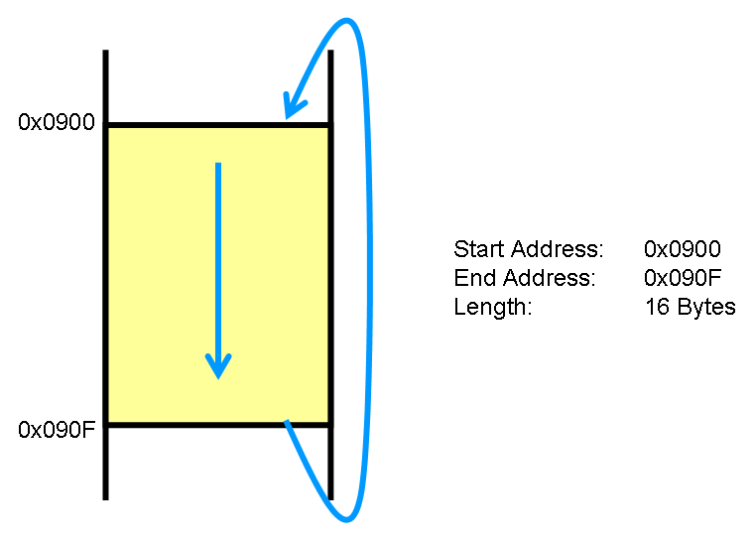
Figure 1: Implementation of a circular buffer using available modulo addressing support of target hardware
With this generic circular buffer implementation there is no assumption about the target processer where the module is to be used. Of course on a standard microcontroller or DSP there is only a linear address space available. Thus a software approach is used to firstly define a block of memory as a circular buffer, and secondly to implement the address wrap-around described above. The diagram below helps to describe how the circular buffer is implemented in the linear memory of the processor, and how it then can be conceptulised in its circular format.
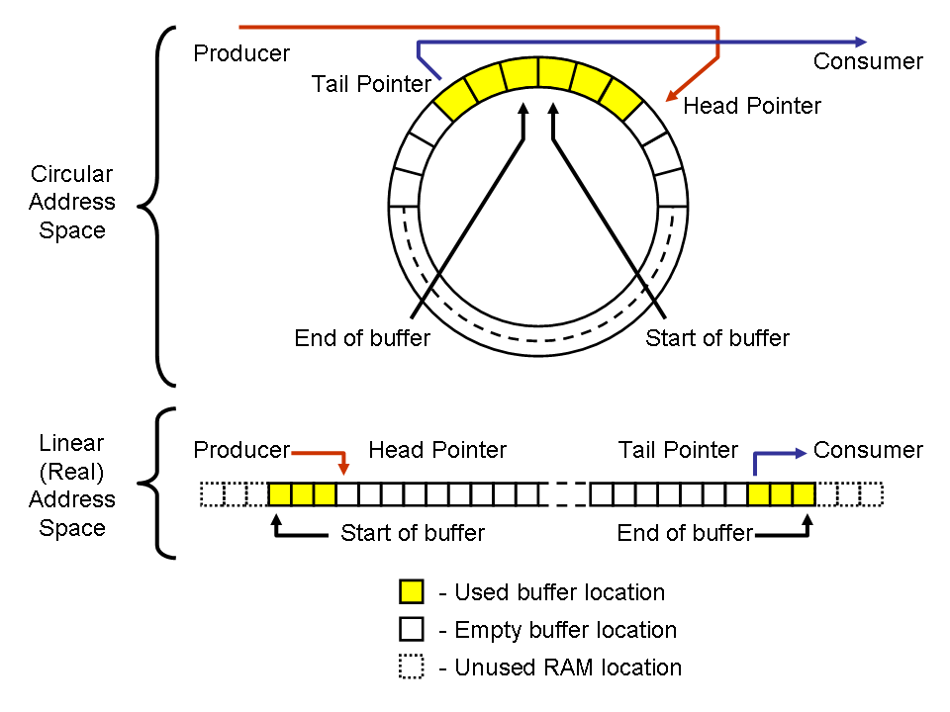
Figure 2: Visualisation of a circular buffer, and its implementation in the linear address space in the memory of a typical processor
The important terms here are:
- Head - the next free space in the buffer
- Head pointer - a pointer to this next free space
- Tail - the place where the oldest piece of data in the buffer is stored
- Tail pointer - a pointer to the location where this data is stored
- Start of buffer - address in processor's memory where the reserved space for the circular buffer starts
- End of buffer - address in processor's memory where the reserved space for the circular buffer ends
- Producer - the source generating the data
- Consumer - the target which is evaluating and using the data

Using the CBUFF Module
In order to create one or more circular buffers using the CBUFF module, please follow the following steps, refering when necessary to the code documentation in the /DOM and /CHM directories.
For further clarification, use the example code in the /cbuffExamples directory.

- Declare one (or more) arrays of data type CBUFF and one (or more) variables of data type CBUFFOBJ.
- Call cbuffCreate() one or more times to instantiate one or more CBUFFOBJ buffer objects. Save the return values in individual CBUFFNUM declared variables. The return value is unique to the CBUFFOBJ object you have created. Without it, you won't be able to use cbuffOpen() to open the buffer in the next step.
- Call cbuffOpen() for each buffer object when you are ready to use the buffer, referencing the CBUFFNUM variable you were returned from cbuffCreate(). Save the return value, which is unique to the buffer object you have opened, in a HCBUFF declared variable. This value will be required for all further CBUFF Module calls.
WARNING! :- In a multi-tasking/multi-threaded system, ensure that cbuffOpen()is called inside a critical section if more than one thread/task could potentially attempt to open a buffer object with the same buffer number. If the buffer object has not yet been opened there is a risk of a race condition occuring whereby two or more threads simultaneously requesting the same buffer object all acquire the chosen resource.
- With the handle to the buffer object now available you can use the cbuffGetXXXX(), cbuffPutXXXXX(), cbuffPeekXXXX() and cbuffUnputxxxx() functions to manipulate the buffer.
- (Optional) If you wish to release the buffer object for use by another thread or task, call cbuffClose() refering to the HCBUFF handle you received when opening the buffer. Be sure to save the CBUFFNUM value this function returns if you wish to remove this buffer object from the list of objects in the modules linked list of buffer objects and free the memory associated with this object.
- (Optional) If you wish to free the memory associated with this buffer object, call cbuffDestroy(). If this call is successful, the memory associated with the CBUFFOBJ buffer object and the CBUFF array can be freed.
- (Optional) If you are finished with the CBUFF Module and have destroyed all available CBUFFOBJ buffer objects, you may de-initialise the CBUFF Module using the cbuffDeinit() function.
A general code example is given here. For processor specific examples, please refer to the examples in the cbuffExamples/ directory.
#define BUFFER_ONE_SIZE 20
#define BUFFER_TWO_SIZE 40

int main(void)
{
CBUFF bufferOne[BUFFER_ONE_SIZE];
CBUFF bufferTwo[BUFFER_TWO_SIZE];
CBUFFOBJ bufferOneObj;
CBUFFOBJ bufferTwoObj;
CBUFFNUM bufferNumOne;
CBUFFNUM bufferNumTwo;
HCBUFF hBufferOne;
HCBUFF hBufferTwo;
CBUFF dataIn;

cbuffInit();

bufferNumOne = cbuffCreate(bufferOne, BUFFER_ONE_SIZE,
bufferOneObj);
bufferNumTwo = cbuffCreate(bufferTwo, BUFFER_TWO_SIZE,
bufferTwoObj);

if (bufferNumOne == 0 ||
bufferNumTwo == 0)
{
/* Handle error; create failed */
}

hBufferOne = cbuffOpen(bufferNumOne);
hBufferTwo = cbuffOpen(bufferNumTwo);

if (hBufferOne == (void *) 0 ||
hBufferTwo == (void *) )
{
/* Handle error; open failed */
}

if (cbuffPutByte(hBufferOne, 'A') != CBUFF_PUT_OK)
{
/* Handle error; failed to put data in buffer */
}
if (cbuffPutByte(hBufferOne, 'z') != CBUFF_PUT_OK)
{
/* Handle error; failed to put data in buffer */
}

if (cbuffGetByte(hBufferOne, &dataIn) != CBUFF_GET_OK)
{
/* Handle error; failed to get data from buffer */
}
if (cbuffGetByte(hBufferTwo, &dataIn) != CBUFF_GET_OK)
{
/* Handle error; failed to get data from buffer */
}

bufferOneNum = cbuffClose(hBufferOne);
bufferTwoNum = cbuffClose(hBufferOne);

cbuffDestroy(bufferOneNum);
cbuffDestroy(bufferTwoNum);

cbuffDeinit();

}

Code Example 1: Generic usage example of the CBUFF Module

Further hints on CBUFF Module Usage
When using the CBUFF Module, the following information may be useful to know regarding how certain functions are implemented.
cbuffCreate() & cbuffOpen() - the cbuffCreate() function adds the new buffer object which it is passed to a linked list of buffer objects stored in the CBUFF module. Due to the way in which this function is programmed, each new buffer object is inserted into the start of the linked list for reasons of speed. The disadvantage of this approach is that, when you then call cbuffOpen() to get a handle to your buffer, the buffers you created first take longest to get a handle to. Therefore it is recommended that, in situations where you regularly wish to open and close buffers, the buffers which are open and closed most often are created last. This will ensure that the time to open them is as short as possible.
cbuffDestroy() - This function also suffers from a performance hit when removing buffers from the linked list if the buffers are removed in the order they are created. In order to keep execution time as short as possible, it is recommended to destroy buffers in the reverse order to that in which they were created where possible.

Static Creation of Buffer Objects for Performance Constrained Systems
Yet to be implemented.

Memory and Stack Usage for Selected MCUs and DSPs

Performance Measurements for Selected MCUs and DSPs

Known Issues
The function cbuffUngetByte() does not work reliably. This requires further development and testing.

Future Improvements
Improve cbuffCreate so that it adds buffer objects to the linked list faster. Proposed method would then reduce the maximum number of supported buffers from 253 down to 15.
Fix known bug in cbuffUngetByte().

See also http://en.wikipedia.org/wiki/Producer-consumer_problem
See also http://en.wikipedia.org/wiki/Critical_section
See also http://en.wikipedia.org/wiki/Race_condition

