Notes on Design Patterns

Summary
Design Patterns are language agnostic solutions that can be grouped together in terms of functionality to solve families of similar problems.

A design pattern encapsulates solutions that we have given in the past repeating the same conceptual solution allowing us to detect a “boiler plate” template that can be applied in future cases that present the same coding challenges.

Design patters are not bound to programming languages although their need can be dictated from them and some Object Oriented Design experts called them as “missing language features”. Conceptually though, design patterns are applicable to any kind of software development and is some cases covers even non object oriented programming languages; the lower levels of COM C for example are implemented in C and are heavy users of them.

A little bit of History
Strangely enough the origin of Design Patterns goes back to an architecture, urban design, and community livability book with the title: “A Pattern Language: Towns, Buildings, Construction” by Christopher Alexander that was published in 1977. In this book the author presents a “pattern language” to describe and offer solutions to common problems that are found in architecture, public building construction or urban.

As far as software development goes, one of the first related books is “Advanced C++ Programming Styles and Idioms” by James Coplien (1992) but there is no doubt the most influential book on the topic is the notorious: “Design Patterns: Elements of Reusable Object-Oriented Software” published in 1995 from Erich Gamma, Richard Helm, Ralph Johnson, and John Vlissides, have since been know as “The Gang of Four”.

The Design Patterns movement became dominant in software development during the same period that Object Oriented Systems were becoming the standard approach in almost every kind of project. After the mid-90’s and setting aside operating systems, device drivers and embedded code in general every other kind of software was and still is developed in object oriented languages which quickly adopted the design patterns principles as they are described in the “The Gang of Four” book. Of course the original 23 original patterns in the book were quickly inflated by many others and a rich related bibliography followed although without any of the subsequent texts to reach the influence of it. Still, as we will see shortly the concept, the categorization and the description templates remain unchanged and applicable even in the most modern platforms.

Why Design Patterns?

There are several definitions of what consist a high quality software; most of these though seem to confuse the goal with the means to reach it. Sure, having good unit tests or comprehensive documentation are great to have but I do think we should use them to define and measure quality. The ultimate test to judge the quality level of any piece of software lies in its endurance in time and its ability to evolve and adapt to future needs that are not known during the initial phases of design and implementation.

As software matures its evolution is determined by its ability to extend its functionality and the possibilities for code reuse that presents to the developers. This ability is reflected directly to the business domain that is served and in many cases it dictates the success or failure of a corporation.

Although it is true that we do not have any concrete and successful measurement to predict the success of software, experience has taught us to recognize some characteristics that have be proven in the past to produce high quality software and the aim of design patterns is to build on top of them trying to avoid past mistakes and produce the best possible solution. Of course in the end of the day developing a successful platform depends heavily in the talent, knowledge and commitment of the developers involved; it is quite possible to use design patterns, extreme programming, and good coding principles in general and still create an inefficient solution but it is also true that these approaches represent proven and robust methodologies that make them an essential part of the success.

Reusable and adaptable code needs to be frequently reorganized and refactored and design patterns can be seen as a means to make this process safer, doable and even simpler keep the development cost as low as possible. One way to view design patterns is as the process of implementing an analysis model based on the reuse of generic repeatable solutions that describe a specific need.

Design patterns are build on top of very concrete coding principles that prevent common errors and pitfalls suggesting specific uses of the features of any object oriented language although some implementation details might defer or in same cases even make a pattern obsolete (given that some language feature or idiom might serve as a replacement).

Some of the typical solutions that design patterns can offer:

Hiding explicit construction | Pick the class to use in run time allowing for polymorphic behavior of distinct concrete classes
Decide what function to call in run time | Make the actual function call dynamic and depended on data that consumed in run time.
Eliminate coupling to third party libraries | Neutralize the use of third party libraries by a proxy layer making it possible to easily migrate to a different  provider.
Customize behavior dynamically | Allow for users of the system to configure it in run time using mechanisms based on xml, json etc

Some examples of applied Design Patterns
Design Patterns are applied in every real world projects can can be found in commercial large scale frameworks, in open source solutions that are used as the base for enterprise platforms and of course is any propitiatory code base focusing in a specific business domain.

Some examples of platforms / frameworks / libraries from distinct domains that are heavy users of the principles of design patterns are the following:

MFC | COM/DCOM | CORBA
Java Beans | Swing | Angular
React | Motif | Spring
NSpring | Hibernate | JDBC

Of course this list can grow to include pretty much every project that relies on an Object Oriented approach and cover almost all the modern programming languages.

The extremely wide use and application of Design patterns make it obvious that an in depth understanding of them is an obvious need for any programmer who wants to become a master of his craft.

Where DP fit in the software development building

From a high level perspective we can think of any software project relying on the business logic that is dictated by the domain, on a set of third party tools and libraries and of propitiatory algorithms to solve related problems. These logical components are implemented in the language of choice generating the source code to meet business needs.

We can think that Design Patterns consist a layer between these logical components and the source code; the purpose of this layer is to improve the flexibility, extensibility and maintainability of the source code by applying well known, proven and robust generic solutions that will increase the quality of the final code allowing
it to evolve for a long period without significant re-rewrites.

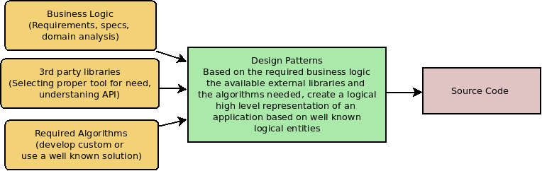

Basic Principles behind design patterns

To recognize a problem as a candidate for the application of a specific pattern we need to understand both the relationships and the interactions among the classes or objects that appear on it.

The most dominant principles of implementing a design pattern are:

Programming to an interface and not an implementation

Every time we create an object by its name (for example calling its constructor in Java or its initializer in python) we are committing to an implementation detail doing so has two important effects:

* Client code has access to all the details of the object providing the option for a deep bind to functionality that is not meant to be re-used.

* A strong coupling is introduced between the client and the implementer of the class.

The alternative way is to use a class name independent mechanism that will provide access to a generic interface which will dictate all of the user interaction hiding any lower lever details from the client code.

When possible prefer composition instead of inheritance

The available mechanisms to allow for functionality reuse in any Object-Oriented programming language are inheritance, composition and generics and in this text following the approach of the Go4 book we are focusing on the first two of them.

Realizing the pros and cons of inheritance and composition usually leads to successful design decisions and having the ability to make the related judgment calls is one of the most critical skills for an object oriented designer.

Since inheritance is supported directly from the language makes it simple and efficient to use and also makes changes to the base level of implementation immediately available to derived classes. On the other hand since inheritance imposes static coupling across the hierarchy tree it cannot be changed during run time making it difficult to maintain in many cases.

Composition is an alternative to inheritance and provides the advantage that instead of hard coding dependencies to code that exists in the parent’s level we can alter behavior in run time by injecting objects that comply to a specific interface but provide completely different implementation details. Assuming that all communication across different objects is based only on interfaces this approach does not break encapsulation making it a suitable for most of the code reuse cases found in an object oriented system.

Families of Design Patterns

Applying the fundamental principles of Design Patterns in real world problems we can create the following families for them based on the problem they try to solve:

Family Name | Description
Creational | Hiding the construction of objects providing interfaces to build them based on specific information that describe them
Structural | Compose the objects in a dynamically specifying their relationships and dependencies
Behavioral | Assign object responsibilities and specify communication across them

Combining patterns

As the designer gains more experience he realizes that the core challenge when it comes to patters is how to combine them putting to work together to provide a good solution. The objective is understand Design Patterns collectively and become capable of recognizing not only their applicability in specific parts of the problem to solve but how they can be orchestrated to a high quality abstraction that will be easy to understand and maintain as time goes by and the platform evolves.

Composition vs Inheritance

Implementing a pattern we need to understand well the options we are given in terms of composition versus inheritance. Both have their place in our code but the latter should be limited to orthogonal class relations usually based on interfaces.

Composition
Advantages | Disadvantages
Using composition instead of inheritance makes a class more encapsulated and single task oriented. | We might end up creating more objects by hand
Hierarchies remain shallow and easier to understand and manage. | The behavior of the system depends on (visible) interfaces as opposed to been hidden in a closed  inheritance tree.
Defined dynamically at run time
An object can be shared
Any composed object can be replaced dynamically from another assuming they are of
the same type
The are fewer implementation dependencies (imports).

Inheritance
Advantages | Disadvantages
Defined statically and is mechanics are handled by the programming language. | Inherited code cannot be changed in run time.
Makes code reuse very simple as all the implementation is inherited in lower levels of  the hierarchy. | It can break encapsulation as parent’s code might depend silently to derived levels.
 | Allocated memory from parent class might be unused from derived leading to memory waste,
 | A change to the parent level might need to be propagated to all of its descendants.

Delegation
We refer to delegation when a message send to an object is redirected to another object with exactly the same signature (some times we refer to this mechanism as a pass through function). In the case of inheritance instead of a composite object we have to use the object itself (for example in python we will use self or this in C++). It is easy to realize that delegation offers more flexibility as the type of the composite object is decided in run time where in the inherited hierarchy it is hard coded as part of the class hierarchy. The main disadvantage of this approach is that when not used carefully it might lead to complicated code (this is why though documentation and unit testing is usually required to simplify usage).

Example

Let’s assume that we have an EmployeeCreator class which exposes a create method while it derives from a base class called MySqlDbUser providing an execute_sql method as can be seen here:

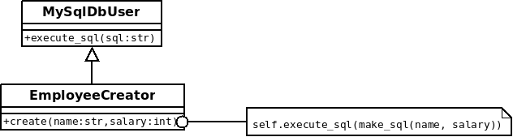

Note that the implementation of the create method is constructing the insertion sql statement and calls its parent class to save it to the data base.

If now need to migrate from MySql to Postrgess we have no easy way to do so but to change the base class of the creator, meaning we need to change the code itself. Think how awkward this can be, we might be using the same approach in many other classes in our system or we might not even have the source code if this happens to be an external dependency.

The alternative way using delegation is the following:

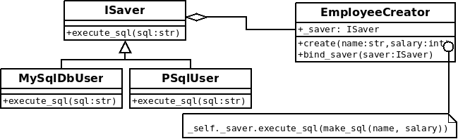

Note that now the EmployeeCreator object receives its ISaver derived object from the client meaning that we can change in real time the means of storage without having to change the code.

Aggregation vs Acquaintance

When thinking in terms of Design Patters one of the most fundamental decisions we are facing has to do with the “structural” relations among the participating classes.

One important distinction we can make when it comes on how classes related to each other is to separate them in two main categories known in the object oriented design community as aggregation and acquaintance. Related definitions vary according to books authors or framework providers but for the purpose of this text we will use the “Gang of four” vocabulary.

Aggregation

Aggregation relation happens when one class “owns” an instance of another meaning that the latter is part of the former. In this case the “aggregatee”’s lifespan is dictated by the “aggregator” which when it will go out of scope it will automatically destroy all of its “owned” objects.

For example let’s thing that we have the classes Car and Color.

Since there is no meaning of having the car’s color outlive the lifespan of Car, it makes sense to model their relation as aggregation and represent it schematically with the following diagram:

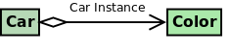

The diamond in the base of the relation arrow denotes an aggregation relation.

The related python code looks might look like this:

"""Aggregation sample."""
class Color:
pass

class Car:
def __init__(self):
self.color = Color()

Acquaintance

Acquaintance occurs when one object happens to “know” about another but their lifespans are independent. This kind of an object relation is also known simply as association or even a knows relationship.

Acquaintance represents a weaker relationship when compared to aggregation and results to loose coupling something that creates the opportunities for some interesting interactions that can be found in several design patterns as we will see shortly.

As an example lets think of a DbRecord class that is using a DbConnection to interact with the database. The DbConnection instance is handled independently and it is the job of the user of the DbRecord class to bind it to the DbRecord. The DbRecord going out of scope does not affect the DbConnection instance which continues to live and serve other clients.

The schematic representation of this relation is the following:
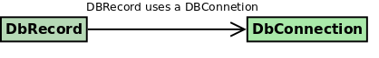

The related python code looks might look like this:

acquaintance example
class DbRecord:
def bind(self, connection):
self._connection = connection

def save(self):
self._connection.save(self)

class DbConnection:
def save(self, record):
pass

def create_record(conn):
record = DbRecord()
record.bind(conn)
record.save()

connection = DbConnection()
create_record(connection)
create_record(connection)
Note that the lifespan of the connection instance outlives the records that are created every time the create_record is called. Of course the language mechanics play a role here; this snippet takes advantage of python’s garbage collector and the reference count of the connection instance to keep it alive while in C++ to achieve the same effect we could have used a reference or a pointer.

We can see that what is more important to us as designers is not the explicit language mechanics but our intend which can be implemented differently depending on the language but always maintaining the same object relationships.

Deciding between aggregation and acquaintance is not always straight forward but making the proper judgment call is very important for solving a problem successfully and doing so requires experience and even talent since there does not exist a clear deterministic decision tree that will always give us a clear direction. We have to keep in mind that the need for aggregation is less than acquaintance which provides for more dynamic and scalable solutions and is widely adopted from commercial and open source frameworks (like spring for example).

Since relations among participants in an object oriented design are so critical for the success of a platform they are grouped under one of the three fundamental families of design patterns under the name “Structural Patterns” consisting of Adapter, Bridge, Composite, Decorator, Facade, Flyweight and Proxy.

The following table compares these two types of association:

Association Type | Instance Relationship | Lifespan
Aggregation | Owns an instance | Same lifespan
Acquaintance | Knows about an instance | Lifespans differ

