Laura Makokha
CSD-325 Module 6
4/13/2025
Group Assignment.
Forest fires simulation with added lake.

What the code does:
This code shows an added water feature.
Code Changes:
We added a lake to the center of the display. Making sure that the water has a different color(Blue) to be exact. This water feature is to act as a firebreak, making it hard for the flames to cross through. A -v2 copy was created to keep the lake from flactuating in size everytime the code was ran.
Code:
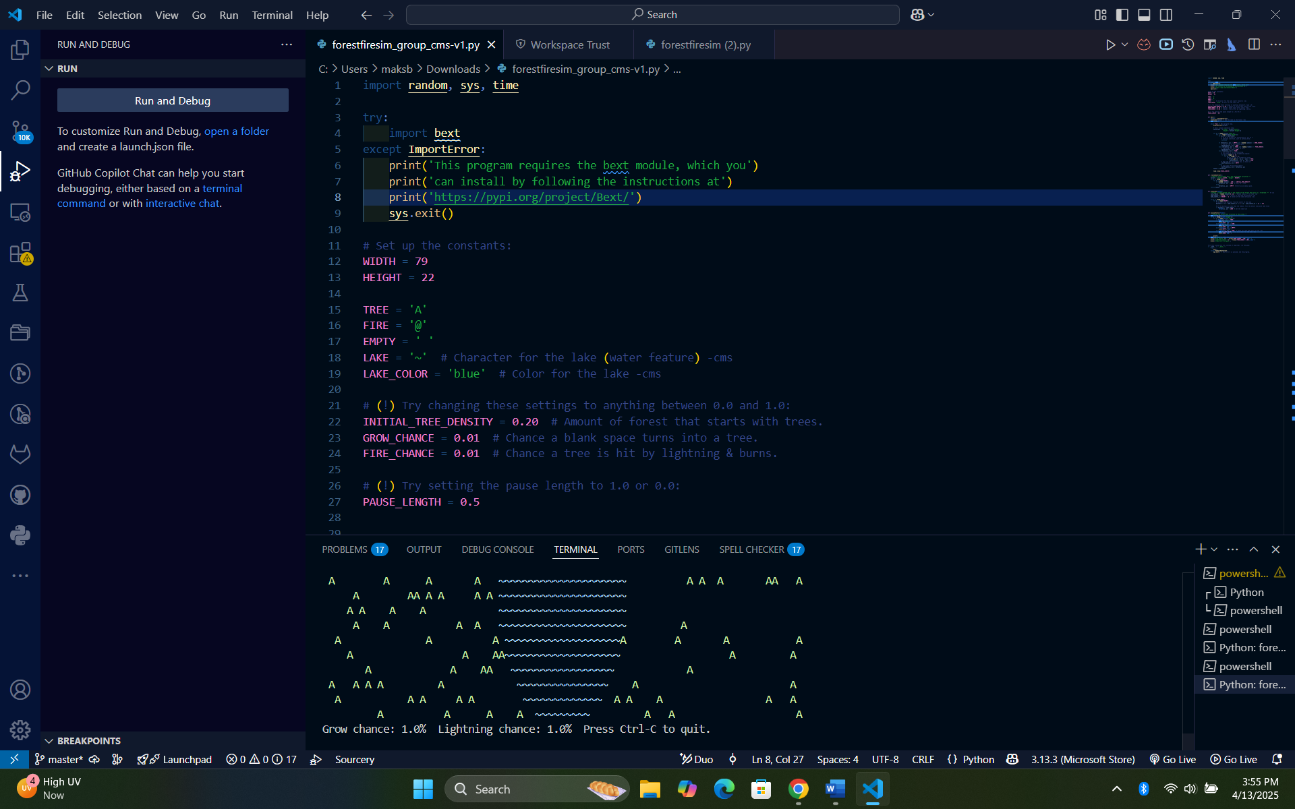

Flow-chart:
