🚘 Volkswagen After-Sales Intelligence Ecosystem (Proposed Architecture)
AI-Powered, Predictive, and Fully Integrated Service Platform

🧠 1. Top-Level System Architecture Overview
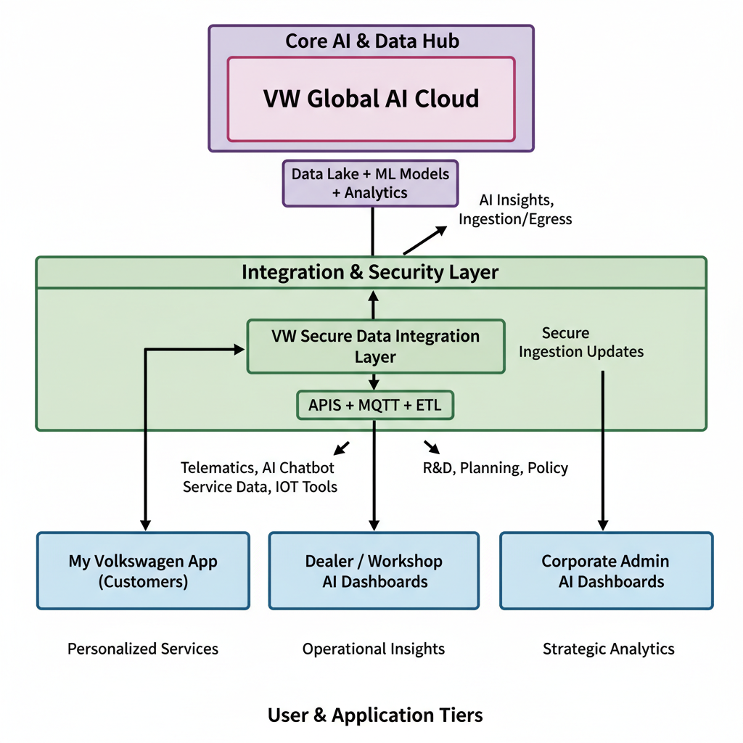

⚙️ 2. Core System Layers
Layer | Description | Technologies / AI Modules
Data Collection | From vehicles, service centers, customer apps, sensors | Telematics, IoT Gateways, OBD-II, ERP APIs
Data Lake & AI Core | Unified data platform | BigQuery / Azure Data Lake, ML models, NLP
Workflow Orchestration | Manages end-to-end service, warranty, escalation | AI Decision Engine + Workflow Automation
User Dashboards Layer | Role-based dashboards for all stakeholders | Web UI + Role-based Access + BI integration
Security Layer | Data access control, compliance, encryption | IAM, OAuth2, GDPR modules

🧩 3. Key Roles & Dashboards
Here’s a professional mapping of 10+ dashboards representing all stakeholders across the after-sales chain.

1️⃣ Customer Dashboard (My Volkswagen App)
Role: Vehicle Owner
Purpose: Transparency, predictive alerts, service scheduling, trust.
Features:
- Predictive maintenance alerts
- Service history & cost breakdown
- AI chatbot for instant support
- Warranty checker & claim tracker
- Tyre & battery health tracker
- RC/licence renewal reminders
- Feedback & satisfaction scoring

2️⃣ Service Advisor Dashboard
Role: Frontline service representative at dealership
Purpose: Manage customer intake, job cards, and service follow-ups.
Features:
- Customer vehicle health summary (AI-predicted issues)
- Job card creation + auto part availability check
- AI-based service cost estimator
- Communication log with customer
- SLA tracking and feedback integration

3️⃣ Workshop / Mechanic Dashboard
Role: Technician / Mechanic
Purpose: Technical workflow for diagnosis, repair, and AI assistance.
Features:
- Real-time fault code reader (OBD integrated)
- Step-by-step repair guidance (AR overlay possible)
- AI diagnostic suggestions (based on global patterns)
- Parts request automation
- Job completion logging & time tracking

4️⃣ Spare Parts Manager Dashboard
Role: Parts & Inventory Controller
Purpose: Predict, procure, and manage spare parts efficiently.
Features:
- AI-driven demand forecast per model/region
- Real-time stock visibility (warehouse + dealer)
- Critical shortage alerts
- Supplier lead time tracker
- Automated re-order system

5️⃣ Sensor & IoT Data Manager Dashboard
Role: Data Engineer / Telemetry Supervisor
Purpose: Monitor incoming vehicle sensor data & detect anomalies.
Features:
- Live feed of sensor data (engine, transmission, etc.)
- Anomaly detection heatmaps
- Fault clustering by VIN/model/location
- Predictive failure models for DSG, ABS, etc.
- Integration with R&D defect reports

6️⃣ Tyre & Accessory Services Dashboard
Role: Tyre Service / Accessory Lead
Purpose: Track tyre health and related services.
Features:
- Predictive tyre wear algorithm (based on usage & terrain)
- Tyre replacement scheduler
- Tyre brand performance analytics
- Inventory of accessories and consumables

7️⃣ License / RC / Compliance Manager Dashboard
Role: Legal & Document Administration
Purpose: Manage government-related ownership records and renewals.
Features:
- Vehicle RC, licence, and insurance integration APIs
- Automatic renewal reminders
- AI document validator (OCR + compliance check)
- Regional compliance status dashboard

8️⃣ Customer Care & Sentiment Manager Dashboard
Role: Customer Relations Executive
Purpose: Handle escalations and monitor customer mood trends.
Features:
- Live sentiment map (by dealer, region, product)
- AI-driven response prioritization
- Chatbot conversation analytics
- Escalation history & resolution tracking
- Satisfaction Index (Trust Score AI)

9️⃣ Service Manager / Workshop Head Dashboard
Role: Regional or dealership head of service operations
Purpose: Oversee service performance, SLA compliance, and profitability.
Features:
- KPI dashboard (turnaround time, repeat visits, satisfaction)
- AI recommendations for staffing & parts optimization
- Warranty claim summary
- Escalation analytics and root cause trends
- Real-time workshop load monitoring

🔟 Product Designer / R&D Research Dashboard
Role: Design & Engineering Analyst
Purpose: Analyze field data to improve design reliability.
Features:
- Failure heatmaps by component and climate zone
- AI clustering of defects across models
- Correlation of driving patterns → part failure
- Predictive simulation for design changes
- Feedback loop to product development teams

11️⃣ Spare Supply Chain & Logistics Dashboard
Role: Logistics Manager
Purpose: Manage shipment and stock levels across network.
Features:
- ETA tracking for in-transit parts
- Supply chain digital twin
- Delay risk predictions
- Carbon footprint tracking for shipments

12️⃣ Corporate Strategy & Data Intelligence Dashboard
Role: HQ Leadership / CXO
Purpose: Macro view of global after-sales performance and costs.
Features:
- Real-time NPS & Trust Score
- Warranty spend and cost-of-service index
- Regional reliability benchmarks
- Predictive defect alert system (for recalls)
- Business Intelligence Insights (Power BI / Tableau layer)

🧠 4. AI Modules Supporting All Dashboards
Module | Function | Supported Roles
Predictive Maintenance AI | Forecast component failures | Customer, Mechanic, Service Advisor
Sentiment Analysis AI | Detect customer frustration & trust level | Customer Care, HQ
Cost Transparency AI | Explain & validate repair costs | Customer, Service Advisor
Parts Demand AI | Forecast spare needs | Parts & Supply Chain Manager
Warranty Claim Validator | Auto-check legitimacy | Service Manager, HQ
Anomaly Detection Engine | Find recurring defects | R&D, Sensor Manager
Smart Escalation Router | Auto-route critical complaints | Customer Care, Manager
Digital Twin System | Simulate vehicle & component performance | R&D, Product Designer
Voice of Customer AI | Aggregate feedback insights | HQ, Strategy

🧾 5. Data Flow Diagram (Simplified)
Vehicle Sensors → IoT Gateway → VW AI Cloud (Telemetry Data Lake)
↓ ↑
Mechanic / Service Dashboard ←→ My Volkswagen App
↓ ↑
Parts & Supply Chain AI ←→ Service Workflow AI ←→ Customer Care AI
↓ ↑
R&D & Product Design AI ←→ Corporate Dashboard
Each system writes to the central AI Data Lake, where predictive models, NLP sentiment engines, and workflow AI learn continuously.

🧩 6. Admin System Overview
Admin Role | Responsibilities
Super Admin (HQ) | Full control: monitor all dashboards, set KPIs, manage permissions
Regional Admin | Approves escalations, reviews SLA breaches, regional reports
Dealer Admin | Manages workshop staff, assigns job cards, validates invoices
Data Admin | Maintains AI models, ensures GDPR compliance, audits logs
IT Security Admin | Role-based access, encryption, API controls

📊 7. Technology Stack (Indicative)
Layer | Tools / Technologies
Frontend | React / Angular + Tailwind + VW Design System
Backend | Node.js / Python FastAPI / .NET Core
AI/ML | TensorFlow, PyTorch, OpenAI, Hugging Face
Data | BigQuery / Snowflake / Azure Synapse
Integration | REST / GraphQL APIs, MQTT, Kafka
Analytics | Power BI / Tableau / Grafana
Security | Azure AD / OAuth2 / SSO / RBAC

🎯 8. Benefits of This Architecture
Impact Area | Outcome
Customer Trust | +30% satisfaction via transparency
Downtime | -40% breakdowns (predictive AI)
Spare Part Availability | -50% delays
Cost Efficiency | -35% warranty cost
Service Consistency | +25% SLA compliance
Design Reliability | +20% fewer field failures

