1.1

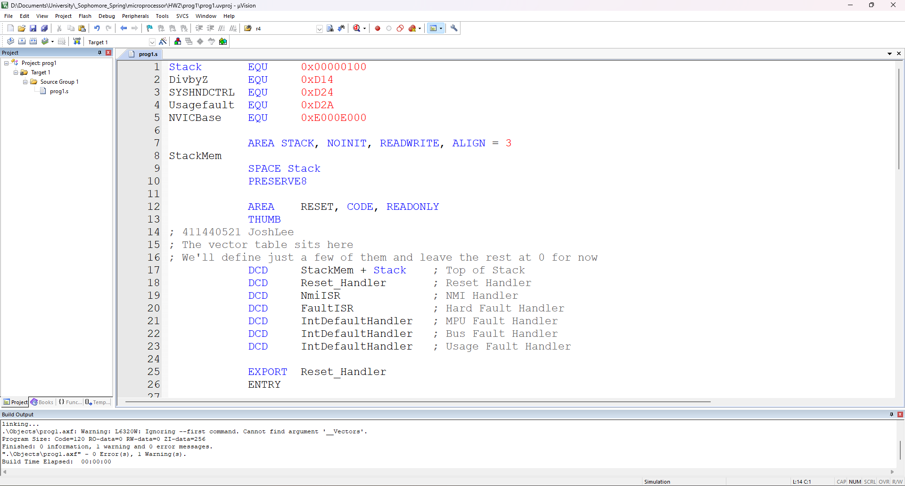

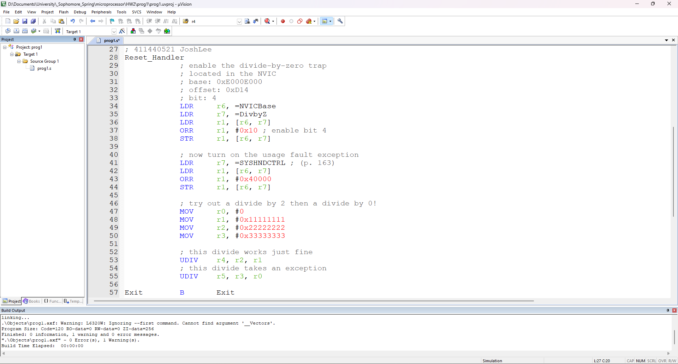

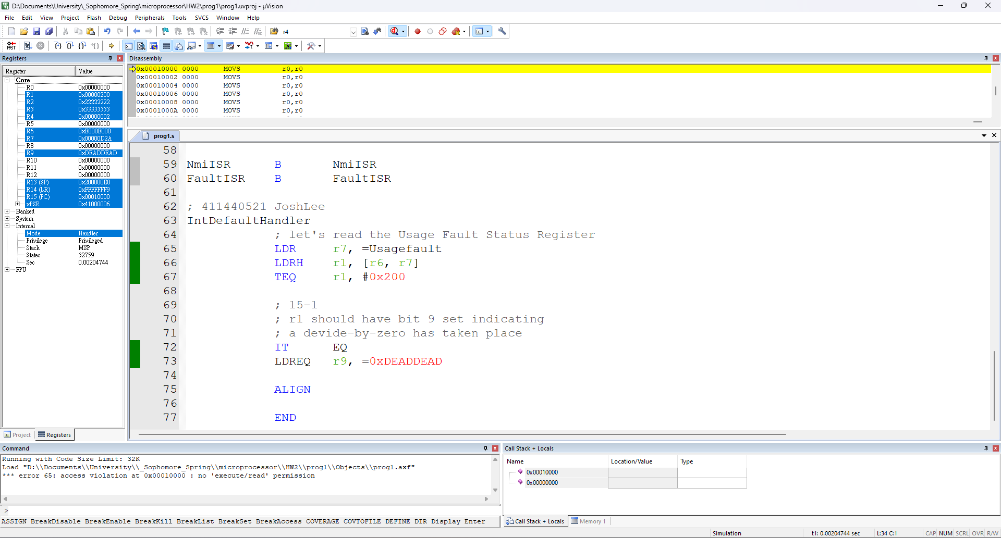

1.2

Thread Privileged

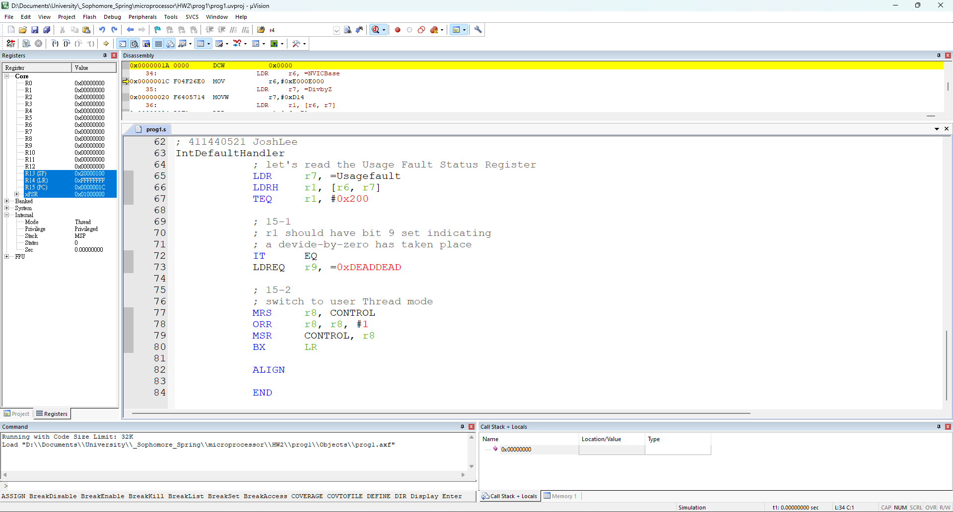

Handler Privileged

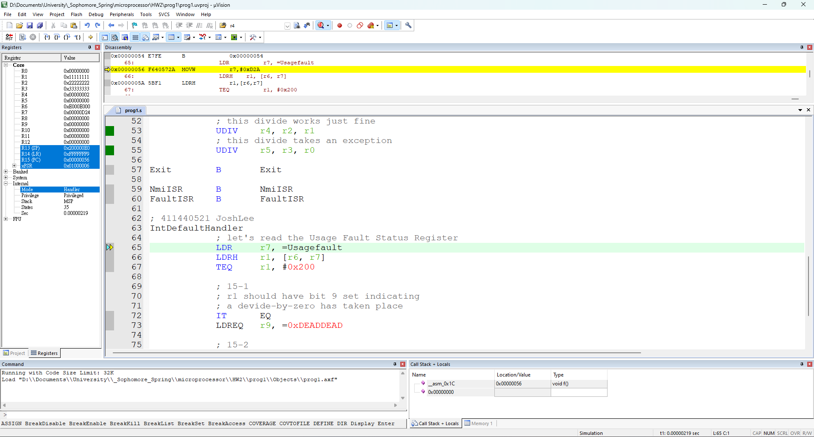

Thread Unprivileged

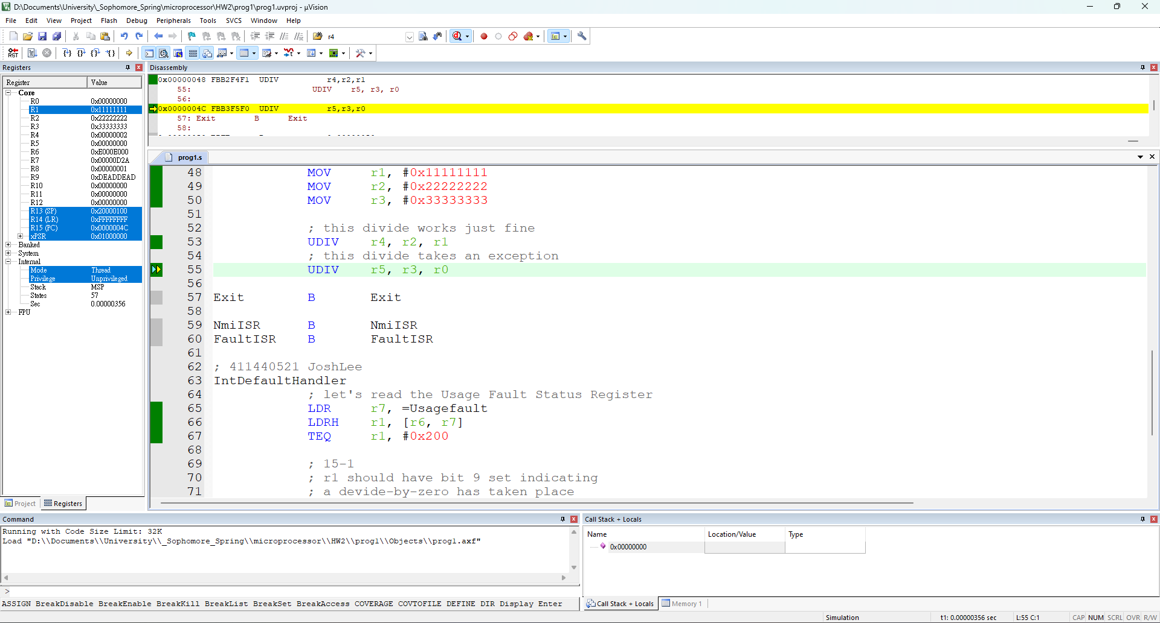

1.3

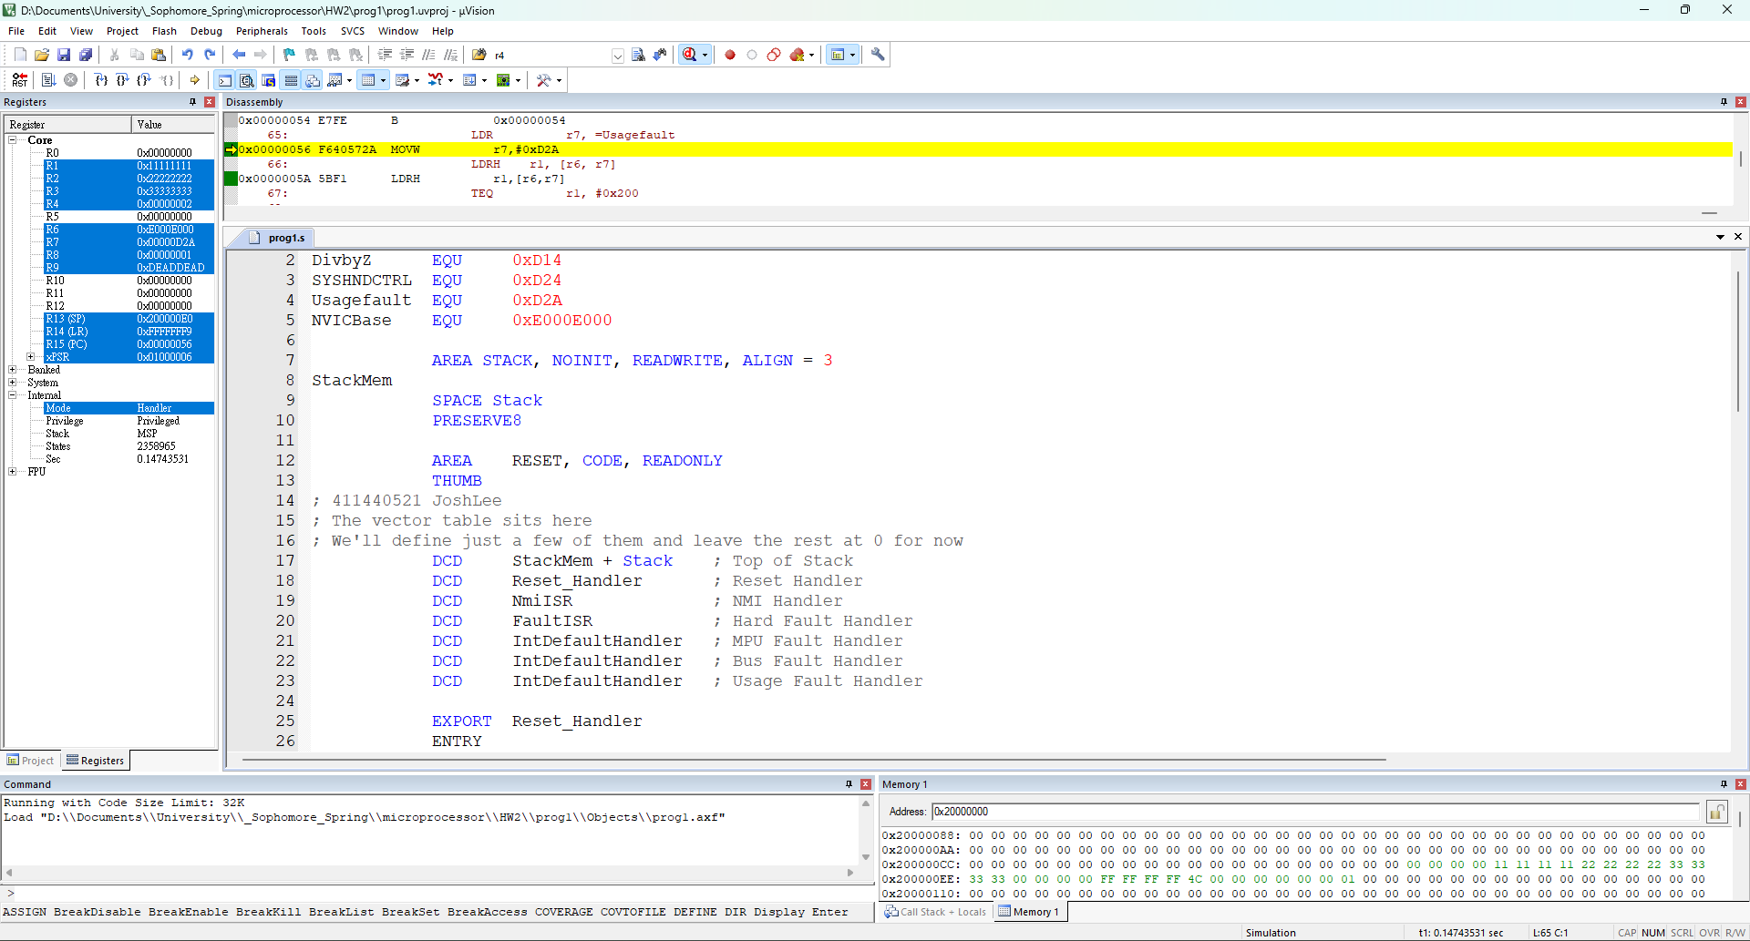

2.1

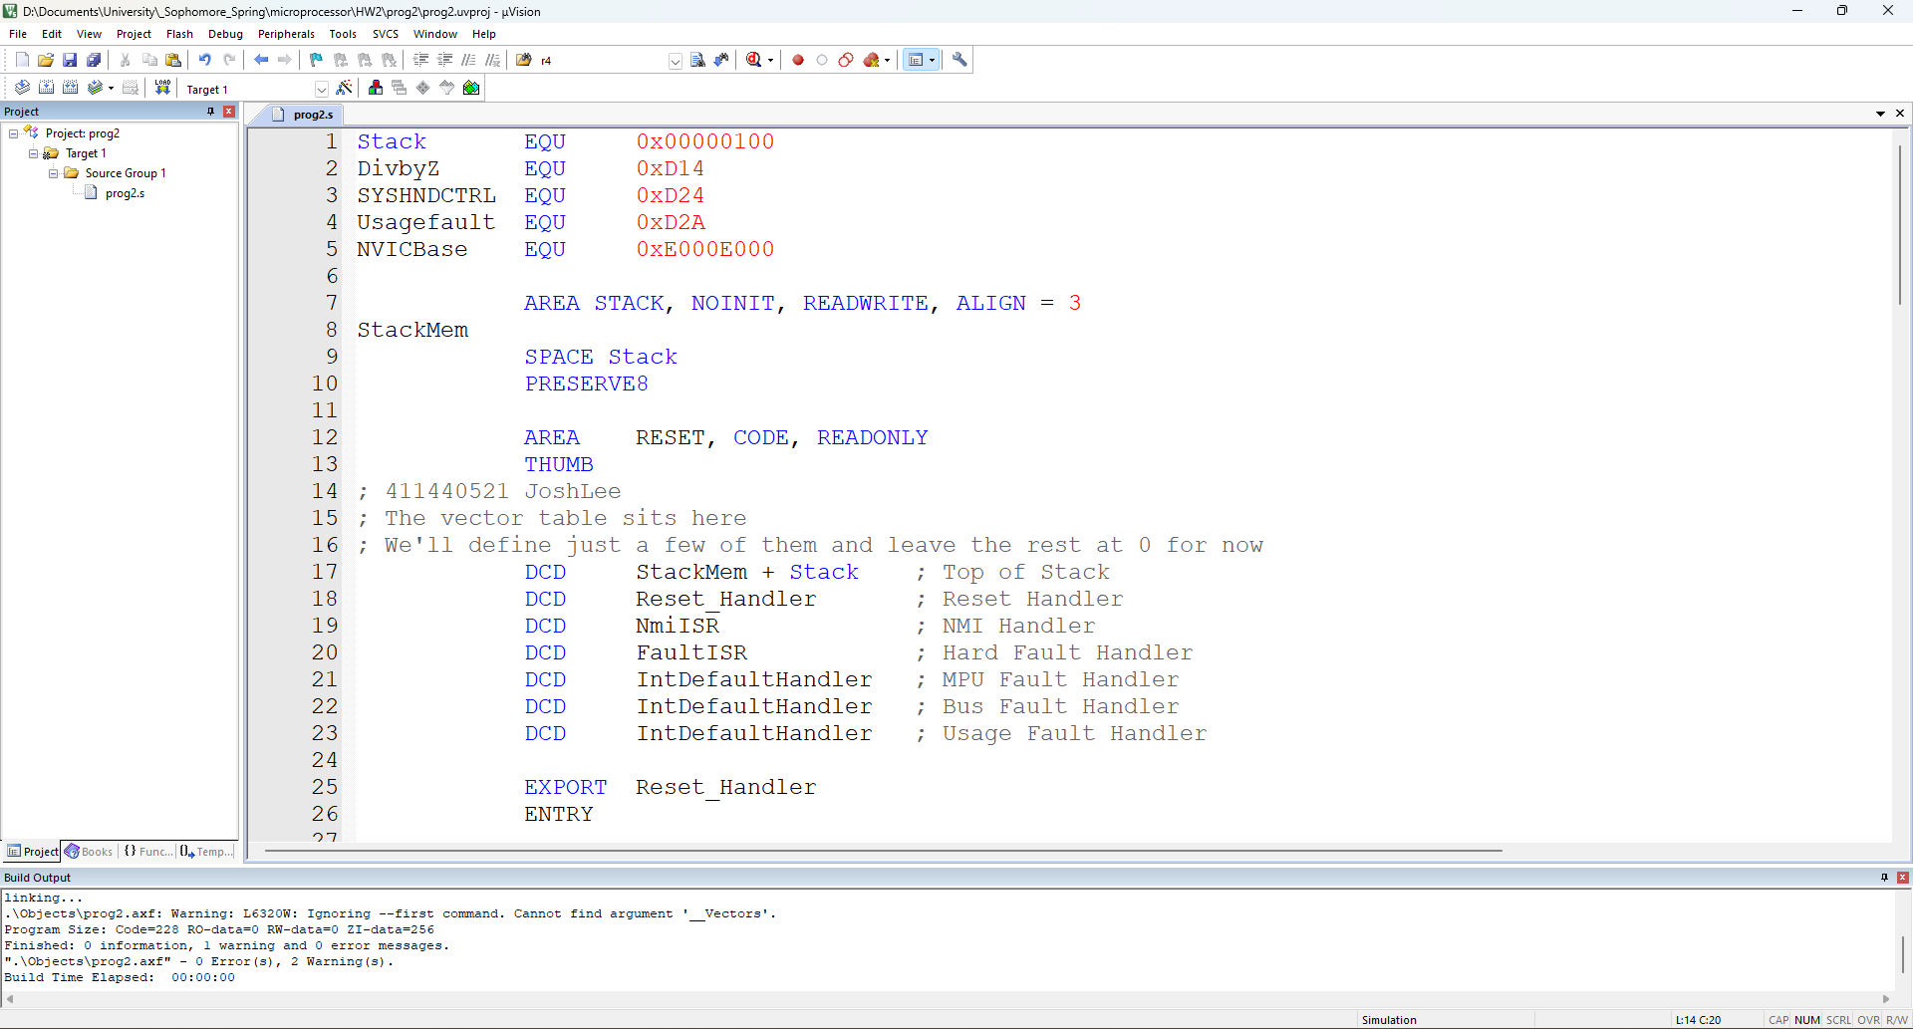

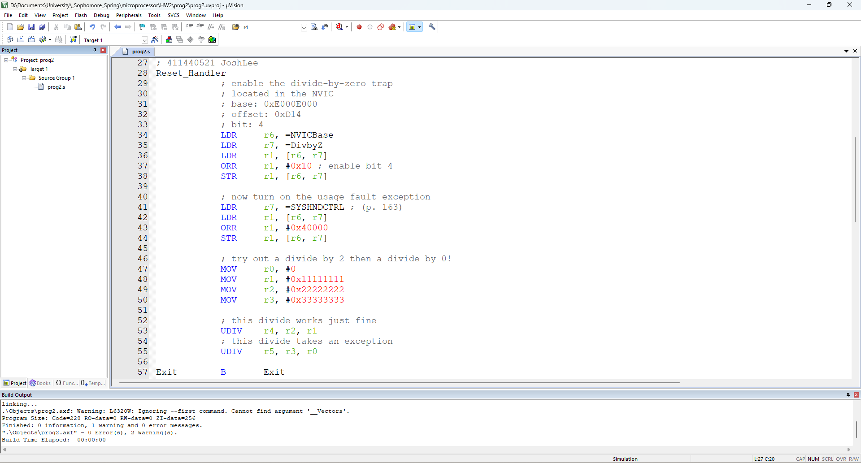

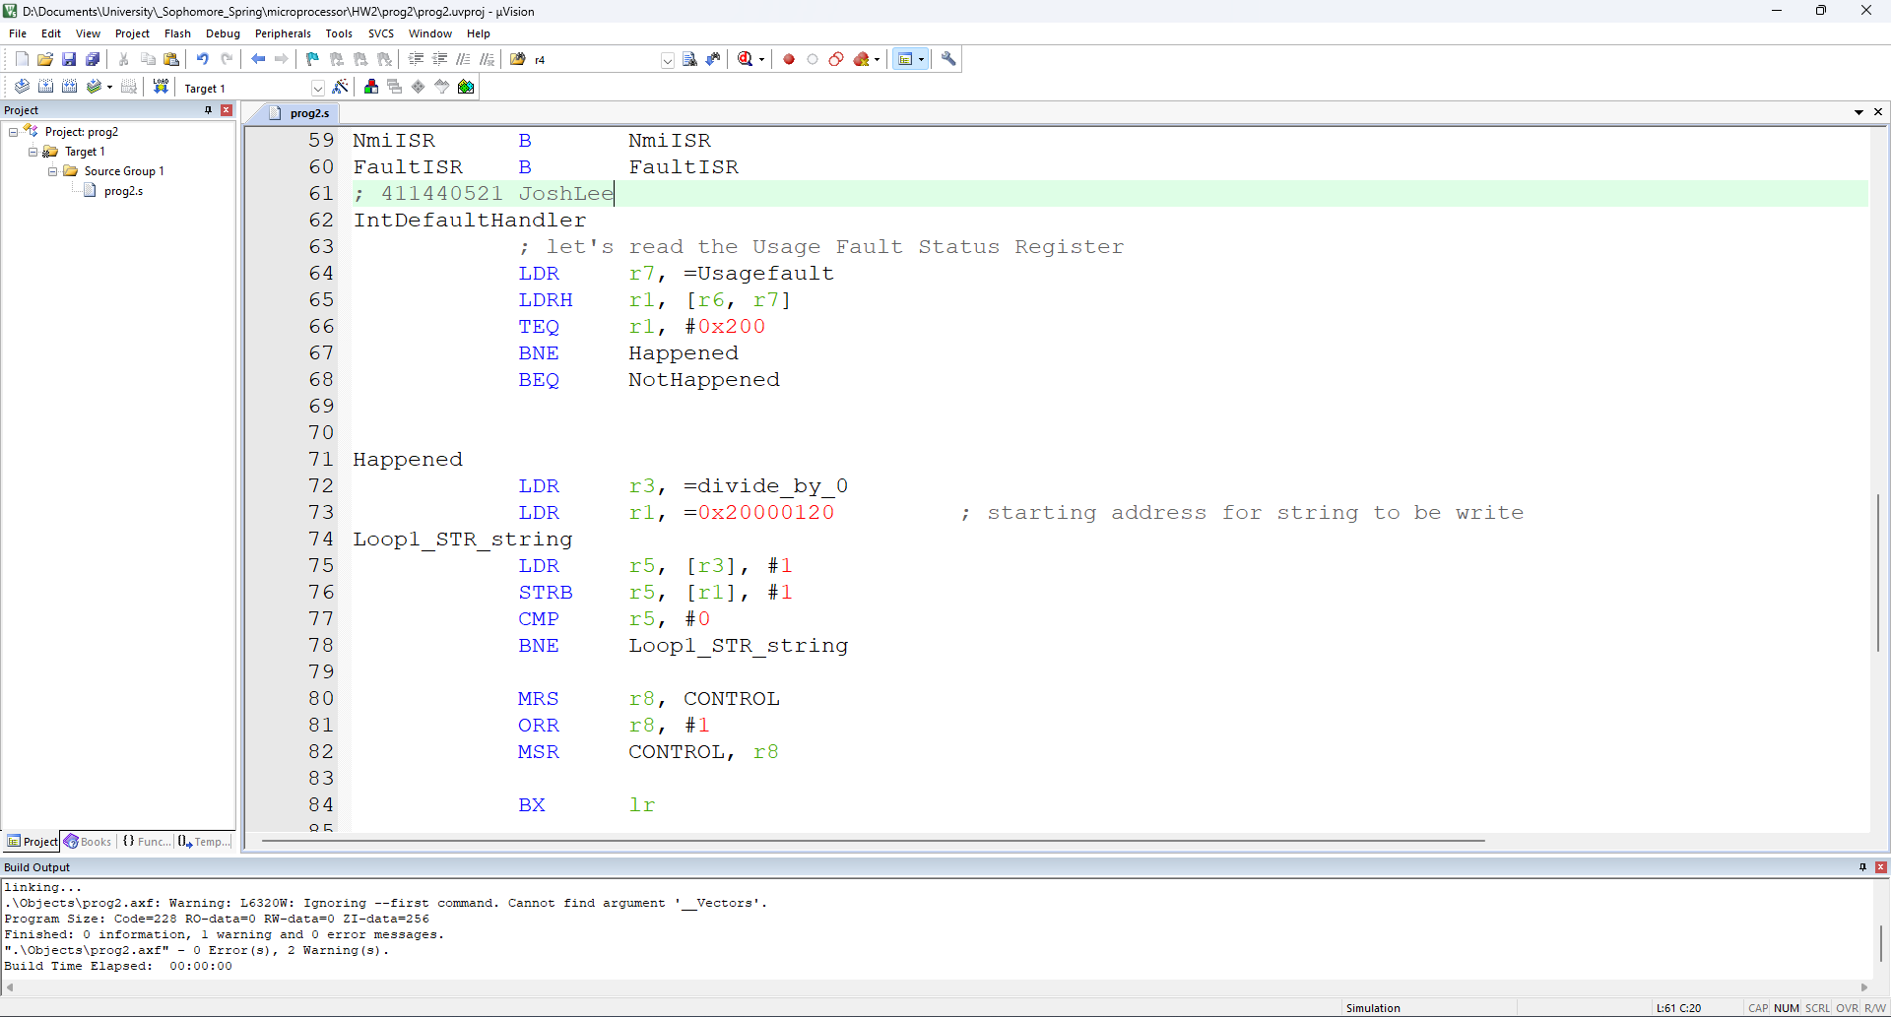

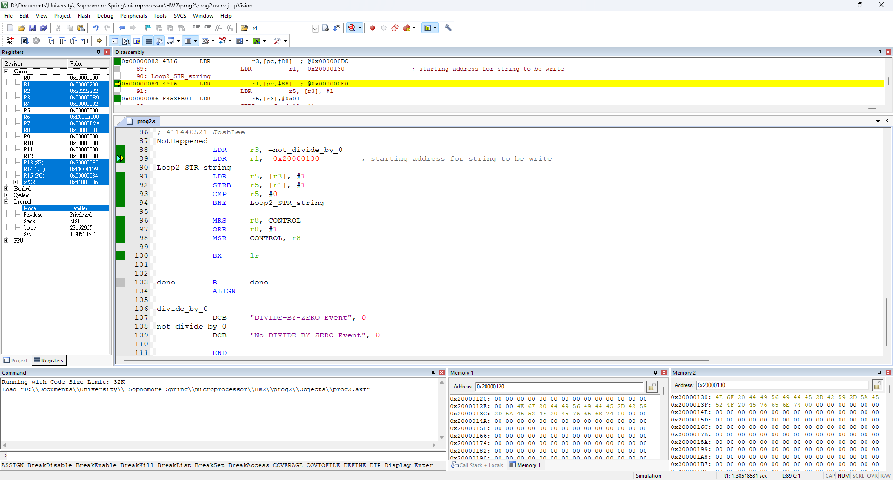

2.2

(a) from privileged thread mode to unprivileged thread mode

|  |  |
| --- | --- |
|  |  |

(b) from privileged thread mode to privileged handler mode

|  |  |
| --- | --- |
|  |  |

(c) from privileged handler mode to privileged thread mode

|  |  |
| --- | --- |
|  |  |

(d) from privileged handler mode to unprivileged thread mode

|  |  |
| --- | --- |
|  |  |

2.3

Step

1. privileged thread mode to unprivileged thread mode
2. don’t setup the usage fault exception
3. make a hard fault under unprivileged thread mode

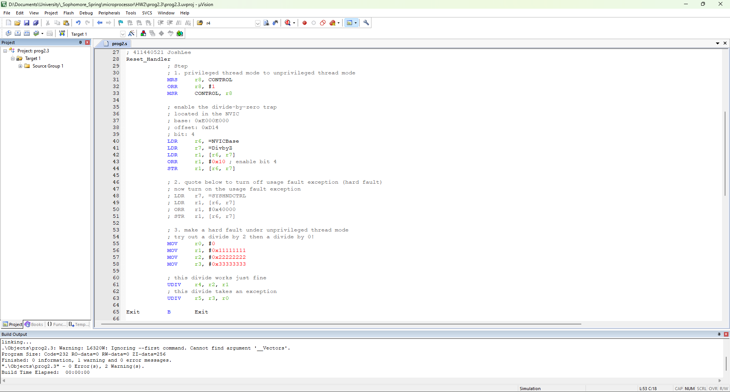

unprivileged thread mode

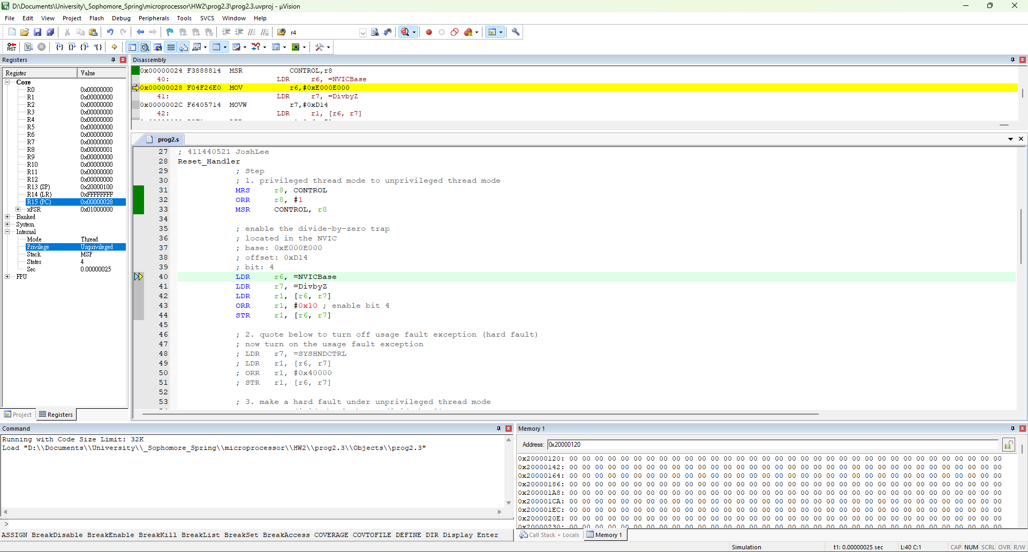

Hard fault triggered

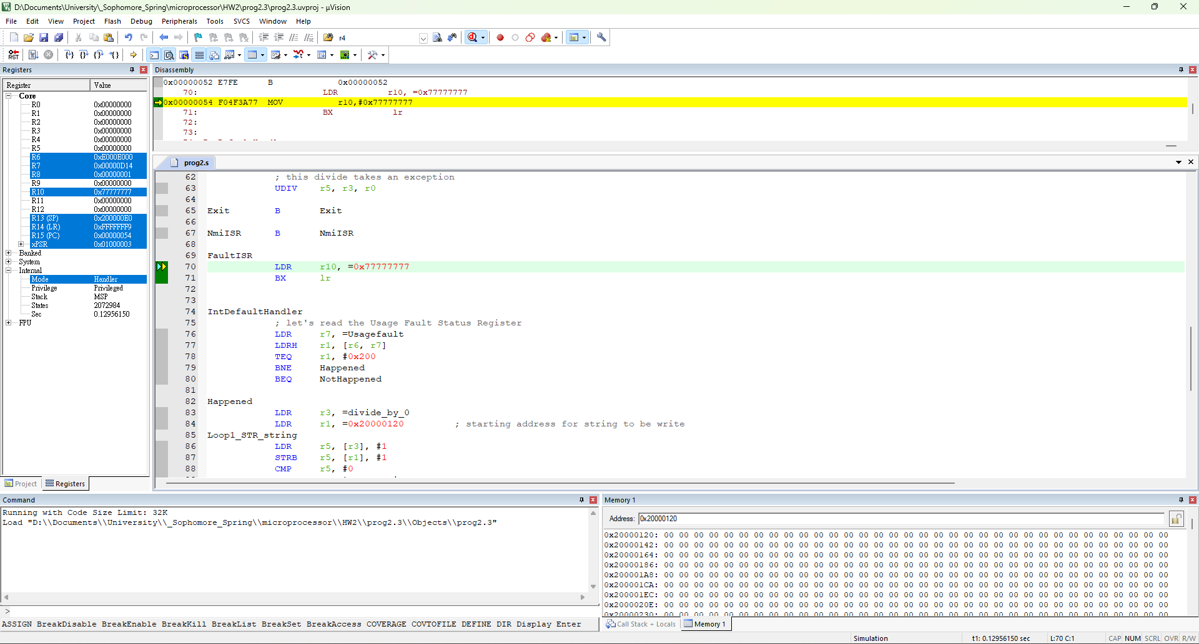

3.1

1. 設定priority group number (用empty ascending stack暫存恢復)(假設AIRCR暫存器位址為 0x400000C8)(呼叫前欲設定的priority group number需先存入自選的暫存器中）

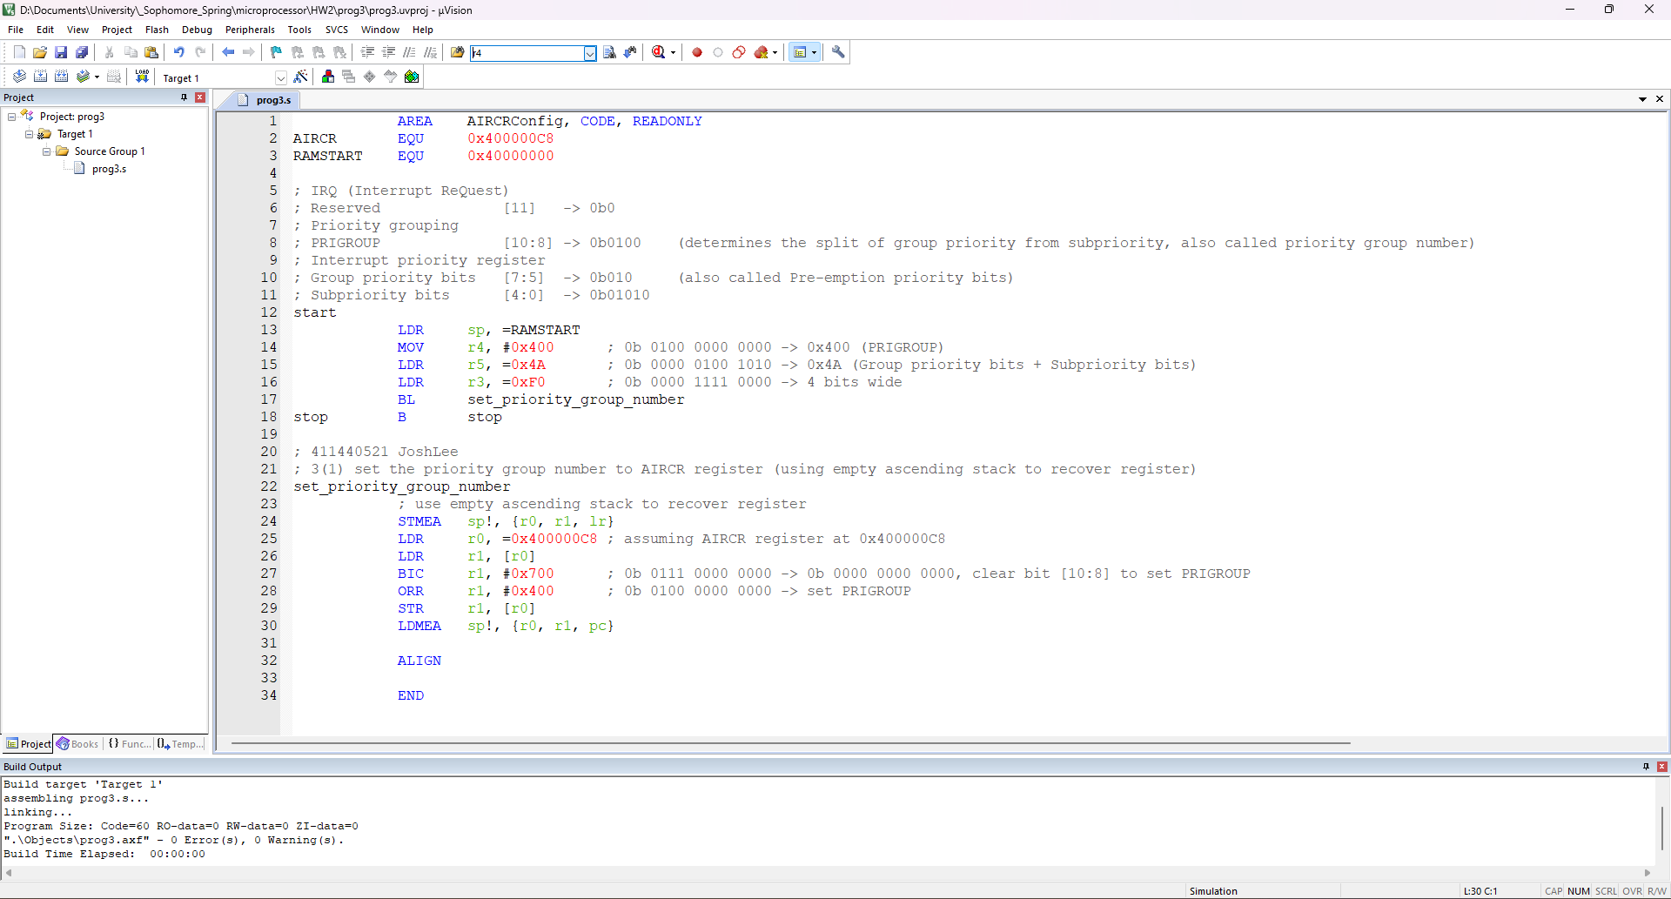

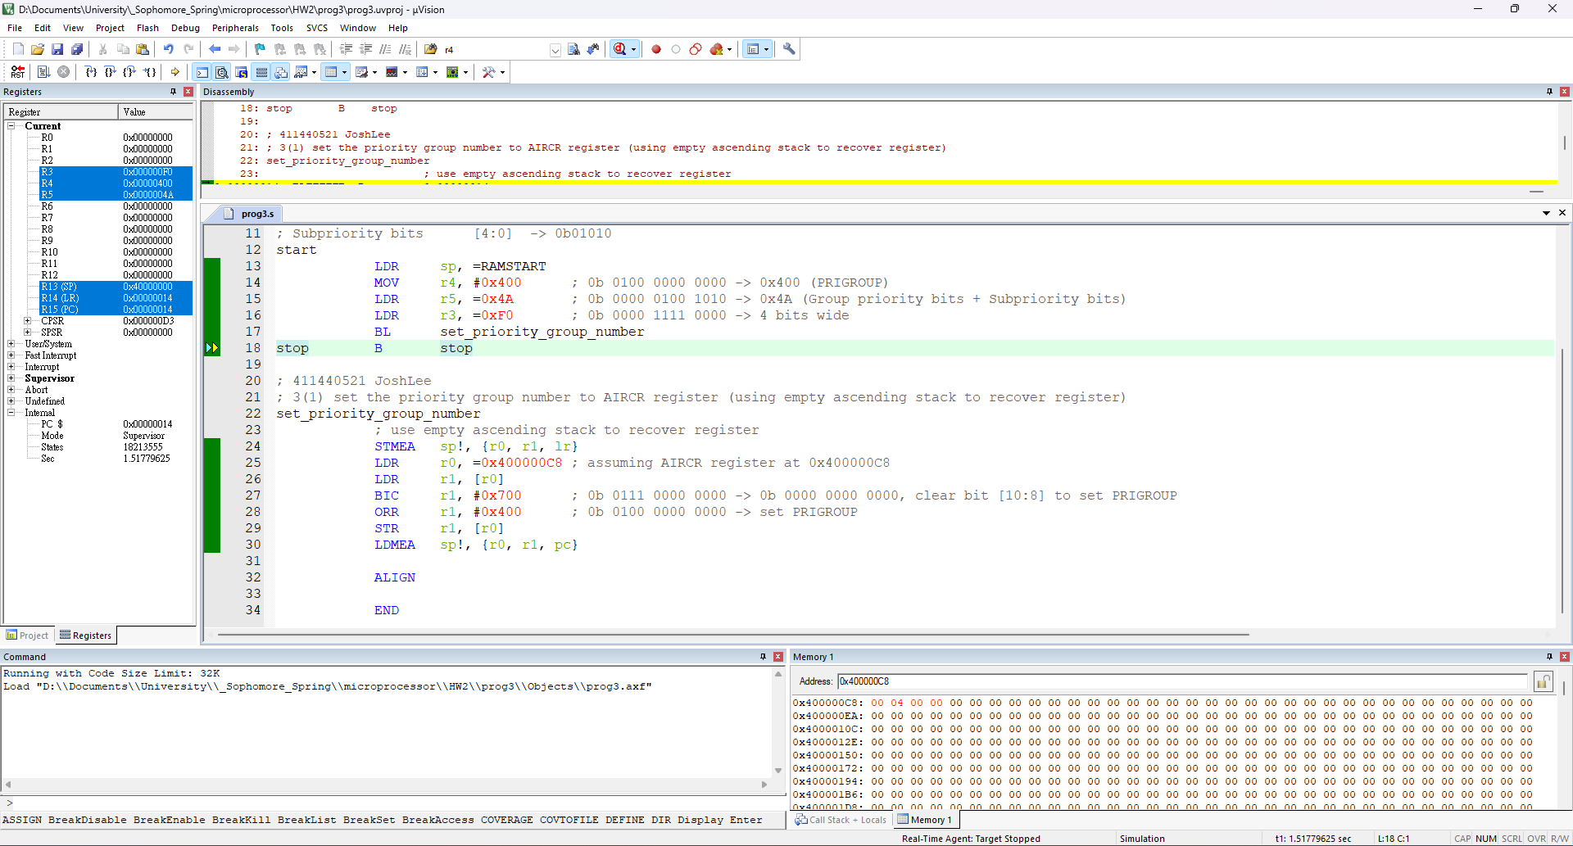

1. 讀取priority group number (用full ascending stack暫存恢復)(假設AIRCR暫存器位址為 0x400000C8)

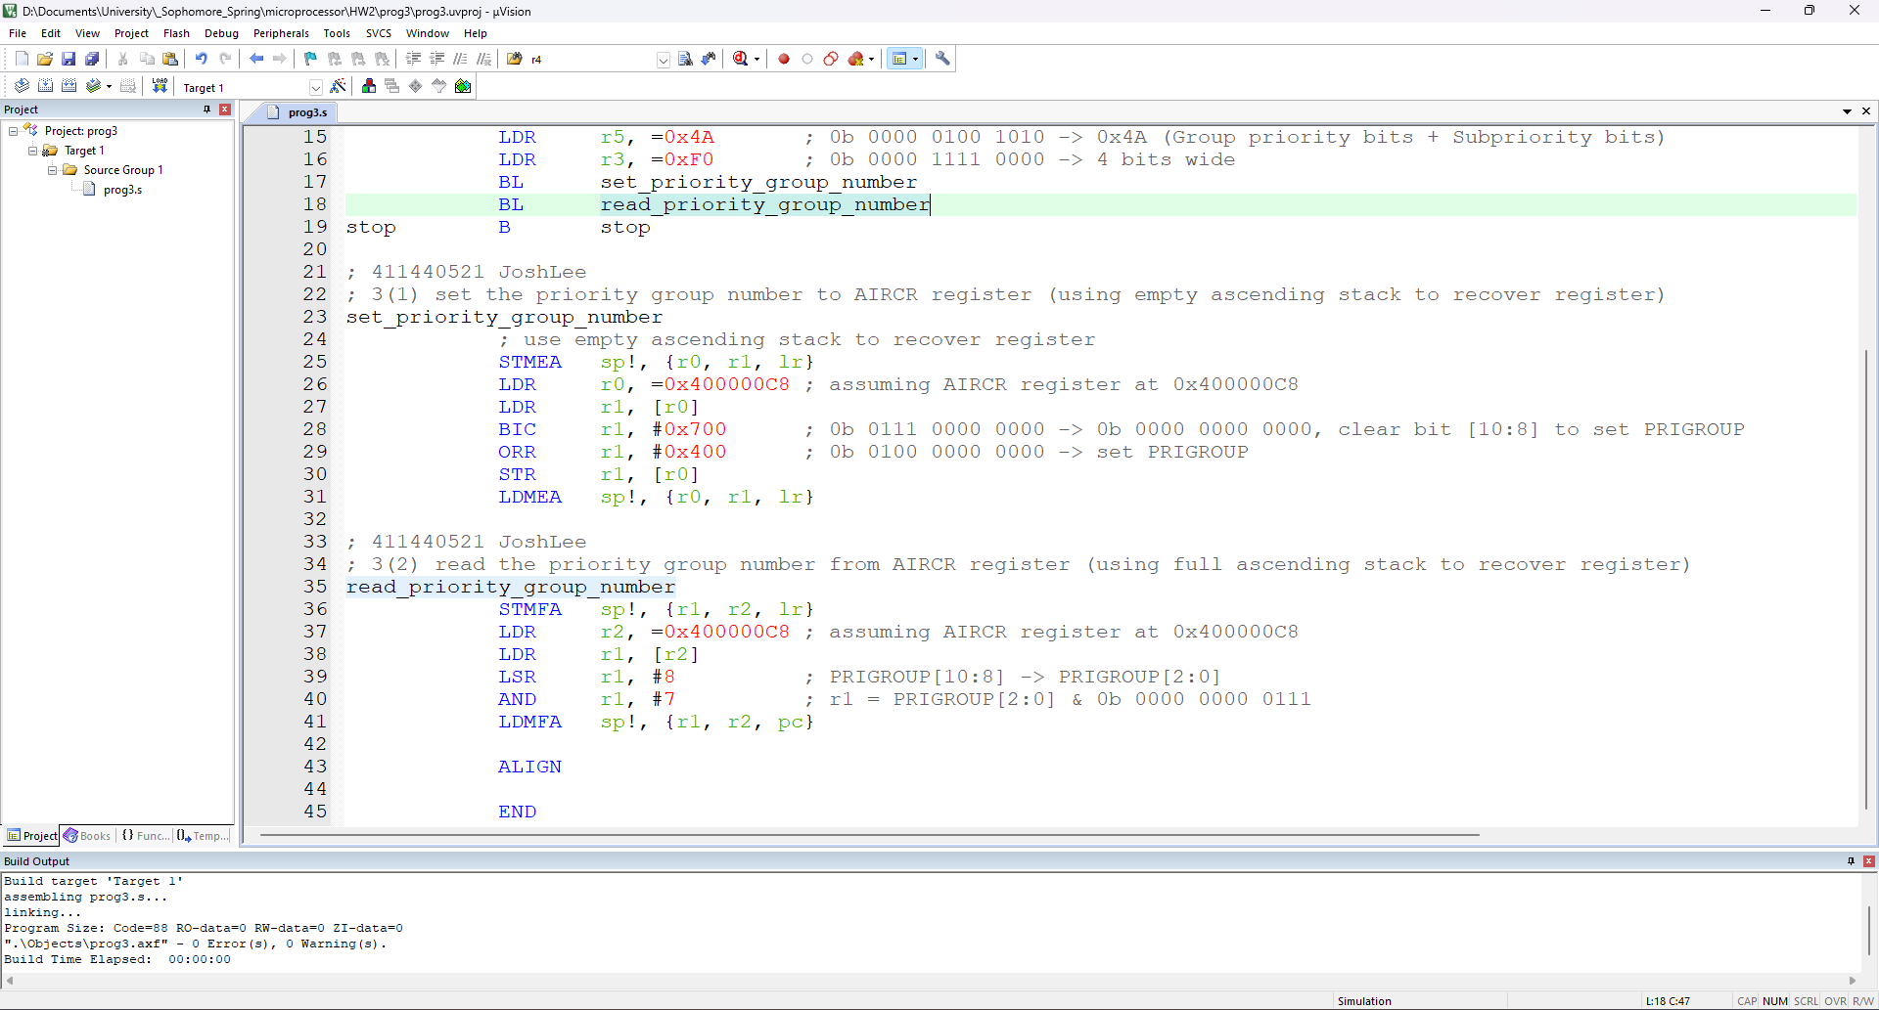

priority group number = 4

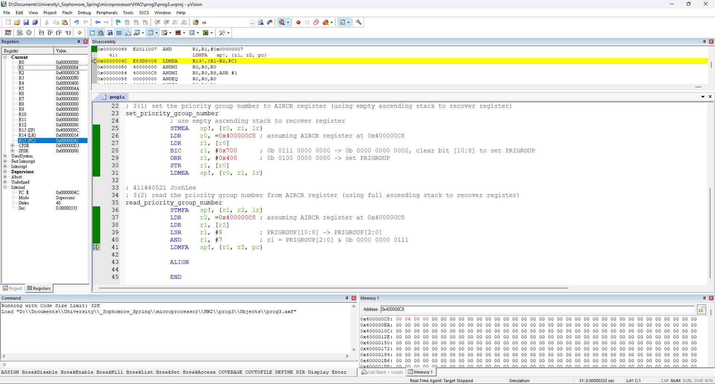

1. 計算某一IRQ的pre-emption priority及sub priority (用empty descending stack暫存恢復)(呼叫前假設的width of the interrupt priority register 、priority group number、與該IRQ的interrupt priority register內容值需先存入自選的暫存器中）

R5 = sub priority

R6 = group priority

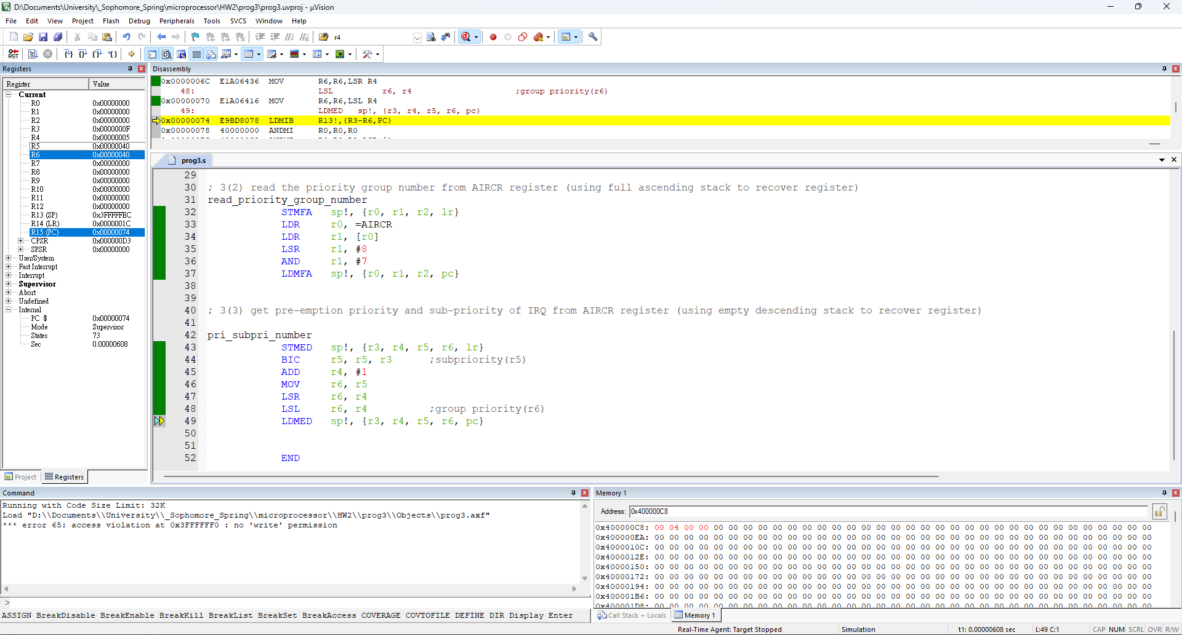

4

1. Using LSR with test pattern LSR

R6 = width = 6

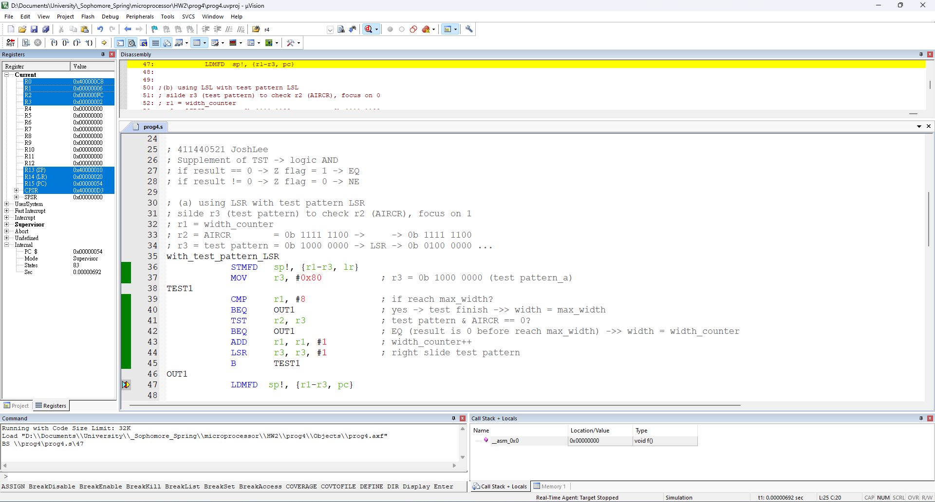

1. Using LSL with test pattern LSL

R4 = width = 6

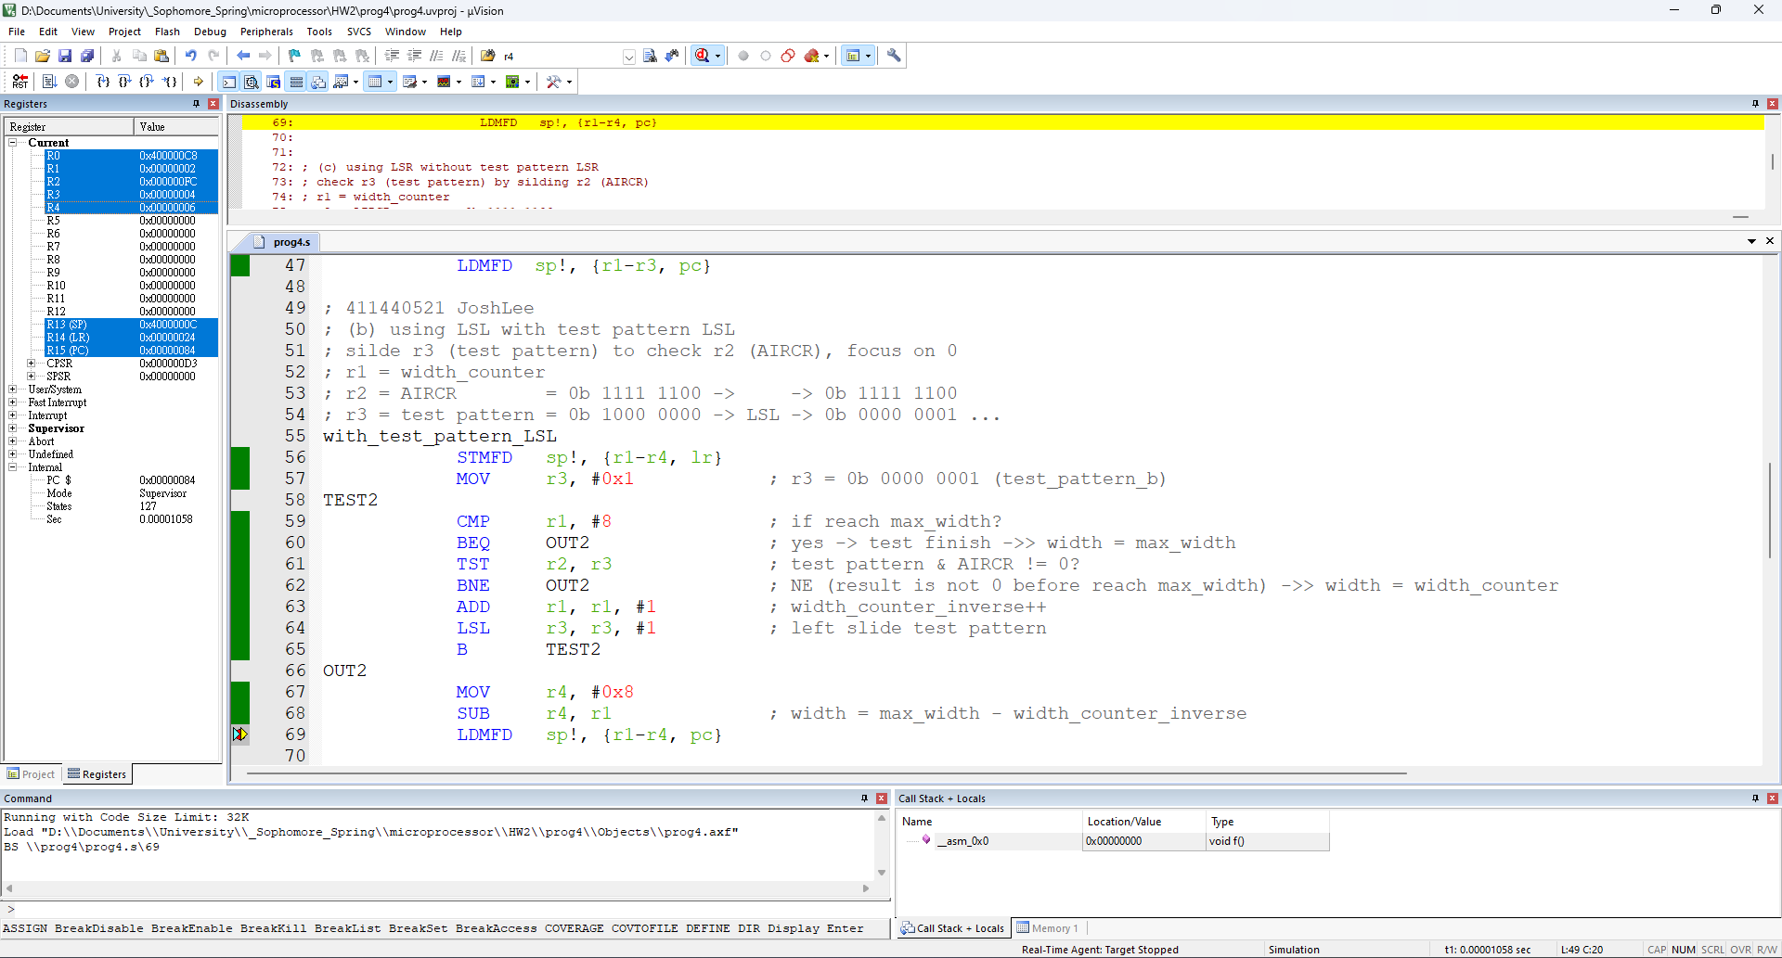

1. Using LSR without test pattern LSR

R4 = width = 6

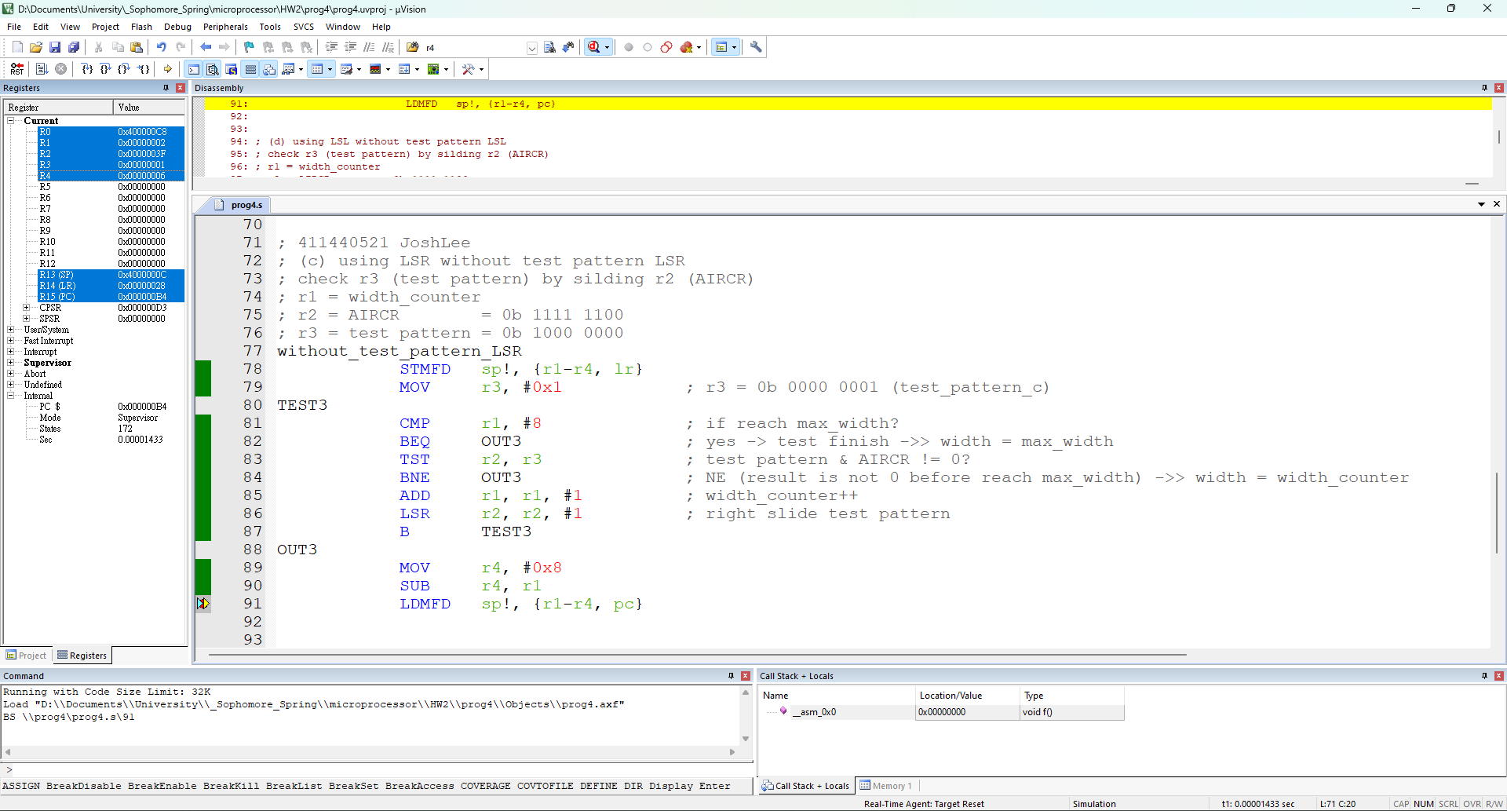

1. using LSL without test pattern LSL

r1 = width = 6

