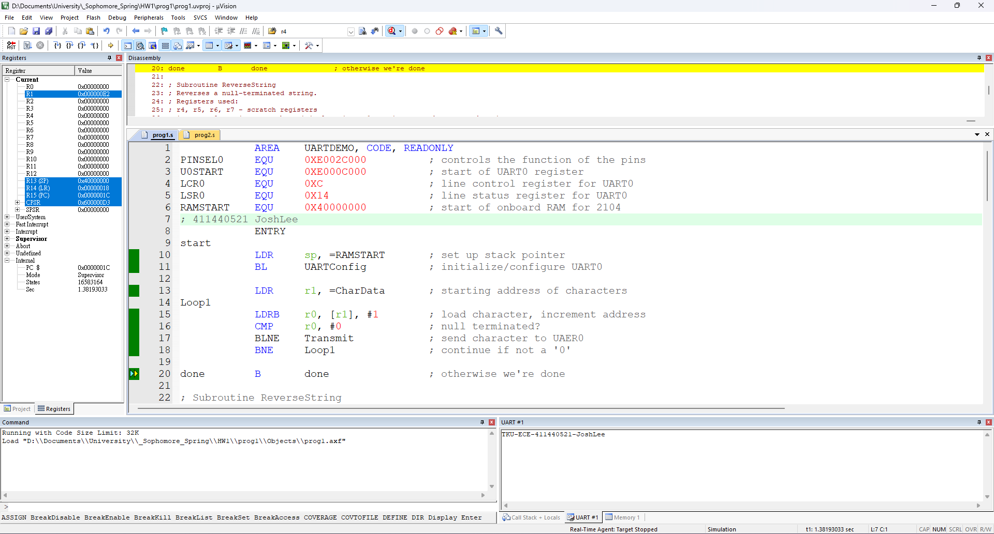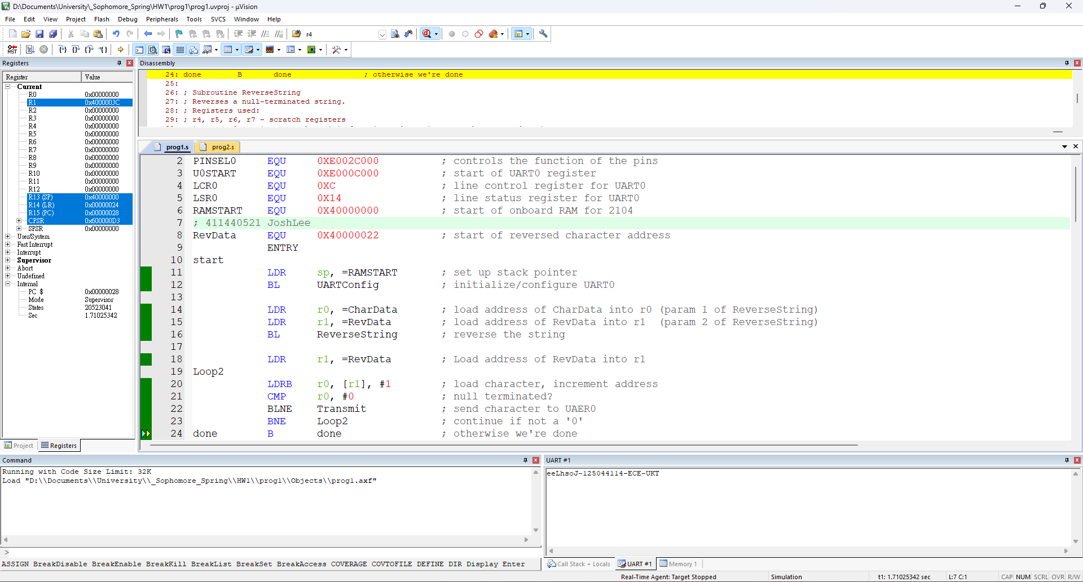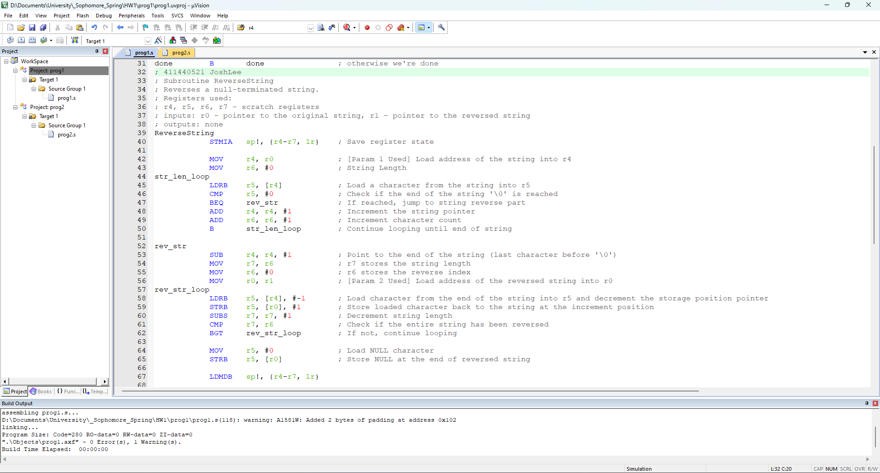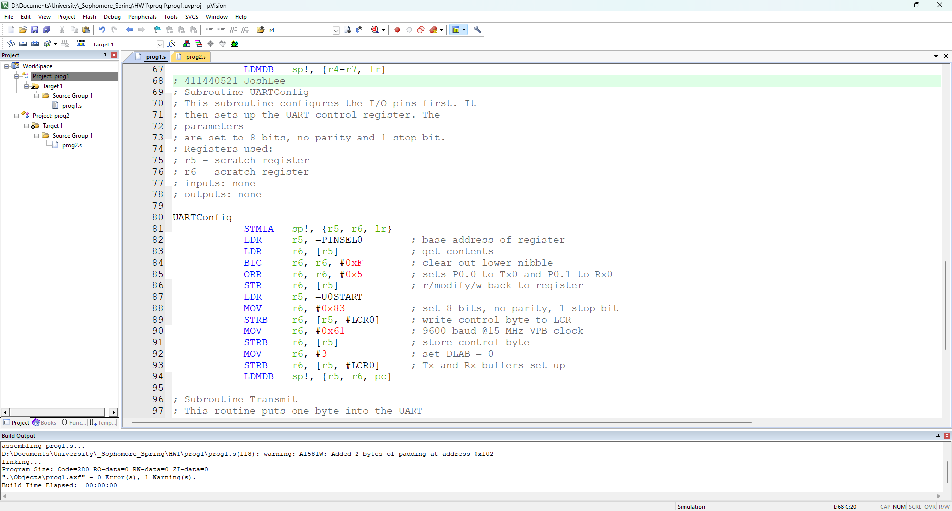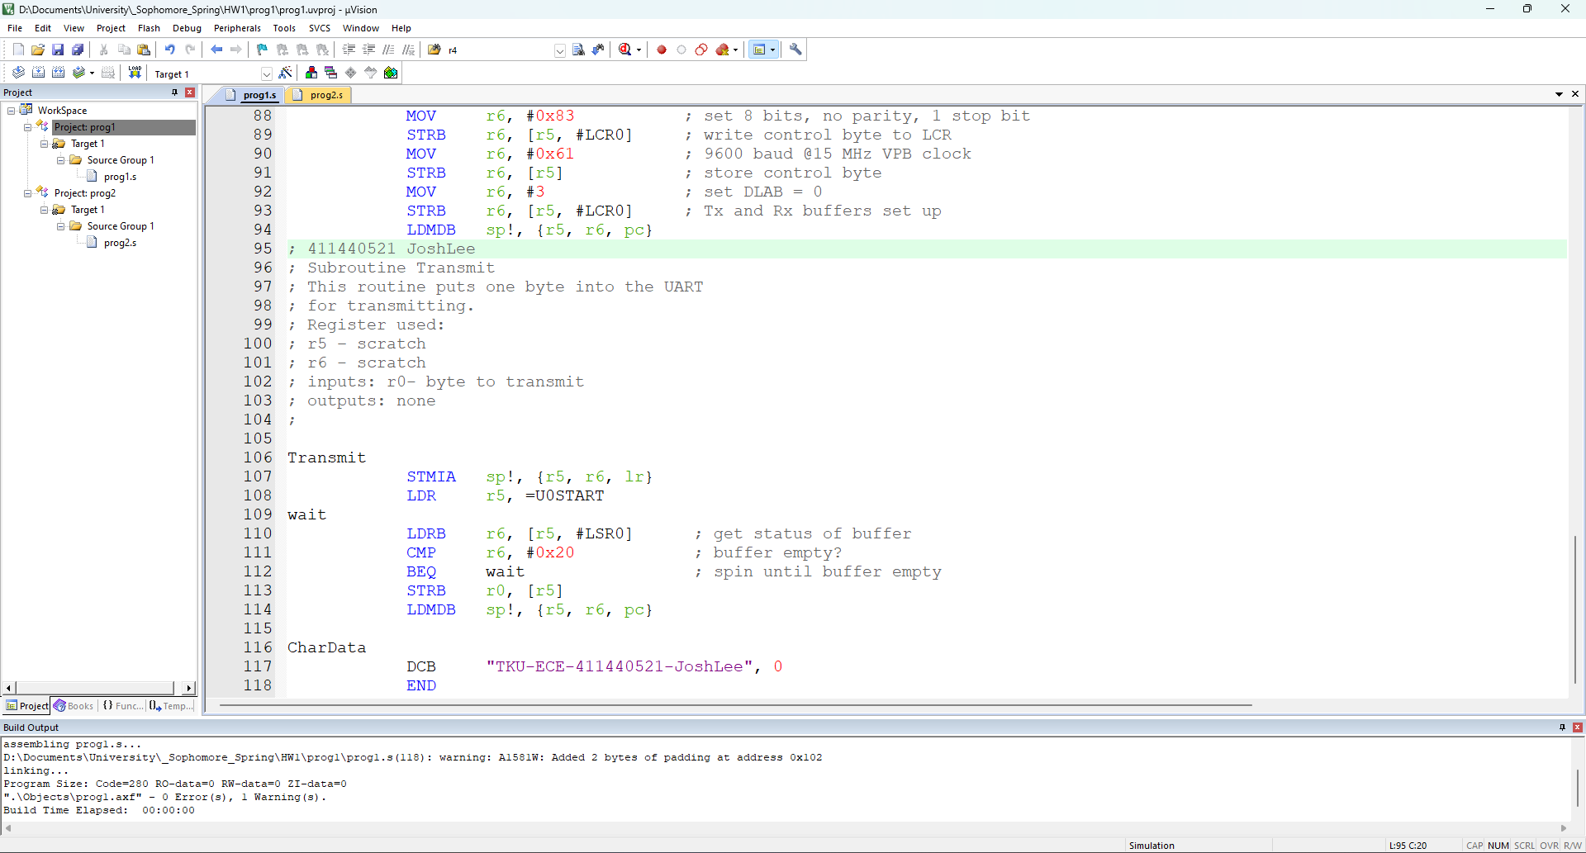

第一次作業

第一部分

|  |  |
| --- | --- |
| F5和F10執行時會將字串完整印出 | F11則會卡無窮迴圈，無法印出字串 |
|  |  |

3. Calculate Keil Tool System Clock Frequency and rewrite the initialization to show about 9600 baud on the divisor latch window

|  |  |
| --- | --- |
|  | Claculate Clock Frequency Clock Frequency = value * Baud Rate * 16  = |
|  |  |

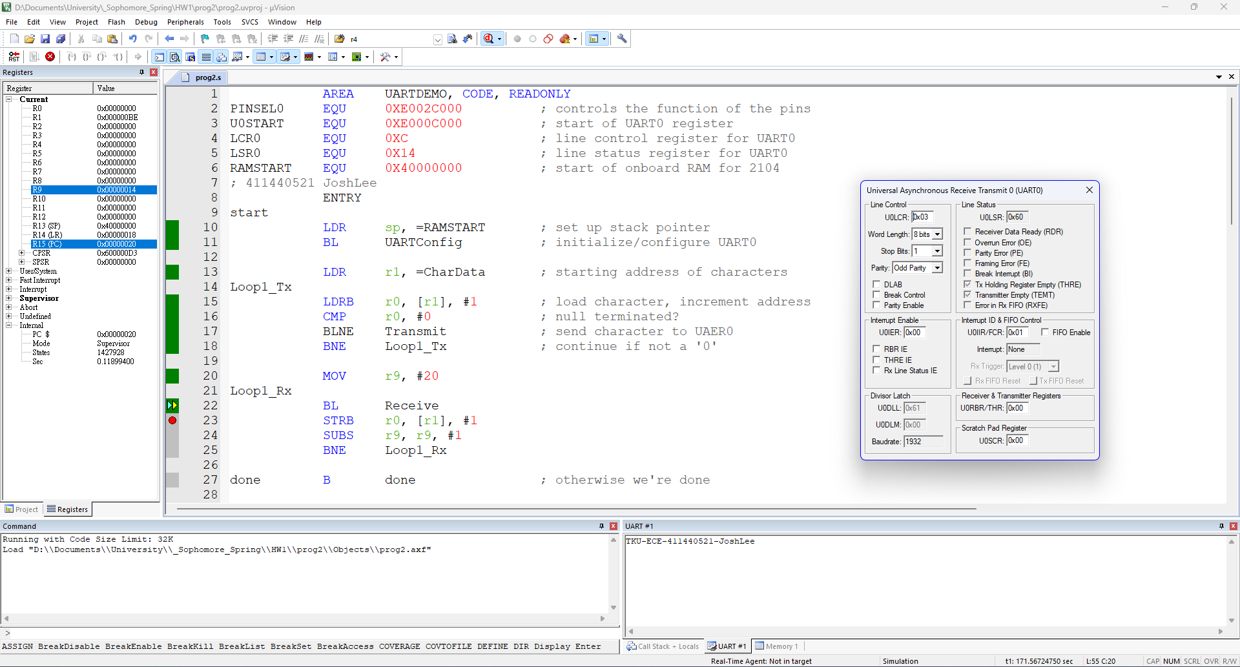

第一次作業

第二部分

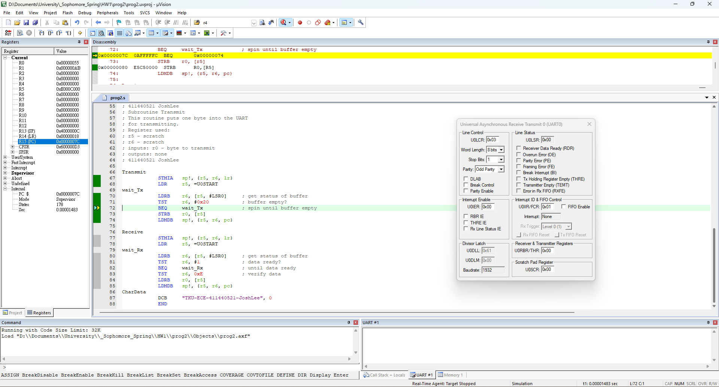

用F10的時候，UART會正常輸出字串

1. U0LSR會恢復0x60
2. Tx Holding Register Empty (THRE) = 0
3. Transmitter Empty (TEMT) = 0

用F11的時候，UART不會輸出字串

1. U0LSR會變為0x00
2. Tx Holding Register Empty (THRE) = 0
3. Transmitter Empty (TEMT) = 0