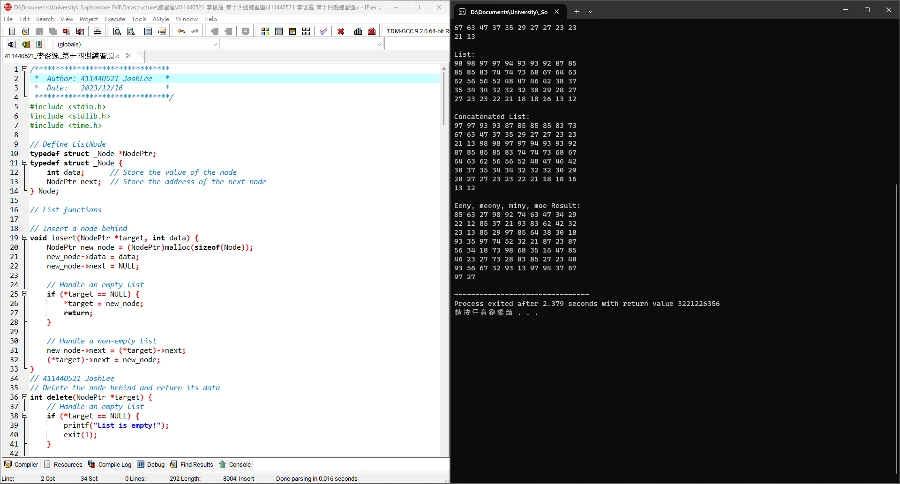1

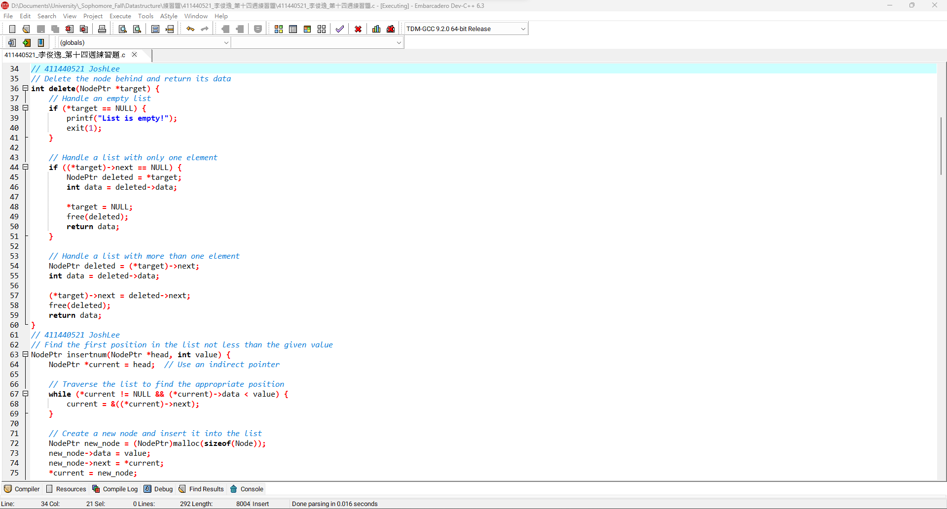2

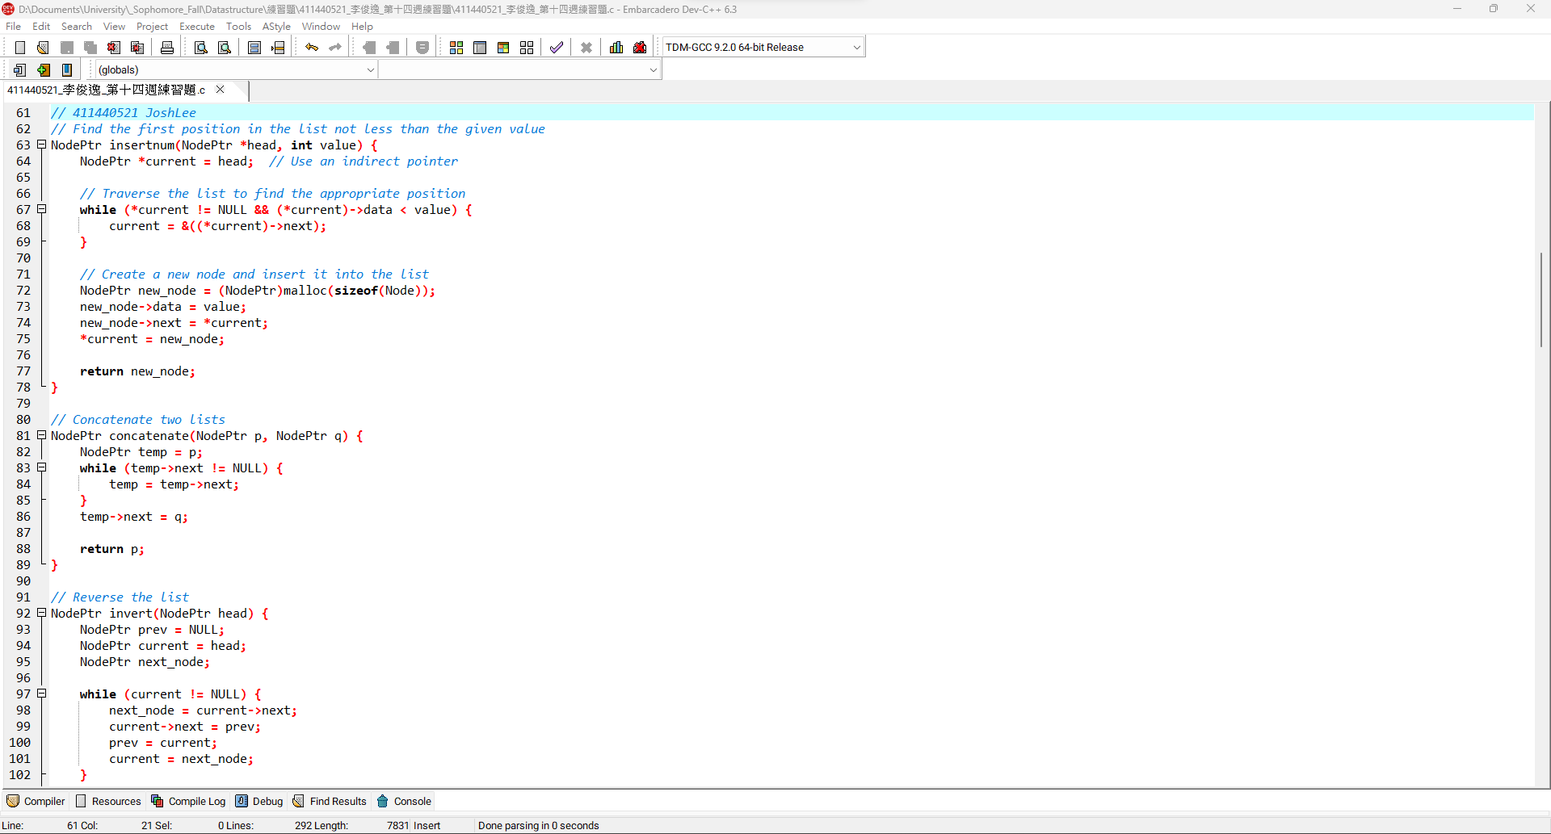3

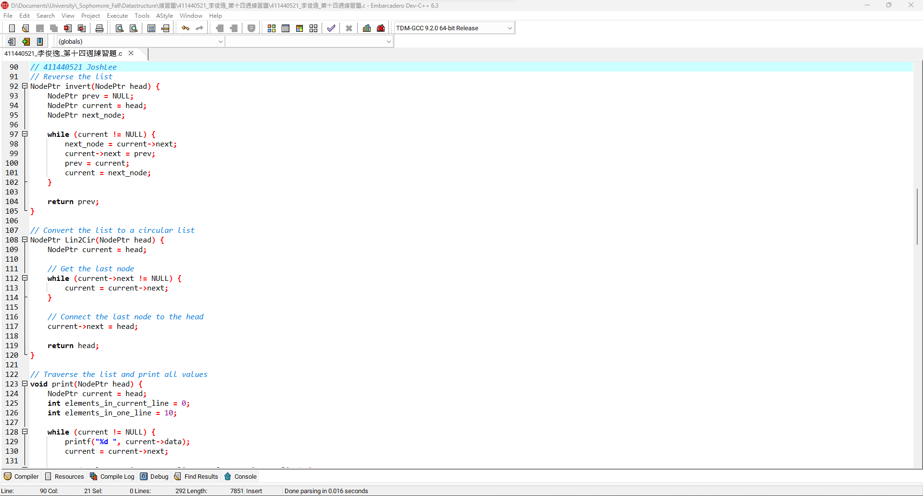4

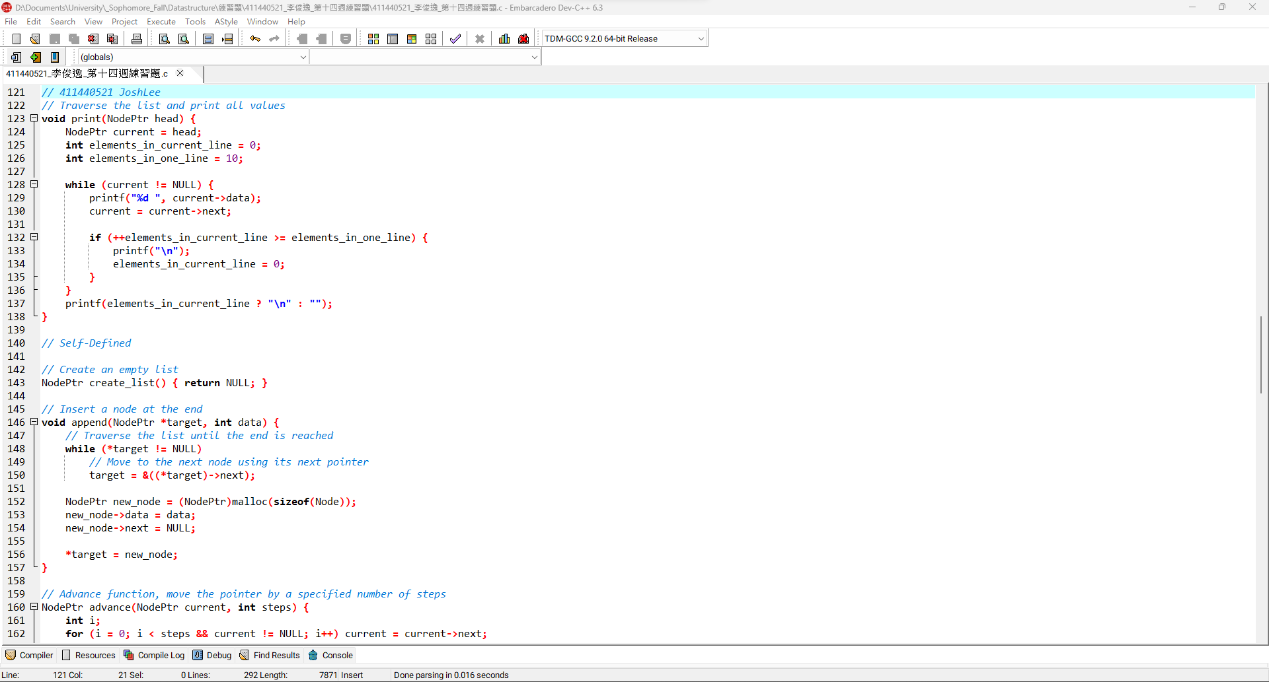5

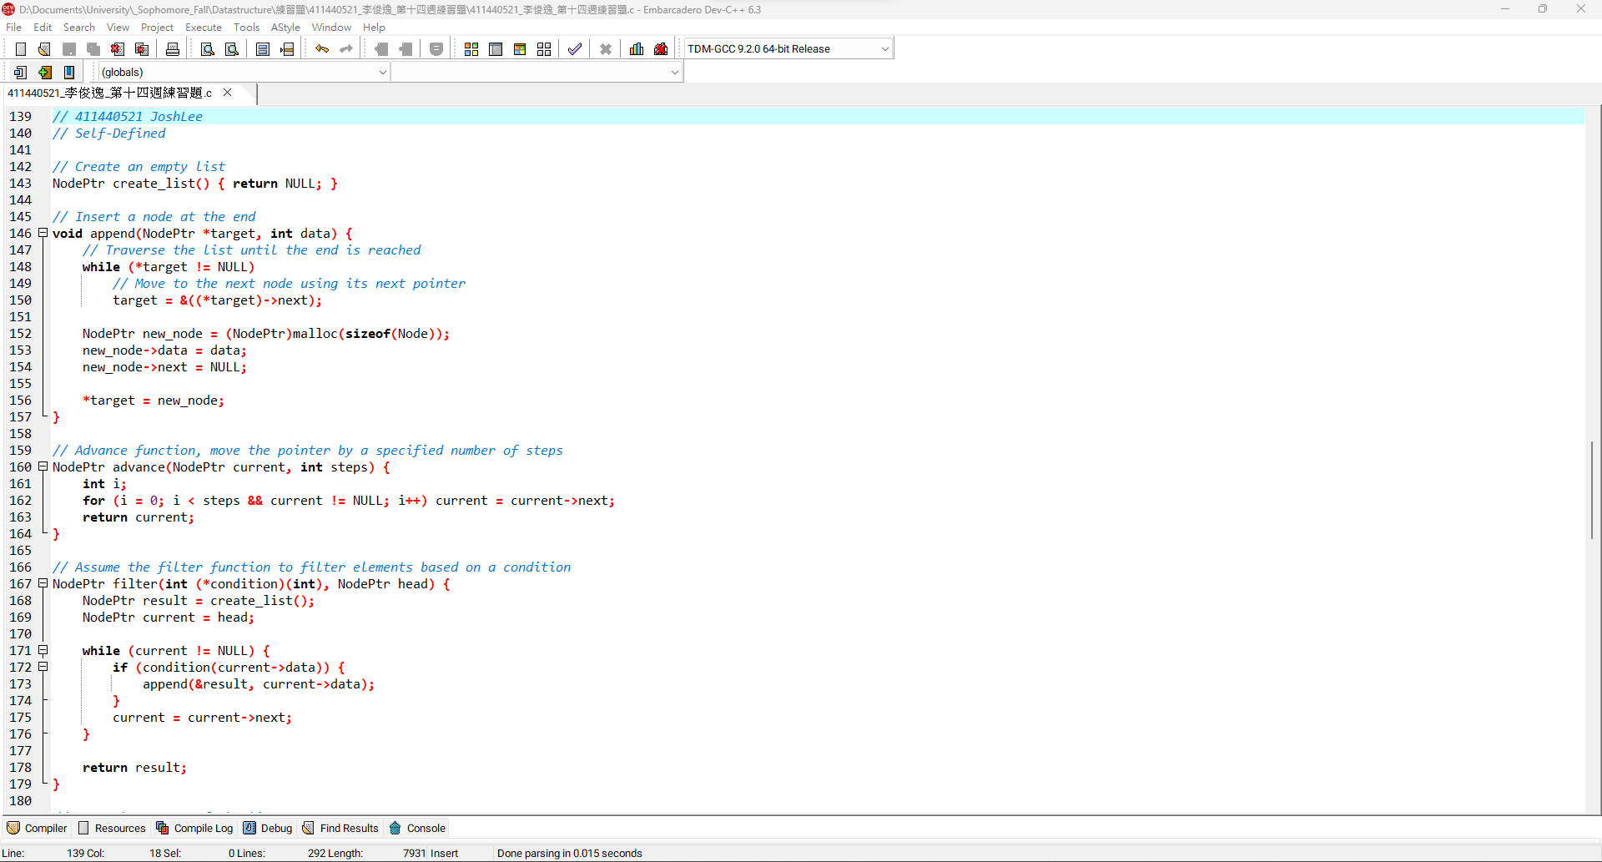6

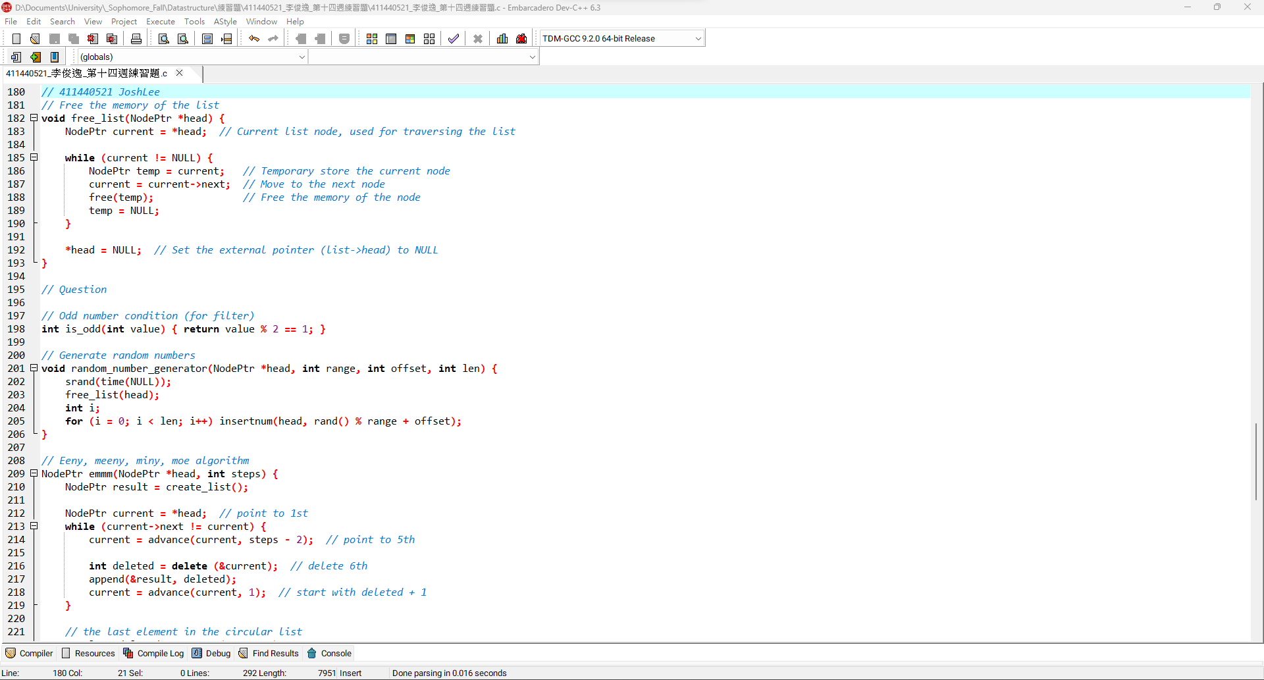7

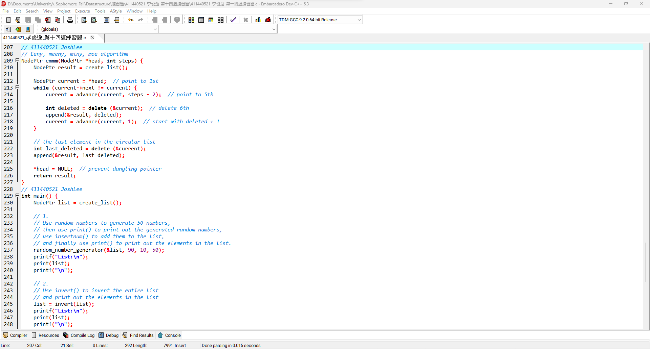8

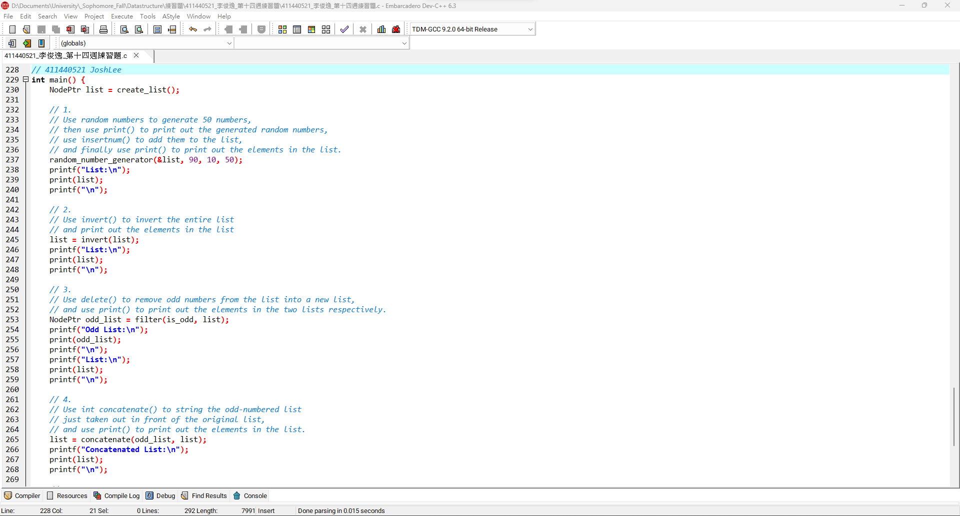9

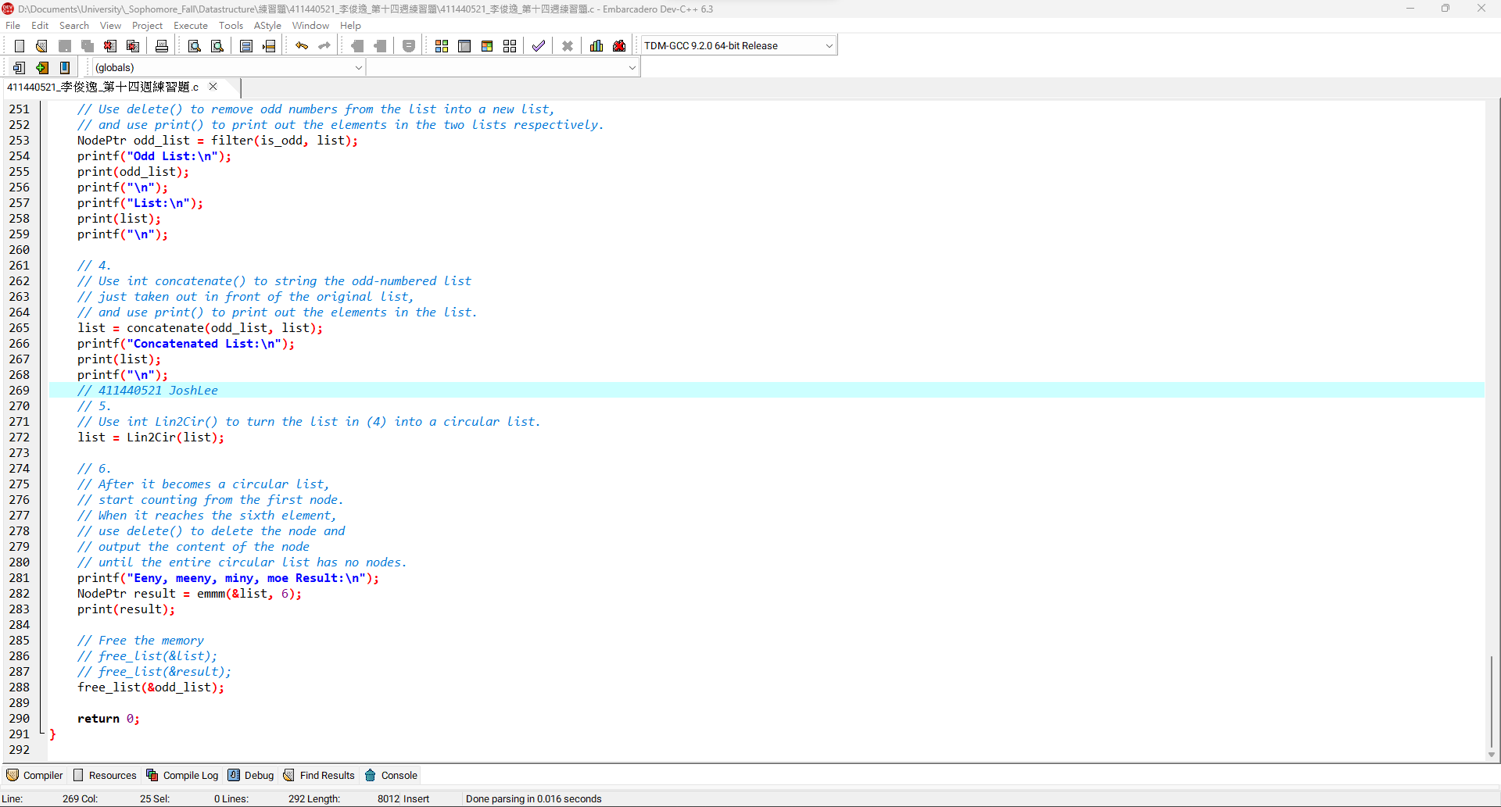10

**程式碼:**

insert:

|  |
| --- |
| *// Insert a node behind*  void insert(NodePtr *target, int data) {  NodePtr new_node = (NodePtr)malloc(sizeof(Node));  new_node->data = data;  new_node->next = NULL;  *// Handle an empty list*  if (*target == NULL) {  *target = new_node;  return;  }  *// Handle a non-empty list*  new_node->next = (*target)->next;  (*target)->next = new_node;  } |

delete

|  |
| --- |
| *// Delete the node behind and return its data*  int delete(NodePtr *target) {  *// Handle an empty list*  if (*target == NULL) {  printf("List is empty!");  exit(1);  }  *// Handle a list with only one element*  if ((*target)->next == NULL) {  NodePtr deleted = *target;  int data = deleted->data;  *target = NULL;  free(deleted);  return data;  }  *// Handle a list with more than one element*  NodePtr deleted = (*target)->next;  int data = deleted->data;  (*target)->next = deleted->next;  free(deleted);  return data;  } |

insertnum:

|  |
| --- |
| *// Find the first position in the list not less than the given value*  NodePtr insertnum(NodePtr *head, int value) {  NodePtr *current = head; *// Use an indirect pointer*  *// Traverse the list to find the appropriate position*  while (*current != NULL && (*current)->data < value) {  current = &((*current)->next);  }  *// Create a new node and insert it into the list*  NodePtr new_node = (NodePtr)malloc(sizeof(Node));  new_node->data = value;  new_node->next = *current;  *current = new_node;  return new_node;  } |

concatenate:

|  |
| --- |
| *// Concatenate two lists*  NodePtr concatenate(NodePtr p, NodePtr q) {  NodePtr temp = p;  while (temp->next != NULL) {  temp = temp->next;  }  temp->next = q;  return p;  } |

invert:

|  |
| --- |
| *// Reverse the list*  NodePtr invert(NodePtr head) {  NodePtr prev = NULL;  NodePtr current = head;  NodePtr next_node;  while (current != NULL) {  next_node = current->next;  current->next = prev;  prev = current;  current = next_node;  }  return prev;  } |

Lin2Cir:

|  |
| --- |
| *// Convert the list to a circular list*  NodePtr Lin2Cir(NodePtr head) {  NodePtr current = head;  *// Get the last node*  while (current->next != NULL) {  current = current->next;  }  *// Connect the last node to the head*  current->next = head;  return head;  } |

print:

|  |
| --- |
| *// Traverse the list and print all values*  void print(NodePtr head) {  NodePtr current = head;  int elements_in_current_line = 0;  int elements_in_one_line = 10;  while (current != NULL) {  printf("%d ", current->data);  current = current->next;  if (++elements_in_current_line >= elements_in_one_line) {  printf("\n");  elements_in_current_line = 0;  }  }  printf(elements_in_current_line ? "\n" : "");  } |