SignLink: An Environment-Immune Sign Language Translation Framework Combining sEMG Ensemble Tree Classification and Heuristic-Driven Mobile Design
Author 1¹[0000-0000-0000-0000], Author 2²[0000-0000-0000-0000] and Author3[0000-0000-0000-0000]
¹ Affiliation 1
² Affiliation 2
³ Affiliation 3
Abstract. Communication is a fundamental human right, yet significant barriers remain between sign language users and non-signers. This persistent disconnect often isolates individuals within everyday social, educational and professional spaces, turning routine interactions into frustrating obstacles. To address this societal gap and move toward true communication equity, this paper presents the development of SignLink, an environment-immune sign language translation framework utilizing surface electromyography (sEMG) [14]. We propose a modular, two-part framework consisting of an offline machine learning intelligence engine and a standalone mobile user interface designed for future integration. To establish a robust classification pipeline, we utilize a publicly available American Sign Language (ASL) fingerspelling dataset captured via an 8-channel sEMG and IMU wearable array (Myo Armband) [15]. Our approach addresses inter-user signal variability by implementing a segmented, multi-window statistical feature engineering process paired with a tree-based attribute reduction strategy. Rather than deploying complex, data-heavy Deep Learning models that risk failure on constrained datasets, we demonstrate that an effectively tuned Extra Trees baseline can deliver highly competitive and consistent results (highest accuracy at 92.8%) while minimizing computational overhead. To validate the practical deployment vehicle, we concurrently present a modular, Kotlin-based Android application architecture designed around Nielsen’s Usability Heuristics to maximize accessibility. Preliminary usability evaluations with 15 participants yielded a promising baseline System Usability Scale (SUS) score of 96.8, suggesting that the interface layout is on a constructive track for user acceptance [12,13]. Ultimately, this work contributes a verified machine learning pipeline and a scalable mobile framework, offering a foundational step toward a low-overhead, environment-immune assistive technology prior to full system unification.
Keywords: Assistive Technology, surface electromyography (sEMG) classification, American Sign Language (ASL), Extra trees
- Introduction
Communication serves as the cornerstone of human interaction, yet individuals who rely on sign language constantly face profound barriers when navigating a predominantly spoken world. While the development of assistive technologies aims to bridge this gap, the vast majority of current solutions rely heavily on computer vision frameworks. Though visually intuitive, vision-based approaches suffer from severe real-world constraints: they require optimal environmental lighting, demand a constant and unobstructed line of sight, and inherently restrict the user’s physical mobility by forcing them to remain within a camera's fixed field of view.
To achieve true, unconstrained communication equity, assistive tools must transition toward environment-immune modalities that operate reliably across any physical setting. We propose a framework to address these real-world limitations through SignLink, a system designed around a modular, two-part architecture. It pairs an offline, low-overhead artificial intelligence-driven surface electromyography (sEMG) gesture classification engine with a dedicated Android application. While the machine learning pipeline bypasses environmental vulnerabilities via neuromuscular tracking, the mobile application acts as a supportive, multi-modal communication hub incorporating features like text-to-speech, speech-to-text, and more to bridge conversational gaps that a physiological wearable alone cannot address. The complete data flow and interaction between these hardware and software sub-systems are illustrated in the SignLink Architectural Framework (see Figure 1).
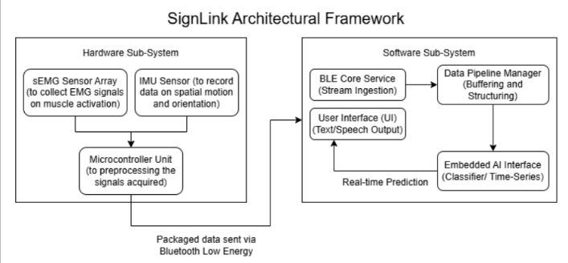
Fig. 1. SignLink Framework
Rather than chasing computationally heavy and data-hungry deep learning models that frequently fail under real-world small-dataset constraints, this paper demonstrates that a carefully optimized, lightweight machine learning baseline can achieve highly competitive results on mobile edge hardware. Concurrently, we present a human-centered mobile interface designed to maximize usability for assistive technology deployment.
The primary contributions of this work are summarized as follows:
- A Lightweight, Noise-Immune Machine Learning Pipeline: We propose a statistical feature engineering that was taken inspiration from DyFav [4] and tree-based attribute reduction pipeline optimized for an Extra Trees ensemble [5], proving that low-overhead baselines can stabilize variance and match complex deep learning metrics without requiring heavy computational hardware.
- A Heuristic-Driven Mobile Architecture: We introduce a modular, Kotlin-based Android application framework structured strictly around Nielsen’s Ten Usability Heuristics [6] to establish an accessible, intuitive layout for fluid, multi-modal communication.
- Related Works and Previous Iterations
Sign Language is a complete and complex natural visual-spatial language that enables communication through a synchronized combination of manual indicators, such as hand gestures and wrist orientations. However, profound communication barriers frequently arise in daily social environments as well as in critical sectors like healthcare, education, and employment [1]. To alleviate these disparities and prioritize user inclusivity, contemporary research has focused heavily on engineering automated sign language translation systems, which can be broadly categorized into three paradigms: vision-based, sensor-based architectures [2] and a hybrid architecture as seen below.

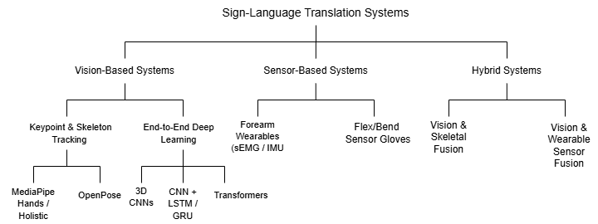
Fig. 1. Sign-Language Translation Systems
  - Environmental Restrictions of Vision-Based Frameworks
Early iterations of automated sign language translation predominantly leveraged computer vision architectures, utilizing standard RGB cameras, depth sensors, or infrared tracking to map hand geometries and skeletal joints. While vision-based systems provide a highly intuitive interface without requiring users to don physical apparel, their performance drops significantly outside of structured laboratory environments.
Vision-based frameworks suffer from fundamental real-world constraints: they require optimal and highly consistent environmental lighting, demand a constant, unobstructed line of sight, and face catastrophic failure when encountering foreground or background occlusions. Furthermore, these systems inherently restrict a user's physical mobility, forcing them to remain strictly within a camera's fixed and limited field of view. To achieve true, unconstrained communication equity, assistive tools must transition toward environment-immune, physiological sensing modalities that operate reliably across any physical setting.
  - Deep Learning and Data Bottlenecks in sEMG Tracking
To establish environment-immune tracking, surface electromyography (sEMG) has emerged as a premier methodology for non-invasively capturing the bioelectric signals generated by forearm muscle contractions directly from a user's skin surface. By bypassing visual dependencies entirely, an sEMG-based approach remains completely unaffected by poor lighting, physical occlusions, or spatial orientation. In recent literature, hardware arrays like the 8-channel Myo Armband [15] have been widely adopted as benchmark data acquisition tools for American Sign Language (ASL) fingerspelling and hand gesture recognition.
Concurrently, the state-of-the-art in sEMG classification has become increasingly dominated by Deep Learning (DL) and custom algorithmic architectures. Researchers frequently implement complex configurations, including:
- Convolutional Neural Networks (CNNs) and Multi-Layer Perceptron (MLP’s): Utilized to extract spatial feature maps from multi-channel sEMG grids with accuracies being 74.6% by MAST [7], 93.7 by MyoSign [8] and 90.45% by DyFav [4].
- Long Short-Term Memory (LSTM) Networks: Paired with Recurrent Neural Networks (RNNs) to map the sequential, temporal patterns inherent to fluid gestural communication with an accuracy of around 93% by MyoSign [8].
- Custom Algorithms: Researchers increasingly develop novel end-to-end architectures by integrating domain-specific feature extraction, custom neural network modules, dynamic voting mechanisms, attention-based learning, or hybrid ensemble strategies with conventional machine learning and deep learning components to address the unique challenges of sEMG-based gesture recognition [4,7,9].
While these deep learning and custom algorithmic models such have achieved impressive peak accuracies in isolated testing environments, translating raw biological signals into text or speech presents a distinct set of operational bottlenecks. High inter-user variability, signal degradation over time, and the high-dimensional nature of neuromuscular data typically demand heavy computational resources, making seamless deployment on mobile edge devices traditionally difficult. To optimize performance, these complex architectures require massive datasets to fine-tune millions of parameters and achieve high statistical confidence [11]. Consequently, they perform optimally only when the training data is exceptionally clean, noise-free, and narrow enough to avoid the curse of dimensionality
  - The Small-Dataset Problem and Computational Barriers
In real-world assistive technology research, the availability of large-scale, high-density physiological datasets is profoundly restricted. Collecting continuous hours of neuromuscular signals introduces severe muscular fatigue and user discomfort; thus, experimental protocols must remain relatively brief to ensure the well-being and compliance of the human participants involved [4]. Without an abundance of training data, data-hungry deep learning models suffer from high variance and severe overfitting, leading to poor generalization across noisy, real-world sessions. As seen in Fig 2, the model does perform better with more and more data but even when the dataset is limited, the performance does come up to satisfactory levels, taking a steep increase at around 600 examples.
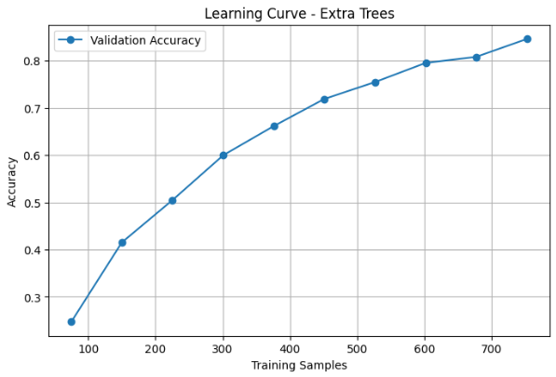
Fig. 2. Accuracy v/s Training samples.
Beyond the data bottleneck lies a steep barrier to replication and practical edge deployment. Navigating these highly complex deep learning architectures and the extensive data manipulation techniques required to make them perform optimally while managing steep time complexities and processing constraints renders replication exceptionally difficult for independent developers or researchers, particularly when high-end computational hardware is unavailable.
  - Algorithmic Recalibration: Transitioning to Extra Trees
These systemic challenges necessitate a re-evaluation of baseline Machine Learning (ML) models. Utilizing robust baselines that require minimal parameter tuning and low computational power while effectively handling small-dataset constraints is essential to creating solutions that are easily replicable and implementable by the wider scientific community. While traditional ensemble methods like Random Forests have occasionally been utilized to reduce the computational footprint of sEMG processing [4,7], they still rely on exhaustive, greedy threshold searches to determine local optimal splits, which remains computationally taxing on high-dimensional data.
To resolve this final constraint, the SignLink framework deviates from standard deep learning and traditional tree-based architectures by utilizing Extra Trees (Extremely Randomized Trees). As an ensemble method, Extra Trees is uniquely engineered to thrive under conditions of low data availability, heavy environmental noise, and high-dimensional datasets, all while minimizing computational overhead [5].
Rather than expending computational energy to search for and sort local optimal split points like traditional decision trees, Extra Trees selects splitting thresholds completely at random from a subset of features. This structural randomization introduces an ensemble that averages out over diverse decision boundaries, effectively smoothing the prediction surface compared to the sharp, highly localized boundaries created by standard greedy split criteria [5]. In small datasets, this smoothing effect acts as a robust safeguard, ensuring the model does not make erratic predictions based on isolated signal outliers, a frequent occurrence in noisy sEMG arrays, thereby directly neutralizing the problem of signal randomness.
Furthermore, Extra Trees executes drastically faster than alternative tree-based ensemble techniques because it completely avoids time-consuming threshold optimization via its randomized search mechanics. Critically for small-sample domains, the algorithm trains on the entire original dataset rather than utilizing bootstrapping, ensuring that the architecture maximizes the learning utility of every available data point. Finally, it masterfully balances the bias-variance tradeoff [5], yielding lower total generalization error in high-noise, high-dimensional sEMG spaces where variance is traditionally the primary catalyst for model failure.
Ultimately, this methodology demonstrates that a low-overhead, highly accessible baseline model like ensemble tree methods can match and even outperform the performance of computationally expensive deep learning architectures [11] without requiring specialized field expertise, extensive data engineering, or high-performance hardware from the end user.
- Methodology
  - AI Model

Dataset. To evaluate the baseline feasibility of the proposed framework, this study utilizes the publicly available American Sign Language (ASL) Fingerspelling Dataset for Myo Sensor, released by Arizona State University [10]. The dataset compiles surface electromyography (sEMG) and inertial measurement unit (IMU) data recorded from 9 distinct human subjects. For each letter of the ASL alphabet, raw data streams were captured over a continuous 5-second interval per trial.
The raw signal acquisition for all physiological and kinematic streams was originally executed via the open-source 'Myolib' library [3, 4]. Each data record contains a high-dimensional feature matrix spanning multiple sensory columns. The first 8 columns contain raw bioelectric amplitudes captured by the 8 equidistant sEMG sensor pods of the wearable array. The subsequent 6 columns record kinematic data from the onboard IMU, dedicated to 3-axis accelerometer readings (x, y, z) and 3-axis gyroscope readings (x, y, z), respectively. The final columns contain orientation values natively captured as unit quaternions (w, x, y, z). To translate these spatial dimensions into interpretable geometric angles, the quaternion values are converted into Euler angles specifically roll, pitch, and yaw according to the following mathematical transformations:
$$\text{roll}=\tan^{-1}\left(\frac{2\left(wx+yz\right)}{1-2\left(x^{2}+y^{2}\right)}\right)$$
$$\text{pitch}=\sin^{-1}\left(\max\left(-1, \min\left(1, 2\left(wy-zx\right)\right)\right)\right)$$
$$\text{yaw}=\tan^{-1}\left(\frac{2\left(wz+xy\right)}{1-2\left(y^{2}+z^{2}\right)}\right)$$
Data Partitioning and Intra-User Validation. At first a LOGO(Leave-One-Group-Out) was used to evaluate the model’s predictive power on completely unseen users. An accuracy of around 20% to 25% was found. This steep performance penalty was anticipated, as the architecture was forced to train on one subset of human subjects and test on an entirely different population. As highlighted in previous benchmarks, such as DyFav [4] high inter-user variability represents a profound limitation in physiological sensing, given that identical sign language gestures manifest as drastically different sEMG signature readings across different individuals.
To circumvent these structural biological differences and ensure robust signal alignment, an intra-user validation paradigm was established. The final dataset was partitioned using a stratified 80:20 train-test split. This stratification strategy guarantees strict class balance across all ASL alphabet letters while ensuring that data from every individual user is proportionally represented in both the training and testing phases.

Feature Engineering and Segmentation. Traditional feature engineering frameworks for sEMG data heavily rely on rolling temporal windowing techniques. However, continuous sliding windows could not be reliably applied to the utilized dataset due to structural inconsistencies in temporal linearity. Given the Myo Armband's native sampling rate of 200 Hz, a standard 5-second trial should theoretically yield 1,000 data rows per recording; instead, the captured dataset contained only 50 samples per trial. To resolve this down-sampled density constraint, a non-overlapping segmented aggregation strategy was implemented.
The data set for each trial was partitioned into 5 discrete, non-overlapping segments. For each singular segment, as well as across the entire global trial duration, foundational features were extracted , comprising of min, max, mean, std_dev, tot_eng [4].
To maximize the information density extracted from the highly volatile neuromuscular channels, the 8 sEMG sensor streams were enriched with specialized domain-specific features:
- Root Mean Square (RMS): Reflects the continuous electrical power of the muscle contractions.
- Mean Absolute Value (MAV): Acts as a robust baseline indicator of muscle contraction levels.
- Waveform Length (WL): Captures the cumulative complexity and amplitude variations of the signal.
- Zero Crossings (ZC): Measures frequency shifts across the zero-amplitude baseline to capture muscle fatigue variations. Slope Sign Changes (SSC): Tracks frequency domain properties by counting changes in signal direction.
- Willison Amplitude (WAMP): Monitors the frequency of structural motor unit action potential firings exceeding a predefined threshold.
For the kinematic IMU streams, a Signal Magnitude Vector (SMV) was calculated and appended to encapsulate total spatial acceleration and angular momentum independent of coordinate rotation. Through this multi-tiered engineering approach, the total feature space expanded sequentially from 17 baseline channels to 510 intermediate attributes, ultimately reaching 914 complex structural features.

Feature Selection and Dimensionality Reduction. As the engineered feature space scaled to 914 dimensions, the architecture risked exposure to the curse of dimensionality, necessitating a targeted feature selection pipeline to eliminate noise and structural redundancy. Traditional dimensionality reduction frameworks, such as PCA, proved ineffective due to the high mathematical complexity of the multi-modal features and the small-sample properties of the dataset [4].
To address this, an embedded feature selection strategy utilizing an Extra Trees classifier was deployed. The ensemble estimated the structural relative importance of each engineered attribute by evaluating the Gini impurity reduction across all randomized split paths. By mapping the performance trajectory, the top 315 highest-ranked features were isolated and gave out the maximum accuracy of 92.80%.
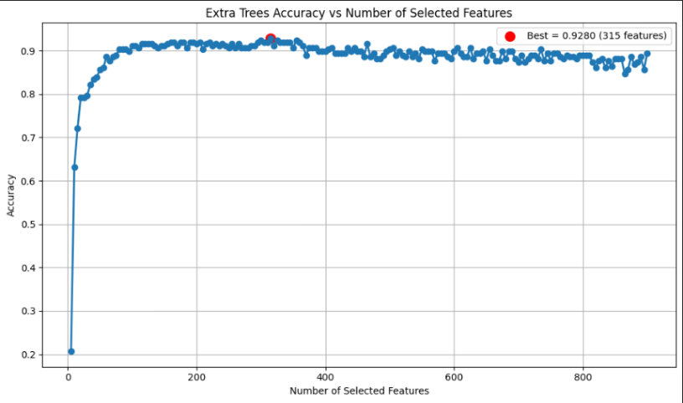
Fig. 3. Accuracy v/s Number of Features

Attribute Importance Analysis. To identify the most predictive signal markers, an embedded feature importance evaluation was conducted via the Extra Trees classifier. Through graphical visualization, isolating the top N = 315 features yielded the optimal performance ceiling, securing a peak accuracy of 92.80%. This threshold aligns with existing benchmarks in literature; notably, a related physiological tracking architecture by DyFav [4] similarly documented a performance plateau when scaling around 300 features.
An architectural analysis of the feature ranking revealed that the most critical attributes heavily clustered around fundamental statistical and time-domain metrics specifically minimum, maximum, mean, standard deviation, root mean square (RMS), and total energy. Higher-order frequency markers, such as Willison amplitude and zero crossings, occupied lower relative importance tiers.
Despite their lower individual rankings, these complex features proved mathematically non-negligible to the overall system framework; their inclusion drove a distinct performance increase, raising the classification accuracy from a baseline of 91.52% to the peak of 92.80%. This incremental shift indicates that subtle neuromuscular variances captured by these complex transformations provide crucial stabilizing information for edge classification boundaries.

Ensemble Optimization and Training. The initial iteration of the training pipeline utilized a traditional Random Forest (RF) classifier as a foundational baseline. While the Random Forest model was systematically tuned to maximize its predictive capacity, its performance was heavily bottlenecked by the inherent environmental noise, signal drift, and trial-to-trial randomness characteristic of the high-dimensional sEMG dataset. Because standard Random Forests rely on greedy, exhaustive threshold searches to determine optimal local split points, the architecture struggled to build generalized decision boundaries when confronted with noisy neuromuscular variations.
This limitation prompted a structural migration to an Extra Trees (Extremely Randomized Trees) architecture for the final classification framework. Extra Trees introduces complete randomization when establishing split thresholds from selected feature subsets, heavily smoothing out the prediction surface. This structural randomization renders the model exceptionally resilient to local signal noise and outliers [5].
  - Mobile Interface and User Testing

Heuristic UI/UX Design and Feature Prioritization. To translate future bioelectric classifications into a seamless assistive tool, the SignLink mobile interface was developed using a user-centered design paradigm grounded strictly in Nielsen’s Ten Usability Heuristics. The architecture prioritizes cognitive ease, clear system status feedback, and accessibility-first navigation to accommodate users across varying degrees of sign language proficiency, technical literacy, and physical capabilities. By centering the interface on flexible user-adaptive workflows, the application accommodates diverse accessibility needs without forcing a one-size-fits-all interaction model.
To systematically guide the development lifecycle under chronological constraints, functional requirements were established using the MoSCoW prioritization matrix:
- Must-Have Features: Core software components required for immediate functional deployment, including the universal accessibility control panel, integrated Text-to-Speech (TTS) synthesis, real-time Speech-to-Text (STT) transcription, local conversational history logging, and the high-fidelity UI framework (mock screens) for future Bluetooth Low Energy (BLE) peripheral hardware pairing and sensor calibration
- Should-Have Features: Modular expansions such as a simulated surface electromyography (sEMG) waveform visualization dashboard, multi-language translation toggles, a localized database for offline mode execution, and interactive sign language tutorials.
- Could-Have / Won't-Have Features: Long-term enhancements reserved for subsequent iterations following hardware development, such as cloud-synchronized conversation backups, haptic feedback pattern optimization, and sequence-driven 3D avatar animations for continuous gestural sign narratives.
Following requirement formulation, interaction pathways were mapped to maximize navigation clarity, moving systematically from early low-fidelity wireframes into high-fidelity interactive prototypes to validate user flows and accessibility compliance before engineering the production code.

Software Architecture and Interactive Interface Workflow. The application was developed natively in Kotlin using Android Studio with a modular and decoupled architecture. The workflow is organized into logical interface layers governing system initialization, simulated device connectivity, and multimodal communication.
- Onboarding and Initialization: The application launches into a Welcome Screen before transitioning to the main interface. All communication modules, system functions, and personalization features are immediately accessible to eliminate unnecessary navigation.
- Hardware Connectivity (BLE Pairing Mock): The Device Pairing Screen simulates a future Bluetooth Low Energy (BLE) pairing process by displaying real-time status indicators during a mock peripheral scan, illustrating the intended onboarding workflow for the wearable sEMG/IMU armband.
- Guided Sensor Calibration Wizard (Simulated): A wizard-based Calibration Screen guides users through sequential gestures (e.g., Rest, Fist, Open Palm, Wave), requiring each posture to be held for three seconds. This high-fidelity simulation demonstrates future baseline data acquisition to reduce muscle variability while providing haptic feedback before granting access to the main dashboard.
- Core Multi-Modal Communication Hub: The Home Dashboard links directly to the three central interaction nodes:
  - Live Translation Module: Displays real-time text generated by the future gesture classification framework.
  - Speech-to-Text (STT) Module: Converts spoken language into on-screen text using the device microphone.
  - Text-to-Speech (TTS) Module: Converts typed text into synthesized speech through a dedicated text input interface
- Supporting Subsystems and Accessibility Customization: Additional modules include Chat History, a Learning Mode for gesture practice, and a Settings panel offering accessibility options such as high-contrast themes, adjustable text size, and configurable haptic feedback intensity.
  - Usability Evaluation and Testing Framework
To validate the interface’s practical layout efficacy, user acceptance, and cognitive accessibility across its various operational modes, a comprehensive evaluation framework was deployed across two discrete developmental milestones using a diversified cohort of 20 participants. Both evaluation cycles utilized a rigorous hybrid deployment structure, combining on-site in-person testing sessions to evaluate ergonomic flow with remote video conferencing sessions to measure remote comprehension and self-directed navigation clarity.
- Phase 1 (Initial Usability Testing). Evaluated early-stage interactive Figma prototypes with 5 participants (3 on-site, 2 remote) over a multi-week span to uncover navigational friction points within the mocked BLE pairing configurations, core navigation flows, and initial accessibility menus.
- Phase 2 (Final Application Testing). Conducted a robust, high-fidelity assessment of the compiled Kotlin application with 15 participants (9 on-site, 6 remote downloading the production software directly to target smartphones) to measure final design enhancements, interactive mock screens navigation, accessibility settings adjustments, and visual layout consistency.

Data collection across both testing milestones was strictly multi-tiered, ensuring equal representation of qualitative and quantitative user feedback:
- Think-Aloud Protocols (Qualitative). Participants verbally expressed immediate thoughts, expectations, and operational discomforts while moving through system states, capturing qualitative insights into user intent and identifying visual or interaction friction barriers across different interface configurations.
- System Usability Scale (Quantitative). Following task completion, users filled out an anonymized, standardized 10-item System Usability Scale (SUS) questionnaire, providing an objective, empirical benchmark to evaluate whether the application layout cleared acceptable industrial usability thresholds.
- Semi-Structured Exit Interviews (Qualitative). Post-test open-ended dialogues were conducted to isolate explicit pain points, with a specific focus on extracting feedback regarding user comfort during the simulated sensor calibration workflow and the direct utility of the integrated accessibility overrides.
- Results
  - AI Model Performance
The Extra Trees classifier was evaluated using a leakage-free machine learning pipeline incorporating Recursive Feature Elimination (RFE) and repeated stratified cross-validation to ensure intra-user splits and eliminate the risk of artificial accuracy inflation from fortunate data splits. Feature selection was performed strictly within the training folds to prevent information leakage, ensuring that the reported performance accurately reflected the model’s generalization capability. The final classifier employed the manually optimized hyperparameters obtained through iterative experimentation, which included 1,500 trees, entropy as the splitting criterion, a maximum tree depth of 15, logarithmic feature selection (log2) at each split, and bootstrap sampling disabled.
The proposed pipeline achieved high classification accuracy on the independent test set while maintaining strong cross-validation performance across repeated stratified folds. This indicates that the model generalizes effectively to unseen recordings from the calibrated user. The observed difference between training and validation accuracies suggests a moderate degree of overfitting, which is expected for high-capacity ensemble methods trained on a relatively small but high-dimensional dataset. Nevertheless, the validation results remained stable across repeated folds, demonstrating that the model retained good generalization despite the high-dimensional feature space. Feature selection significantly reduced the dimensionality of the engineered feature space while preserving the most discriminative electromyography (EMG) characteristics. This reduction improved computational efficiency without compromising classification performance, thereby addressing the curse of dimensionality commonly encountered in EMG-based gesture recognition. The final model successfully captured the temporal and statistical characteristics extracted from the segmented EMG signals, resulting in accurate recognition of the 26 American Sign Language (ASL) fingerspelling gestures.

Error Analysis and Confusion Patterns. Overall, the results demonstrate that combining statistical feature engineering, recursive feature elimination, and the Extra Trees ensemble provides an effective solution for intra-user EMG gesture classification. The proposed approach offers high recognition accuracy while remaining computationally efficient, making it suitable for deployment within the proposed calibration-based sign language recognition application. As seen in the confusion matrices and the classification report, the model performs exceptionally well, achieving near-perfect accuracies for specific target classes.
However, systematic misclassifications persist among specific gesture groups sharing closely related physiological configurations:
- U,V, and W: These gestures exhibit highly localized spatial variations in finger extension, resulting in overlapping surface electromyography (sEMG) muscle activation profiles along the forearm.
- M, N, and P: These signs involve subtle adjustments in thumb placement tucked beneath folded fingers, producing minimal variance in surface-level bioelectric potentials.
- Asymmetrical Confusion with "I": A notable subset of peripheral gestures are disproportionately misclassified as the letter "I", indicating a shared baseline muscular profile that masks distinct gestural features (M,T both have a similar closed palm sign comparable to that of I.).
- Random confusion errors such as F,U and so on. These could be due to slightly similar gestures and not having enough data samples for the model to make accurate predictions
While these localized confusions are expected due to the structural similarities inherent to physical sign language configurations, this architecture represents a massive improvement over previous random forest baseline iterations. Further iterations to resolve these specific points of friction will focus on implementing a multi-stage architecture, utilizing custom, secondary localized models trained specifically on the identified confusion clusters to boost overall classification confidence.

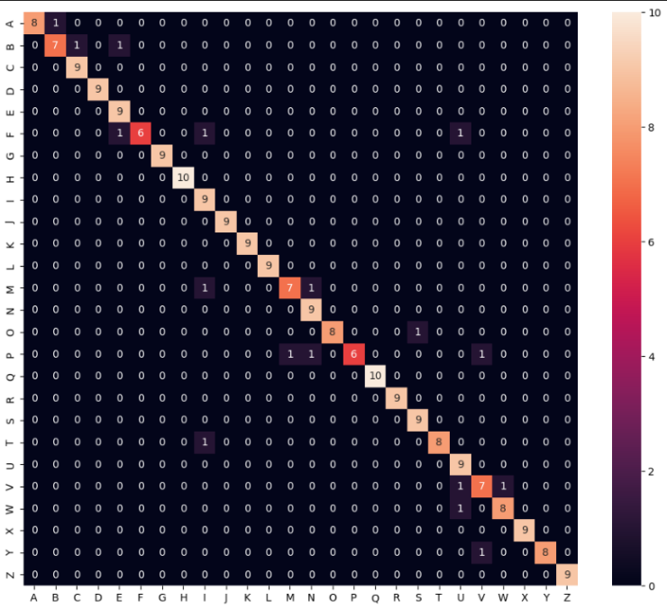
Fig. 3. Confusion Matrix
  - Evaluation Phases and Outcomes
Initial UI/UX Prototype Evaluation (Phase 1). It was conducted with 5 participants using a Figma prototype, this phase focused on initial menu navigation and simulated calibration flows. The design proved highly accessible, securing an 89.0 System Usability Scale (SUS) score, which ranks the prototype in the "Excellent" (Grade A) tier and places it within the top 10% of software applications for usability. On a 1–5 Likert scale, metrics reflected overwhelmingly positive user satisfaction; initial clarity and calibration logic both scored a high 4.8, and visual contrast scored 4.6. Bluetooth menu navigation scored a slightly lower, though still favorable, 4.4 due to minor discovery friction experienced by participant P4, who struggled to locate the pairing button. This finding highlighted a critical implication for the next design phase: the Bluetooth UI required more prominent visual cues to prevent onboarding drop-off. Qualitative feedback was highly positive regarding the uncluttered translation interface, though some users noted that the wizard-driven sensor setup felt abstract without physical hardware present. This qualitative finding implies a cognitive disconnect when the software is isolated from its physical counterpart, indicating that the digital interface must incorporate richer tooltips or micro-animations to simulate hardware behavior when the physical device is absent.

Final App Version Testing. This was done with 15 smartphone-based participants (9 in-person, 6 remote) testing the live mobile build. Design refinements were implemented based on Phase 1 feedback to maximize the app's standalone practicality for everyday use, even in the absence of a wearable device. These updates integrated key accessibility and privacy features, including Text-to-Speech (TTS), Speech-to-Text (STT), user-controlled local data storage, and a highly intuitive user interface. Consequently, these refinements pushed the final average SUS score to a world-class 96.8 (Grade A+, "Best Imaginable"), with every single user scoring the application between 95.0 and 100.0, proving that the updates effectively eliminated user friction. Likert metrics improved uniformly to near-perfect levels: initial app clarity and translated text readability achieved perfect 5.0/5.0 ratings, indicating absolute user consensus. Visual accessibility rose to 4.9, and Bluetooth navigation improved to 4.8, confirming that the onboarding adjustments successfully resolved Phase 1's discovery issues. Calibration logic scored 4.7. While qualitative interviews confirmed a completely fluid translation and onboarding experience, users reaffirmed that integrating the physical hardware armband would fully optimize the calibration workflow. The primary implication of this final finding is that the software has reached its standalone peak; future development must transition to comprehensive hardware-in-the-loop testing to ensure the digital interface matches the physical ergonomics of the armband.

References
- United Nations: Convention on the Rights of Persons with Disabilities. United Nations, New York (2006). https://www.un.org/development/desa/disabilities/convention-on-the-rights-of-persons-with-disabilities.html 3
- Papatsimouli, M., Kollias, K.F., Lazaridis, L., Maraslidis, G.S., Fragulis, G.F., Sarigiannidis, P., Fragulis, G.F.: Real Time Sign Language Translation Systems: A review study. In: 2022 11th International Conference on Modern Circuits and Systems Technologies (MOCAST). pp. 1–4. IEEE (2022). https://doi.org/10.1109/MOCAST54814.2022.9837666 3
- Darken: MyoLib. GitHub repository (2015). https://github.com/d4rken/myolib 5
- Paudyal, P., Lee, J., Banerjee, A., Sandeep, K.S.: DyFAV: Dynamic Feature Selection and Voting for Real-time Recognition of Fingerspelled Alphabet using Wearables. In: Proceedings of the 22nd International Conference on Intelligent User Interfaces. pp. 357–367. ACM (2017). https://doi.org/10.1145/3025171.3025216 5
- Geurts, P., Ernst, D., Wehenkel, L.: Extremely randomized trees. Machine Learning 63(1), 3–42 (2006). https://doi.org/10.1007/s10994-006-6226-1
- Nielsen, J.: Usability Engineering. Morgan Kaufmann Publishers, San Francisco (1994).
- Shakeel, Z.M., So, S., Lingga, P., Jeong, J.P.: MAST: Myo armband sign-language translator for human hand activity classification. In: 2020 International Conference on Information and Communication Technology Convergence (ICTC), pp. 1–6. IEEE, Jeju, South Korea (2020). https://doi.org/10.1109/ICTC49870.2020.9289153
- Zhang, Q., Wang, D., Zhao, R., Yu, Y.: MyoSign: Enabling end-to-end sign language recognition with wearables. In: The 24th International Conference on Intelligent User Interfaces (IUI 2019), pp. 1–12. ACM, New York (2019). https://doi.org/10.1145/3301275.3302296
- Paudyal, P., Banerjee, A., Gupta, S.K.S.: SCEPTRE: A pervasive, non-invasive, and programmable gesture recognition technology. In: Proceedings of the 21st International Conference on Intelligent User Interfaces (IUI '16), pp. 282–293. ACM, New York (2016). https://doi.org/10.1145/2856767.2856794
- Paudyal, P.: American Sign Language (ASL) Fingerspelling dataset for Myo Sensor, Version 1. Mendeley Data (2018). https://doi.org/10.17632/dbymbhhpk9.1
- Grinsztajn, L., Oyallon, E., Varoquaux, G.: Why do tree-based models still outperform deep learning on tabular data? arXiv preprint arXiv:2207.08815 (2022). https://doi.org/10.48550/arXiv.2207.08815
- Bangor, A., Kortum, P.T., Miller, J.T.: Determining what individual SUS scores mean: Adding an adjective rating scale. Journal of Usability Studies 4(3), 114–123 (2009).
- Brooke, J.: SUS: A “quick and dirty” usability scale. In: Jordan, P.W., Thomas, B., Weerdmeester, B.A., McClelland, I.L. (eds.) Usability Evaluation in Industry, pp. 189–194. Taylor & Francis, London (1996).
- Konrad, P.: The ABC of EMG: A Practical Introduction to Kinesiological Electromyography. Noraxon Inc., Scottsdale (2005).
- Visconti, P., Gaetani, F., Zappatore, G.A., Primiceri, P.: Technical features and functionalities of Myo Armband: An overview on related literature and advanced applications of myoelectric armbands mainly focused on arm prostheses. Int. J. Smart Sens. Intell. Syst. 11(2), 1–25 (2018). https://doi.org/10.21307/ijsis-2018-005

