电站汇总实时数据：
69 69 01 00 3E 00 00 00 01 00 01 00 00 00 04 00 29 00 FF FF 00 00 1D 09 0F 0E 04 0C 05 00 03 01 00 91 7E 00 00 01 03 02 00 18 5B 05 00 01 01 03 00 00 00 07 00 01 01 05 00 E7 00 00 00 01 01 06 00 C8 00 00 00 01 B2 96
环境实时数据：
69 69 01 00 3E 00 00 00 01 00 01 00 00 00 04 00 29 00 FF 00 00 00 1E 09 0F 0E 04 0C 05 00 01 91 01 07 00 00 00 01 01 93 01 E7 00 00 00 01 01 94 01 C8 00 00 00 01 01 95 01 82 00 00 00 01 01 96 01 65 04 00 00 01 FD 4F
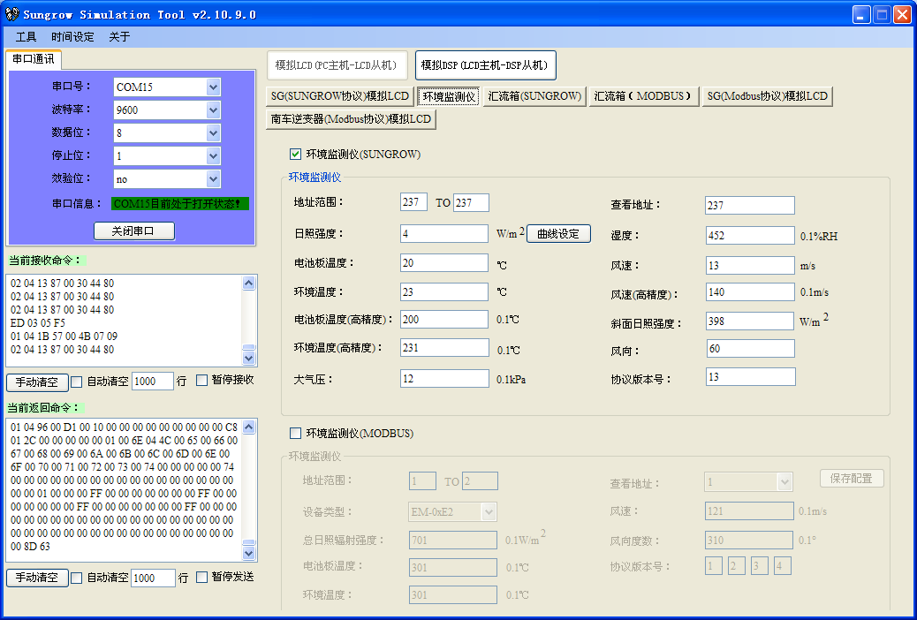
汇流箱实时数据：
69 69 01 00 A6 00 00 00 01 00 01 00 00 00 04 00 29 00 01 00 00 00 1D 09 0F 0E 04 0C 12 00 01 2D 01 2C 01 00 00 01 01 2E 01 C8 00 00 00 01 01 2F 01 65 00 00 00 01 01 30 01 66 00 00 00 01 01 31 01 67 00 00 00 01 01 32 01 68 00 00 00 01 01 33 01 69 00 00 00 01 01 34 01 6A 00 00 00 01 01 35 01 6B 00 00 00 01 01 36 01 6C 00 00 00 01 01 37 01 6D 00 00 00 01 01 38 01 6E 00 00 00 01 01 39 01 6F 00 00 00 01 01 3A 01 70 00 00 00 01 01 3B 01 71 00 00 00 01 01 3C 01 72 00 00 00 01 01 3D 01 73 00 00 00 01 01 3E 01 74 00 00 00 01 D9 F6 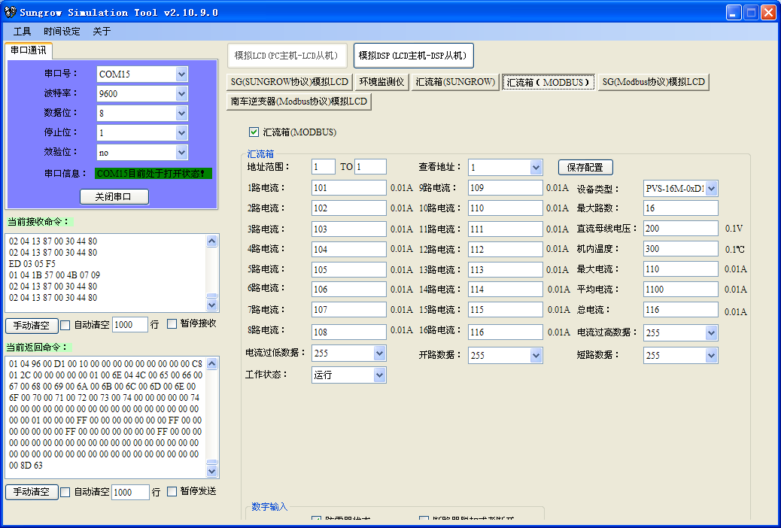
逆变器数据：
69 69 01 00 9E 00 00 00 01 00 01 00 00 00 04 00 29 00 02 00 02 00 17 0A 0F 0E 04 0C 11 00 03 C9 00 F9 7F 00 00 01 03 CA 00 28 69 05 00 01 01 CB 00 00 00 46 00 01 01 CC 00 DF 00 00 00 01 01 CF 00 D8 0E 00 00 01 01 D0 00 8A 01 00 00 01 01 D1 00 83 3A 00 00 01 01 D2 00 98 08 00 00 01 01 D3 00 A3 08 00 00 01 01 D4 00 9D 08 00 00 01 01 D5 00 AA 02 00 00 01 01 D6 00 A6 02 00 00 01 01 D7 00 A8 02 00 00 01 01 DB 00 00 00 C8 32 01 01 DD 00 E6 03 00 00 01 01 DD 00 F4 01 00 00 01 01 DD 00 E5 03 00 00 01 25 FF
