The Conscription Crisis of 1917

Begin your inquiry using this website from the Canadian War Museum:

<https://www.warmuseum.ca/firstworldwar/history/life-at-home-during-the-war/recruitment-and-conscription/conscription-1917/>

Inquiry Questions

1) What was conscription and why did the government of Canada feel it was necessary? Conscription is the enlistment into the armed forces. In 1917, the Federal government decided to conscript young men overseas for military service. The government felt conscription was necessary because voluntary recruitment was failing to maintain troop numbers. The prime minister at the time, Robert Borden, also believed in Canada making a strong contribution to the war.

2) Who supported it and why? Who didn’t and why? French-Canadians, as well as many farmers, unionized workers, non-British immigrants, and other Canadians generally opposed conscription. English-speaking Canadians, led by Prime Minister Borden and senior members of his Cabinet, as well as British immigrants, the families of soldiers, and older Canadians generally supported conscription.

3) What were the positions of Borden, Laurier and Bourassa? Laurier: Laurier strongly supported the war effort, but not the conscription government policy. He rejected many of Borden’s first introductions to conscription and became much like a celebrity to most of French Canada for being opposed to conscription in 1917. Many Liberals abandoned him to join Borden’s Unionized government.

Borden: Borden was the one initialized the idea of compulsory service or conscription in 1917. He won the election against Laurier through controversy by persuading Liberals into his Unionist concept by making conscription a test of loyalty against their own country. He improved his likelihood of winning the election by giving votes to people who are likely supporters of conscription. Conscription continued to be debated because of Borden.

Bourassa: A leading French-Canadian nationalist. In 1914, Bourassa supported the war effort but within a year he started to question Canada’s sacrifice. He was a very public opposer to compulsory service and referred to it as the blood tax. Bourassa was an advocate for peaceful protest against conscription after the Military Service act was passed in 1917.

4) From the primary sources on the website, look at the following primary source documents:

Conscription Trap

Directions for Voters

Enforcement of the Military Services Act

In terms of the origin, purpose and content of each document, discuss the values and limitations of each for a historian studying the conscription crisis.

Conscription Trap: In the Conscription Trap primary source document, it is a poster notice from a Methodist Church. The Church is putting out a notice for those who are eligible for compulsory service on how to avoid conscription. The poster contains information about a guest speaker, Captain Parsons, who is famous for speaking and her work in the Canadian newspapers. Captain Parsons also has 3 sons who are in the Canadian army. For a historian, the values of the origin of this document is that it is from a Methodist Church and you can easily draw conclusions. At this time, this poster would influence many people (including men eligible for conscription) since many Canadians were Christian at the time. The content of this primary source is valuable because it contains a prestigious speaker who has sons in the Canadian Army which can offer unique perspectives on the topic of conscription. The purpose

Directions for Voters: The origin of the Directions for Guidance of Voters document from the Dominion of Canada. The purpose of this document is to provide the guidance for voters on the nearing election at the time. The content of this document explains the details on who may vote and who may be voted for. One of the values of the origin of this document is that it is from the Dominion of Canada. The document is from a reputable source and can offer information on how the government of Canada gave notice to its voters. The origin of this document also has limitations because it is only offering one perspective which is the government. The content of the document is valuable because a historian can clearly analyze how the government chooses who can vote or not. This relates directly to the conscription crisis on how Borden only wanted people who had war relations to vote.

Enforcement of the Military Services Act: The origin of the document is from the Government of Canada. The purpose of the primary source document is to inform people of Canada about the enforcement on the Military Service Act. The content of the document regards information about who is being considered for exemption from the military service act.

**Values:**

**Limitaitons:**

5) Search the web for posters supporting and opposing conscription in Canada during WW1. What types of messages are conveyed on these posters? Describe the methods of propaganda that you see on the posters? Many of the types of messages on these posters are very straightforward in either direction. The posters supporting conscription generally have very bold messages in the middle saying things like, ‘WE WANT YOU’ or ‘VOTE YES’. Similarly, posters opposing conscription have messages like, ‘VOTE NO’ or ‘THE DEATH BALLOT’. Also, the anti-conscription posters have more images and stories than posters supporting conscription. Common methods of propaganda that these posters use are ‘Bandwagon’ and ‘Plain Folks’. The bandwagon method is used when posters provide messages pressuring readers to conscript because many of their friends have already. The plain folk method is used in the posters to make it seem more relatable to the majority of readers.

6) Have a look at the political cartoon below:

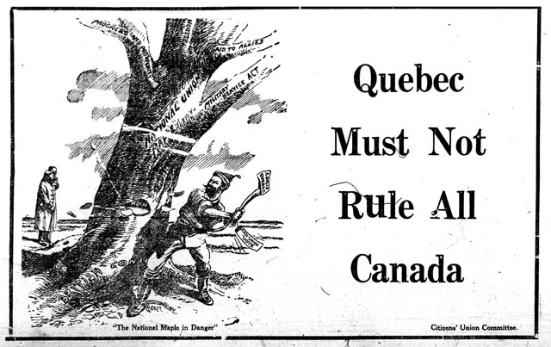

What is the message of the cartoon regarding conscription? This message of the cartoon regarding conscription is about French Canada’s resistance towards conscription.