Editor’s note:
- Delete all highlighted text before submission.
- All instructional text in each section should also be replaced.
- Make use of the predefined styles in the document to mark up your text.
- Take special care to format graphs, images and tables carefully. Make sure to include descriptive captions.
- If you are unsure of how a specific section should look, consult a few high quality published journal articles to understand what is expected.

Diegetic versus non-diegetic failure feedback: frustration and perceived competence in a 2D platformer

Name Surname 1, Name Surname 2 [replace with names and surnames]

- Abstract
Players fail often in games, so the way failure is communicated may affect how frustrated and competent they feel. This study compared diegetic failure feedback, presented inside the game world, with non-diegetic feedback, presented on the interface, in a 2D platformer. Both versions gave the same correction after each failure: a dog companion acted out the correct move in one, while an on-screen message and arrow described it in the other. Ten participants played one version each and then completed a questionnaire on competence satisfaction, competence frustration and tension/annoyance, followed by an interview. The questionnaire showed no significant differences, with only a small, non-significant trend towards less tension/annoyance in the diegetic version. Thematic analysis of the interviews showed that players in both versions understood their failures and saw the controls as the main source of difficulty. The main difference was how players saw the dog: useful when it acted and purposeless when idle. These exploratory findings suggest that whether failure feedback explains the mistake matters more than where it appears, and that in-world characters should take an active part in feedback.

- Introduction
In a platformer, players may fall or hit a hazard many times before finishing a level, so the way a game responds to failure shapes much of the experience. Self-determination theory treats competence as one of the basic needs behind motivation (Ryan and Deci, 2000), and every failure puts it at risk. Feedback that helps players understand what went wrong may protect their sense of competence, while unclear feedback may add to their frustration.
One design choice in failure feedback is where it is shown. Diegetic feedback belongs to the game world, such as a character demonstrating a move, while non-diegetic feedback sits outside the world and is meant for the player, such as on-screen text (Fagerholt and Lorentzon, 2009). Games research has compared the two mainly for immersion. It found that the benefits of diegesis depend on the player's expertise (Iacovides et al., 2015) and the type of game (Köhle et al., 2021), and that diegetic elements such as maps can support several kinds of immersion (Dormann and Wallner, 2026). Separate research shows that the content of feedback also matters, because explaining a mistake has a different effect from simply signalling it (Woo et al., 2015).
However, these studies examined interfaces in general, such as health displays and maps, rather than the moment of failure, when frustration and doubts about competence are strongest. In some, the information changed along with its presentation, for example when the heads-up display was removed entirely (Iacovides et al., 2015), making it hard to tell which caused the effect. To our knowledge, no study has compared diegetic and non-diegetic failure feedback while keeping the information identical, and measured how this affects players' frustration and sense of competence.
This study addresses that gap with a 2D platformer built in two versions. Both versions use the same system to detect the player's mistake, such as jumping too early or too late, and give the same correction. Only the presentation differs: in the diegetic version, a dog companion demonstrates the correct move, while in the non-diegetic version, on-screen text and an arrow explain it. The dog is visible in both versions. Ten participants each played one version, then completed a questionnaire and an interview.
No questionnaire measure differed significantly between the versions, with tension/annoyance only marginally lower for diegetic feedback. The interviews suggest why. Both versions explained every failure, so players understood their mistakes, and most named the controls as their main obstacle. The clearest contrast lay in how players viewed the dog, which was welcomed when it demonstrated and questioned when it did nothing. Overall, the explanation given seemed more important than its location, and an in-world character was judged by whether it helped.
This study investigates the effect of diegetic versus non-diegetic failure feedback on player frustration and perceived competence in a 2D platformer game. Two literature-based sub-questions support this aim. The first asks how existing definitions distinguish diegetic from non-diegetic game interfaces and feedback, which is needed to classify the two versions. The second asks how interface diegesis compares to non-diegesis in terms of its effect on immersion, frustration, and perceived competence, according to existing research, setting out what earlier work predicts. Two empirical sub-questions then address the gap directly. The third asks how diegetic failure feedback compares to non-diegetic failure feedback in terms of players' self-reported frustration and perceived competence, answered with the questionnaire. The fourth asks how players' descriptions of failure, competence, and motivation to continue compare between the diegetic and non-diegetic conditions, answered with interviews that explain what the scores alone cannot.

- Literature review (600-800 words)
This review covers how diegetic and non-diegetic interfaces are defined, what is known about their effect on player experience, and how failure feedback relates to frustration and perceived competence.

1.1 Diegetic and non-diegetic game interfaces
Fagerholt and Lorentzon (2009) provide the most widely used framework for classifying game interface elements. It classifies each element by whether it is part of the game's story world (diegetic) and whether it is located in the game's space (spatial). The answers give four categories. Diegetic elements belong to both, so the player character could perceive them (e.g. a health meter built into the character's suit). Meta elements belong to the story but not to the game space (e.g. blood spatter across the screen). Spatial elements appear in the game space but are not part of the story (e.g. glowing outlines of teammates that only the player can see). Non-diegetic elements belong to neither (e.g. a heads-up display showing a health bar or text prompt). Fagerholt and Lorentzon note that the more competitive a game, the more it needs unambiguous information, which an overlay display provides, whereas some diegetic cues must be interpreted by the player. Llanos and Jørgensen (2011) found the same tension in a qualitative study of players: in many cases players preferred overlay interfaces for their clear information, and interfaces built into the game world were not necessarily more involving.

2.1 Diegesis, immersion and player experience
Iacovides et al. (2015) compared two versions of a first-person shooter, with and without a non-diegetic heads-up display. Removing the display increased immersion for expert players, who felt more involved and more in control, which suggests that the benefit of diegetic presentation depends on the player's expertise. Peacocke et al. (2015) compared heads-up and diegetic ammunition displays in a first-person shooter and found that a diegetic number shown beside the weapon gave the best performance. Köhle et al. (2021) compared a non-diegetic health bar with a diegetic wristwatch and a physical cue in a virtual reality shooter. Participants saw the bar as suited to multiplayer games and the wristwatch as suited to single-player, story-driven games, so each approach had its own strengths. Dormann and Wallner (2026) analysed players' online posts about video game maps and found that diegetic maps, ranging from maps on walls to fully digital ones, can support spatial, narrative and emotional immersion. These studies are informative but limited: they examine immersion or performance rather than frustration or competence, three of them use shooters, and Dormann and Wallner's findings come from what players wrote online rather than from controlled play.

Failure feedback, frustration and perceived competence
Self-determination theory (Ryan and Deci, 2000) describes competence, together with autonomy and relatedness, as a basic psychological need. In games, players' sense of competence and autonomy predicts their enjoyment and wish to keep playing, and is linked to how intuitive the controls feel (Ryan, Rigby and Przybylski, 2006). Ballou et al. (2024) measure these needs in games with the Basic Needs in Games Scale, which treats competence satisfaction and competence frustration as two separate experiences rather than opposite ends of one scale, since a player can feel capable in some ways and inadequate in others after failing. Research on feedback adds that how a failure is explained also matters. Woo et al. (2015) found that feedback which only reported a failure increased activity in brain regions linked to negative emotion, whereas feedback that also gave task information helped participants regulate those emotions. Their participants were fourteen male students completing a laboratory task, but a meta-analysis of 435 educational studies supports the same principle: feedback's effect depends largely on the information it carries, with high-information feedback far more effective than simple reinforcement (Wisniewski, Zierer and Hattie, 2020). In a puzzle game, Shokeen et al. (2020) observed that well-designed failure and feedback produced productive frustration that supported learning, while poorly designed feedback produced frustration that got in the way of play. Ballou and Deterding (2023) add that need frustration arises when failures do not match what players expected, and that repeated mismatches lead players to quit.

Taken together, the literature offers two findings that have not yet been connected. The effect of diegesis depends on context and player expertise, and the way failure feedback is designed shapes frustration and competence. Existing comparisons of diegetic and non-diegetic interfaces concern general play rather than failure, and none has varied where failure feedback is shown while keeping its content the same. It therefore remains unknown whether presenting failure feedback within the game world or on the interface changes how frustrating or competence-supporting it is. This is the gap the present study addresses.

- Methods (800-1200 words)
This study used a mixed-methods, between-subjects design to compare diegetic and non-diegetic failure feedback: each participant played only one of two versions of a custom 2D platformer, then completed a post-play questionnaire and a short interview. The two versions were identical apart from how failure feedback was presented. A mixed-methods approach was used because the questionnaire could show whether the two versions differed, while the interviews could explain why, which a sample of ten could not do through statistics alone (Creswell, 2014).

1.1 Participants
Ten participants took part, five in each condition. They were recruited through convenience sampling, meaning the researchers invited people they could easily reach: all were friends of the researchers, and six were university students. This approach was chosen because recruitment and scheduling had to fit within a module-length project, and the study aimed to identify early patterns rather than results that apply to all players. Participants were allocated to a condition as they became available rather than at random. No demographic information, such as age, gender or prior gaming experience, was collected, as the questionnaire was limited to the items needed to answer the empirical sub-questions. Standard participant protections were followed: each participant received a written information sheet and gave informed consent, including separate consent for audio-recording of the interview, and was told they could stop at any point or withdraw their data afterwards without penalty. All data were anonymised using participant codes (P1–P10).

2.1 Materials
The game was built in Godot 4 using GDScript, chosen because its built-in physics and collision detection supported the hazards, checkpoints and controlled comparison the study required. It has five levels in which the player must avoid gaps, spikes and moving platforms. Both versions share the same level layout, hazard placement and difficulty, and a single failure-detection system that identifies what the player did just before failing: not jumping, jumping too early, jumping too late, or another mistake. Each type of mistake is linked to a matching correction, and after every failure the player restarts from the most recent checkpoint, which works the same way in both versions. In the diegetic version, the correction is demonstrated by a dog companion that is on screen from the start (e.g. pausing at the correct take-off point after an early jump), and the player character reacts physically with a stumble or recoil. In the non-diegetic version, the same correction is shown as heads-up display (HUD) text naming the mistake (e.g. “Jumped too early, take off later”) together with an on-screen arrow; the dog remains visible but does not demonstrate, and the player character does not react. Keeping the levels, timing and correction the same while changing only how the correction is presented means that any difference between the versions can be attributed to the presentation, in line with the diegetic/non-diegetic distinction described in the literature review (Fagerholt and Lorentzon, 2009).

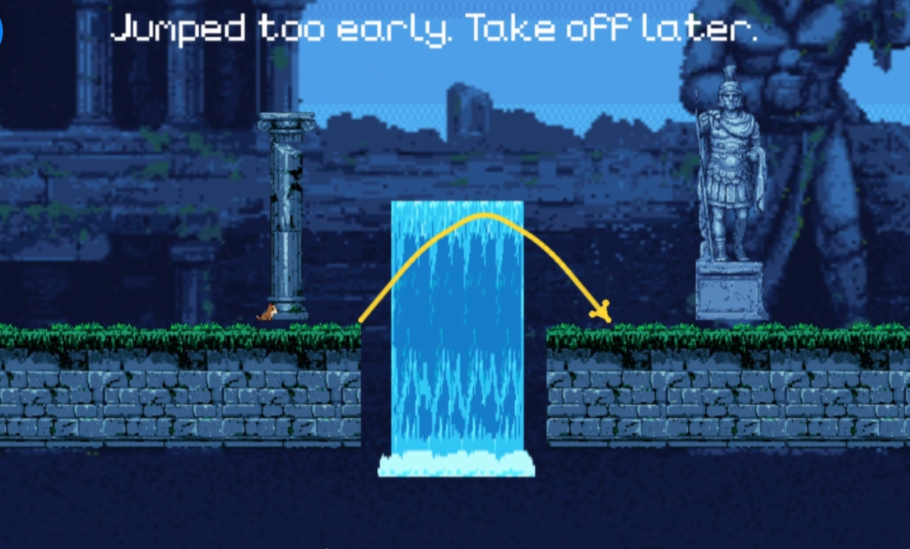
Figure 1: Screenshot of the non-diegetic condition, showing the heads-up display feedback message and arrow overlay displayed after a failed jump.

Two further instruments were used after gameplay. A post-play questionnaire on Google Forms combined six items from the Basic Needs in Games Scale (BANGS; Ballou et al., 2024), measuring competence satisfaction and competence frustration on a 7-point scale, with three tension/annoyance items from the Game Experience Questionnaire (GEQ; IJsselsteijn et al., 2013), rated on a 0–4 scale. The GEQ lacks a formal peer-reviewed publication, but its use has been systematically reviewed and its structure tested (Law, Brühlmann and Mekler, 2018). The BANGS items alternated between satisfaction and frustration, and the three GEQ items came last. These validated instruments were used instead of self-written items so that the results could be compared with earlier research. A semi-structured interview of eight open-ended questions (one opening question, six core questions on frustration, perceived competence and motivation to continue, and one closing question) guided an audio-recorded conversation with each participant.

3.1 Procedure
Each participant experienced only one condition, to avoid the learning and comparison effects that would arise from playing both versions. Ten sessions were held: seven in person on the researcher's laptop, and three remotely over a video call with screen sharing, for which the correct build of the game (two macOS, one Windows) was sent in advance via Google Drive. Remote sessions gave less control over the playing environment and hardware, but made it possible to include participants who were not available in person. For in-person sessions, the researcher selected the condition on the game's launcher screen before the participant sat down, so participants did not see which version had been chosen. After giving informed consent, each participant played their assigned version for up to fifteen minutes, or until they completed Level 5, without help from the researcher, then completed the questionnaire straight away, while the experience was still fresh, followed by an audio-recorded interview of about five minutes. Each session ended with a short debrief explaining that the difficulty was intentional and that the study compared two ways of presenting the same correction. Afterwards, the interview recordings were transcribed automatically and anonymised, with names replaced by participant codes before analysis. Questionnaire responses were exported from Google Forms into a spreadsheet, with names and email addresses removed and each response labelled with its participant code, so that no identifying information was stored with the responses.

- Results
Sub-question 3: How does diegetic failure feedback compare to non-diegetic failure feedback in terms of players' self-reported frustration and perceived competence?
For each participant, three subscale scores were calculated as the mean of their items: competence satisfaction (BANGS items 1, 3 and 5) and competence frustration (items 2, 4 and 6), kept separate as recommended by Ballou et al. (2024), and tension/annoyance (GEQ items 7–9). Normality was checked in each group using the Shapiro-Wilk test (Shapiro and Wilk, 1965). Normal subscales were compared using a two-tailed Welch's t-test (Welch, 1947), and non-normal subscales using a Mann-Whitney U test (Mann and Whitney, 1947), with α = .05.
As Table 1 shows, all subscales were normally distributed except competence satisfaction in the non-diegetic group, W = .77, p = .045, where one low score (3.67) skewed the distribution. Competence satisfaction was therefore compared using the Mann-Whitney U test instead.

Table 1: Descriptive statistics and Shapiro-Wilk normality results for each subscale by condition (n = 5 per group). Competence satisfaction and competence frustration were rated on a 1–7 scale, and tension/annoyance on a 0–4 scale.
Subscale | Condition | M | SD | Mdn | W | p
Competence satisfaction | Diegetic | 6.07 | 1.01 | 6.33 | .80 | .086
 | Non-diegetic | 6.00 | 1.35 | 6.67 | .77 | .045
Competence frustration | Diegetic | 2.40 | 0.98 | 2.00 | .83 | .141
 | Non-diegetic | 2.53 | 1.22 | 2.67 | .97 | .884
Tension/annoyance | Diegetic | 1.33 | 0.85 | 1.67 | .85 | .207
 | Non-diegetic | 1.73 | 1.30 | 1.33 | .95 | .758

None of the differences between the groups were significant (Table 2; Figure 2). Competence satisfaction was similar in the diegetic (Mdn = 6.33) and non-diegetic (Mdn = 6.67) groups, U = 12.00, p = 1.000, r = .03, as was competence frustration (diegetic M = 2.40, SD = 0.98; non-diegetic M = 2.53, SD = 1.22), t(7.66) = −0.19, p = .854, d = −0.12. Tension/annoyance was slightly lower in the diegetic group (M = 1.33, SD = 0.85) than in the non-diegetic group (M = 1.73, SD = 1.30), t(6.89) = −0.58, p = .583, d = −0.36.

Table 2: Between-group comparisons for each subscale (two-tailed, α = .05). Effect sizes are r for the Mann-Whitney U test and Cohen's d for the t-tests. Negative values indicate lower scores in the diegetic group.
Subscale | Test | Test statistic | p | Effect size
Competence satisfaction | Mann-Whitney U | U = 12.00 | 1.000 | r = .03
Competence frustration | Welch's t-test | t(7.66) = −0.19 | .854 | d = −0.12
Tension/annoyance | Welch's t-test | t(6.89) = −0.58 | .583 | d = −0.36

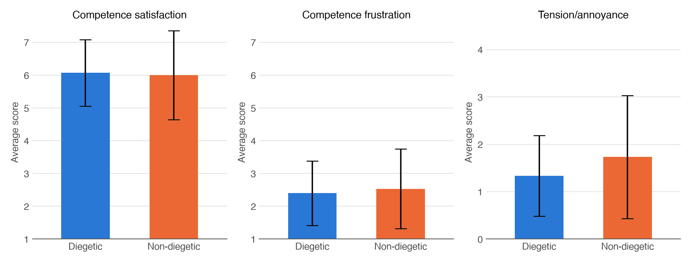
Figure 2: Mean subscale scores for the diegetic (n = 5) and non-diegetic (n = 5) groups. Competence satisfaction and competence frustration were rated on a 1–7 scale, and tension/annoyance on a 0–4 scale. Error bars show ±1 standard deviation. None of the differences between groups were statistically significant.
Answer to sub-question 3. Feedback type made no clear difference to perceived competence or frustration: both groups felt highly competent and only mildly frustrated. The one trend, lower tension/annoyance with diegetic feedback, was small (Cohen, 1988) and not significant. With five participants per group, the tests could reliably detect only very large effects (around d = 2.0), so a smaller effect cannot be ruled out.
Sub-question 4: How do players' descriptions of failure, competence, and motivation to continue compare between the diegetic and non-diegetic conditions?
The transcripts were analysed using reflexive thematic analysis (Braun and Clarke, 2006). After familiarisation with the data, segments relating to failure, the feedback, competence and motivation were coded inductively, grouped into candidate themes, reviewed against the full dataset, and then defined and named. The five resulting themes, summarised in Figure 3, were compared between the diegetic (P1, P2, P5, P7, P9) and non-diegetic (P3, P4, P6, P8, P10) groups.

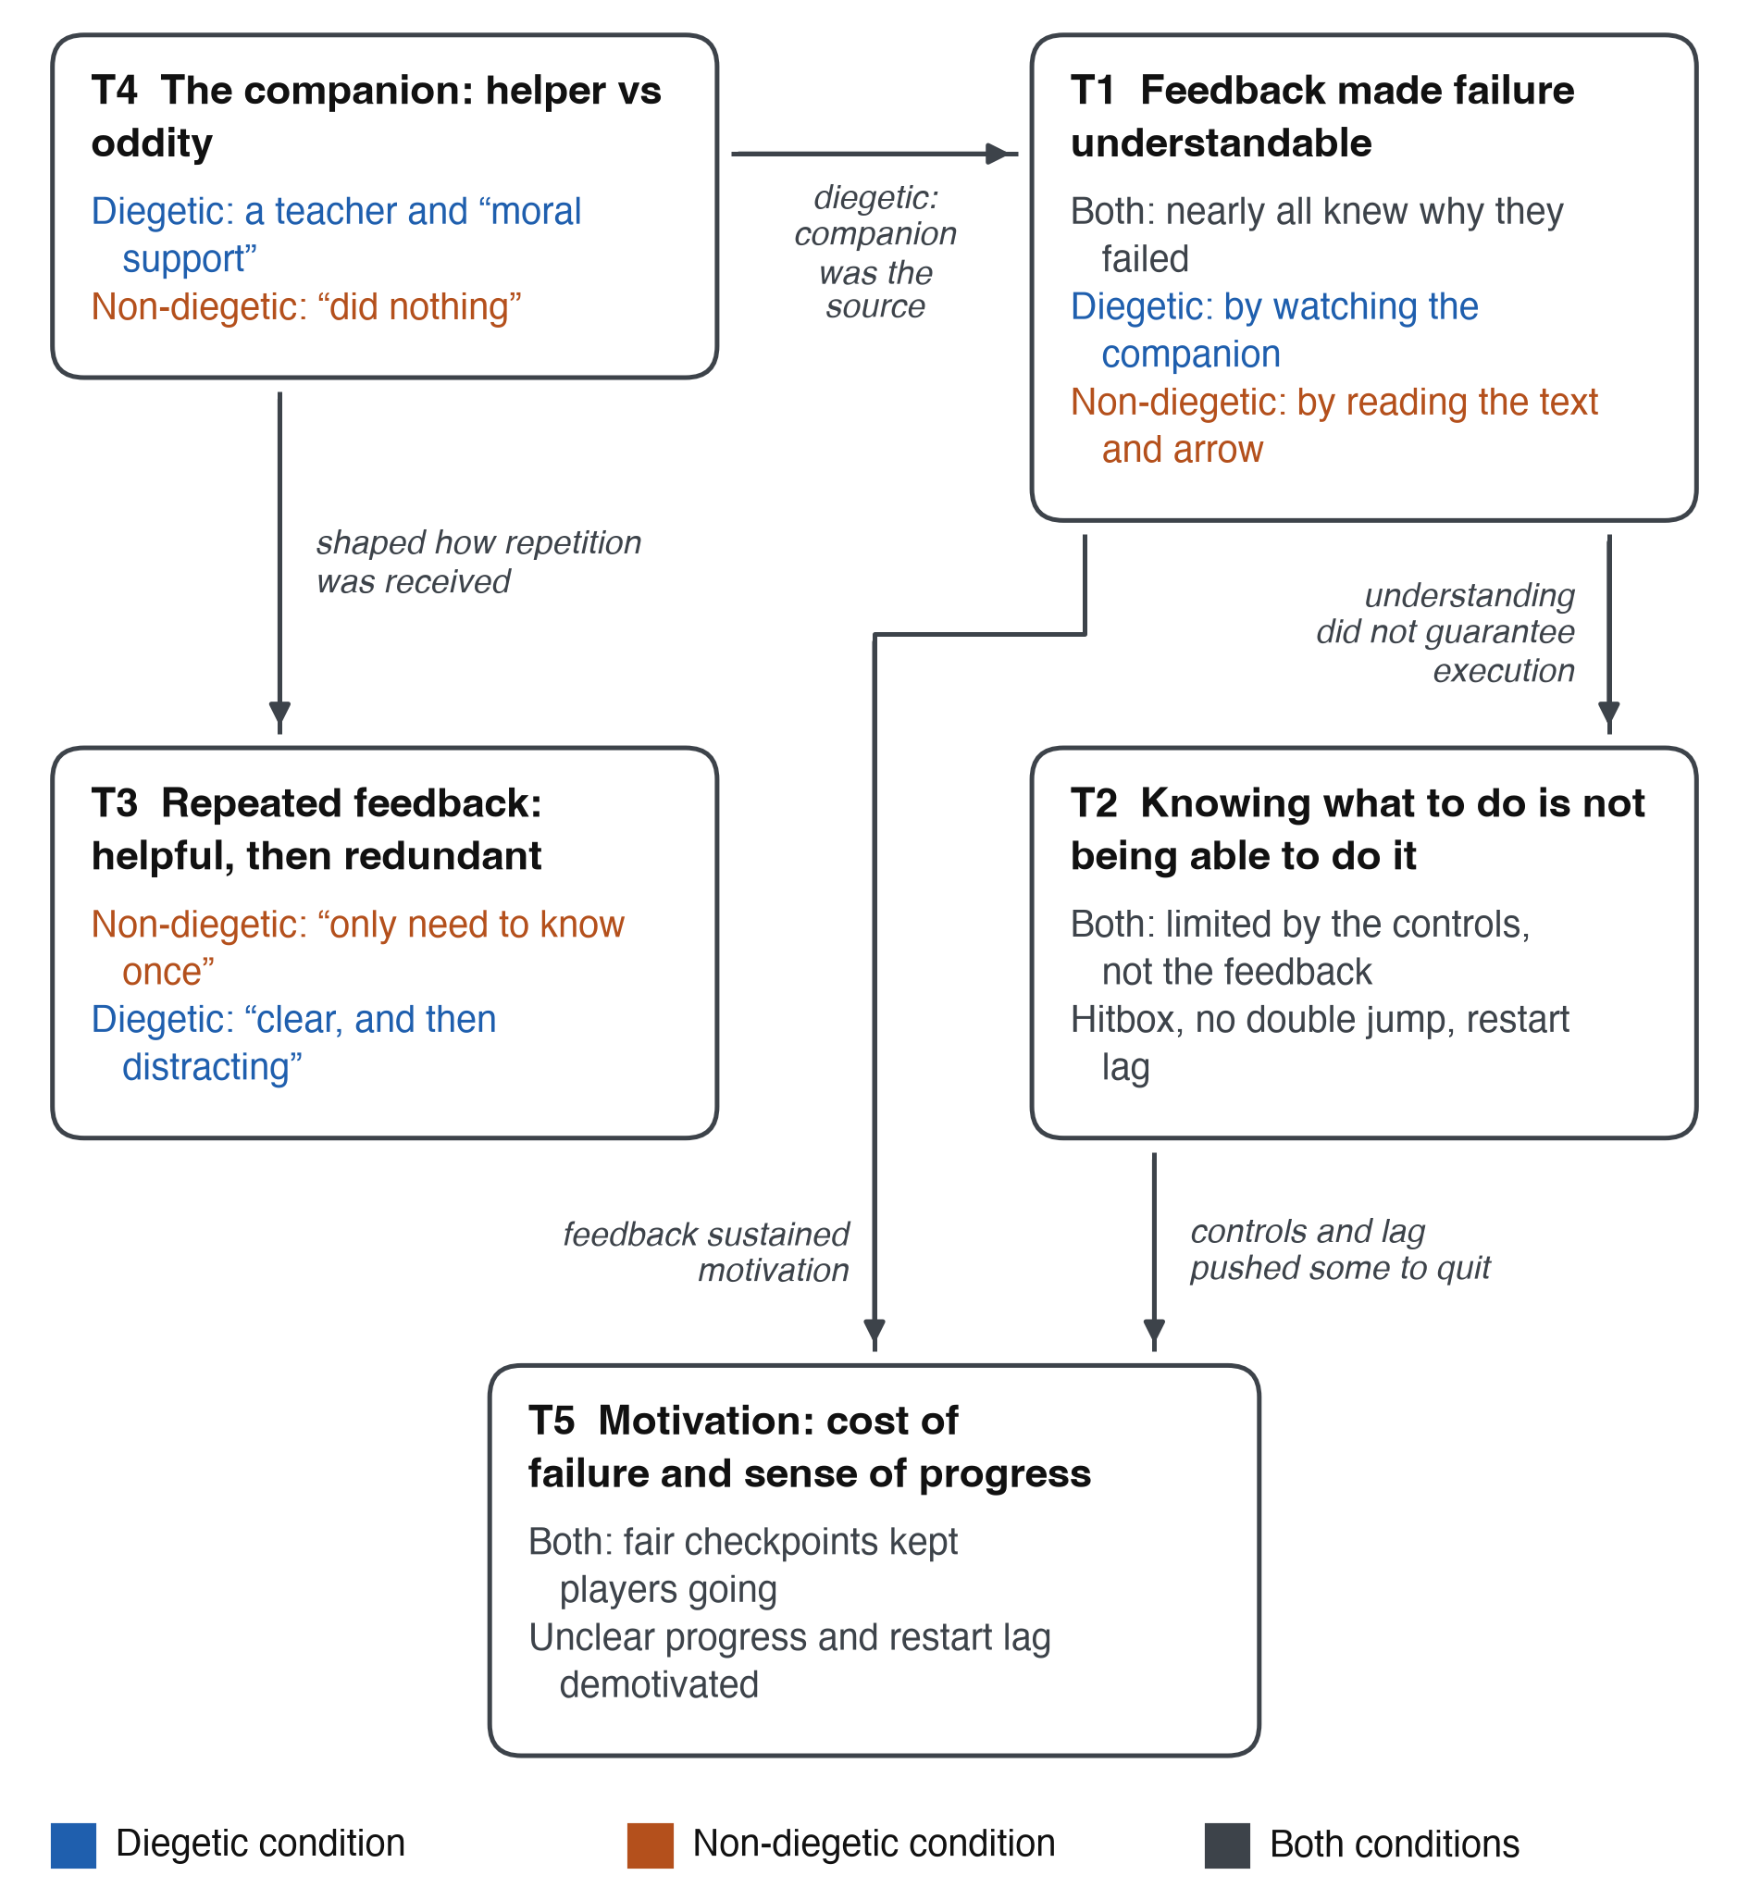
Figure 3: Thematic map of the five themes developed from the post-play interviews. Text colour shows whether a code came from the diegetic group (blue), the non-diegetic group (orange) or both groups (grey), and arrows show the links between themes.
Theme 1: Feedback made failure understandable in both conditions. Nearly all players knew why they had failed, but they learned it differently. Diegetic players watched the companion, whose demonstration made failure “easy to understand and easy to follow” (P2). Non-diegetic players read the text, which “tells you exactly what you did wrong” (P8). In both groups, understanding sometimes took a few attempts (P1, P3). Feedback type changed how players understood failure, not whether they did.
Theme 2: Knowing what to do was not the same as being able to do it. Both groups blamed the controls, not the feedback, for limiting their competence: the missing double jump, the hitbox, and the character sticking in the air on restart. P3 knew what to do, but “it was the implementing that was difficult”. The same feedback could help or hinder. The arrow showed P8 there was no double jump, which made them feel more capable, while being told to jump further than the controls allowed gave P4 “a false sense of capability”.
Theme 3: Repeated feedback was helpful at first, then redundant. Once understood, repeated feedback became redundant, mainly in the non-diegetic group: P6 said “I only need to know once”, and P8 felt the game “holds your hand”. P3 disagreed, valuing the text as a reminder. Diegetic player P7 also found the demonstration “clear, and then distracting”, but said they “would find words distracting”, which suggests repetition may be easier to accept from the companion.
Theme 4: The companion was a helper when it demonstrated, and an oddity when it did not. This was the clearest difference between the groups. Diegetic players saw the companion as a helper that would “show you how to do it” (P1) and was worth keeping “for moral support” (P5). Non-diegetic players, whose companion never demonstrated, saw no purpose in it: it “did nothing” (P6), was “not helping” (P3) or looked “out of place” (P8). Whether the companion took part in the feedback decided how it was seen.
Theme 5: Motivation to continue depended on the cost of failure and a sense of progress. Most players kept going because failure was cheap: it “didn't feel catastrophic” (P2), although for P6 the lack of “consequences” encouraged careless jumping. Some credited the feedback, without which P8 “probably would have quit”. Demotivation came from elsewhere. The restart lag made it “easier to quit” (P4), and not knowing how many levels remained left P5 asking, “Am I just gonna fail forever?” Several players (P3, P5, P8, P9, P10) wanted clearer signs of progress.
Answer to sub-question 4. In both conditions, players found failure understandable and worth retrying, and blamed the controls rather than the feedback for the limits on their competence. Motivation hinged less on feedback type than on how cheap failure felt and whether progress was visible. The conditions differed mainly in the companion's role: a teacher when it demonstrated, and pointless when it did not. Non-diegetic players also more often found repeated feedback redundant. This fits the questionnaire results, which showed similar competence scores, and slightly lower tension/annoyance in the diegetic group.

- Discussion
This section first answers the two literature-based sub-questions, and then uses all four answers to address the primary research question.
Sub-question 1: How do existing definitions distinguish diegetic from non-diegetic game interfaces and feedback?
The literature review showed that the most widely used definition comes from Fagerholt and Lorentzon (2009). They sort interface elements using two questions: does the element belong to the story world, and does it appear inside the game's space? Diegetic elements do both, so the characters in the game could see them. Non-diegetic elements do neither and are visible to the player alone, for example text on a heads-up display. Two in-between categories cover elements that meet only one of these conditions. Dormann and Wallner (2026) show that even diegetic maps alone take many forms, so diegesis covers a range of designs rather than a single type.
Answer to sub-question 1. Diegetic and non-diegetic feedback are told apart by where the feedback appears, inside or outside the game world, not by what it says. Because the definition concerns location rather than content, the same correction can be given either way, which is what allowed this study to keep the content the same in both versions. Under this definition, the dog's demonstration is diegetic, while the on-screen text and arrow are non-diegetic.
Sub-question 2: How does interface diegesis compare to non-diegesis in terms of its effect on immersion, frustration, and perceived competence, according to existing research?
Earlier studies do not show that either approach is better in general, as their effect on immersion depends on the situation. Expert players in particular became more immersed without the heads-up display (Iacovides et al., 2015). A non-diegetic bar fitted multiplayer play and a diegetic wristwatch fitted story-driven play (Köhle et al., 2021), and while a diegetic display can improve performance (Peacocke et al., 2015), players often prefer overlays for their clarity (Llanos and Jørgensen, 2011). Diegetic maps also supported immersion in several ways (Dormann and Wallner, 2026). None of the reviewed studies measured how either approach affects frustration or competence. The closest evidence concerns what feedback says rather than where it appears. Feedback that explains a mistake is processed by the brain as useful information, while feedback that only signals a mistake is processed as a threat (Woo et al., 2015), and across education, high-information feedback is the most effective kind (Wisniewski, Zierer and Hattie, 2020). In games, poorly designed failure feedback has been linked to frustration that disrupts play (Shokeen et al., 2020), and players disengage when failures repeatedly defy their expectations (Ballou and Deterding, 2023).
Answer to sub-question 2. Diegetic interfaces can increase immersion, but the benefit varies with player expertise and the type of game. Their effect on frustration and competence has not been tested directly. However, research on feedback suggests that these outcomes depend mostly on whether the feedback explains the failure. This leads to the expectation that where feedback is presented should matter less when what it says is the same.
Primary research question: The effect of diegetic versus non-diegetic failure feedback on player frustration and perceived competence in a 2D platformer game
Together, the four answers suggest that when both types of feedback give the same explanation, they affect frustration and perceived competence similarly. The questionnaire found no significant differences (sub-question 3), and interviewees in both groups could explain their failures (sub-question 4). This matches the expectation from sub-question 2. Because one failure-detection system controlled both versions, every failure was followed by an explanation of what went wrong. Both versions therefore gave players what the literature identifies as the key to keeping frustration useful (Woo et al., 2015; Shokeen et al., 2020), which left little for the presentation itself to change. This is the study's main contribution to the gap identified in the literature review. Earlier studies compared whole interface styles, so their differences may partly reflect what each interface communicated. Once the content was kept the same, where the feedback appeared made little measurable difference.
Other explanations for the lack of a difference should also be considered. First, both groups rated their competence close to the top of the scale, leaving little room for either version to raise it further. Second, players in both versions attributed their remaining difficulty to the controls. Players understood this frustration but could not overcome it, and no type of feedback could remove it. This is consistent with Ryan, Rigby and Przybylski (2006), who found that perceived competence in games depends partly on whether the controls feel intuitive. Ballou and Deterding (2023) found that repeated frustration of this kind leads players to quit, yet most players here kept going, helped by quick restarts (sub-question 4). Third, Iacovides et al. (2015) found that the benefit of removing the heads-up display depended on expertise, which suggests that diegetic cues take skill to read. Yet diegetic players here did not struggle more to understand the feedback, perhaps because the dog showed the exact route to take, which needs little interpretation. Finally, the study had a low chance of detecting small effects: about 8% for an effect the size of the tension/annoyance difference (d = 0.36).
Where the versions did differ, the differences suggest how presentation might still matter. The diegetic group's slightly lower tension/annoyance matches the interview finding that repeated messages became tiresome mainly for non-diegetic players. According to Llanos and Jørgensen (2011), overlay interface elements become annoying once players receive more information than they need. Once players already knew the correction, the same message may have felt like this, while the dog's demonstration remained part of the game world. This explanation is tentative, as it rests on a non-significant trend and a small number of interviews. The clearest difference concerned the dog itself. In the non-diegetic version the dog stayed on screen but never helped, and players described it as pointless. This fits Ballou and Deterding's (2023) account of frustration arising when events break players' expectations: a companion that is present but never helps breaks the expectation that it will. The non-diegetic version was therefore not only missing diegetic feedback; it also contained an inactive in-world character, which may have added to its slightly higher tension/annoyance.
In answer to the primary question, this exploratory study found no clear effect of diegetic versus non-diegetic failure feedback on frustration or perceived competence when both gave the same correction. Whether the feedback explained the failure appeared to matter more than where it was shown. Diegetic feedback may slightly reduce tension/annoyance, but this could not be confirmed. Its clearest effect was on whether the in-world character was seen as a helper or as pointless, which suggests that giving such characters an active role in feedback may be as important as diegesis itself.

- Implications (400-600 words)
These results agree with earlier findings that diegesis has no fixed effect (see sub-question 2) and extend them to the moment of failure. They also support Woo et al.'s (2015) finding, here in a game setting, that people's response to negative feedback depends on what it says. This fits self-determination theory, which holds that feedback supports competence when it informs rather than judges (Ryan and Deci, 2000). For research, the main implication concerns study design: studies comparing the two kinds of interface need to keep the information identical, or any difference cannot be attributed to presentation alone.

There is also another way to read the questionnaire results. Instead of showing that diegetic and non-diegetic feedback work equally well, they may show that something shared by both versions outweighed the feedback. Players in both groups linked their frustration to the controls, and a strong shared source of frustration could have hidden a smaller difference caused by the feedback (see Limitations). On this reading, the study does not show that presentation is unimportant, only that its effect was smaller than that of the game's controls.

The most unexpected result was how players reacted to the dog when it did not help. The dog appeared in both versions so that its presence would not differ between them, yet in the non-diegetic version it attracted criticism. One player felt it was “unfair” that the dog was “literally just there” (P3). Fagerholt and Lorentzon's (2009) definition asks only whether characters could perceive an element. These reactions suggest that players also expect an in-world character to act. Once a companion is part of the world, doing nothing sends a message of its own.

For game designers, these findings have four practical implications, although they come from a small exploratory study. First, how clearly failure feedback explains the error appears to matter more than its form, so designers can choose the presentation that suits their game, provided the feedback explains what went wrong. For example, a story-driven game could use a character, while a multiplayer game could use text. Second, diegetic feedback that shows the solution, as the dog did, may suit players of all skill levels, whereas the benefits of less direct in-world cues have been found mainly for experts (Iacovides et al., 2015). Third, a companion character that is present when the player fails should take part in the feedback, or it may be seen as pointless or unfair. Fourth, repeated feedback could be reduced once the player has understood it, since repetition was where the non-diegetic version seemed to lose players' patience.

- Limitations (200-400 words)
The main limitation is sample size. With ten participants, the study could detect only very large differences between the versions, so its null results are inconclusive: they do not show that feedback type has no effect, and the small tension/annoyance difference may be either a real effect or chance. The study's conclusions therefore rest more on the interviews than on the questionnaire.

The sample may also be biased. Because conditions were assigned by availability rather than at random, and no gaming-experience data were collected, the groups may have differed in, for example, platformer experience. This matters because expertise affected how players responded to interface design in earlier work (Iacovides et al., 2015). In addition, every participant knew the researchers, who also built the game and conducted the interviews, which may have made them more positive or less critical than other players would be.

The measures and data also had gaps. The questionnaire's general items could not separate frustration caused by the controls from frustration caused by the feedback, and none asked about the companion, so the main contrast between the conditions appeared only in the interviews. A large validation study also did not support the GEQ's original structure (Law, Brühlmann and Mekler, 2018), so the tension/annoyance scores should be read with some caution. Two interview transcripts (P7 and P9) were incomplete, leaving the diegetic group's themes to rest mainly on three participants.

Finally, the study used one short play session in a single custom platformer, so the findings may not apply to longer play, other genres or other forms of diegetic feedback.

- Future work (200-400 words)
Future studies need a larger sample. Detecting a tension/annoyance difference as small as the one observed here (d = 0.36) with 80% power would require about 123 participants per group. A larger study could also record gaming experience and test whether it changes how players respond to each version, for example whether a demonstration helps less experienced players most.

The controls should be improved before the comparison is repeated, for example by tightening the spike hitbox and adding the double jump players expected. This would separate frustration with the controls from frustration with the feedback, making any remaining difference easier to attribute to the feedback. Clearer signs of progress between levels, which several players requested, would also remove a source of demotivation shared by both versions.

Because the companion produced the clearest difference, future work should add questionnaire items on how players see an in-world helper, such as its usefulness and fairness. Comparing an active companion, an idle companion and no companion would also show how much of the effect comes from the companion's presence rather than from diegetic feedback itself.

Because some players found the feedback helpful at first and redundant later, longer or repeated sessions could test whether an in-world demonstration holds up better over time than a repeated on-screen message. Finally, repeating the study in another genre, with random allocation and participants from outside the researchers' social circle, would show how far the findings apply beyond this platformer and sample.

- Conclusion
This study set out to address a gap identified in the introduction. Research on diegetic and non-diegetic interfaces had focused on immersion during general play, and no study had compared the two at the moment of failure while keeping the information they gave the same. It was therefore unclear whether presenting failure feedback inside the game world changes how frustrated or competent players feel.
To test this, two versions of a 2D platformer gave identical corrections after each failure, delivered either by a dog companion demonstrating the right jump or by a written message with an arrow. Across ten players, neither version produced significantly different levels of competence satisfaction, competence frustration or tension/annoyance. The interviews explained why: both versions told players exactly what had gone wrong, so each group could make sense of its failures, and what held players back was mostly the game's controls. The versions differed most in how players saw the companion, valuing it when it helped and dismissing it when it stood idle.
The study's main contribution is to separate what failure feedback says from where it is shown. In this sample, the explanation mattered more than its location, in line with earlier work showing that the information carried by feedback drives its effect. At the same time, diegesis shaped how players judged a character placed in the game world, which suggests that such characters should help deliver feedback rather than stand by. These conclusions remain exploratory given the small sample, but the study offers a controlled design that future work can repeat at a larger scale to test whether the small difference in tension/annoyance holds.

- Critical reflection
We began with a different question: how punitive failure feedback, which penalises the player, compares with informative feedback, which helps them, in its effect on frustration, perceived competence and persistence. Feedback on our first deliverable exposed its weaknesses. The outcome was easy to predict, because one version was designed to annoy players and the other to help them, few real games work this way, and we planned to measure too many things, including retry counts that would not show how players actually felt. Changing direction meant setting aside a literature review we had already written, which was frustrating, but looking back it was one of the most useful decisions we made. Returning to the literature taught us to judge a gap by asking whether it has actually been studied, whether its outcome is genuinely uncertain, and whether we could test it with the time and participants we had. Keeping failure feedback, frustration and competence, but comparing where the feedback is shown rather than whether it helps, gave us a question that met all three, especially once we kept the content of the feedback identical. The lesson we take forward is to test a research idea against the literature, and against existing games, before committing to it.
We also started with an assumption we did not examine closely enough: that diegetic feedback would be less frustrating because it keeps players inside the game world. The results did not support this. At first we read the null result, finding no significant difference, as a failure of the study. Working through the Discussion changed our view, because a carefully explained null result still says something useful, particularly when it suggests that earlier comparisons may have mixed up what an interface says with where it says it. The finding we did not expect at all was the dog. We put the dog in both versions to keep them equivalent, yet when it stood idle, players saw it as pointless. A decision made to control one variable created another, which showed us how hard it is to change only one thing in a game.
Several lessons came from feedback on our deliverables. Our lecturer's comments on the beta version showed that the two conditions did not give the same information: the text named the mistake, while the dog only showed a route. Rebuilding both versions around a single failure-detection system made the study a fair comparison, and taught us that equivalence has to be designed in, not assumed. Our statistical plan also changed twice. We first planned descriptive statistics only, were then asked to run t-tests despite the small sample, and after the Deliverable 7 feedback learned to check whether the data were normally distributed before choosing between a t-test and a Mann-Whitney U test. This forced us to understand what each test assumes rather than follow a recipe. The study also made clear why mixed methods mattered: the questionnaire alone would have told us only that nothing differed, whereas the interviews explained why and revealed the two findings we now consider most important: the idle dog and the controls.
The biggest challenge was the gap between our plan and what we could carry out. In Deliverable 4 we planned a larger sample, allocation balanced by gaming skill, and a sub-question about skill level. Our lecturer advised that the skill question needed more advanced statistics than the study allowed, and in practice participants were allocated as they became available. We chose to report this openly rather than present the study as more controlled than it was. Three sessions also had to run online, which meant building a Windows version and accepting less control over each player's setup. We took informal notes on what players said while playing, but these had not been planned in earlier deliverables and could not be standardised, so we left them out of the analysis. This taught us to fix our data sources before collecting data, not after.
Early playtesting brought its own surprises. One playtester found a gap that let them fall out of Level 3 into empty space. We fixed it by adding an invisible floor beneath the platform, but it was a route our own testing had never covered. Catching it before data collection showed us that players do things designers do not expect, a lesson we learned again when players reacted to the idle dog in ways we had not anticipated. Late in the writing process, we also found that some sources had been described more strongly than the papers supported. Checking every claim against the original papers took time, but it made us far more careful in how we use literature. Finally, writing separate sections meant ideas were repeated across the article, and learning to edit it into one voice was a challenge in itself.
If we repeated the study, we would pilot the game with people outside the team specifically to find control problems, since players blamed the controls more than the feedback. We would also decide the sample size and allocation method before recruiting, ask a simple question about gaming experience, and include a version without the companion, rather than discovering its effect by accident.
Overall, this project changed how we understand research. We learned that a study is only as strong as its control over what it compares, that a null result can be a contribution when it is explained carefully, and that literature has to be read closely, not just cited. It also changed how we think about game design: where feedback appears matters less than whether it shows players their mistake, and every element in a game world, even a dog that does nothing, tells the player something. We will carry these lessons into future projects, above all by planning our analysis, sample and data collection in full before the first participant arrives.

- References
Ballou, N. and Deterding, S. (2023) ‘“I just wanted to get it over and done with”: a grounded theory of psychological need frustration in video games’, Proceedings of the ACM on Human-Computer Interaction, 7(CHI PLAY), pp. 217–236. doi:10.1145/3611028.
Ballou, N., Denisova, A., Ryan, R.M., Rigby, C.S. and Deterding, S. (2024) ‘The Basic Needs in Games Scale (BANGS): a new tool for investigating positive and negative video game experiences’, International Journal of Human-Computer Studies, 188, 103289. doi:10.1016/j.ijhcs.2024.103289.
Braun, V. and Clarke, V. (2006) ‘Using thematic analysis in psychology’, Qualitative Research in Psychology, 3(2), pp. 77–101. doi:10.1191/1478088706qp063oa.
Cohen, J. (1988) Statistical power analysis for the behavioral sciences. 2nd edn. Hillsdale, NJ: Lawrence Erlbaum Associates.
Creswell, J.W. (2014) Research design: qualitative, quantitative, and mixed methods approaches. 4th edn. Thousand Oaks, CA: SAGE.
Dormann, C. and Wallner, G. (2026) ‘How diegetic maps shape wayfinding, storytelling, and immersion’, in Proceedings of the 21st International Conference on the Foundations of Digital Games. New York: ACM. doi:10.1145/3815598.3815655.
Fagerholt, E. and Lorentzon, M. (2009) Beyond the HUD: user interfaces for increased player immersion in FPS games. Master's thesis. Chalmers University of Technology.
Iacovides, I., Cox, A., Kennedy, R., Cairns, P. and Jennett, C. (2015) ‘Removing the HUD: the impact of non-diegetic game elements and expertise on player involvement’, in Proceedings of the 2015 Annual Symposium on Computer-Human Interaction in Play (CHI PLAY ’15). New York: ACM, pp. 13–22. doi:10.1145/2793107.2793120.
IJsselsteijn, W.A., de Kort, Y.A.W. and Poels, K. (2013) The Game Experience Questionnaire. Eindhoven: Technische Universiteit Eindhoven.
Köhle, K., Hoppe, M., Schmidt, A. and Mäkelä, V. (2021) ‘Diegetic and non-diegetic health interfaces in VR shooter games’, in Human-Computer Interaction – INTERACT 2021. Cham: Springer, pp. 3–11. doi:10.1007/978-3-030-85613-7_1.
Law, E.L.-C., Brühlmann, F. and Mekler, E.D. (2018) ‘Systematic review and validation of the Game Experience Questionnaire (GEQ): implications for citation and reporting practice’, in Proceedings of the 2018 Annual Symposium on Computer-Human Interaction in Play (CHI PLAY ’18). New York: ACM, pp. 257–270. doi:10.1145/3242671.3242683.
Llanos, S.C. and Jørgensen, K. (2011) ‘Do players prefer integrated user interfaces? A qualitative study of game UI design issues’, in Proceedings of DiGRA 2011 Conference: Think Design Play. DiGRA. doi:10.26503/dl.v2011i1.514.
Mann, H.B. and Whitney, D.R. (1947) ‘On a test of whether one of two random variables is stochastically larger than the other’, The Annals of Mathematical Statistics, 18(1), pp. 50–60. doi:10.1214/aoms/1177730491.
Peacocke, M., Teather, R.J., Carette, J. and MacKenzie, I.S. (2015) ‘Evaluating the effectiveness of HUDs and diegetic ammo displays in first-person shooter games’, in 2015 IEEE Games Entertainment Media Conference (GEM). IEEE, pp. 1–8. doi:10.1109/GEM.2015.7377211.
Ryan, R.M. and Deci, E.L. (2000) ‘Self-determination theory and the facilitation of intrinsic motivation, social development, and well-being’, American Psychologist, 55(1), pp. 68–78. doi:10.1037/0003-066X.55.1.68.
Ryan, R.M., Rigby, C.S. and Przybylski, A. (2006) ‘The motivational pull of video games: a self-determination theory approach’, Motivation and Emotion, 30(4), pp. 344–360. doi:10.1007/s11031-006-9051-8.
Shapiro, S.S. and Wilk, M.B. (1965) ‘An analysis of variance test for normality (complete samples)’, Biometrika, 52(3–4), pp. 591–611. doi:10.1093/biomet/52.3-4.591.
Shokeen, E., Pellicone, A., Weintrop, D., Ketelhut, D.J., Williams, C.C., Plane, J.D. and Cukier, M. (2020) ‘Designing failure and feedback within puzzles’, in Extended Abstracts of the 2020 Annual Symposium on Computer-Human Interaction in Play (CHI PLAY ’20 EA). New York: ACM, pp. 370–374. doi:10.1145/3383668.3419901.
Welch, B.L. (1947) ‘The generalization of “Student's” problem when several different population variances are involved’, Biometrika, 34(1–2), pp. 28–35. doi:10.1093/biomet/34.1-2.28.
Wisniewski, B., Zierer, K. and Hattie, J. (2020) ‘The power of feedback revisited: a meta-analysis of educational feedback research’, Frontiers in Psychology, 10, article 3087. doi:10.3389/fpsyg.2019.03087.
Woo, Y., Song, J., Jiang, Y., Cho, C., Bong, M. and Kim, S. (2015) ‘Effects of informative and confirmatory feedback on brain activation during negative feedback processing’, Frontiers in Human Neuroscience, 9, article 378. doi:10.3389/fnhum.2015.00378.

