Make sure that Hadoop is installed on your system with the Java SDK.

**Steps**

1. Open Eclipse> File > New > Java Project >( Name it – MRProgramsDemo) > Finish.
2. Right Click > New > Package ( Name it - PackageDemo) > Finish.
3. Right Click on Package > New > Class (Name it - WordCount).
4. Add Following Reference Libraries:
   1. Right Click on Project > Build Path> Add External
      1. */usr/lib/hadoop-0.20/****hadoop-core.jar***
      2. *Usr/lib/hadoop-0.20/lib/****Commons-cli-1.2.jar***

Source Code:

package PackageDemo;

import java.io.IOException;

import org.apache.hadoop.conf.Configuration;

import org.apache.hadoop.fs.Path;

import org.apache.hadoop.io.IntWritable;

import org.apache.hadoop.io.LongWritable;

import org.apache.hadoop.io.Text;

import org.apache.hadoop.mapreduce.Job;

import org.apache.hadoop.mapreduce.Mapper;

import org.apache.hadoop.mapreduce.Reducer;

import org.apache.hadoop.mapreduce.lib.input.FileInputFormat;

import org.apache.hadoop.mapreduce.lib.output.FileOutputFormat;

import org.apache.hadoop.util.GenericOptionsParser;

public class WordCount {

public static void main(String [] args) throws Exception

{

Configuration c=new Configuration();

String[] files=new GenericOptionsParser(c,args).getRemainingArgs();

Path input=new Path(files[0]);

Path output=new Path(files[1]);

Job j=new Job(c,"wordcount");

j.setJarByClass(WordCount.class);

j.setMapperClass(MapForWordCount.class);

j.setReducerClass(ReduceForWordCount.class);

j.setOutputKeyClass(Text.class);

j.setOutputValueClass(IntWritable.class);

FileInputFormat.addInputPath(j, input);

FileOutputFormat.setOutputPath(j, output);

System.exit(j.waitForCompletion(true)?0:1);

}

public static class MapForWordCount extends Mapper<LongWritable, Text, Text, IntWritable>{

public void map(LongWritable key, Text value, Context con) throws IOException, InterruptedException

{

String line = value.toString();

String[] words=line.split(",");

for(String word: words )

{

Text outputKey = new Text(word.toUpperCase().trim());

IntWritable outputValue = new IntWritable(1);

con.write(outputKey, outputValue);

}

}

}

public static class ReduceForWordCount extends Reducer<Text, IntWritable, Text, IntWritable>

{

public void reduce(Text word, Iterable<IntWritable> values, Context con) throws IOException, InterruptedException

{

int sum = 0;

for(IntWritable value : values)

{

sum += value.get();

}

con.write(word, new IntWritable(sum));

}

}

}

The above program consists of three classes:

* Driver class (Public, void, static, or main; this is the entry point).
* The Map class which **extends** the public class Mapper<KEYIN,VALUEIN,KEYOUT,VALUEOUT>  and implements the Map function.
* The Reduce class which extends the public class Reducer<KEYIN,VALUEIN,KEYOUT,VALUEOUT> and implements the Reduce function.

6. Make  a jar file Right Click on Project> Export> Select export destination as **Jar File** > next> Finish.

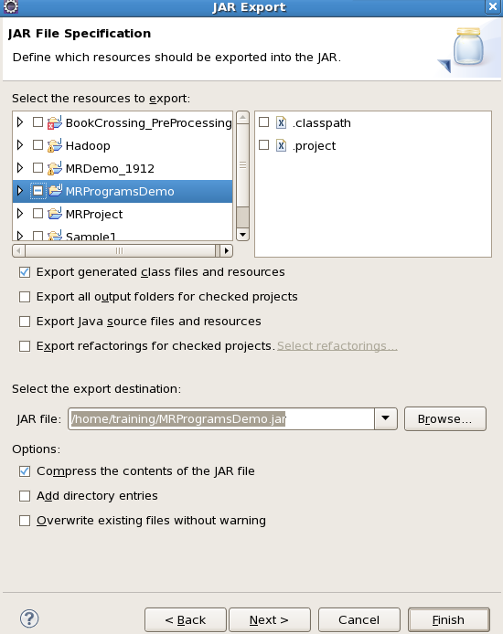

7. Take a text file and move it into HDFS format:

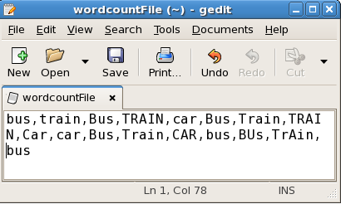

To move this into Hadoop directly, open the terminal and enter the following commands:

1

[training@localhost ~]$ hadoop fs -put wordcountFile wordCountFile

8. Run the jar file:

*(Hadoop jar jarfilename.jar packageName.ClassName  PathToInputTextFile PathToOutputDirectry)*

1

[training@localhost ~]$ hadoop jar MRProgramsDemo.jar PackageDemo.WordCount wordCountFile MRDir1

9. Open the result:

1

[training@localhost ~]$ hadoop fs -ls MRDir1

2

​

3

Found 3 items

4

​

5

-rw-r--r-- 1 training supergroup 0 2016-02-23 03:36 /user/training/MRDir1/_SUCCESS

6

drwxr-xr-x - training supergroup 0 2016-02-23 03:36 /user/training/MRDir1/_logs

7

-rw-r--r-- 1 training supergroup 20 2016-02-23 03:36 /user/training/MRDir1/part-r-00000

1

[training@localhost ~]$ hadoop fs -cat MRDir1/part-r-00000

2

BUS 7

3

CAR 4

4

TRAIN 6