**MEGHA TOMAR**

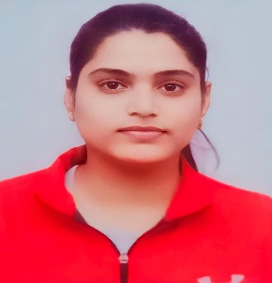**Address : Plot** J-1 Flat no A4 Krishna Garden

Govindpuram, Ghaziabad

**Mobile : +**91-8178440378

**Email :** meghatomar361@gmail.com

**Github :** [codingwithmegha (Megha Tomar) (github.com)](https://github.com/codingwithmegha)

**Career Objective:**

To work in a dynamic environment that uses my skills and expertise in process of growth and development while allowing me to learn and grow myself to achieve goals.

**Academic Qualification:**

|  |  |  |  |  |
| --- | --- | --- | --- | --- |
| Course | School/College | Board | Year | Percentage |
| B.C.A | VMLG college | CCS University | 2023 | 75% (up to 5th sem) |
| 12TH | Sunway Senior Sec School | C.B.S.E | 2019 | 72.6% |
| 10TH | Sunway Senior Sec School | C.B.S.E | 2017 | 84% |

**Technical Skills:**

* Basic Knowledge of MS Office(MS word, PowerPoint, Excel)
* Basic Language : C, C++, HTML, SQL commands
* Pursuing full stack JAVA course from Anudip Foundation

**Project:**

* Traffic Light Signal by using Computer Graphics
* E-commerce Website on cosmetic products

**Strengths:**

* Sincere, hardworking, quick leaner and honest
* Ability to grasp new skills quickly
* Team work skills

**Hobbies:**

* Listing Song
* Clicking picture
* Cooking

**Achievements:**

* Certificate of Hackathon (Code Fest)
* Certificate/Diploma of Computer Course
* Certificate of Completion Digital Training on Microsoft Office 365 Productivity Suite Offering Beginners Course

**Personal Details:**

* Father’s Name : Satendar Pal Singh
* Gender : Female
* Marital Status : Single
* Nationality : Indian
* Date of Birth : 14/04/2002
* Languages known : English and Hindi

**Declaration:**

I hereby declare that the details and information given above are complete and true to the best of my knowledge, so that I can prove the best of myself. I shall ever be thankful and grateful to you.

**Date: ____/____/_______ Signature: _______________**

**Place:_________________**