TECHNICAL TASK – 1

Subhadeep Ghosal

Part 1

Setting up environment

1. Command to set up apache server sudo apt install apache2 –y

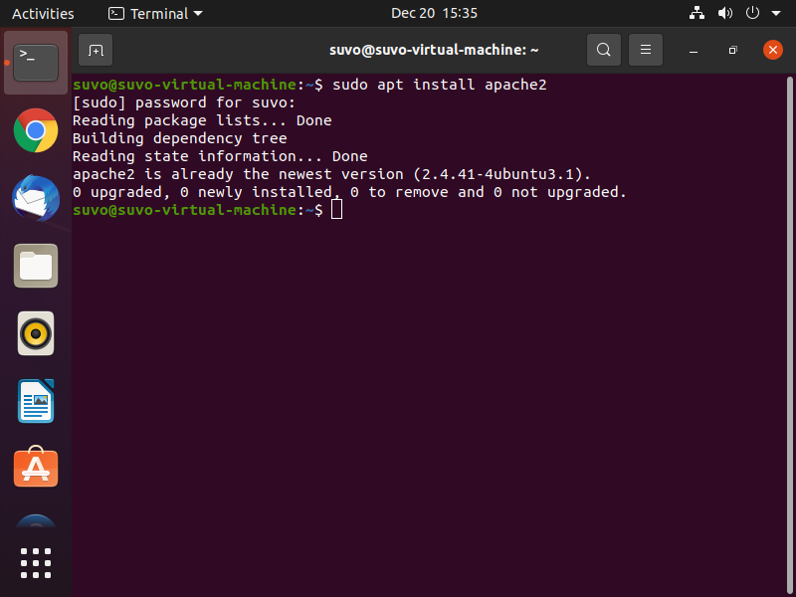

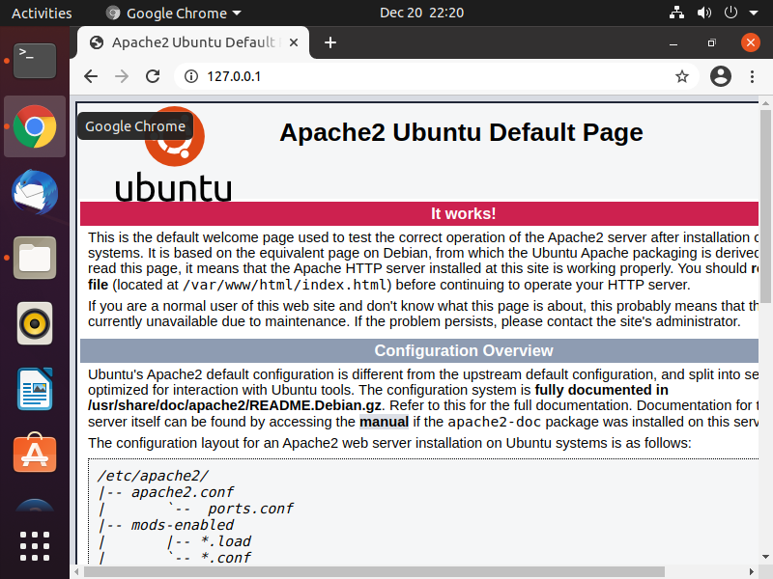

1. command to setup mysql server

sudo apt install mysql-server

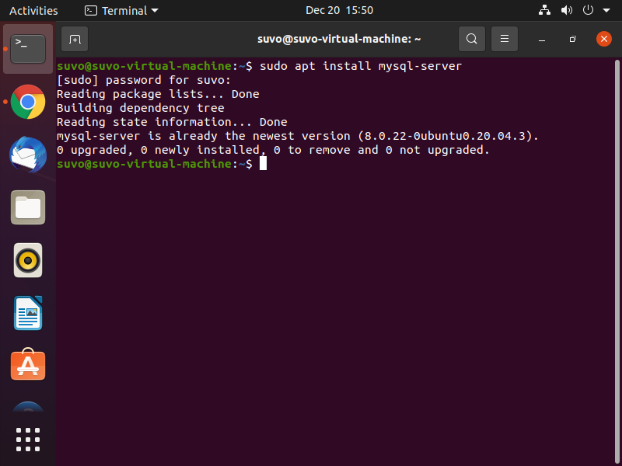

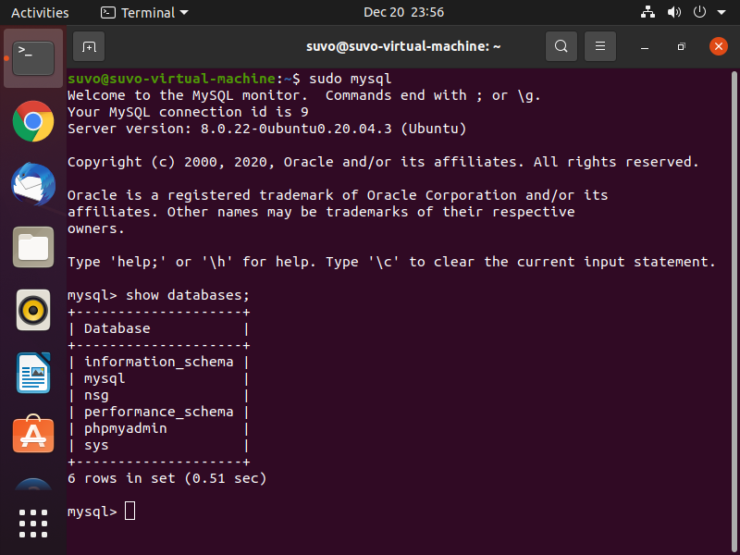

1. command to setup php 7

sudo apt install php php-myql libapache2-mod-php –y

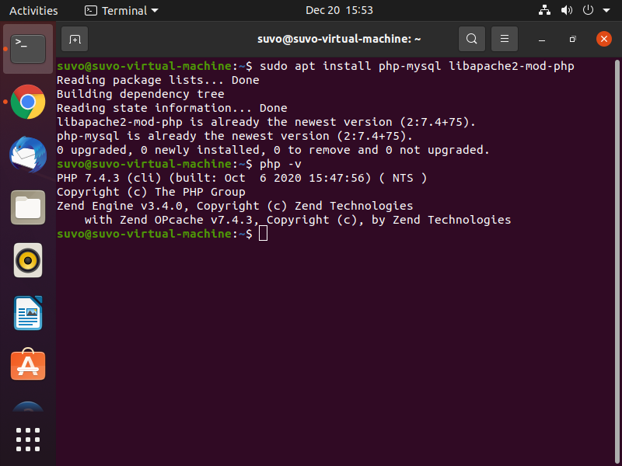

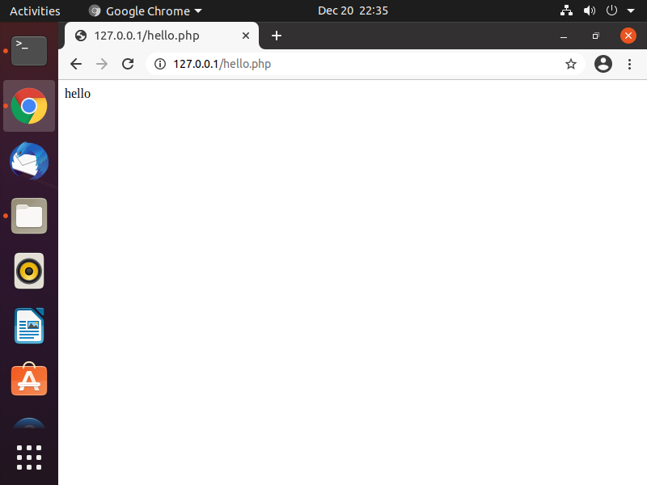

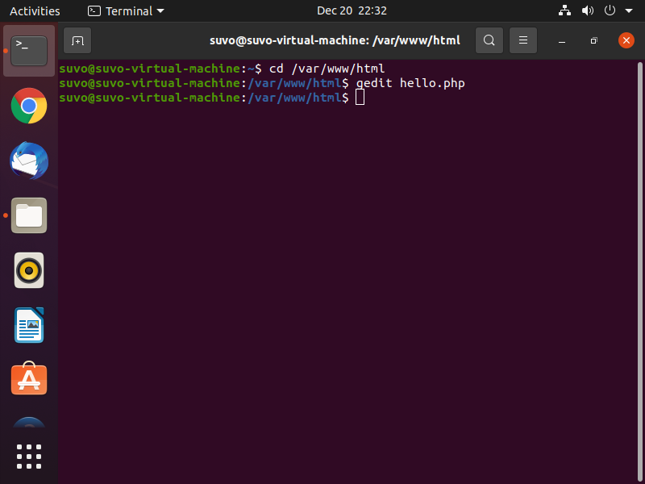

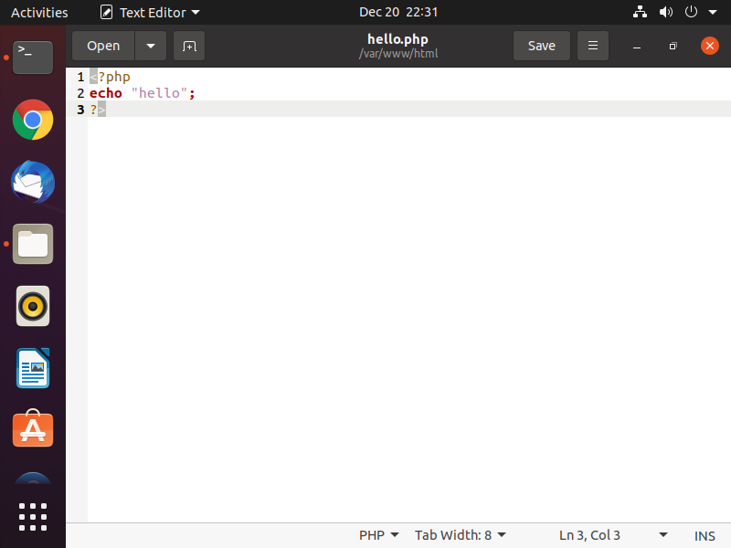

1. setting up phpmyadmin

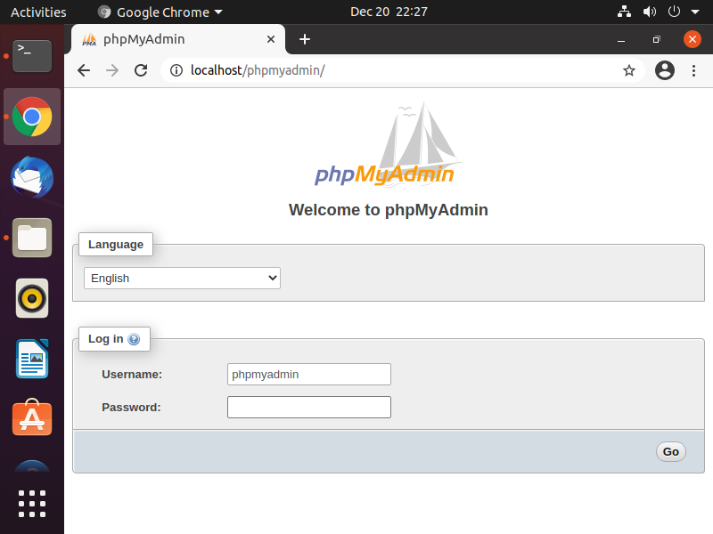sudo apt install phpmyadmin php-mbstring php-zip php-gd php-json php-curl