FINAL REPORT
Global Health Indicators Dashboard (2000–2025)
AnalystLab Africa – Data Analytics Capstone Project
Prepared by: Dada Oluwatomisin Rinuola
Internship Batch: Batch B (1st June – 1st August)
Submission Date: 1st August 2026

Table of Contents
- Introduction
- Project Objective
- Dataset Description
- Data Cleaning Process
- Analysis Methodology
- Dashboard Overview
- Key Findings
- Recommendations
- Conclusion

1. Introduction
Healthcare is one of the most important indicators of a country's development. Governments and international organizations rely on health data to monitor population wellbeing, evaluate healthcare systems and guide policy decisions.
This project analyses selected health indicators from the World Bank World Development Indicators (WDI) dataset using Microsoft Power BI. The dashboard provides an interactive overview of global health trends from 2000 to 2025.

2. Project Objective
The objective of this project is to analyze global health indicators and identify trends in life expectancy, healthcare expenditure, immunization coverage, and mortality rates across different countries and regions.
The dashboard aims to help stakeholders compare health outcomes across regions and monitor changes over time.

3. Dataset Description
Dataset Source
World Bank – World Development Indicators (WDI)
https://datatopics.worldbank.org/world-development-indicators/
Dataset Overview
The World Development Indicators dataset contains development statistics for more than 200 countries covering areas such as:
- Health
- Economy
- Education
- Environment
- Population
- Infrastructure
- Trade
For this project, only health-related indicators were analyzed.
Selected Indicators
- Life Expectancy
- Health Expenditure (% of GDP)
- Immunization Rate (DPT)
- Mortality Rate
4. Data Cleaning Process
The dataset was cleaned and transformed in Microsoft Power BI before analysis.
The following steps were performed:
- Imported the World Development Indicators CSV dataset into Power BI.
- Filtered the dataset to retain only the selected health indicators.
- Removed unnecessary fields that were not required for the dashboard.
- Checked for missing values and excluded incomplete records where necessary.
- Ensured appropriate data types for numerical and categorical variables.
- Created measures for:
  - Average Life Expectancy
  - Average Health Expenditure
  - Immunization Rate
  - Average Mortality Rate
- Built relationships between the indicator dataset and the country lookup table.
- Applied filters to improve dashboard performance.

5. Analysis Methodology
Microsoft Power BI was used to analyze the dataset.
The following techniques were applied:
- Descriptive statistics
- Trend analysis
- Regional comparison
- KPI reporting
- Interactive filtering using slicers
- Hierarchical analysis using a decomposition tree
The dashboard allows users to filter results by:
- Year
- Region
- Income Group

6. Dashboard Overview
The dashboard contains the following visualizations:
KPI Cards
The dashboard displays four Key Performance Indicators:
- Average Life Expectancy
- Average Health Expenditure
- Immunization Rate
- Average Mortality Rate
Line Chart
Shows changes in immunization rate across the study period.
Clustered Column Charts
Compare:
- Average Life Expectancy by Region
- Health Expenditure by Region
Decomposition Tree
Allows users to drill down from regional life expectancy to country and income group.
Slicers
Users can filter the dashboard by:
- Year
- Region and
- Income Group
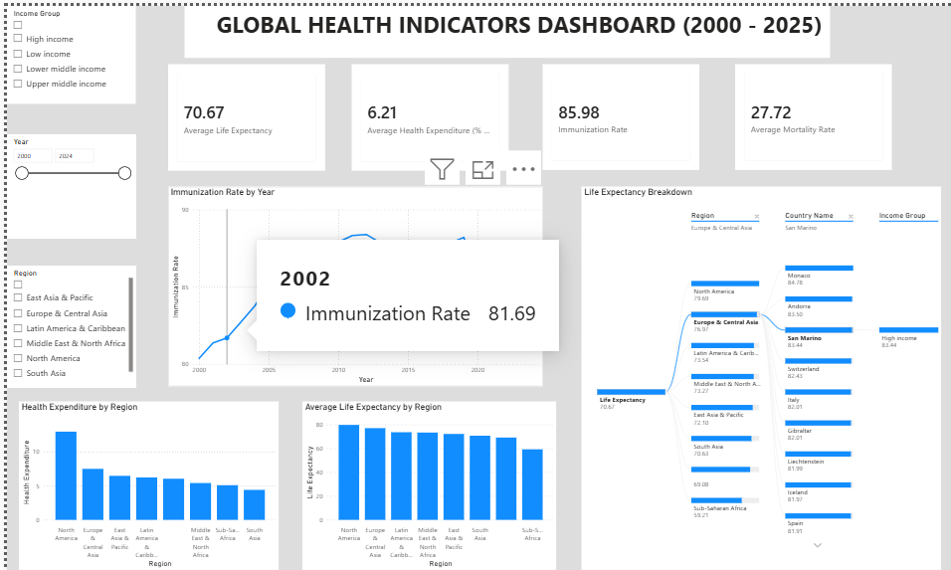

7. Key Findings
The analysis revealed several important insights:
- Average life expectancy generally improved across the study period.
- Immunization coverage remained relatively high over time, although slight fluctuations were observed in recent years.
- Health expenditure varies considerably across regions, indicating differences in healthcare investment.
- Regions with higher life expectancy generally demonstrate stronger healthcare outcomes.
- Lower-performing regions continue to experience lower average life expectancy, suggesting disparities in access to healthcare and health services.

8. Recommendations
Based on the analysis, the following recommendations are proposed:
- Increase investment in healthcare infrastructure in lower-performing regions.
- Strengthen immunization programs to maintain high vaccination coverage.
- Improve access to preventive healthcare services.
- Reduce inequalities in healthcare funding between regions.
- Continue monitoring health indicators to support evidence-based policy decisions.

9. Conclusion
This project demonstrates how Microsoft Power BI can be used to transform large public datasets into meaningful visual insights.
The dashboard provides an interactive view of global health trends and enables comparisons across countries and regions. The findings highlight the importance of continued investment in healthcare systems and regular monitoring of health indicators to improve global health outcomes.

