Business Analytics Case Study Report
Name: Dada Oluwatomisin Rinuola
Project: Telco Customer Churn Analysis
AnalystLab Africa Internship Program – Batch B
Date: 5th July 2026

Introduction
This project analyses the Telco Customer Churn dataset to identify factors associated with customer churn and provide business recommendations to improve customer retention.
Business Problem Statement
Customer churn reduces revenue and increases customer acquisition costs. The objective is to determine the major factors influencing churn and identify opportunities to improve retention.
Dataset Description
The dataset contains customer demographic information, subscribed services, contract details, billing information and churn status. After cleaning, the dataset contained 7,032 customer records across 21 columns.
Data Cleaning and Preparation
The analysis involved:
- Inspecting data types and summary statistics.
- Identifying that Total Charges was stored as text rather than a numeric type, caused by 11 entries containing a blank space rather than a value.
- Replacing those blanks with missing values and converting the column to numeric.
- Investigating the 11 affected rows and finding that all had a tenure of zero, indicating customers who had signed up but not yet been billed.
- Removing those 11 records, as no total charge could reasonably be estimated for a customer who had not been charged.
- Confirming there were no duplicate records and that all 7,032 customer IDs were unique.
Exploratory Data Analysis
The analysis examined churn across the following dimensions:
- Overall churn distribution.
- Contract type.
- Customer tenure.
- Monthly charges.
- Internet service type.
- Payment method.
- Online security subscription.

Key Findings
Of 7,032 customers, 26.58% churned while 73.42% were retained. Five factors showed a clear association with churn.
- Contract type: Month-to-month customers churned at 42.71%, compared to 11.28% on one-year contracts and 2.85% on two-year contracts. This is the strongest single pattern in the dataset.

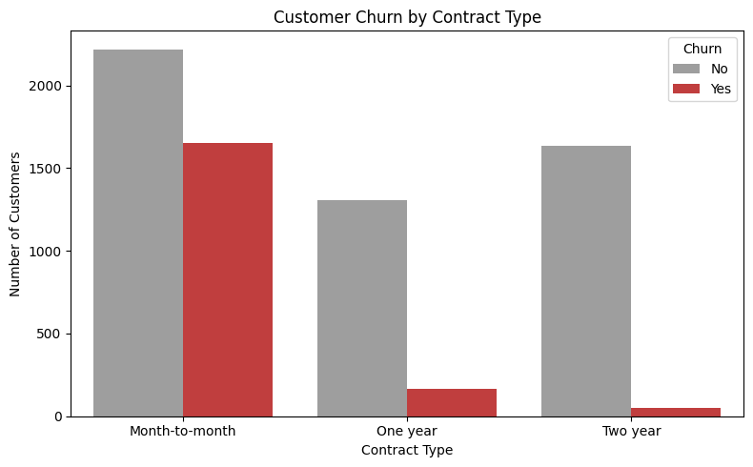

- Tenure: Churned customers had a median tenure of 10 months compared to 38 months for retained customers, and a quarter left within 2 months. Churn concentrates heavily in the early stages of the customer relationship.
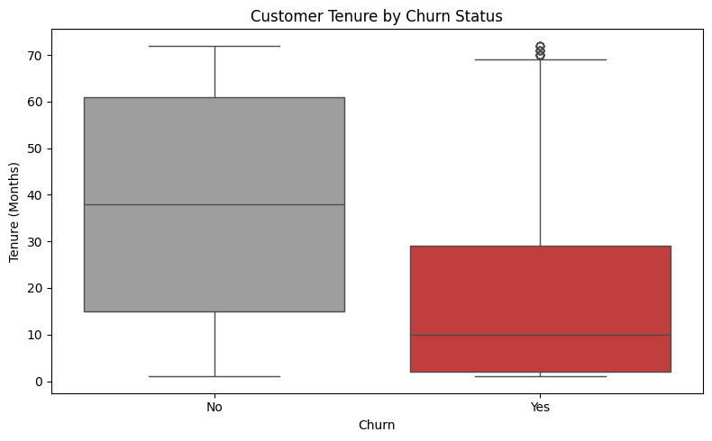
- Payment method: Customers paying by electronic cheque churned at 45.29%, against 15.25% for credit card and 16.73% for bank transfer.
- Internet service: Fibre optic subscribers churned at 41.89%, more than double the 19.00% recorded among DSL customers. Customers with no internet service churned least, at 7.43%.
- Online security: Customers without online security churned at 41.78%, nearly three times the 14.64% recorded among subscribers.
- Monthly charges: Churned customers paid more per month, with a median of $79.65 against $64.45 for retained customers.

Business Insights
The strongest predictors of churn (month-to-month contracts, short tenure, and electronic cheque payment) share a common characteristic: each indicates low commitment to the service. Customers on flexible arrangements with few switching costs leave at several times the rate of those on longer contracts with bundled services.
These factors overlap considerably. Fibre optic customers pay the highest monthly charges and are more likely to use electronic cheque, so the individual contribution of each factor cannot be separated in this analysis. The findings identify associations rather than causes.

Recommendations
- Encourage migration from month-to-month to longer-term contracts through discounts or loyalty incentives.
- Focus retention efforts on the first twelve months of the customer relationship, where half of all churn occurs.
- Investigate customer satisfaction among fibre optic subscribers and address service quality or pricing concerns for this tier.
- Bundle online security into internet packages rather than selling it separately, given the substantial difference in churn rates.
- Promote automatic payment methods by offering incentives for bank transfer or credit card payment.
- Define a high-risk profile combining month-to-month contract, tenure under twelve months and electronic cheque payment and target these customers for proactive retention before renewal.

Limitations
This analysis identifies associations, not causes. Several factors overlap with one another, so the individual contribution of each cannot be isolated without further modelling. The dataset also represents a single point in time and does not capture why customers chose to leave.
Conclusion
The analysis identified contract type, tenure, payment method, internet service and online security as the factors most strongly associated with customer churn. Contract length and tenure emerged as the clearest signals, with month-to-month customers churning at fifteen times the rate of two-year customers and half of all churn occurring within the first ten months. Retention strategies targeting early-tenure customers on flexible contracts are therefore likely to have the greatest impact.

