Testing for General Linear Hypothesis:

The general linear hypothesis is 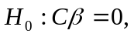 where

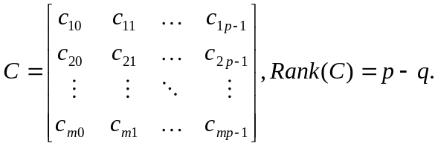
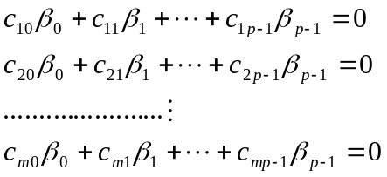

Example:

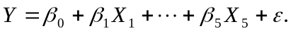 Test 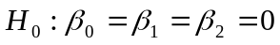
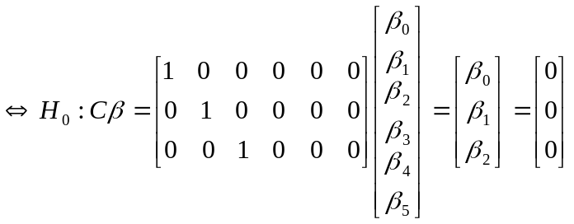.

Example:

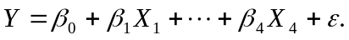 Then,
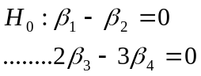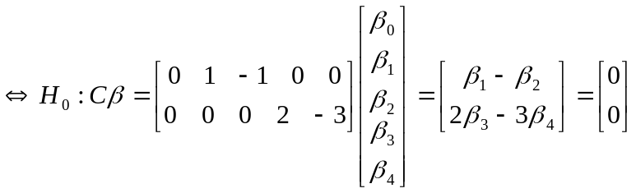

Note: linear hypothesis typically arise from the knowledge of the experimenter (or scientist) and his or her conjectures about possible models.

A general procedure to test for a general linear hypothesis:
1. Find the reduced model,
satisfying all equation in , for instance, in the previous example, the reduced model satisfying being
,
where

2. In the reduced model, 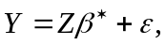 where
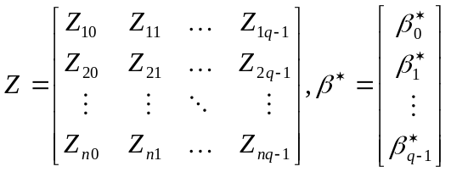.
Then,
And
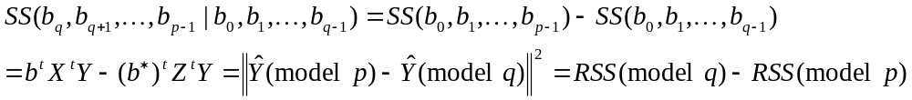
- The F-statistic used to test the general linear hypothesis is
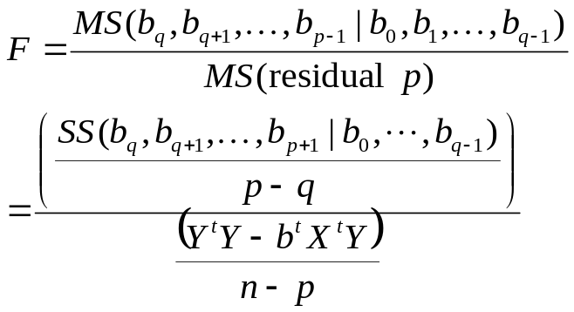
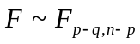 as is true.

Example:
Let
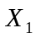 | -1 | -1 | 0 | 1 | 1
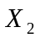 | -1 | 0 | 0 | 0 | 1
 | 7.2 | 8.1 | 9.8 | 12.3 | 12.9
and 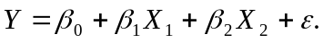 Find the F statistic for 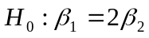.
[solution]:
- As 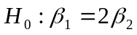 is true, the reduced model is
where
.

2. In the reduced model, where
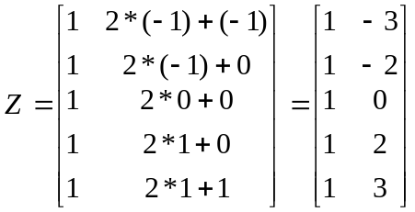. Then,
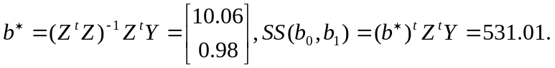
In the original model, 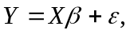 where
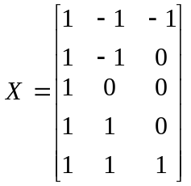. Then,
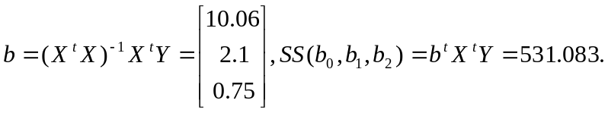 Thus,
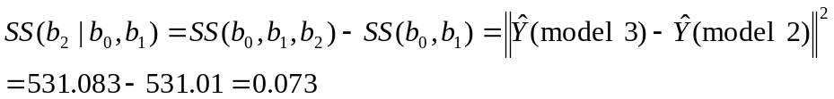
and

3.


