# 问题描述

启动FastAPI项目后访问http://127.0.0.1:8000/docs时内容加载不出来，页面是空白：



具体提示错误为：swagger-ui.css failed，swagger-ui-bundle.js failed。

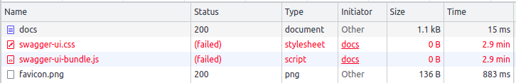

# **问题描述**

# **解决方法**

from fastapi.openapi.docs import get_swagger_ui_html

from fastapi import FastAPI, applications

def swagger_monkey_patch(*args, **kwargs):

return get_swagger_ui_html(

*args, **kwargs,

swagger_js_url='https://cdn.bootcdn.net/ajax/libs/swagger-ui/4.10.3/swagger-ui-bundle.js',

swagger_css_url='https://cdn.bootcdn.net/ajax/libs/swagger-ui/4.10.3/swagger-ui.css'

)

applications.get_swagger_ui_html = swagger_monkey_patch

参考资料：

https://blog.csdn.net/weixin_41085315/article/details/124965953