# Errors were encountered while processing

## 问题描述

在ubuntu系统下使用 $ sudo apt install mysql-server 命令安装MySQL的时候出现如下错误：

Renaming removed key_buffer and myisam-recover options (if present)

mysqld will log errors to /var/log/mysql/error.log

mysqld is running as pid 16667

dpkg: error processing package mysql-server-8.0 (--configure):

installed mysql-server-8.0 package post-installation script subprocess returned

error exit status 1

dpkg: dependency problems prevent configuration of mysql-server:

mysql-server depends on mysql-server-8.0; however:

Package mysql-server-8.0 is not configured yet.

dpkg: error processing package mysql-server (--configure):

dependency problems - leaving unconfigured

No apport report written because the error message indicates its a followup erro

r from a previous failure.

Processing triggers for man-db (2.10.2-1) ...

Processing triggers for libc-bin (2.35-0ubuntu3) ...

Errors were encountered while processing:

mysql-server-8.0

mysql-server

E: Sub-process /usr/bin/dpkg returned an error code (1)

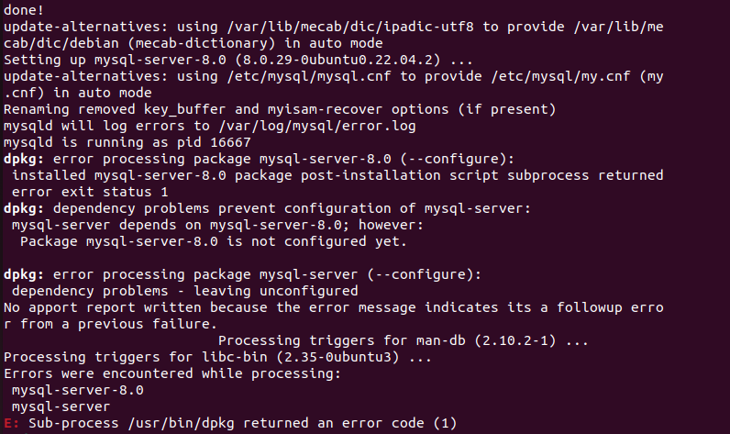

## 问题分析

根据提示：

mysql-server depends on mysql-server-8.0; however:Package mysql-server-8.0 is not configured yet.

需要依赖mysql-server-8.0，但是该包没有配置。

## 解决方法

## 总结

# ERROR 2002 (HY000)

## 问题描述

在ubuntu（TLS 22）上使用命令 $ mysql -u root -p登录mysql的时候出现如下错误：

~$ mysql -u root -p

Enter password:

ERROR 2002 (HY000): Can't connect to local MySQL server through socket '/var/run/mysqld/mysqld.sock' (2)



## 问题分析

输入的密码是没有问题的。

## 解决方法

$ mysql -h 127.0.0.1 -P 3306 -u root -p

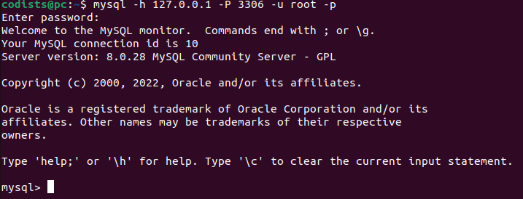

## 总结