# postman格式

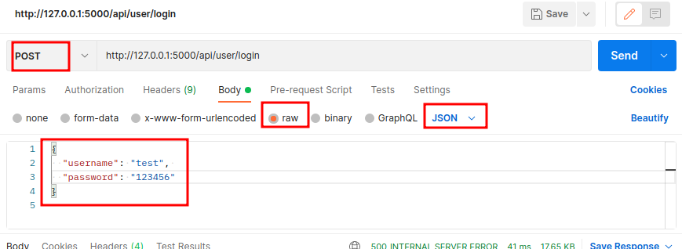

# flask_sqlalchemy组合条件查询

from sqlalchemy.sql import or_, and_

# timedelta格式

from datetime import timedelta

expires_delta=timedelta(days=2)

# postman如何发送authorization