Vue-cli项目配置按需导入

# 安装unplugin-vue-components 和 unplugin-auto-import这两款插件

$ cd frontend/

$ npm install -D unplugin-vue-components unplugin-auto-import

# 配置element plus

webpack配置参考:https://cli.vuejs.org/guide/webpack.html

配置是在vue.config.js文件：

const {defineConfig} = require('@vue/cli-service')  
const AutoImport = require('unplugin-auto-import/webpack')  
const Components = require('unplugin-vue-components/webpack')  
const { ElementPlusResolver } = require('unplugin-vue-components/resolvers')  
  
module.exports = defineConfig({  
 transpileDependencies: true,  
 configureWebpack: {  
 plugins: [  
 AutoImport({  
 resolvers: [ElementPlusResolver()],  
 }),  
 Components({  
 resolvers: [ElementPlusResolver()],  
 }),  
 ],  
 }  
})

# 配置验证

在App.vue添加代码<el-button>测试</el-button>：

<template>  
 <img alt="Vue logo" src="./assets/logo.png">  
 <HelloWorld msg="Welcome to Your Vue.js App"/>  
 <el-button>测试</el-button>  
</template>  
  
<script>  
import ***HelloWorld*** from './components/HelloWorld.vue'  
  
export default {  
 name: 'App',  
 components: {  
 ***HelloWorld*** }  
}  
</script>  
  
<style>  
#app {  
 font-family: Avenir, Helvetica, Arial, sans-serif;  
 -webkit-font-smoothing: antialiased;  
 -moz-osx-font-smoothing: grayscale;  
 text-align: center;  
 color: #2c3e50;  
 margin-top: 60px;  
}  
</style>

启动项目：

$ cd frontend/

$ npm run serve

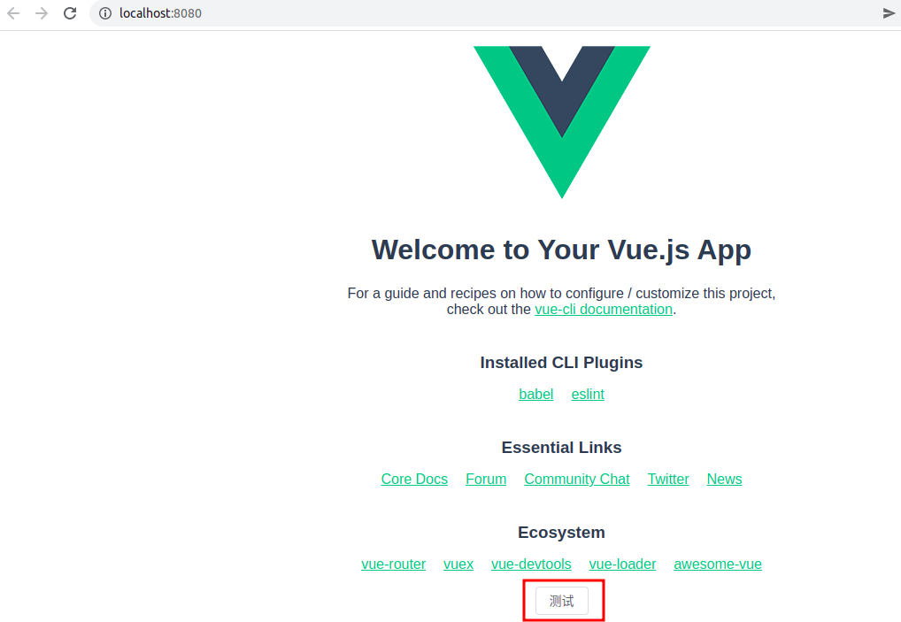

可以看到，在App.vue里面不用导入Element Plus也可以正常使用。