1.
A | B | 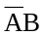 | 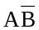 | F₁
0 | 0 | 0 | 0 | 0
0 | 1 | 1 | 0 | 1
1 | 0 | 0 | 1 | 1
1 | 1 | 0 | 0 | 0

A | B | C |  | 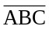 | F2 | 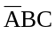 | 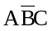 | 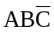 | F3
0 | 0 | 0 | 0 | 1 | 1 | 0 | 0 | 0 | 0
0 | 0 | 1 | 0 | 1 | 1 | 0 | 0 | 0 | 0
0 | 1 | 0 | 0 | 1 | 1 | 0 | 0 | 0 | 0
0 | 1 | 1 | 0 | 1 | 1 | 1 | 0 | 0 | 1
1 | 0 | 0 | 0 | 1 | 1 | 0 | 0 | 0 | 0
1 | 0 | 1 | 0 | 1 | 1 | 0 | 1 | 0 | 1
1 | 1 | 0 | 0 | 1 | 1 | 0 | 0 | 1 | 1
1 | 1 | 1 | 1 | 0 | 1 | 0 | 0 | 0 | 0

2.
A | B | AB | 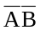 | 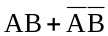 | 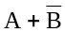 | 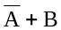 | 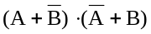
0 | 0 | 0 | 1 | 1 | 1 | 1 | 1
0 | 1 | 0 | 0 | 0 | 0 | 1 | 0
1 | 0 | 0 | 0 | 0 | 1 | 0 | 0
1 | 1 | 1 | 0 | 1 | 1 | 1 | 1

A | B |  |  |  | 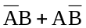
0 | 0 | 0 | 0 | 0 | 0
0 | 1 | 1 | 1 | 0 | 1
1 | 0 | 1 | 0 | 1 | 1
1 | 1 | 0 | 0 | 0 | 0

3.
1)

2)

3) 