学号:031102406 姓名：郑剑峰 学院：数计学院
专业：计算机科学与技术 班级：4班
《Linux 操作系统设计实践》 实验三：文件操作
实验环境：RedHat Linux 9.0 、vi编辑器、gcc编译器
报告内容：
代码：
#include <stdio.h>
#include <stdlib.h>
#include <time.h>
#define MAX_BUF_SIZE 1024

static char g_file[] = "test.txt";
void WriteNewLog()
{
FILE* fp;
time_t Now;
char szTime[32];
char szLog[MAX_BUF_SIZE];
struct tm *LocalTime,*gm;
Now = time(NULL);
LocalTime = localtime(&Now);
snprintf(szTime,sizeof(szTime),
"%04d-%02d-%02d %02d:%02d:%02d\r\n",
LocalTime->tm_year+1900,
LocalTime->tm_mon+1,
LocalTime->tm_mday,
LocalTime->tm_hour,
LocalTime->tm_min,
LocalTime->tm_sec);
fp = fopen(g_file,"a+");
if(fp == NULL)
{
printf("Can't open file %s.\n",g_file);
exit(-1);
}
fwrite(szTime,strlen(szTime),1,fp);
printf("%s\nInput what you want to write \n",szTime);
fgets(szLog,MAX_BUF_SIZE,stdin);
int len = strlen(szLog);
strcat(szLog,"\r\n\0");
fwrite(szLog,strlen(szLog),1,fp);
fclose(fp);
}

void ReadLog()
{
system("cat test.txt | more");
}

int main(int argc, char* argv[])
{
system("clear");
if(argc<=1 || argc>2)
{
printf("\t\t-----------------------------------------\n"
"\t\t|\tI: Write a new log\t\t|\n"
"\t\t|\tC: Look content of log\t\t|\n"
"\t\t----------------------------------------\n");
exit(1);
}
if(*argv[1] == 'i' || *argv[1] =='I')
{
printf("\t\t|\tWelcome to use log Edit\t\t|\n");
WriteNewLog();
}
else if(*argv[1] == 'c' || *argv[1] == 'C')
ReadLog();
else
{
printf("\t\t-----------------------------------------\n"
"\t\t|\tI: Write a new log\t\t|\n"
"\t\t|\tC: Look content of log\t\t|\n"
"\t\t-----------------------------------------\n");
exit(1);
}
return 0;
}

运行结果:
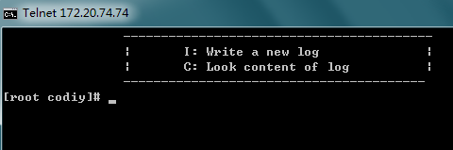
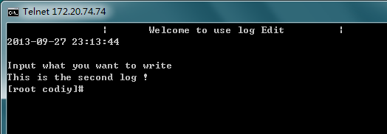
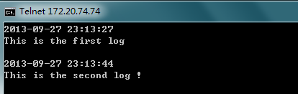

简单的文件操作，运行程序时，加入参数i/I进入添加日志模式，加入参数c/C进入查看日志模式。添加日志时候，会插入添加日志的当前时间

