Get this ‘mysql-connector-java-5.1.13’

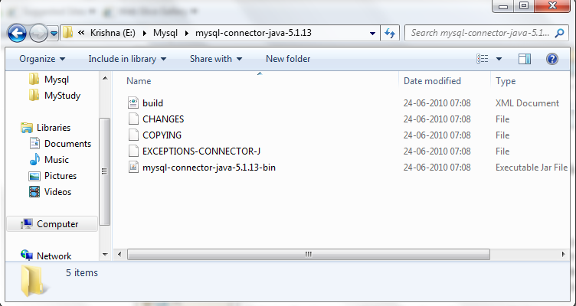

Than you must set the CLASSPATH environment variable with

E:\Mysql\mysql-connector-java-5.1.13\mysql-connector-java-5.1.13-bin.jar

Before starting the ‘setUp’ of mysql.

For more details and complete guide please use below link: E:\Mysql\mysql\Installing and Configuring MySQL Database and Connector-J JD.mht

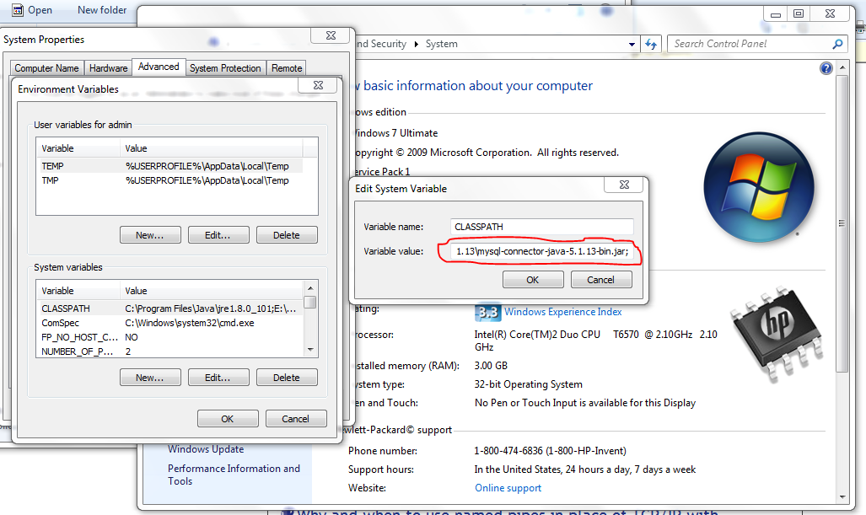

Now you can start the ‘Setup’ to install MySql.

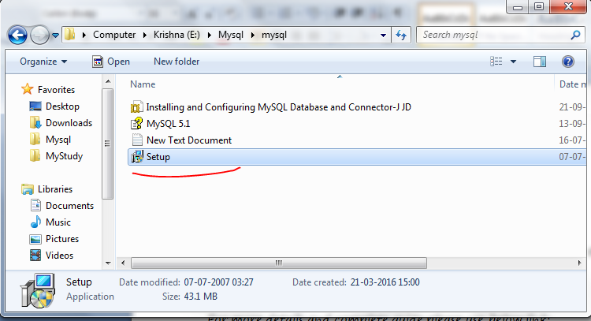

Note: while installing the set up please go with all default setting .

