Corpus Christi Area Power Infrastructure
Shore Power (Cold Ironing) — Overview in support of our Feasibility Study proposal
Prepared: June 2026 | Region: ERCOT South / Coastal Zone | TDSP/TSP: AEP Texas
Purpose of this document. We are responding to the RFP by proposing to perform the shore-power feasibility study. As a local firm with more than 30 design professionals based in Corpus Christi — including in-house coastal, electrical, and infrastructure expertise — we bring on-the-ground knowledge of the port, the AEP Texas grid, and the region's coastal hazards. The material below frames our understanding of the problem and the scope our study will rigorously evaluate — it is not a final engineering design. Figures are planning-level and represent the questions the feasibility study will resolve, not committed values.
This overview summarizes the electrical supply environment serving the Port of Corpus Christi and frames the phased shore-power buildout our feasibility study will assess — from a 2-berth pilot to a full 20-berth deployment — covering the regional grid, the ERCOT interconnection pathway for loads of this magnitude, and the resiliency strategy for a hurricane-exposed coastal industrial port.
~5 MW  Typical load / berth | ~10 MW  Phase 1 (2 berths) | ~100 MW  Full build (20 berths) | 75 MW  ERCOT Large-Load threshold

1. Regional Grid Context
The Port of Corpus Christi is the largest U.S. energy-export gateway and sits within the ERCOT South (Coastal) load zone. Transmission and distribution service in Nueces and San Patricio counties is provided primarily by AEP Texas, with portions of the high-voltage backbone owned by Electric Transmission Texas (ETT). The local network is anchored by a robust 138 kV ring around the inner harbor and a 345 kV backbone tying the area into the broader ERCOT grid. Substantial dispatchable generation sits inside the load pocket, favorable for both voltage support and resource adequacy:
- Barney M. Davis — ~897 MW gas (units 1974 / 2010)
- Nueces Bay — ~635 MW gas, combined-cycle (2010)
- Lon C. Hill — legacy gas peaking capacity
This ~1.5 GW of in-zone generation (now CPS Energy-owned, acquired from Talen in 2024) means the shore-power load can be served from a generation-rich pocket rather than a constrained import path. Key substations relevant to a port-side interconnection include Holly Road, McKenzie Road, Lon Hill, Nueces Bay, Barney Davis, Naval Base, and Warburton — several within a few miles of the port's principal docks.
What our study will test: our working hypothesis is that a 2-berth pilot (~10 MW) can be served at distribution voltage (12.47/25 kV) from an existing AEP Texas circuit, while the full 20-berth program (~80–120 MW) warrants a dedicated port substation fed at 138 kV. The feasibility study will validate both the near-term distribution tap and the long-term transmission-class delivery point, with order-of-magnitude cost and schedule for each.
2. Channel Reaches, Berths & Power Assets
The Corpus Christi Ship Channel runs ~29 miles from the Gulf entrance to the Viola Turning Basin, with the La Quinta Channel (~6 miles) branching north (~35 nautical miles of federal channel total). The USACE/Port Channel Improvement Project (CIP) is deepening it from 47 to 54 ft MLLW and widening it to 530 ft with barge shelves across the Upper Bay. Deeper water draws larger, fully-laden vessels with higher hotelling demand — strengthening the case for shore power. Berths concentrate in the Inner Harbor, with additional energy terminals along La Quinta/Ingleside.
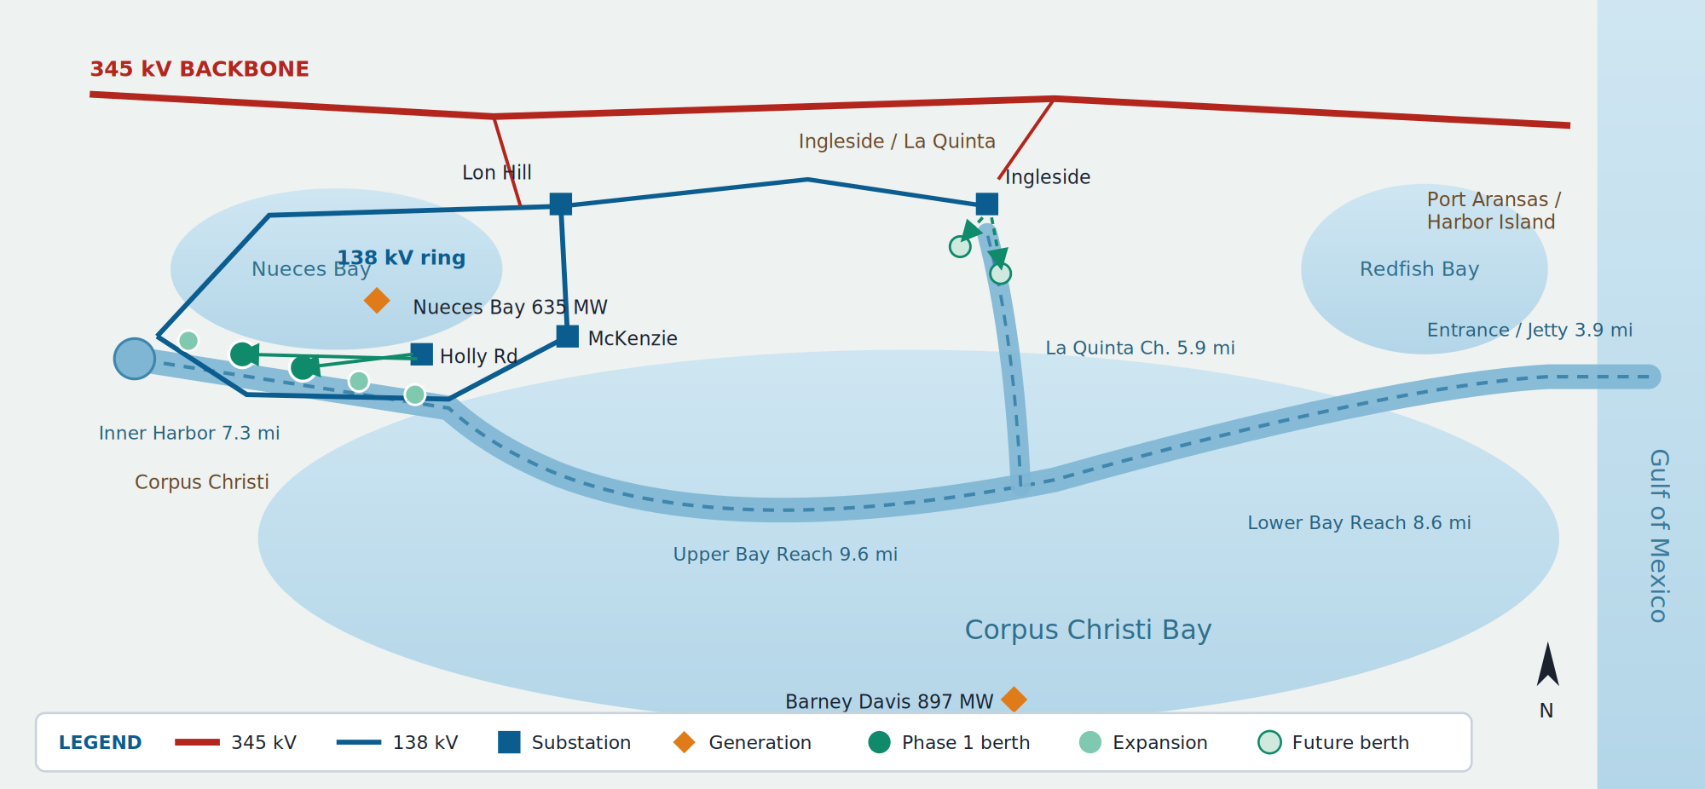
Figure 1 — Geographic Network Diagram (not to scale). Channel reaches Gulf-to-inland: Entrance/Jetty (3.9 mi), Lower Bay (8.6 mi), Upper Bay (9.6 mi), Inner Harbor (7.3 mi), with the La Quinta Channel (5.9 mi) branching north. Power assets and berth locations are approximate; a surveyed GIS alignment is to be developed during the feasibility study.

3. Phased Buildout — 2 Berths to 20 Berths
Shore power (cold ironing / high-voltage shore connection, HVSC) supplies vessels at berth at 6.6 kV or 11 kV per IEC/IEEE 80005-1, allowing main and auxiliary engines to shut down. Per-berth demand depends on vessel class; for the Corpus mix (tankers, bulk, dry cargo, occasional container) a planning figure of ~5 MW/berth is reasonable, with diversity reducing the coincident peak below the simple sum.
Phase | Horizon | Berths | Approx. connected load | Delivery / interconnection
Phase 1 — Pilot | Yr 1–2 | 2 | ~8–12 MW | Distribution tap off existing AEP Texas circuit
Phase 2 — Expand | Yr 2–4 | 6 | ~25–30 MW | New distribution substation / express feeders (crosses 25 MW)
Phase 3 — Scale | Yr 4–7 | 12 | ~55–70 MW | Begin dedicated 138 kV substation (nears 75 MW)
Phase 4 — Full | Yr 7–10 | 20 | ~90–120 MW | Dedicated 138 kV port substation; full LLIS
Geographically, the pilot targets Inner Harbor berths closest to existing AEP Texas feeders, expanding along the Inner Harbor and then to the La Quinta/Ingleside energy terminals as a dedicated 138 kV substation comes online. This sequences the ERCOT studies so the substation is energized ahead of the berths that depend on it. Berth counts, loads, and horizons are the planning basis the study will refine against surveyed vessel data and AEP Texas hosting-capacity input.
4. ERCOT Interconnection for Loads of This Size
ERCOT formalized large-load interconnection through NPRR1234 and PGRR115 (approved by the ERCOT Board on April 8, 2025; phased implementation from July 21, 2025, with key PGRR115 provisions effective Dec 15, 2025). Two thresholds govern this program:
- ≥ 25 MW — modeling standards apply; the load must be explicitly represented in ERCOT planning cases. Reached around Phase 2.
- ≥ 75 MW aggregate at a single site behind common point(s) of interconnection — triggers the full Large Load Interconnection Study (LLIS). Reached at Phase 3–4.
The LLIS is led by the interconnecting TSP (AEP Texas) and includes steady-state, short-circuit, and dynamic/transient stability analyses. A study fee of ~$14,000 per LLIS request applies. Large loads must clear ERCOT's Quarterly Stability Assessment (QSA) before Initial Energization. Each project submits a step-by-step ramp-up schedule with milestone demands, and must demonstrate development milestones (land control, permits, study payments) to hold queue position.
Feasibility study deliverable: Because the program crosses both the 25 MW and 75 MW thresholds over time, our study will map the ERCOT/AEP Texas interconnection pathway and timeline — identifying when modeling submissions (Phase 2) and the LLIS (ahead of Phase 3/4) must start so transmission facilities land on the critical path, not behind it — and flag this coordination as a defined downstream deliverable for the implementation phase.

5. Transmission Reliability & the Harvey Benchmark
Under normal “blue-sky” conditions the 345 kV and 138 kV network is effectively always available: bulk-transmission availability routinely exceeds 99.9%, and N-1 design ensures any single line or transformer can fail without dropping load. The correct planning assumption is therefore not that the grid never fails, but that it is highly reliable except under a major hurricane — the one scenario a Gulf-coast port must explicitly design for. Hurricane Harvey (Category 4, landfall at Rockport/Port Aransas essentially at Corpus Christi, Aug 2017) is the governing benchmark and shows that even the bulk transmission system is not immune:
Harvey at a glance (AEP Texas / ERCOT South-Coastal):
- Forced outages on six 345 kV lines and 200+ 69–138 kV lines along the coast.
- ~25% of AEP Texas’s ~1M customers lost power; ~3,100+ distribution poles and ~500 transmission structures damaged; ~712 miles of conductor replaced; 5,600 mutual-aid linemen.
- A Port Aransas substation was swamped by storm surge — saltwater destroyed breakers, which had to be replaced.
- Corpus’s Inner Harbor recovered in days (~12,000 peak outages); the hardest-hit coastal communities nearest the entrance and La Quinta/Ingleside were not fully restored for ~2 weeks.
Coastal storm-surge exposure
Hurricane Harvey was a significant surge event, but by no means the worst that can be expected. SLOSH modeling by the National Weather Service (NWS) shows the “maximum of maximums” anticipated from storm surge; while it does not capture compound (rainfall/riverine) flooding, it clearly demonstrates the footprint where surge waters would propagate through the inner-harbor region. The NWS storm-surge inundation map for the 100-year annual exceedance probability (Figure 2) illustrates this footprint across the Corpus Christi inner harbor. We recommend using the U.S. Army Corps of Engineers (USACE) Coastal Hazard System (CHS) to conduct a desktop analysis of annual exceedance probabilities (AEPs) to determine the required protective elevations for power infrastructure — substations, switchgear, and shore-power converters.
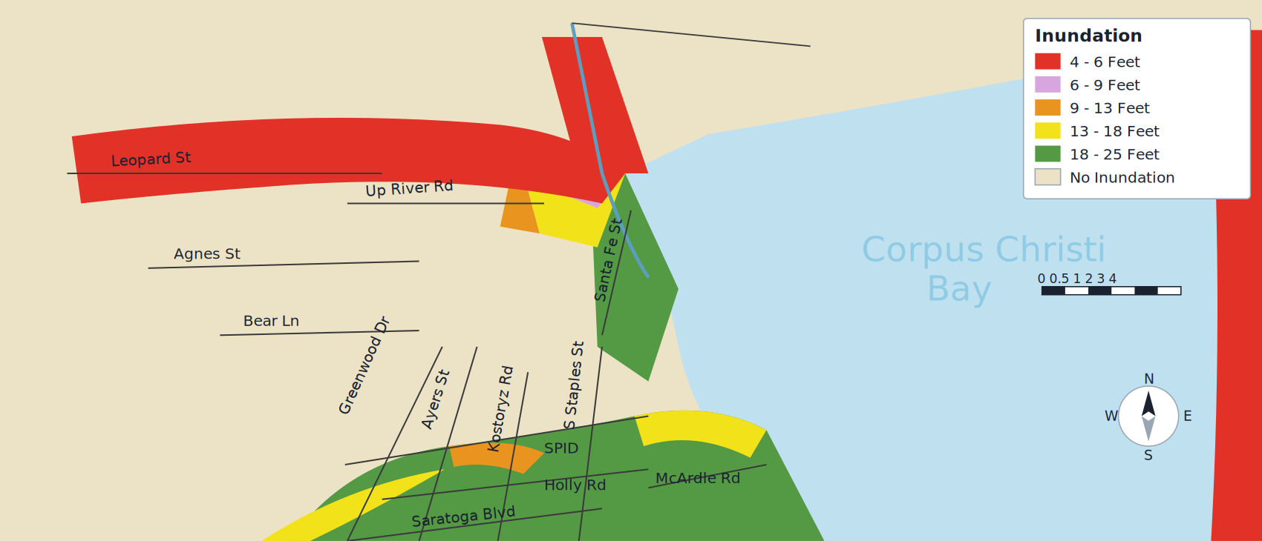
Figure 2 — Storm-surge inundation footprint, Corpus Christi inner harbor (NWS surge-depth bands, 4–6 ft up to 18–25 ft). Schematic representation of the published National Weather Service map, pending the source raster. The footprint — surge entering via the ship channel into the inner harbor and propagating up the low-lying corridors — governs siting and protective elevation of port power infrastructure. Source: National Weather Service (SLOSH).
Implication for backup power — vessels depart before landfall. Under the U.S. Coast Guard Captain of the Port (COTP) heavy-weather protocol and the port's hurricane plan, vessels above a defined tonnage must leave berth (typically ≥24 hours before landfall) because the moorings cannot withstand tropical-cyclone forces. A Harvey-class grid outage therefore coincides with a port that has no large vessels at berth — effectively no hotelling load to serve during the storm and its multi-day restoration. This largely moots the case for dedicated, storm-duration backup generation or islanding sized to vessel load. The resilience priority instead shifts to survive-and-restore: (1) harden and elevate the shore-power equipment so it survives surge and saltwater (platform elevations set from the USACE CHS / AEP analysis above), and (2) re-energize rapidly so berths are ready when vessels return. Any on-site backup is limited to controls/SCADA, life-safety, and brief ride-through — not multi-MW hotelling supply.

6. Resiliency Measures & Backup Power
- N-1 redundancy & looped feeds: the dedicated port substation takes dual 138 kV sources from independent points on the ring, so a single line/transformer outage cannot de-energize the berths.
- In-zone generation buffer: proximity to Barney Davis, Nueces Bay, and Lon Hill (~1.5 GW) supports local voltage and resource adequacy during import constraints.
- BESS: peak-shaving, ride-through for momentary disturbances, and smoother load steps as vessels connect/disconnect.
- Right-sized backup (not storm-duration): because vessels evacuate before landfall, backup is limited to controls/SCADA, security, and brief ride-through — no multi-MW standby generation for hotelling load during a storm outage.
- Microgrid & islanding: optional islanding of a berth on local BESS during brief, non-storm transmission disturbances; not relied upon for hurricanes, when berths are vacated.
- Storm hardening & elevation (primary storm measure): elevated/flood-rated pads set from the CHS/AEP analysis, wind-rated structures, sealed/surge-rated switchgear, and corrosion protection so the asset survives and restores quickly.
- Power quality & redundant conversion: frequency conversion (50/60 Hz vessels), harmonic mitigation, reactive support, and N+1 shore-power converters so one failed unit does not strand a berth.
Resiliency target: during normal operations, priority berths ride through a single transmission contingency without interruption; for hurricanes, the objective is survive-and-restore — equipment hardened and elevated to survive surge while vessels are evacuated, then rapidly re-energized — rather than sustained backup of an absent hotelling load.
What our feasibility study will deliver: (1) surveyed per-berth load profiles and coincident-demand diversity; (2) a costed Phase 1 pilot vs. Phase 4 138 kV substation comparison; (3) a mapped ERCOT/AEP Texas interconnection pathway with LLIS timing; (4) a recommended BESS/microgrid resiliency package with availability targets; and (5) a storm-resilience basis of design reflecting the COTP vessel-departure protocol — confirming that hardening, protective elevation, and rapid restoration (not storm-duration backup generation) are the right investments — benchmarked to Hurricane Harvey, and concluding with a go/no-go recommendation and a phased implementation roadmap.
Sources: USACE CCSC Channel Improvement Project (2019) & Coastal Hazard System; NWS SLOSH storm-surge inundation mapping; ERCOT NPRR1234 / PGRR115 & Harvey response; AEP Texas / ETT filings; U.S. DOE/EIA Hurricane Harvey event reports; CPS Energy / Talen; IEC/IEEE 80005-1.

