# Department of Computing

**EE433: Digital Image Processing**

**Class: BSCS Fall 2022**

***Name: Muhammad Haroon***

***CMS_ID: 420639***

# Lab 7: Morphological Image Processing

**Instructor: Dr. Imran Usman**

# 

# Lab 7: Morphological Image Processing

**Task#1.**

Apply Erosion and Dilation on the image given using 5 x 5 structuring element, and compare the results of both operations.

| **% Load sample image or use a sample binary image img = imread('cameraman.tif'); % Replace with your image if required bw_img = imbinarize(img);  % Create 5x5 structuring element se = strel('square', 5);  % Apply Erosion eroded_img = imerode(bw_img, se);  % Apply Dilation dilated_img = imdilate(bw_img, se);  % Display Results figure; subplot(1,3,1); imshow(bw_img); title('Original Binary Image'); subplot(1,3,2); imshow(eroded_img); title('Eroded Image'); subplot(1,3,3); imshow(dilated_img); title('Dilated Image');** |
| --- |

**Task#2.**

Apply opening morphological operation on the image given, after applying opening morphological operation, the salt noise must be removed.

| **% Add salt noise to image noisy_img = imnoise(bw_img, 'salt', 0.2);  % Apply Opening (Erosion followed by Dilation) opened_img = imopen(noisy_img, se);  % Display Results figure; subplot(1,3,1); imshow(bw_img); title('Original Binary Image'); subplot(1,3,2); imshow(noisy_img); title('With Salt Noise'); subplot(1,3,3); imshow(opened_img); title('After Opening (Salt Removed)');** |
| --- |

**Task#3.**

Convert the given image to grayscale, add 0.7 salt and pepper noise. Apply closing morphological operation on the image. There must be no pepper noise left after applying the closing operation. 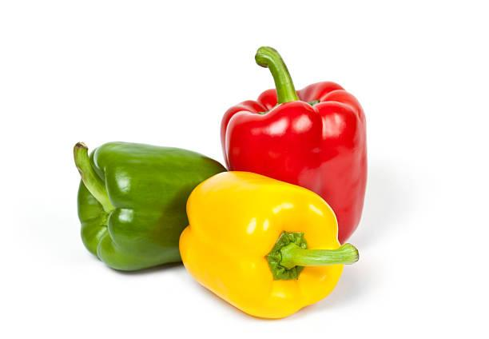

| **% Convert to grayscale (if not already) gray_img = img; % already grayscale in this example  % Add 70% salt & pepper noise noisy_img_3 = imnoise(gray_img, 'salt & pepper', 0.7);  % Apply Closing (Dilation followed by Erosion) closed_img = imclose(noisy_img_3, se);  % Display Results figure; subplot(1,3,1); imshow(gray_img); title('Original Grayscale Image'); subplot(1,3,2); imshow(noisy_img_3); title('With 70% Salt & Pepper Noise'); subplot(1,3,3); imshow(closed_img); title('After Closing (Pepper Removed)');** |
| --- |

### Deliverables

Compile a single word document by filling in the solution part and submit this Word file on Google Classroom/MS Teams. Insert the solution/answer in this document. You must show the implementation of the tasks in the designing tool, along with your complete Word document to get your work graded. You must also submit this Word document on the Google Classroom/MS Teams. In case of any problems with submissions on Google Classroom/MS Teams, submit your Lab assignments by emailing it to: [rozi.kh2@gmail.com](mailto:rozi.kh2@gmail.com)