**SCREENSHOTS**

**CAPSTONE PROJECT : FOODBOX**

BY PRATULYA PRATAP TIWARY

**1.Project Outputs.**

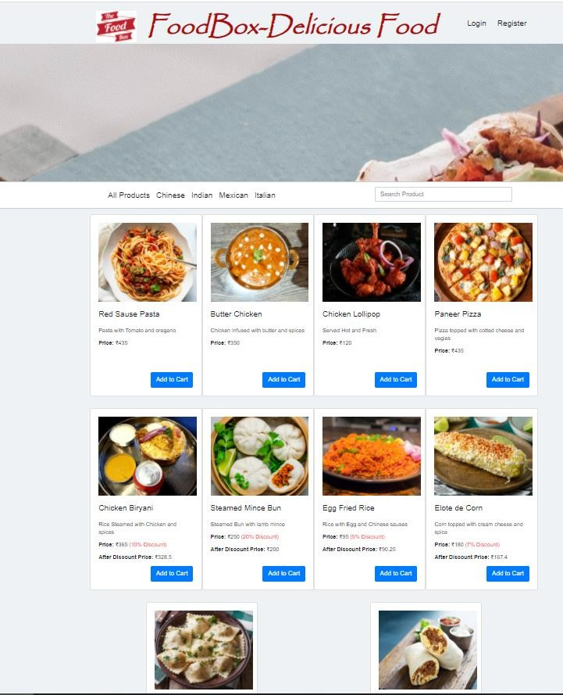

1. HOME PAGE

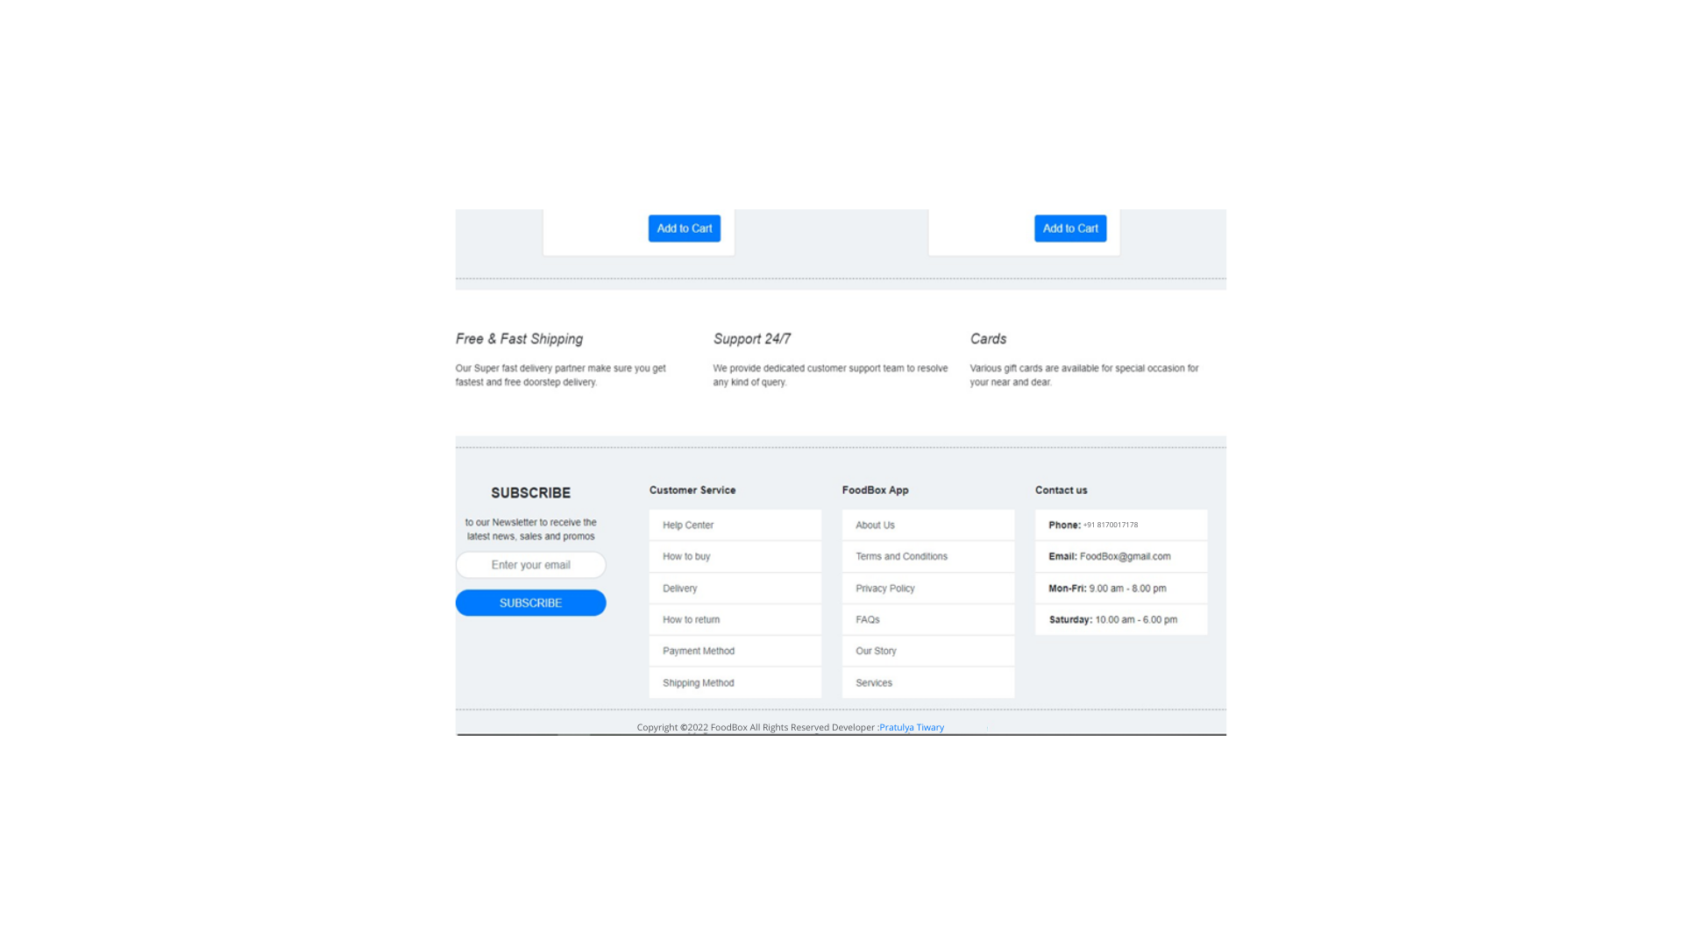

B. Login and Registration Page

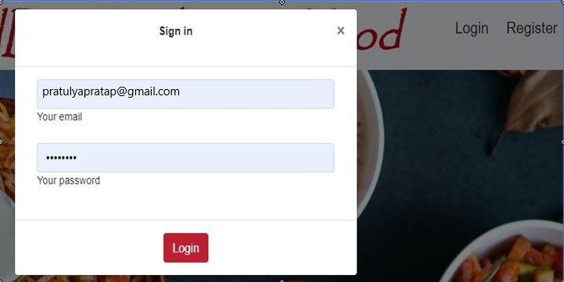

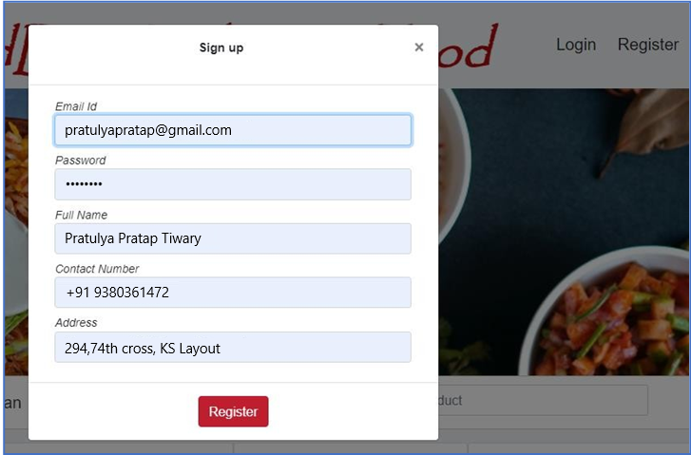

C. Admin Login Page

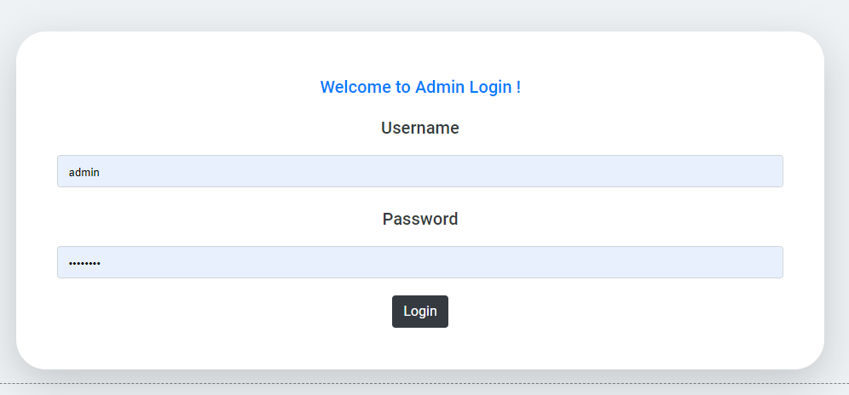

**D. Manage Users, Products , Purchases**

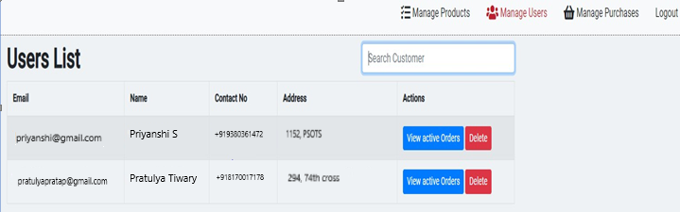

Searching and Sorting:

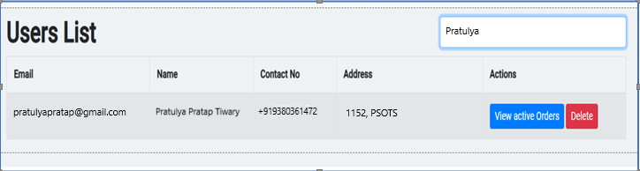

Manage Products:

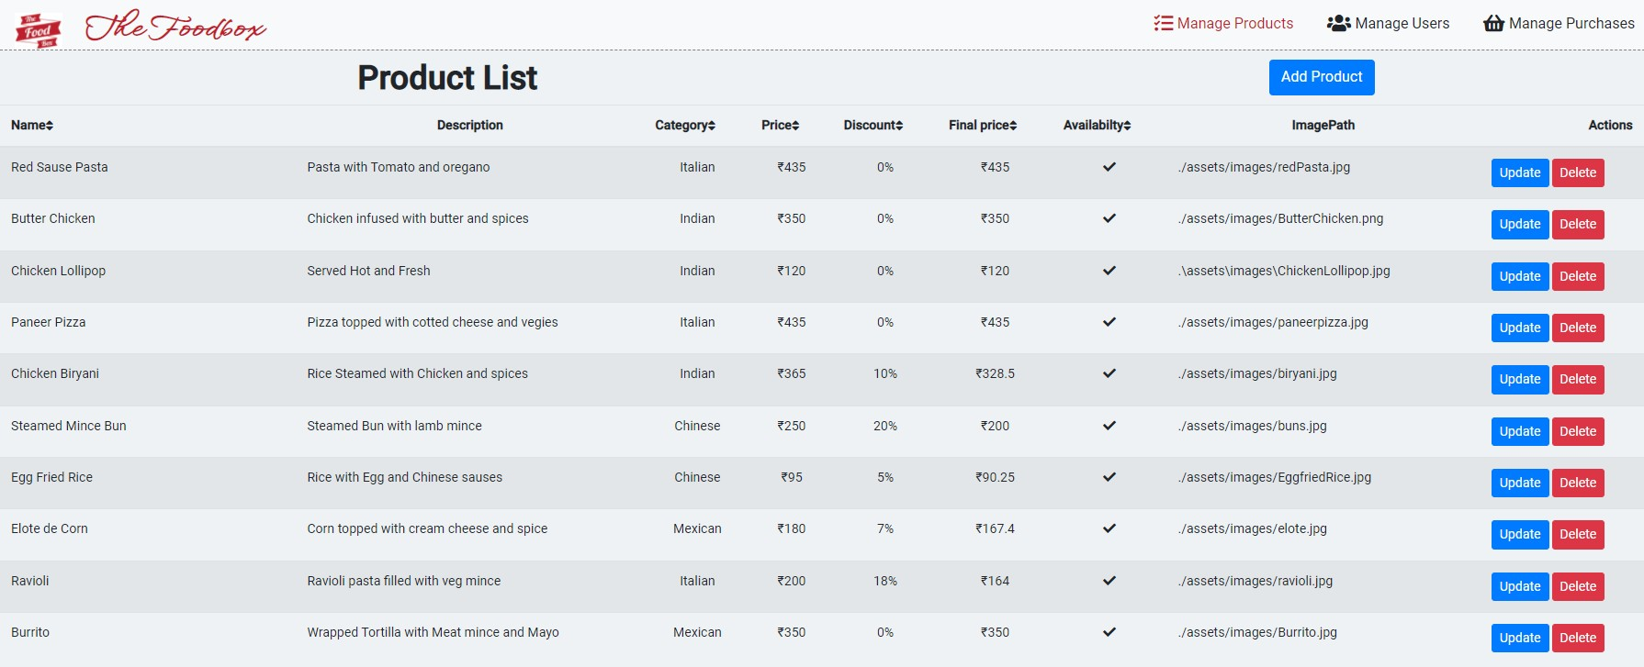

Add Product:

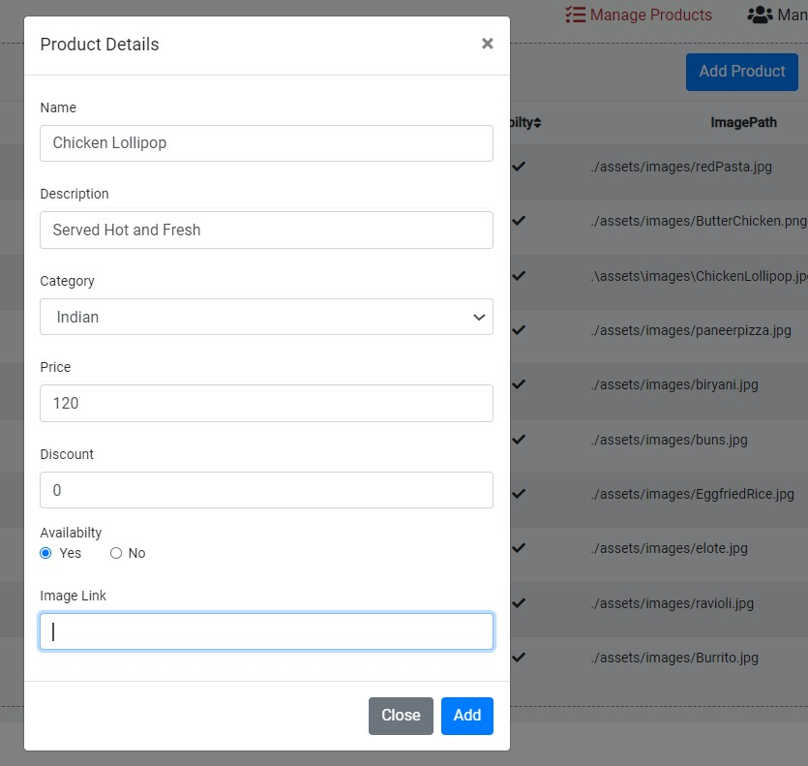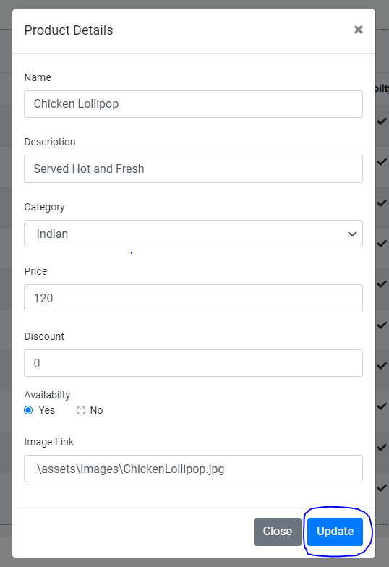

Update Product:

Delete Product:

Product deleted successfully…..

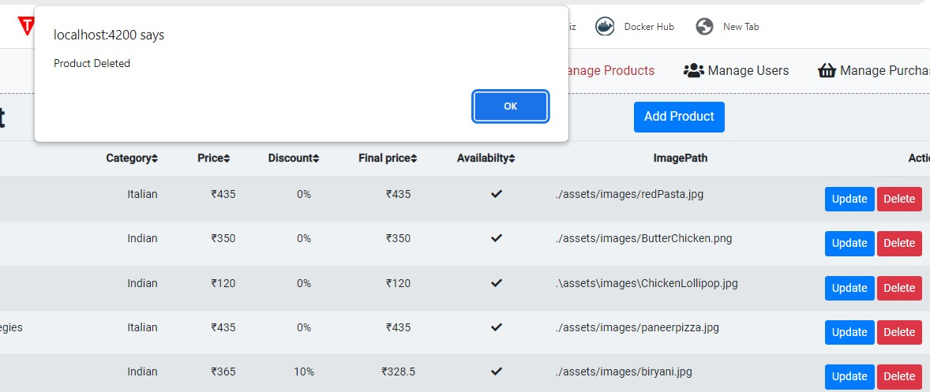

Manage Purchases:

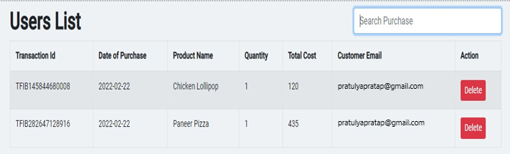

E. View Previous Active Orders

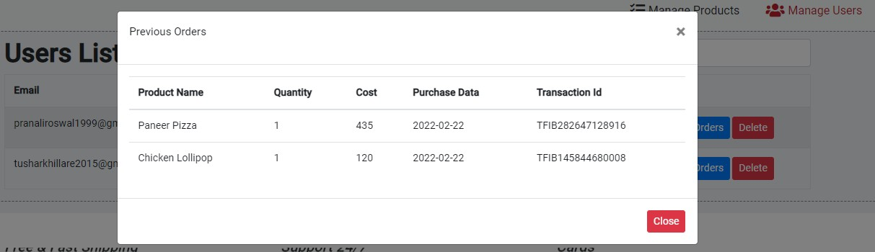

F. User Login

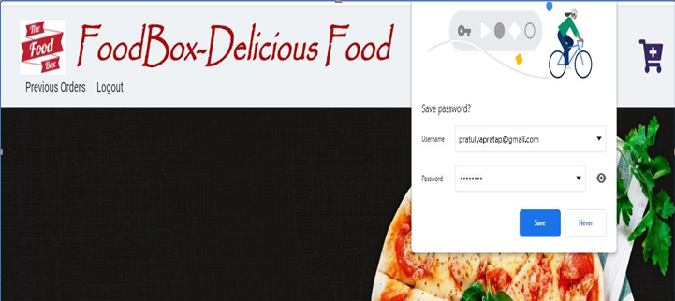

G. Add Cart/View Cart

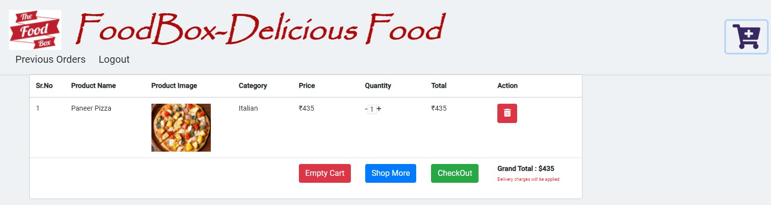

My Cart:

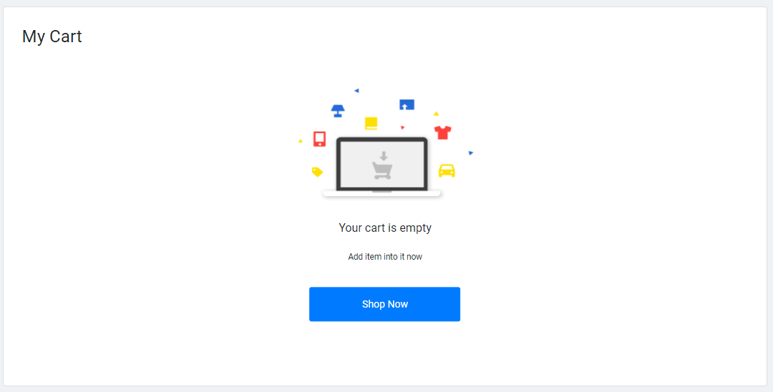

**H. Payment Gateway Page**

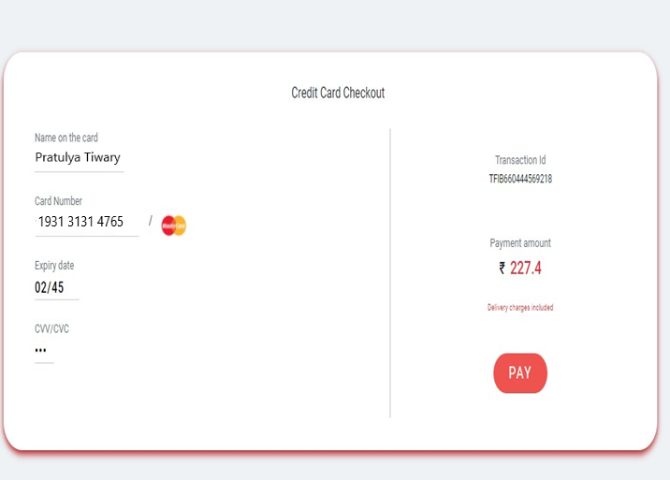

Payment Status:

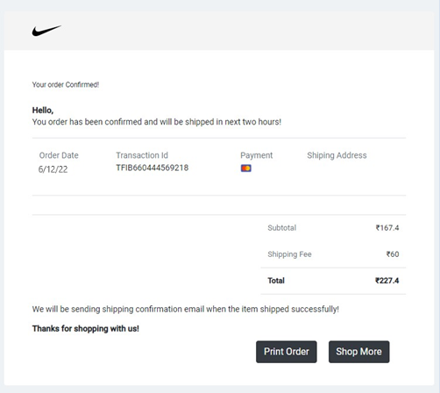

**TESTING AND DEVOPS USING JENKINS**

*Jenkins Build triggered successfully:*

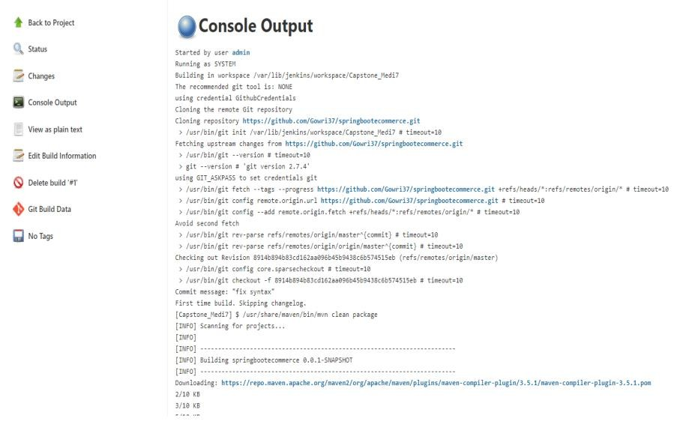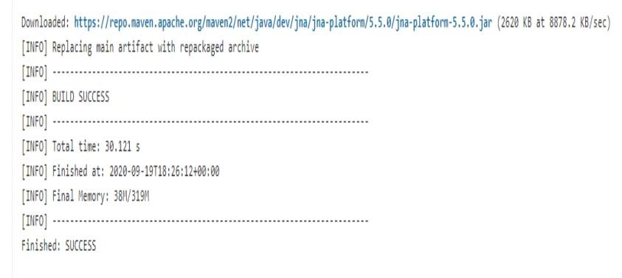

**PROJECT SCREENS POST TESTING AND JENKINS DEPLOYMENT**:

Category Based Searching

http://localhost:4200/products

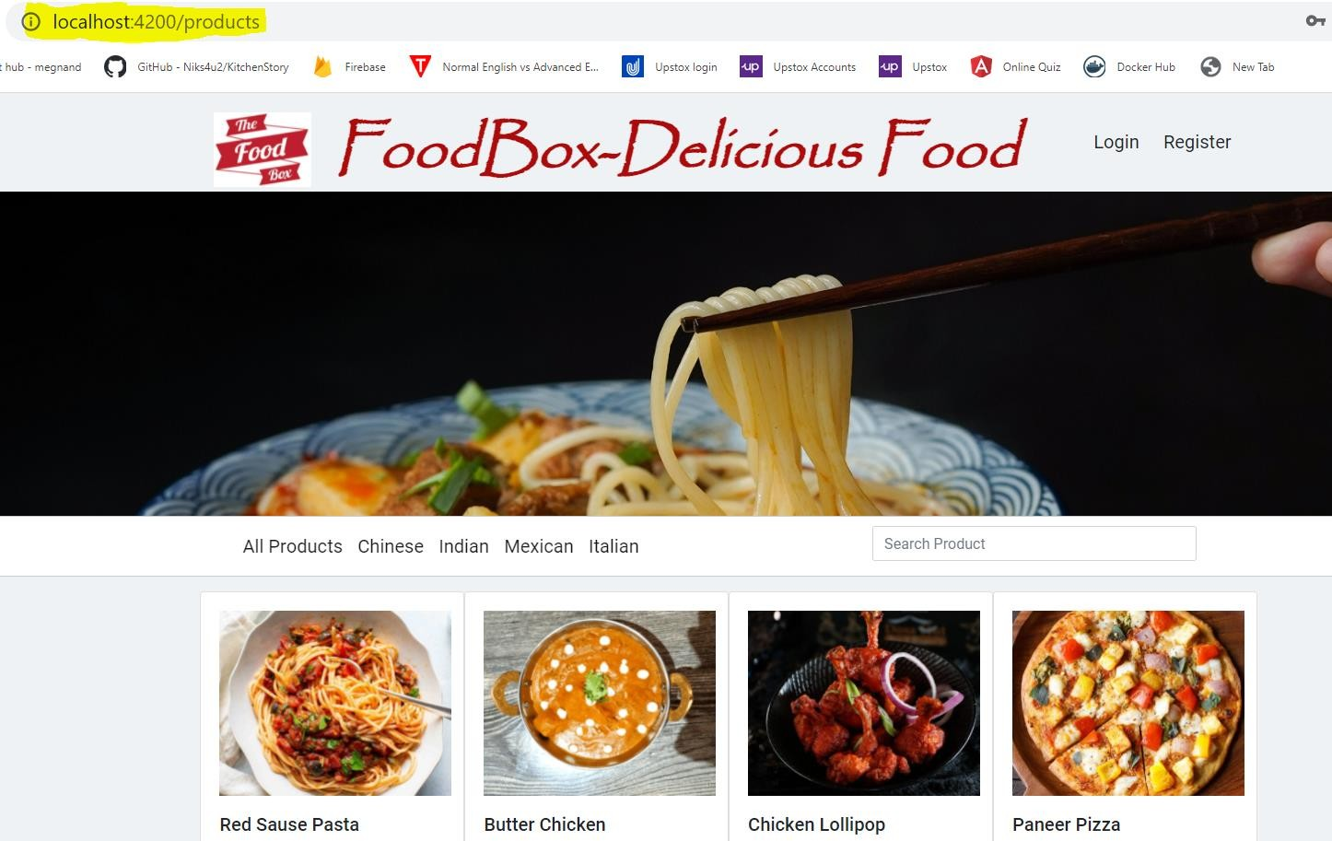

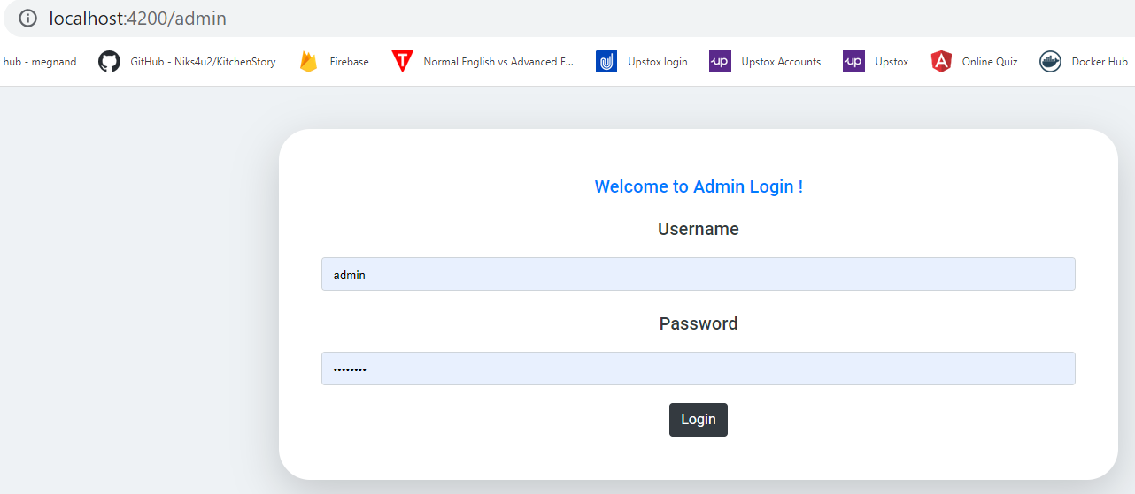

15

THANK YOU……………

16