**Annex: Report for 16.90 PSet 2**

*By Codrin Oneci*

1A. Use this code:

th = 0:pi/50:2*pi;

g=exp(1j*th);

z=zeros(1,length(g));

for i=1:length(g)

c=g(i);

z(i)=(12*c^3-12*c^2)/(23*c^2-16*c+5);

end

disp(g);

xunit = real(z);

yunit = imag(z);

h = plot(xunit, yunit);

title('Adams Bashforth with p=3 stability region ');

xlabel('Real \lambda\Delta t');

ylabel('Imag \lambda\Delta t');

The result is shown below:

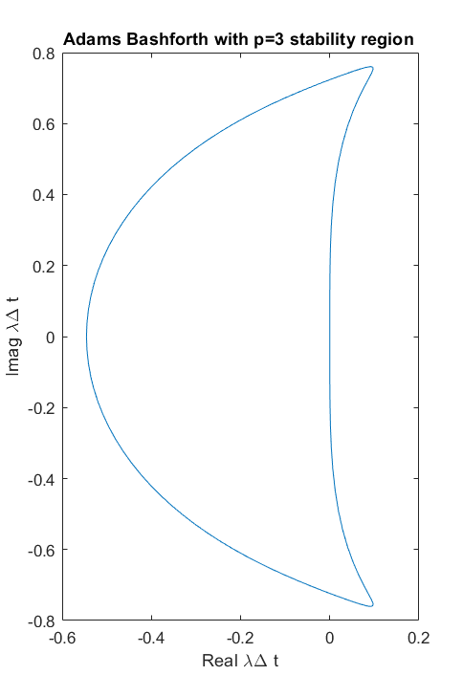

1B. Use this code:

u0=1;

dt=0.01; %timestep

Tfinal=2; %finish time

t=[0:dt:Tfinal]; %time vector

U_AB=zeros(1,length(t));U_AB(1)=u0;

U_exact=zeros(1,length(t));U_exact(1)=u0;

for i=2:4

U_AB(i)=U_AB(i-1)+dt*odefun(U_AB(i-1));

U_exact(i)=exp(1)^(-5*i*dt);

end

for i=4:length(t)

U_AB(i)=U_AB(i-1)+(dt/12)*(23*odefun(U_AB(i-1))-16*odefun(U_AB(i-2)) +5* odefun(U_AB(i-3)));

U_exact(i)=exp(1)^(-5*i*dt);

end

figure(1);

plot(t,U_AB,'-',t,U_exact,'-')

legend('AB3','exact sol')

title('Solution comparison for dt=0.01');

xlabel('t (independent variable)');

ylabel('U');

function dudt=odefun(u)

dudt=-5*u

end

For timestep 0.15 seconds results show instability:

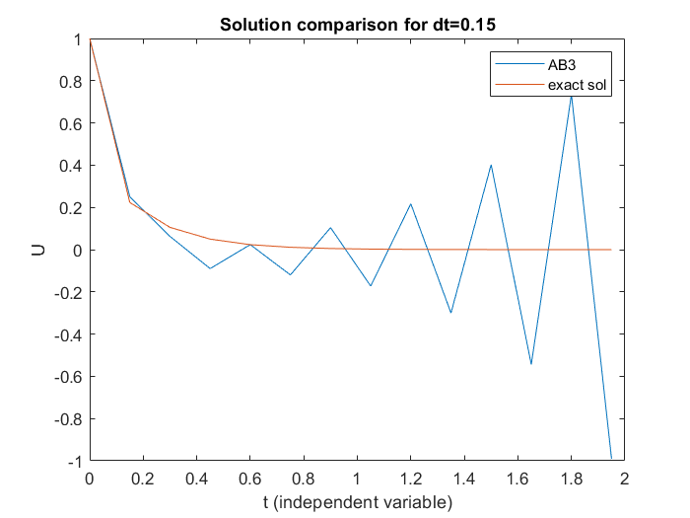

For 0.1 seconds, the solution converges:

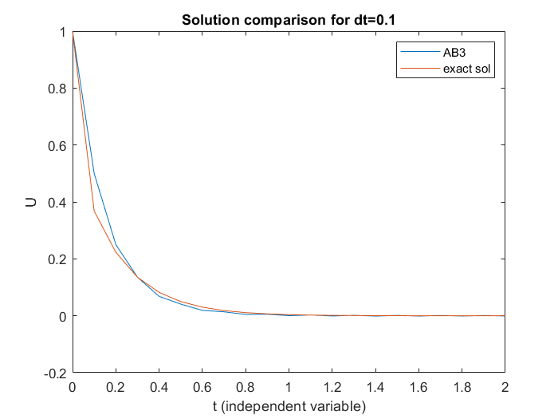

For 0.01 seconds timestep, the curves almost coincide at the scale of the plot:

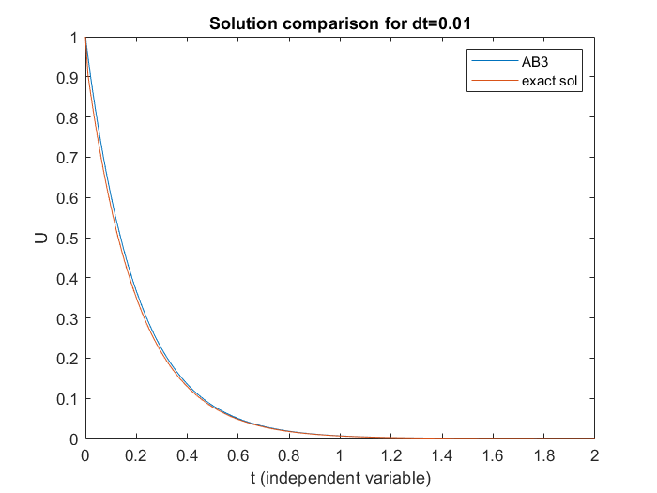

2B. The requested code for parts B and C (including implementations of Backward Euler and Trapezoidal using Newton Raphson subiterations):

dt=0.01; %timestep

Tfinal=10;

t=[0:dt:Tfinal]; %time vector

u0=[0; pi/4]; %initial condition

%BE method

U=zeros(2,length(t));

U(:,1)=u0;

g=9.8;L=1; %gravitational acc and pendulum length

for i=2:length(t)

w = U(:,i-1); %start with an initial guess of the new value

normR=100;

while normR > 1e-12

R = w - U(:,i-1) - dt*([-(g/L)*sin(w(2)); w(1)]); %Residual

J = [0 -(g/L)*cos(w(2)); 1 0]; %Jacobian of the system

dw = (eye(2)-dt*J)\-R; % solve for dw

w = w + dw;

normR = norm(R) ;

end

U(:,i)=w;

end

%trapezoidal integration method

U_trp=zeros(2,length(t));

U_trp(:,1)=u0;

g=9.8;L=1; %gravitational acc and pendulum length

for i=2:length(t)

w = U_trp(:,i-1); %start with an initial guess of the new value

normR=100;

while normR > 1e-12

R = w - U_trp(:,i-1) - 0.5*dt*([-(g/L)*sin(w(2)); w(1)]+[-(g/L)*sin(U_trp(2,i-1)); U_trp(1,i-1)]); %Residual

J = [0 -(g/L)*cos(w(2)); 1 0]; %Jacobian of the system

dw = (eye(2)-0.5*dt*J)\-R; % solve for dw

w = w + dw;

normR = norm(R) ;

end

U_trp(:,i)=w;

end

figure (1);

plot(t,U(2,:),'-',t,U_trp(2,:),'-')

legend('BE with NR','trapezoidal with NR');

title('Pendulum angular displacement calculated using BE/NR and trapezoidal/NR');

xlabel('time (seconds)');

ylabel('Angular displacement (radians)');

The resulting plot is made with dt=0.01 seconds:

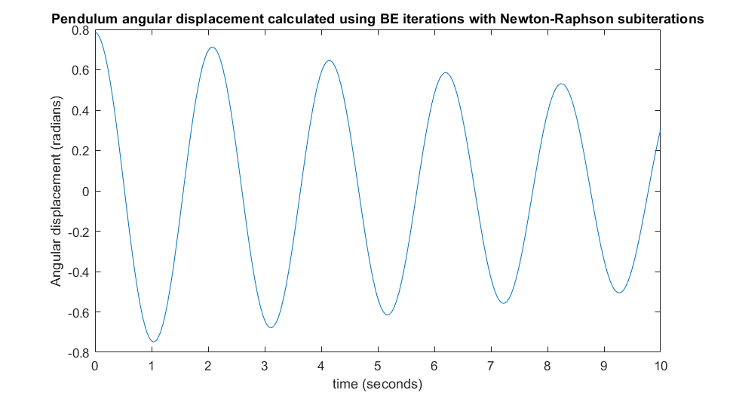

Also for dt=0.001 seconds:

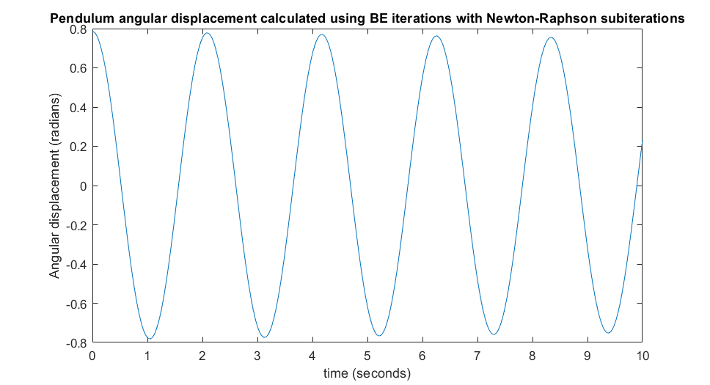

2C. Plot with dt=0.01 seconds:

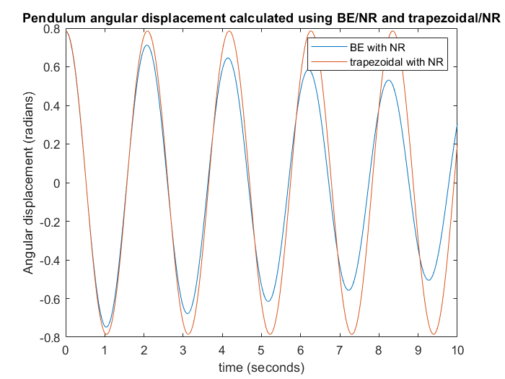

2D. I wrote this code:

dt=0.01; %timestep

u0=[0; pi/4]; %initial condition

%BE method

g=9.8;L=1; %gravitational acc and pendulum length

omega=sqrt(g/L);

Tfinal=2*pi*sqrt(L/g);

t=[0:dt:Tfinal]; %time vector

U=zeros(2,length(t),59);

U_analitic=zeros(2,length(t),59);

for indice=1:59 %initialize 3d matrix wit angular amplitude, knowing that initial ang speed is zero

U(2,1,indice)=pi/(indice+1);

U_analitic(2,1,indice)=pi/(indice+1);

end

for indice=1:59

for i=2:length(t)

w = U(:,i-1,indice); %start with an initial guess of the new value

normR=100;

while normR > 1e-12

R = w - U(:,i-1,indice) - dt*([-(g/L)*sin(w(2)); w(1)]); %Residual

J = [0 -(g/L)*cos(w(2)); 1 0]; %Jacobian of the system

dw = (eye(2)-dt*J)\-R; % solve for dw

w = w + dw;

normR = norm(R) ;

end

U(:,i,indice)=w; %update matrix U at location i-1, indice with a vector

U_analitic(:,i,indice)=[-U_analitic(2,1,indice)*omega*sin(omega*(i-1)*dt),U_analitic(2,1,indice)*cos(omega*(i-1)*dt)];

end

end

relative_errors=zeros(1,59);

for indice=1:59 %look for the maximal absolute relative error

%relative_errors(indice)=norm(U_analitic(:,length(t),indice)-U(:,length(t),indice))/norm(U_analitic(:,length(t),indice));

relative_errors(indice)=norm(U_analitic(2,:,indice)-U(2,:,indice))/norm(U_analitic(2,:,indice));

end

disp(relative_errors)

figure (1);

plot(t,U(2,:,59),'-',t,U_analitic(2,:,59),'-')

legend('BE/NR','analitic');

title('Pendulum angular displacement');

xlabel('time (seconds)');

ylabel('Angular displacement (radians)');

I have read values for relative errors displayed with the last disp() call. All initializations with angular amplitude less or equal 30 degrees give errors of less than 10% (on amplitude; I have seen the errors being larger for angular speed).

For pi/60 amplitude with dt=0.01 s I got:

