CMOS
Mohammad Hasan, Aaron Price
Wa’el Alkalbani , Mosiah Beal
Group 6
10/21/2023

Introduction and physical properties
______________________________________________________________________________
1- Cell Description
This cell consists of a CMOS inverter. They are extremely common and one of the most used circuity. Cmos inverters are used in every digital device that exists. It takes whatever the input may be ,and it inverts it. For example, if the input is a logic 1, the inverter will take that input and transform it into a logic 0.
2- Cell Symbols
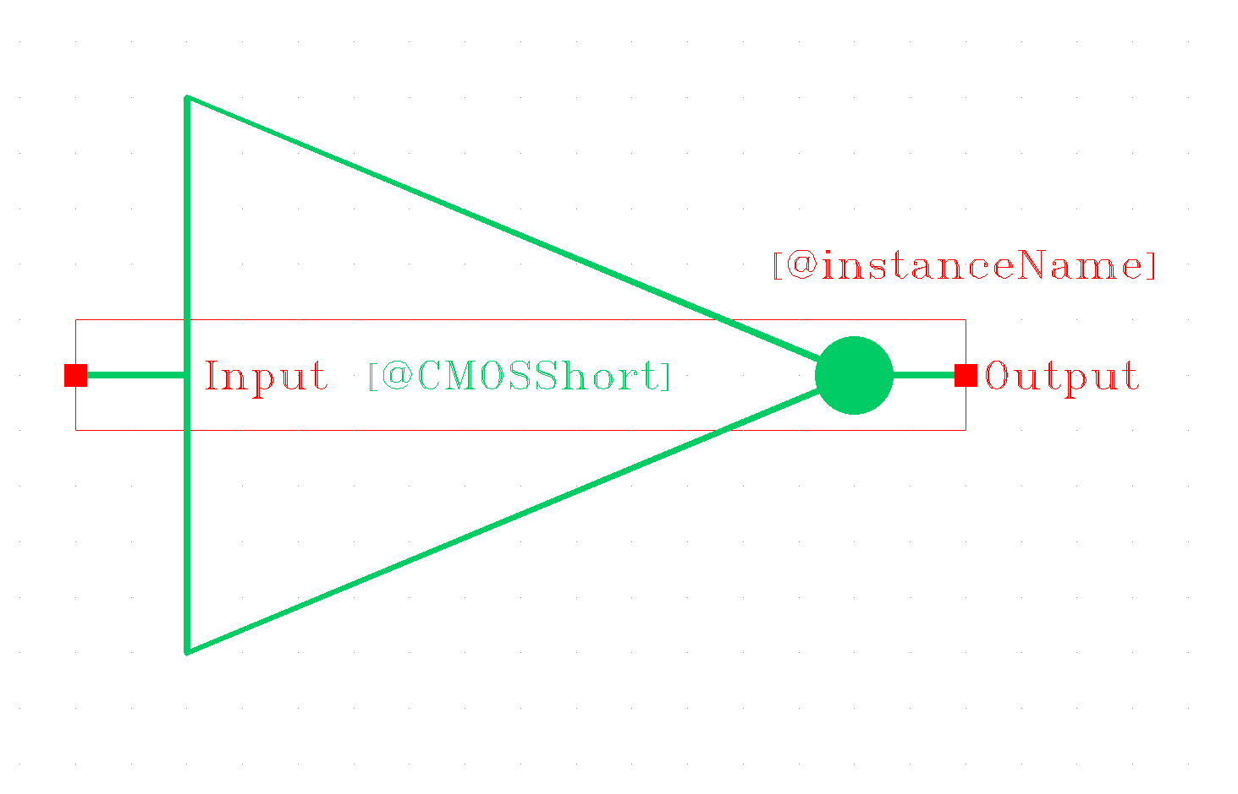
Figure 1: CMOS inverter (normal)
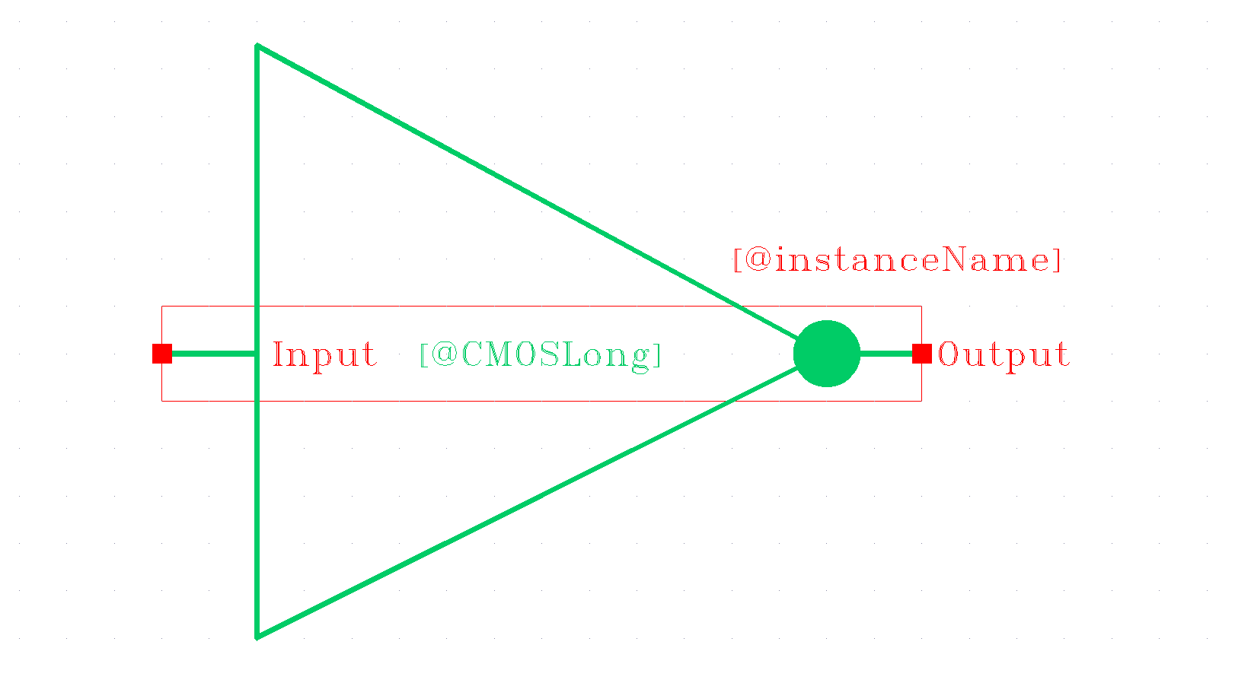
Figure 2: CMOS inverter (long)

3- Cell Truth Table (for both cmos inverters)
Cell input | Cell output
A | Y
0 | 1
1 | 0

4- Cell schematic
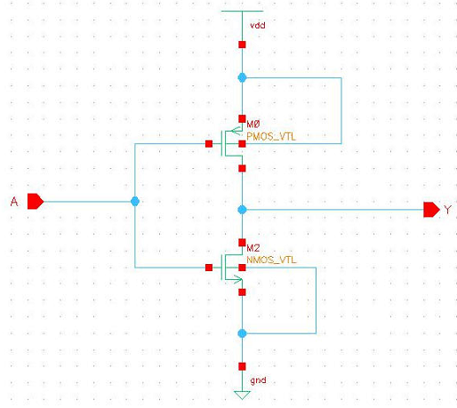
Figure 3: CMOS inverter (short)
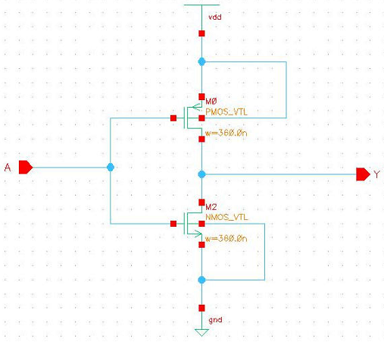
Figure 4: CMOS inverter (long)

5- Cell Dimensions
CMOS
transistor instance number | Width (nm) | Length (nm)
PMOS (M0) | 90 | 50
NMOS (M2) | 90 | 50

CMOS Long
transistor instance number | Width (nm) | Length (nm)
PMOS(M0) | 360 | 50
NMOS(M2) | 360 | 50

6- Input X: output rise time data
CMOS
Input rise/fall time (ps) | FO0 | FO1 | FO2 | FO4 | FO8
40 | —----- | —---- | —----- | 391.1 | —------

CMOS Long
Input rise/fall time (ps) | FO0 | FO1 | FO2 | FO4 | FO8
40 | —----- | —---- | —----- | 94.56 | —------

7- Input X: output fall time data
CMOS
Input rise/fall time (ps) | FO0 | FO1 | FO2 | FO4 | FO8
40 | —----- | —---- | —----- | 116.6 | —------

CMOS Long
Input rise/fall time (ps) | FO0 | FO1 | FO2 | FO4 | FO8
40 | —----- | —---- | —----- | 32.14 | —------

8- Data worst case Low to High propagation delay t_{plh}
CMOS
Input rise/fall time (ps) | FO0 | FO1 | FO2 | FO4 | FO8
40 | —----- | —---- | —----- | 275.404 | —------

CMOS Long
Input rise/fall time (ps) | FO0 | FO1 | FO2 | FO4 | FO8
40 | —----- | —---- | —----- | 75.756 | —------

9- Data worst case High to Low propagation delay t_{phl}
CMOS
Input rise/fall time (ps) | FO0 | FO1 | FO2 | FO4 | FO8
40 | —----- | —---- | —----- | 96.995 | —------

CMOS Long
Input rise/fall time (ps) | FO0 | FO1 | FO2 | FO4 | FO8
40 | —----- | —---- | —----- | 31.985 | —------

10- Transient analysis
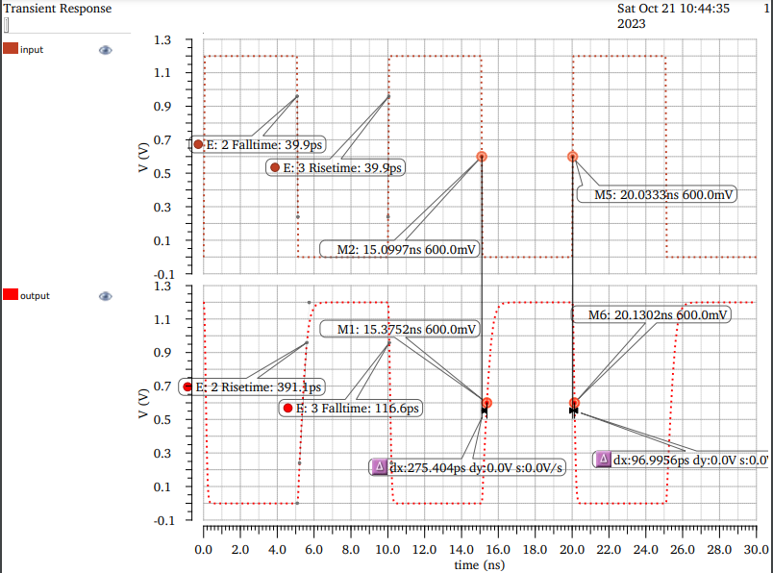
Figure 5: Transient analysis on the normal CMOS circuitry

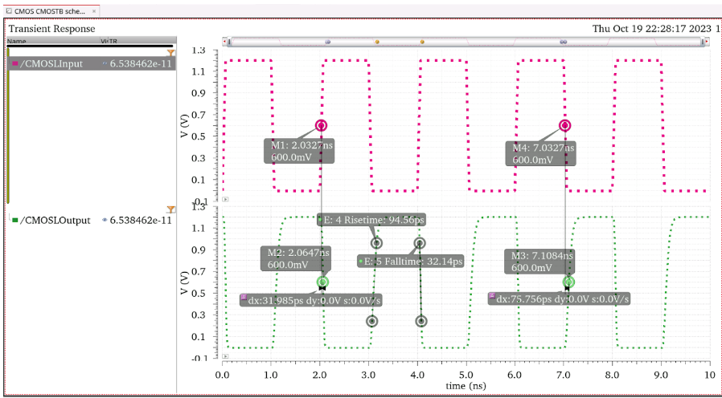
Figure 6: Transient analysis on the CMOS Long circuitry

Table 1: Transient analysis table
TYPE | t_{plh} (ps) | t_{phl} (ps) | t_{r} (ps) | t_{f} (ps)
CMOS | 275.404 | 96.995 | 391.1 | 116.6
CMOS_LONG | 75.756 | 31.985 | 94.56 | 32.14
Enhancement mode NFET | 323.892 | 72.1549 | 1560 | 74.74
Enhancement mode NFET Long | 1034.43 | 62.3649 | 4724 | 77.4
Resistive load | 590.613 | 100.105 | 880.5 | 118.2
Resistive load Long | 2082.7 | 90.7394 | 2925 | 105.8

11- DC analysis
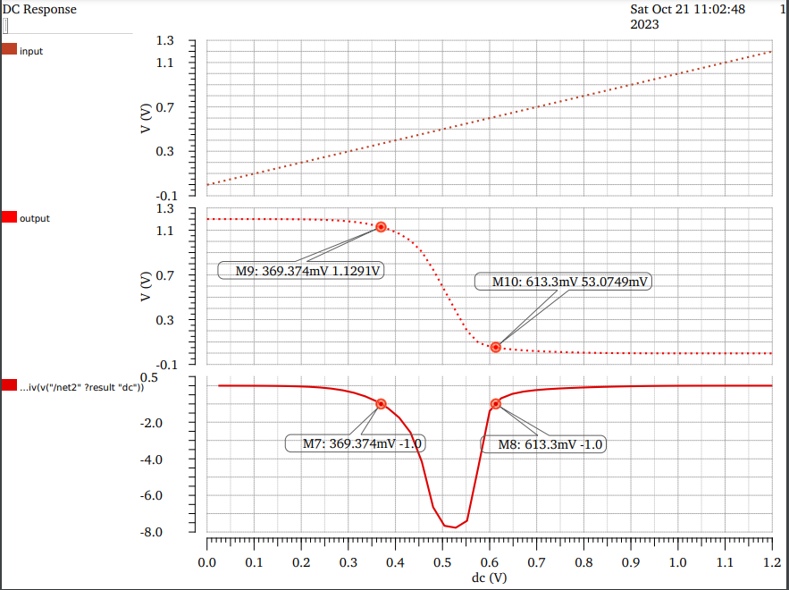
Figure 7: DC analysis on the normal CMOS circuitry

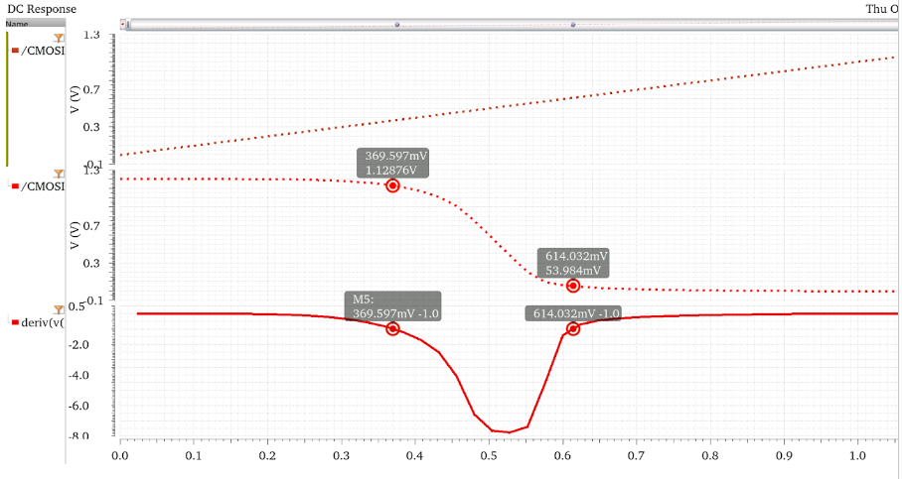
Figure 8: DC analysis on the CMOS Long circuitry

Table 2: DC Analysis table
TYPE | V_{IH_DC} (mV) | V_{IL_DC} (mV) | V_{OH_DC} (mV) | V_{OL_DC} (mV)
CMOS | 613.3 | 369.374 | 1129.1 | 53.0749
CMOS_LONG | 614.032 | 369.597 | 1128.76 | 53.984
Enhancement mode NFET | 344.75 | 624.697 | 508.485 | 117.365
Enhancement mode NFET Long | 270.272 | 550.588 | 528.809 | 66.047
Resistive load | 677.123 | 307.049 | 1126.49 | 115.919
Resistive load Long | 558.172 | 239.854 | 1132.73 | 56.047

