RESISTIVE
Mohammad Hasan, Aaron Price
Wa’el Alkalbani , Mosiah Beal
Group 6
10/21/2023

Introduction and physical properties
______________________________________________________________________________
1- Cell Description
This cell consists of a NMOS and pull up resistor as a load bearing component, vs a typical Enhancement inverter. These resistive load inverters may be used in place of enhancement inverters for various reasons, including but not limited too:
- Simplicity of technology
- Higher output voltage when compared to enhancement
- Availability with older technologies

2- Cell Symbols
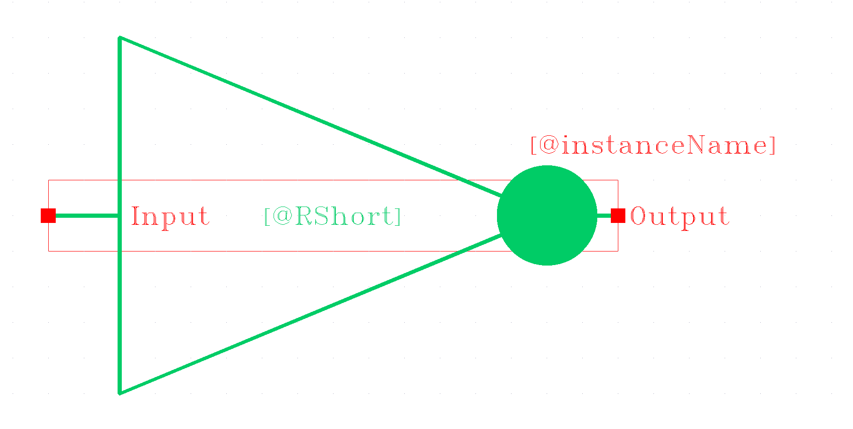
Figure 1: Resistive inverter (Short)

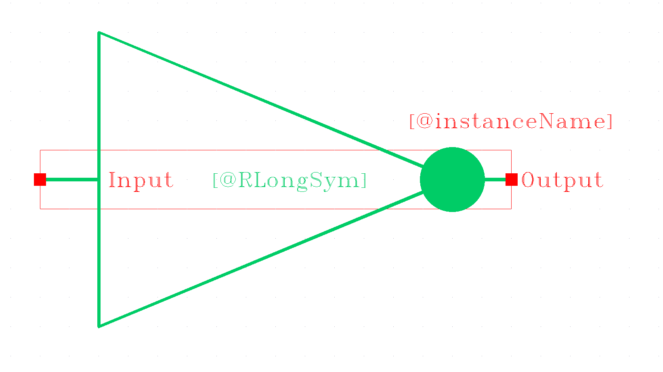
Figure 2: Resistive inverter (long)
3- Cell Truth Table (for both resistive inverters)
Cell input | Cell output
A | Y
0 | 1
1 | 0

4- Cell schematic
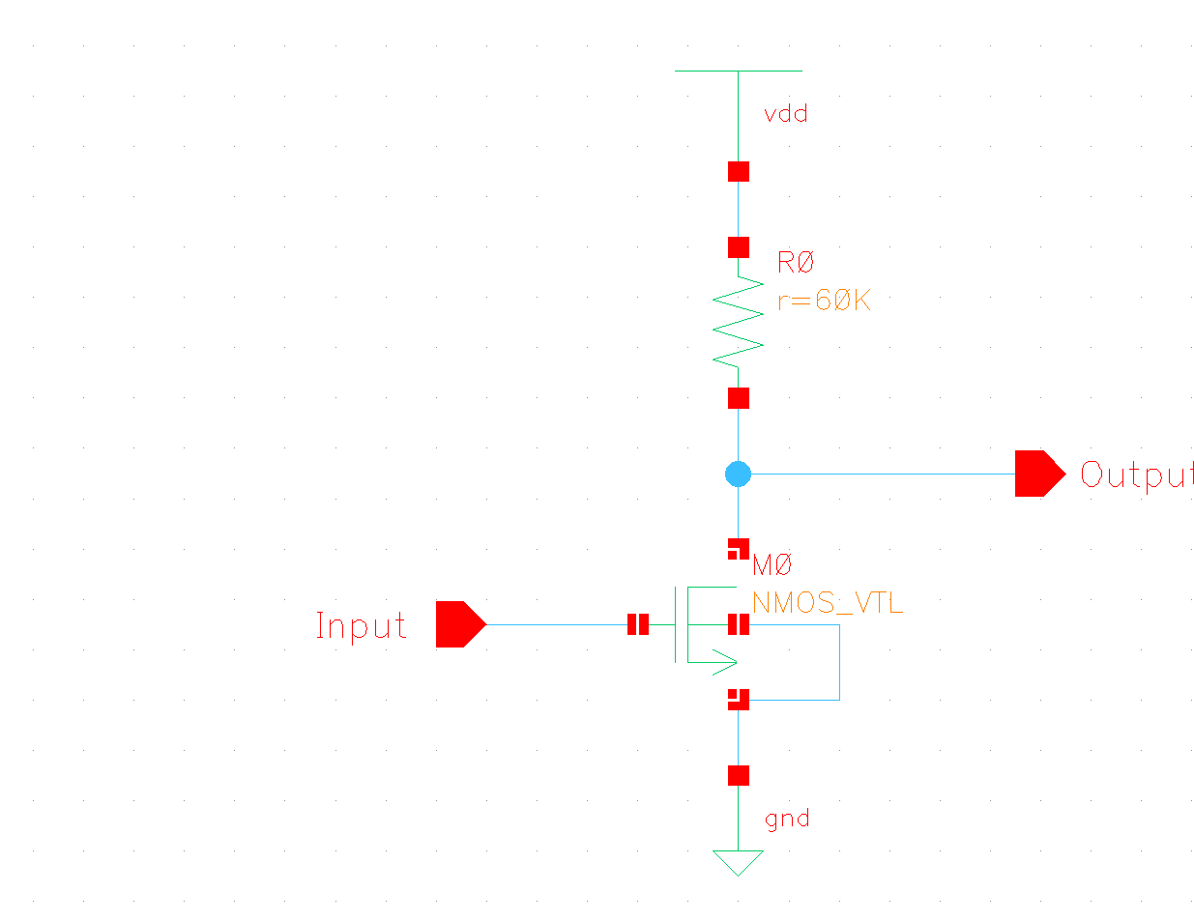
Figure 3: Resistive inverter (short r = 60K)
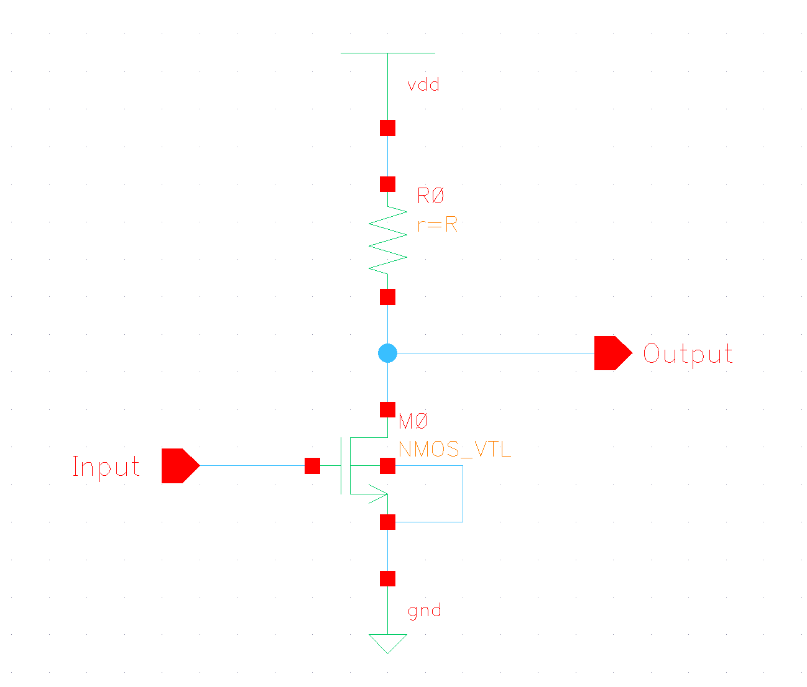
Figure 4: Resistive inverter (long R0 = r=R = 200K)
5- Cell Dimensions
Resistive
transistor instance number | Width (nm) | Length (nm) | resistance (ohms)
Resistor (R0) | — | — | 60k
NMOS (M0) | 90 | 50 | –

Resistive Long
transistor instance number | Width (nm) | Length (nm) | resistance (ohms)
Resistor (R0) | — | — | 200k
NMOS (M0) | 90 | 50 | –

6- Input X: output rise time data
Resistive
Input rise/fall time (ps) | FO0 | FO1 | FO2 | FO4 | FO8
40 | —----- | —---- | —----- | 808.5 | —------

Resistive Long
Input rise/fall time (ps) | FO0 | FO1 | FO2 | FO4 | FO8
40 | —----- | —---- | —----- | 2925.0 | —------

7- Input X: output fall time data
Resistive
Input rise/fall time (ps) | FO0 | FO1 | FO2 | FO4 | FO8
40 | —----- | —---- | —----- | 118.2 | —------

Resistive Long
Input rise/fall time (ps) | FO0 | FO1 | FO2 | FO4 | FO8
40 | —----- | —---- | —----- | 105.8 | —------

8- Data worst case Low to High propagation delay t_{plh}
Resistive
Input rise/fall time (ps) | FO0 | FO1 | FO2 | FO4 | FO8
40 | —----- | —---- | —----- | 590.613 | —------

Resistive Long
Input rise/fall time (ps) | FO0 | FO1 | FO2 | FO4 | FO8
40 | —----- | —---- | —----- | 2082.7 | —------

9- Data worst case High to Low propagation delay t_{phl}
Resistive
Input rise/fall time (ps) | FO0 | FO1 | FO2 | FO4 | FO8
40 | —----- | —---- | —----- | 100.105 | —------

Resistive Long
Input rise/fall time (ps) | FO0 | FO1 | FO2 | FO4 | FO8
40 | —----- | —---- | —----- | 90.7394 | —------

10- Transient analysis

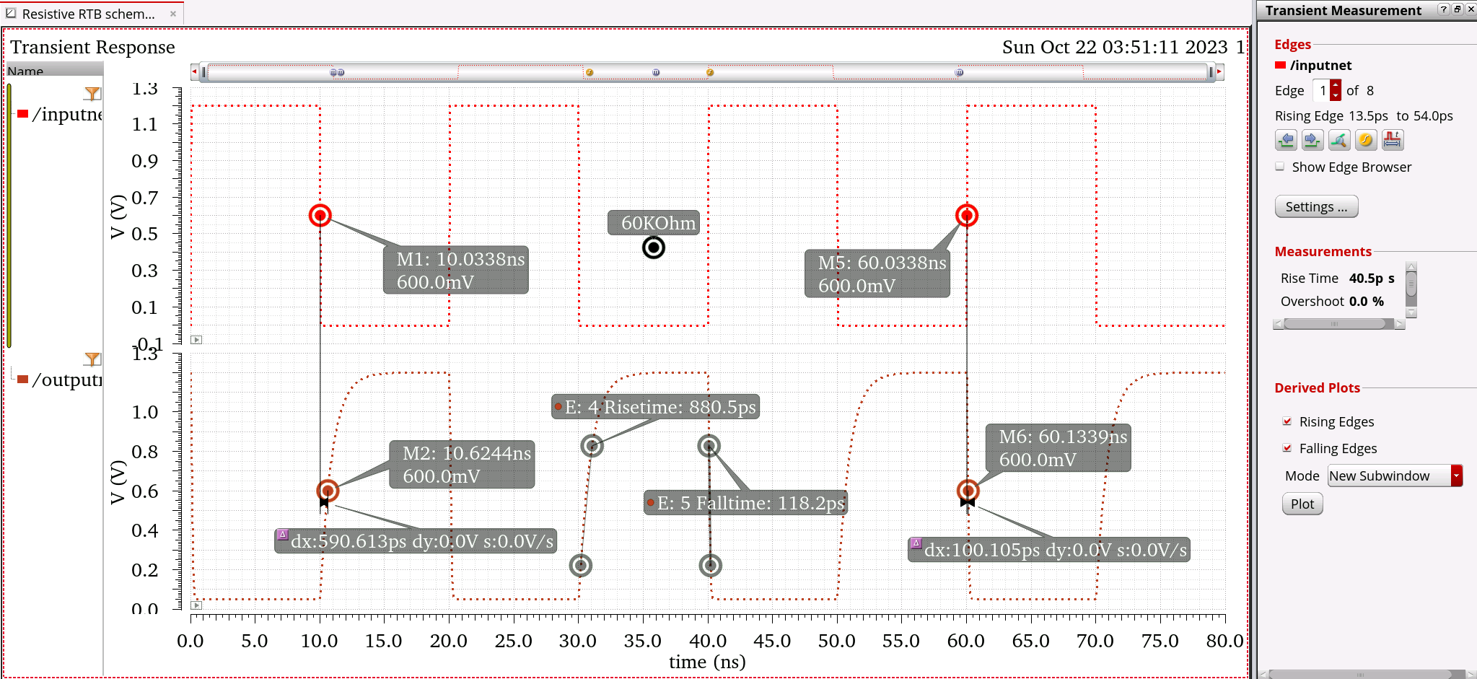
Figure 5: Transient analysis on Resistive Short circuitry
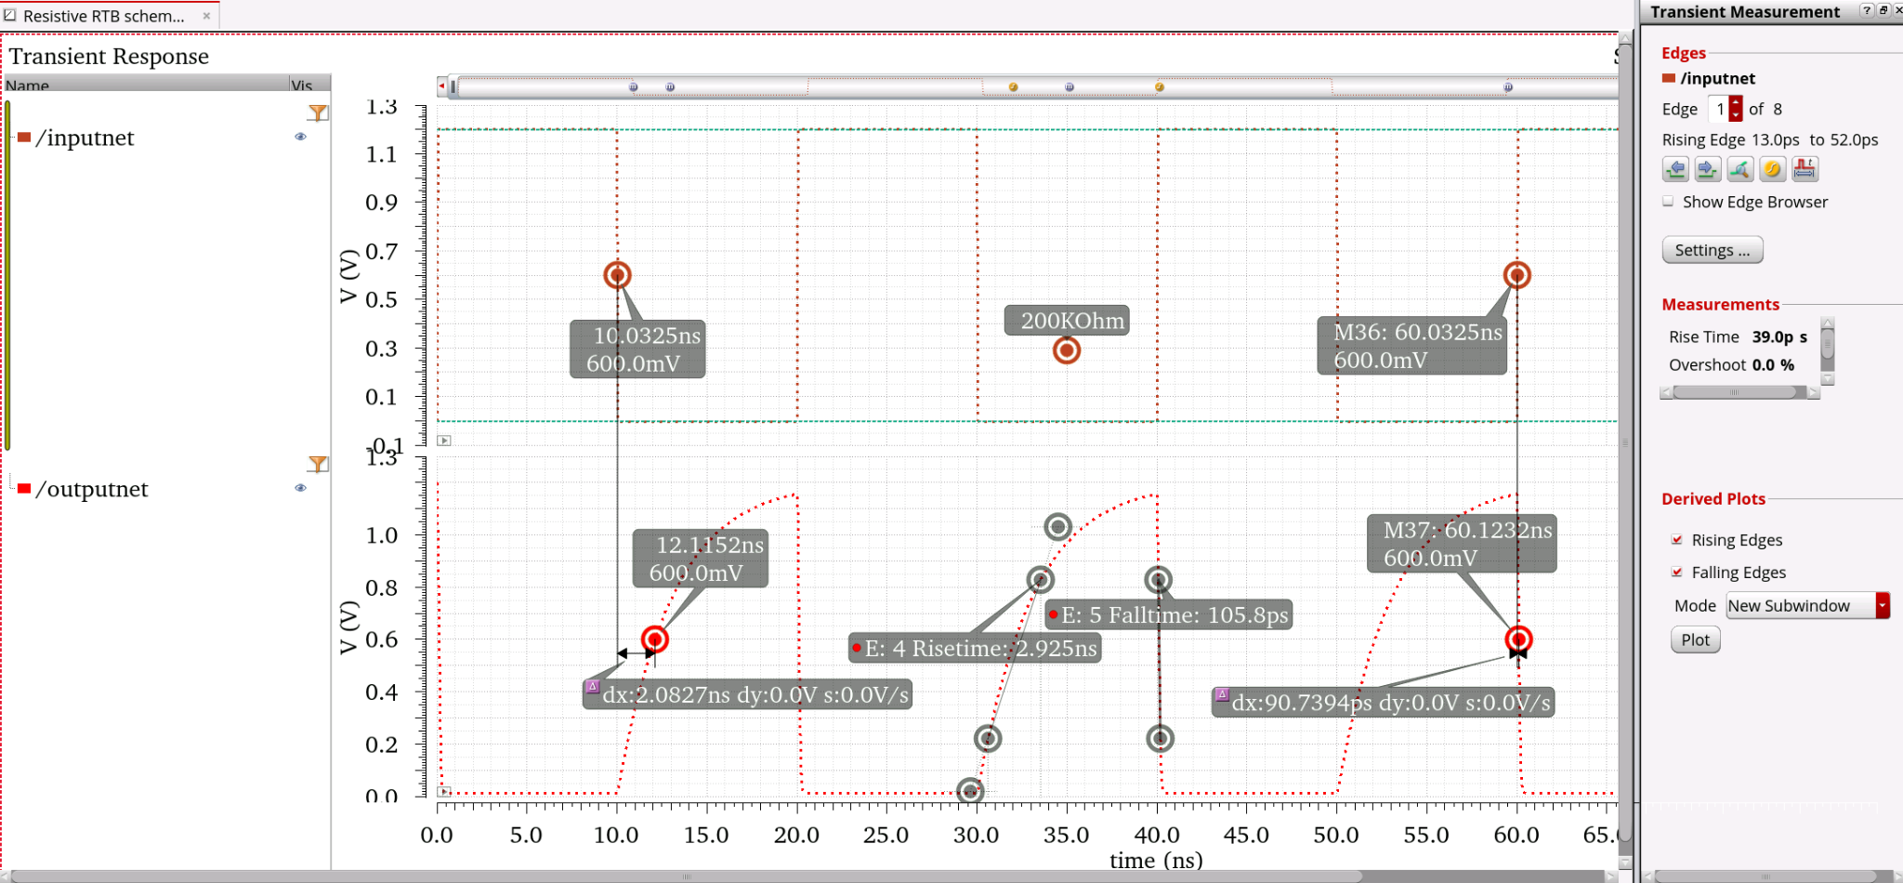
Figure 6: Transient analysis on Resistive Long circuitry

Table of Transient Analysis
TYPE | t_{plh} (ps) | t_{phl} (ps) | t_{r} (ps) | t_{f} (ps)
CMOS | 275.404 | 96.995 | 391.1 | 116.6
CMOS_LONG | 75.756 | 31.985 | 94.56 | 32.14
Enhancement mode NFET | 323.892 | 72.1549 | 1560 | 74.74
Enhancement mode NFET Long | 1034.43 | 62.3649 | 4724 | 77.4
Resistive load | 590.613 | 100.105 | 880.5 | 118.2
Resistive load Long | 2082.7 | 90.7394 | 2925 | 105.8

11- DC analysis
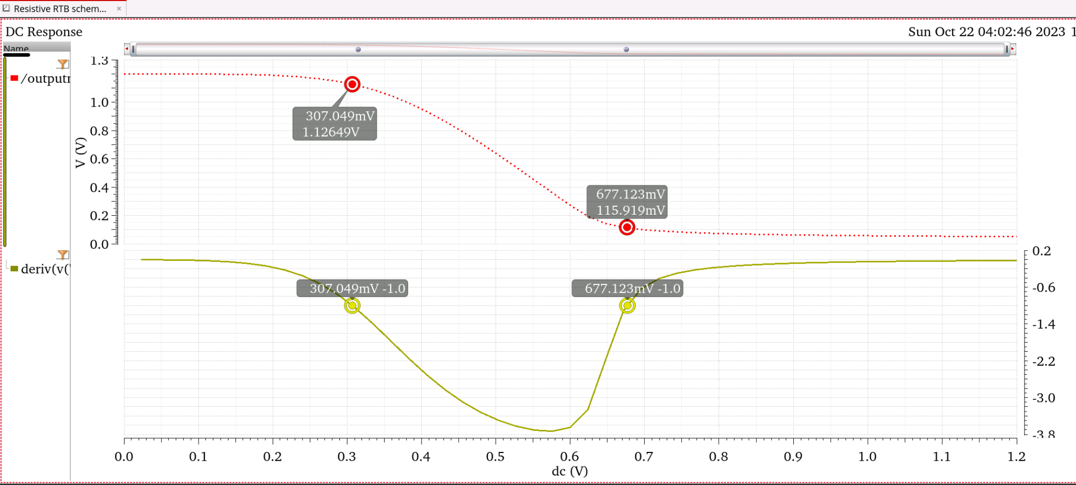
Figure 7: DC analysis on Resistive Short circuitry

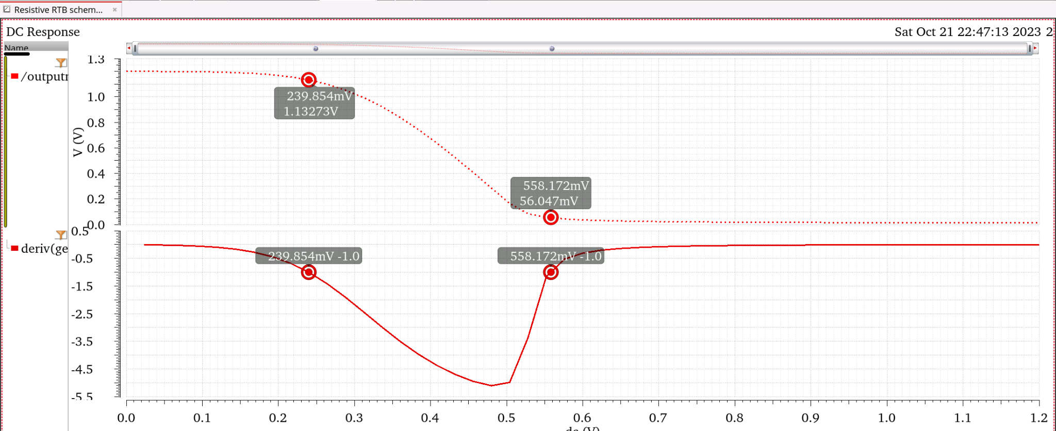
Figure 8: DC analysis on Resistive Long circuitry

Table of DC Analysis
TYPE | V_{IH_DC} (mV) | V_{IL_DC} (mV) | V_{OH_DC} (mV) | V_{OL_DC} (mV)
CMOS | 613.3 | 369.374 | 1129.1 | 53.0749
CMOS_LONG | 614.032 | 369.597 | 1128.76 | 53.984
Enhancement mode NFET | 344.75 | 624.697 | 508.485 | 117.365
Enhancement mode NFET Long | 270.272 | 550.588 | 528.809 | 66.047
Resistive load | 677.123 | 307.049 | 1126.49 | 115.919
Resistive load Long | 558.172 | 239.854 | 1132.73 | 56.047

