BUSINESS ACADEMY AARHUS

MUTIMEDIA DESIGN AND COMMUNCIATION

TITLE

**SUZUKI JIMNY**

**URL:** <https://codrean.github.io/exam/>

Professor:

Lektor univ. Morten Algy Bonderp

Lektor univ. Maria Louise Bendixen

Lektor univ. Sergio Da Luz Benros

Student:

IOANA CODREAN

AARHUS

-2020-

Content

Chapter I

INTRODUCTION

**1.1 Suzuki History …………………………………………………………………….………1**

**1.2** **Shot history of Suzuki Jimny ………………………………………………………….…1**

**1.3 Jimny concept – description ……………………………………………………………...2**

Chapter II

**2.1 Objectives …………………………….…………………………………………………….3**

**2.2 Research Design ……………………………………………………………………………3**

***2.3 SWOT ANALYSIS ………………………………………………………………………….7***

Chapter III

***3.1* Results ……………………………………………………………………………………….8**

**3.2 Discussions ………………………………………………………………………………….13**

***3.3 Conclusions …………………………………………………………………………………13***

***Annex***

***Bibliography***

Introduction

The choice of the project theme was made following a detailed analysis of the other products. This theme, Suziki Jimny, I found to be the best one for me. Also, growing up in a mountain area, I have a greater interest for urban cars.

The decision to create a Jimny car presentation page was also influenced by the large number of people using personal cars instead of public transportation. These people represent site traffic. Also, by presenting the car on the page they can easily acquire information to be guided in their future purchase (such as a shopping guide).

The characteristics of the group of people who participated in the project are unknown. Because the purpose of the questionnaire applied was to identify their wishes and not a differential statistical analysis.

The results of the questionnaires led to the identification of the wishes of the drivers. From the color of the car to the capacity of the engine there were advanced technology present on the market.

The specific objective of the project was to identify the desires that the drivers have, in general and regarding the purchase of a new car.

HTML5 and CSS I used to carry out the project. Adobe Illustration and Adobe Photoshop were used to editing the photos.

The project comprises three major chapters (theoretical framework, methodology, and results).

Keywords: Suzuki Jimny, car, website.

URL: <https://codrean.github.io/exam/>

I. Chapter. Suzuki

**1.2 Suzuki history**

Suzuki's four-wheel car history dates back to 1958. Suzuki's first four-wheel-drive LJ10 (Light Jeep 10) was introduced in 1970. The LJ10 had a 359cc, two-stroke, air-cooled, two-cylinder engine. The liquid-cooled LJ20 was introduced in 1972, with the modified cooling, due to the recently adopted emissions regulations and has gained 3 PS. In 1975, Suzuki completed the LJ20 with the LJ50, which had a larger 5-cylinder, two-stroke, inline three-cylinder and larger differential. It was initially targeted on the Australian market, but more exports followed soon.

Jimny8 / LJ80 was an updated version of the LJ50 with a four-cylinder, 800-stroke four-cylinder in-line engine, followed by Jimny 1000 / SJ410 and Jimny 1300 / SJ413. An updated version of the SJ413 became known as the Samurai and was the first officially released Suzuki in the US. The SJ410 to SJ413 series was known as the Sierra in Australia and Jimny remained on some markets.

**1.2 Shot history of Suzuki Jimny**

Suzuki Jimny (Japanese: ス ズ キ ・ ジ ム ニ ニ uki Suzuki Jimunī) is a line of four-wheel drive off-road SUVs made by 1970s Japanese manufacturer Suzuki. “It originated as a car in the Japanese car Kei ( "light car") and legal class - a Kei car version is still made for the Japanese market today, as well as versions that go beyond the legal limits of this class, in Japan called Jimny Sierra”(Suzuki Jimny, 2019). The latter are also successfully sold on world markets. Suzuki has sold 2.85 million of these in 194 countries since its launch from April 1970 to September 2018.

*First generation 1970-1981 (Chevrolet Samurai, Holden Drover, Maruti Gypsy, Santana Samurai, Suzuki Caribian, Suzuki Katana, Suzuki Potohar, Suzuki Samurai, Suzuki Sierra and Suzuki Fox)*: LJ10, LJ20, SJ10, LJ50, SJ20.

<https://codrean.github.io/exam/>

*Second generation 1981-1998: body style – 2 door wagen and 2 door convertible*: SJ30, SJ40, SJ413/Samurai -1984 (the longer history in the rest of the world.

*Fourth generation 2018-2019 (present)*: JB64W, JB74W.

**1.3 Jimny concept - description**

Suzuki has made its mini 4x4 even tougher - with a new pick-up concept and a 4x4 with Armageddon treadmill, ready to be displayed at the Salon Auto Show 2019 on January 11th.

Suzuki Sierra Pickup Style is an urban pick-up that is aimed at people living in lifestyle who want space for DIY or sports kit in the loading bed. Note the wood-effect body lining and Jimnys-inspired retro front grille.

Meanwhile, Suzuki Jimny Survive is Jimny's ultimate survival - equipped with reinforced sliding boards, high ride height, ultra-gripper field tires and a roll that doubles as a roof.

*Personalization*

Five colors with one tone Jungle Green, Black Blue Pearl, Medium Gray, Silver Silk Metallic, White Superior.

Three colors with double tone Yellow kinetic, Jimny Brisk Blue Metallic, Chiffon Ivory Metallic.

Inside the new Jimny is a cabin with no nonsense, with known bits pulled from the basket for parts of the house. It's not the most classic interior, but it has a certain striped charm - Suzuki says it's "humble, but beautiful" and designed to work in a nonsensical way, even if drivers are wearing gloves in the winter. A seven-inch touch screen is available.

This is not a big car: use it as a four-seater, and rear passengers will find a cramped cabin. Furthermore, the cargo space is 85 liters in this mode. Suzuki cites a more reasonable boot space of 377 liters (53 compared to its predecessor), with the rear seats folded down.

The car is to be displayed at the 2018 Paris Motor Show in October. It is a diminutive off-roader, which is said to extend only 3.6 m - so it is only with three doors.

The new Jimny is based on a completely new black-frame chassis designed to protect Jimny's reputation as a mountain goat, capable of riding in other SUVs that are afraid of ironing. We made our way to Jimny's exit and we can wave for his talents from anywhere.

A small-range transfer case should make scrabbling a steep doddle - and the light weight of fresh fishing will help progress on muddy or swampy terrain.

<https://codrean.github.io/exam/>

Chapter II

**2.1 Objectives**

1. Identifying drivers wishes.

2. Identification and implementation of a solution regarding drivers wishes about cars.

**2.2 Research Design**

The research design is of a qualitative type, following the analysis of the content/text, the answers to the questionnaire with open questions and establishing the drivers considers it important for safety and comfort while driving.

*Tools used*

As a research tool, the case study was used. To describe the case situation or use open questions (Annex 1), these help in interpreting and formulating a finding.

To create the site was used as HTML5 working tools for coding and CSS for the design of the site. Both HTML5 and CSS have been processed in Brackets. Google Chrome was used for periodic verification of the coding (outlook).

The photos were edited in the Adobe Photoshop application. The trophy on the site was created in the Adobe Illustrator program.

The questioner was created by Forms Google (Formulare Google: creați și analizați sondaje gratuit., 2019).

*Variables investigated*

1. Psychological - individual wishes and preferences.

2. Demographic - men and women with or without a driving license;

*Operationalization of concepts*

Personal approach, case description of the situation and interpretation of the case study.

*Participants*

The project was attended by a first-year student of 20 years of female gender, a student from the Faculty of General Medical Assistance.

*The project procedures*

The project involved the following steps:

Before everything, I analyze every product and after that, I have chosen the right product to create a presentation page for it. The choose was Suzuki Jimny car. Therefore, I have analyzed the website to create the questioner.

1. Identifying the driver's wishes.

2. Identification and implementation of a solution regarding drivers' wishes about cars.

Participation in the project was made up of 79 people. In order to identify the wishes of the study participants, a structured questionnaire with answer variants was used. The questions of the questionnaire allowed to choose a single answer depending on the degree of importance each answer has on the study participant. The questionnaire began with a general presentation of it. The decision to participate in the study or not to participate in the study was voluntary.

The questionnaire included five questions (Annex 1). The questions were formed following an in-depth analysis of the important elements that define a good car. This part of the research was one of the longest. The entire process took place in the online environment. To create the questionnaire I used Google Forms.To reach people interested in cars as quickly and easily as possible, I used facebook. Thus, I posted the questionnaire in two groups on facebook. The groups were:

- Aarhus Internationals (public group, 23,000+ members);

- Student Job in Denmark (private group);

<https://codrean.github.io/exam/>

To complete the questionnaire by the participants to allocate two days. Once the questionnaire was completed in a satisfactory number, I went to the next step to create a person. The person is an imaginary individual realized according to the answers given by the study participants. The average of their responses was taken and so I created the persona.

Implementation of a solution suitable for the situation has been through numerous trials and errors. The biggest problem was the implementation of the solution found. Initially, I drew and sketched different maps for the implementation of a site. The realized maps display an imaginary structure, starting from the first idea to the last. In these you can see the road traveled to the final object. The presentation page for the chosen object (Suzuki car) was designed and inspired from other online sources. Thus, combining and recombining different ideas I came to a single, original and final one. The realized maps display an imaginary structure, starting from the first idea to the last. In these you can see the way to the final object. The presentation page for the chosen object (Suzuki car) was designed and inspired from other online sources. Thus, combining and recombining different ideas I came to a single, original and final one. After finishing the sketch and maps I started working on the technical side in Brackets, HTML5 and CSS. From previous experiences I knew that the end result would not be entirely identical to the one in the sketch. So, I aimed to create a presentation page for my project as close to the final idea as the sketch. I think this problem I encounter because I am at the beginning of the road and I have no deep knowledge in coding. I am aware of this and have used HTML Basic (w3schools, 2020) to be successful.

Regarding the design of the page, I used all online sources for inspiration. The first question of the questionnaire, "What color do you prefer to have your car?", I used for the background of the site. Thus, the response of the study participants made it easy for me to decide. I also think that using the favorite color of the drivers will attract their attention and keep them longer on the site. Next I thought about how I can choose the design of the page so as to attract as many views. For this reason I was inspired by the online environment, namely the presentation page of the new Samsung product (Samsung Galaxy Fold, 2019). I like their design because they highlight through a light technique the most important elements of the product without loading the page. What I did in the CSS was to highlight from the typography point of view the answers with the highest weight after completing the questionnaire by the study participants. The design of the page is simple. At the top you will find, the logo and the menu. At the bottom of the page are the most important elements that drivers consider important and according to which they purchase a new car. It was an easy technique to implement. The pictures and images were taken from the official Suzuki Jimny website. At the top of the page I also put the prizes won by this car. That image was created by me using Adobe Illustrator. The color, gold, was chosen because it signifies the value of the car that the users have offered. In the end I chose as the final colors black (in the background - color preferred by most drivers) and gold (for the lines - color chosen by me, it matches well with the pictures chosen).

Posters, magazine covers, for some advertising posters are used maximum three colors. I chose to use only two colors for the design of the page, because I find simplicity in it, without loading the page.

*Method of data analysis*

- interpretation of the answers from the questionnaire;

- to make persona;

- found the best design for page presentation;

- coding.

<https://codrean.github.io/exam/>

***3.3. SWOT ANALYSIS***

|  |  |
| --- | --- |
| Strengths | Weaknesses |
| - the best car in the world  - the best design of the year  - the best urban car in the world  - the cylindrical capacity of the engine is appreciated of people | - the car is quite expensive for the country with a not very good economy (the price can be improved)  - to promote a black color instead of yellow  - to invest more in space for language  - no electric cars |
| Opportunities | Threats |
| - the opportunities are open for global competion  - a small car is good for traffic  - invest more in electric/hybrid cars | - electric car trend  - no electric/htbrid cars  - low sell |

<https://codrean.github.io/exam/>

Chapter III. Results

Objective

1. Identifying drivers wishes.

To identify the drivers' wishes, regarding the purchase of a new car, I created a questionnaire using Google Forms. The result of the questionnaire is the following (<https://docs.google.com/forms/d/e/1FAIpQLSfIyj41ztJa_6dQs0H42twxc7RzzYd44gGzofvHIws2sNHyJg/viewform?usp=sf_link>):

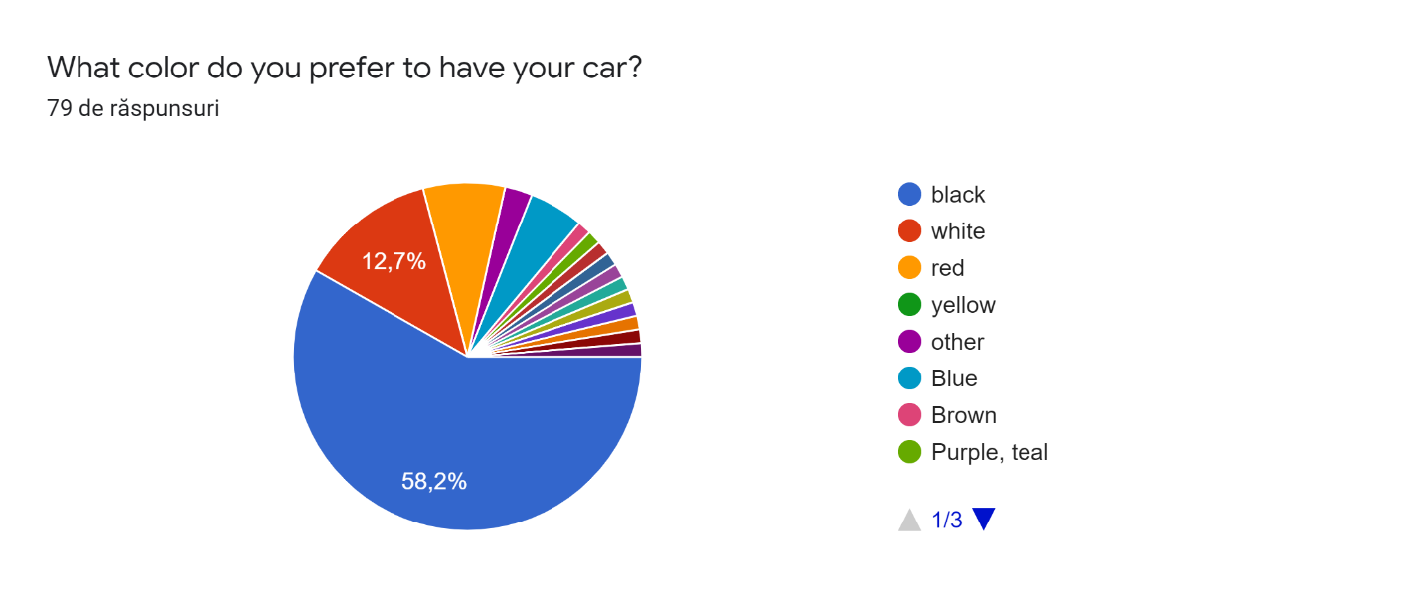

From the result of the first question we can see that 58.2% of the study participants prefer a black car and 12.7% prefer a white car.

Also, the list of response variants was completed with three other colors. Blue, Brown, Purple, teal, but they had a small share not getting many votes.

<https://codrean.github.io/exam/>

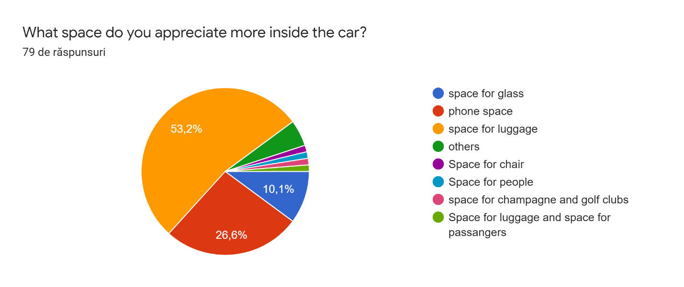

In the second question of the questionnaire was voted the space for luggage, with a weight of 53.2% of the answers. This was followed by the telephone space with 26.6% of the vote. The answers were supplemented with four other variants but they obtained a score too low to be meaningful.

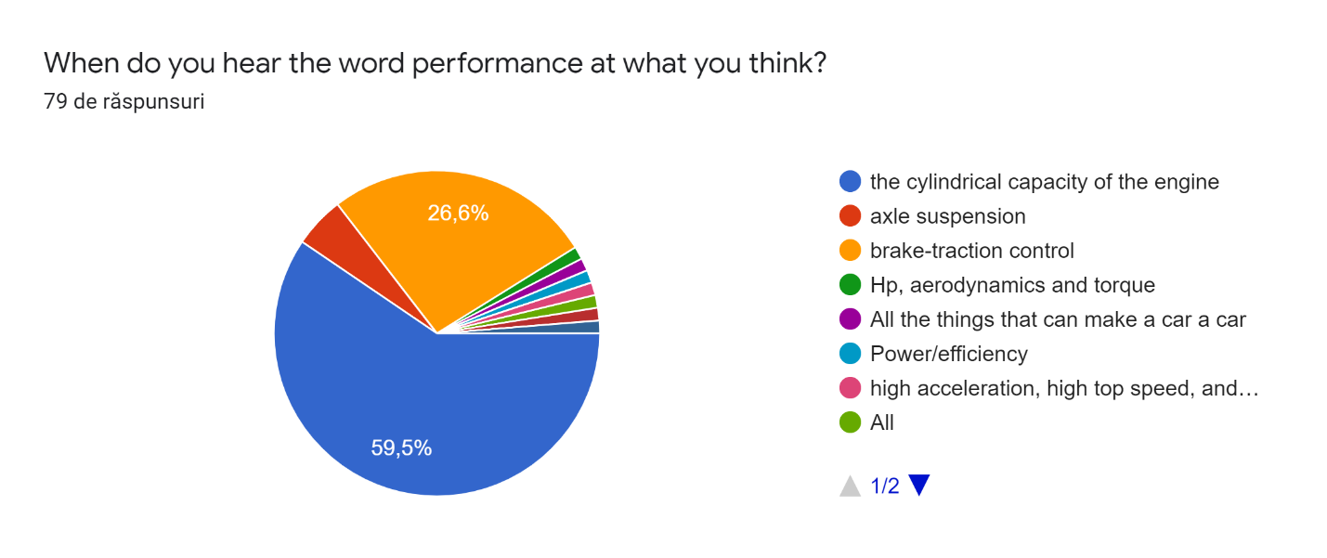

The third question in the questionnaire "When do you hear the word performance at what you think?" received 59.5% of the answers for the "the cylindrical capacity of the engine" answer followed by "brake-traction control" with only 26.6% of the total answers.

<https://codrean.github.io/exam/>

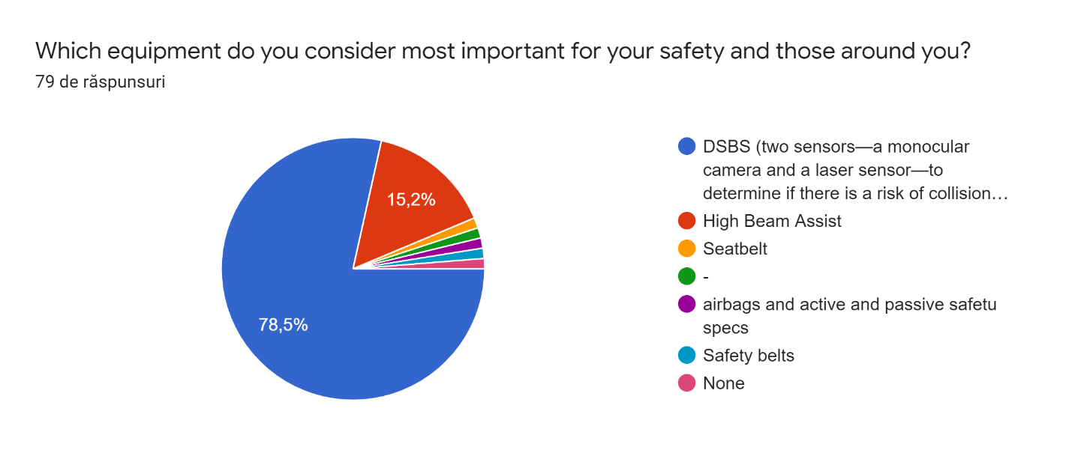

The third question provided for safety while driving. Most participants in the study chose "DSBS (two sensors — a monocular camera and a laser sensor — to determine if there is a risk of collision with a forward vehicle or pedestrian)" giving 78.5% of the total votes. However, some of them chose "High Beam Assist" as the most important, but it got too few votes to be statistically significant.

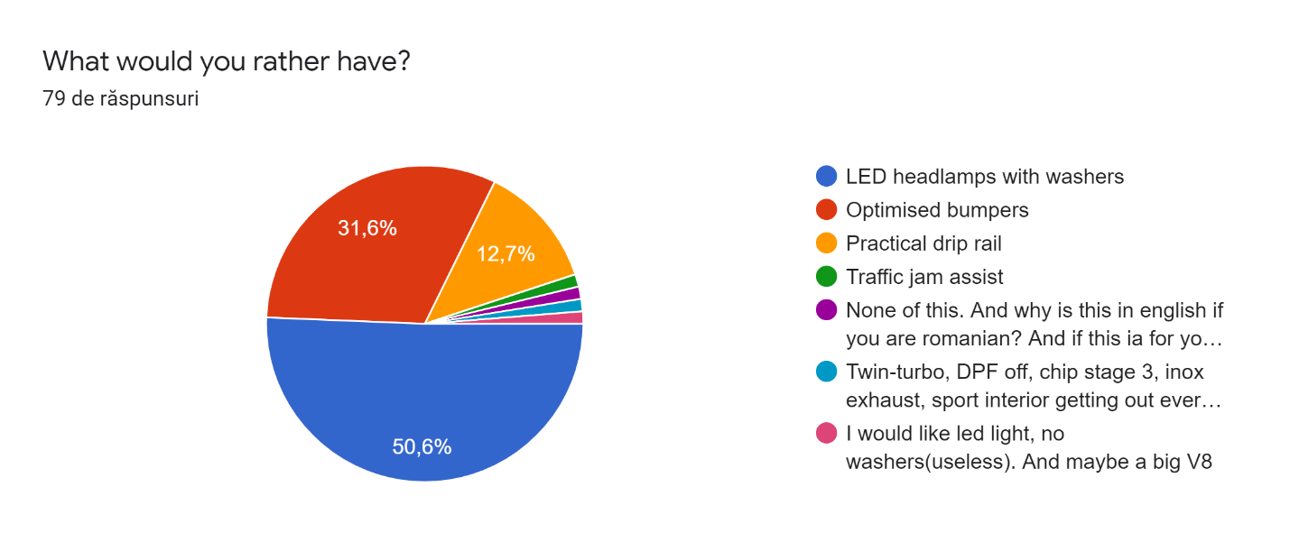

In the last question most elections were for "LED headlamps with washers" 50.6%, half of the participants. Almost the first and "Optimized bumpers" received multiple elections, 31.6% of the total. "Optimized bumpers" with 12.7% of the vote.

<https://codrean.github.io/exam/>

2. Identification and implementation of a solution regarding drivers wishes about cars.

Following the answers received from the participants I created a persona (see annex 2) based on which I created a presentation page for Suzuki Jimny.

I gave the presentation page the name Suzuki Jimny. The page contains three main parts, head, body and footer.

*Head*

In the head part I added a tag <meta> with the description of the page. This helps users to reach the page more easily from the SEO point of view.

*Body*

I used <body> to cover the entire content of the page. In this I added different tags. To create the menu I used an image, and for the logo - on the top left - I even used the logo on the official Suzuki website.

The menu and the logo are differentiated from the menu bar by a horizontal line. Whose color is style = "color: # 8c8c8c;". To make my bar I used tag <ul> => <li> for unordered lists. As for the typography I used: font-family: sans-serif;. After the menu bar I chose to display the name of the car. So visitors to the page can see clearly what the car is about on the page. For this I used an image online. Thus I respected the original typography. I created the golden trophy in Adobe Illustrator. To achieve this I used simple buttons such as line, circle, anchor etc.

The images and the writing I gave it a zoom animation (Animista, 2020).

To optimize the page from the SEO point of view I used tags like <u>, <b> and <i>. Thus focusing on the keywords of the page. For all the text on the page I used the same type of typography, this is sans-serif.

The penultimate element added to the body was a top bottom. Because the page elements are displayed one below the other, I have chosen to display a button on the display that will help the page visitor to scroll up when he / she deems necessary. To start with, I created a <div> with the "container" class in front of which I put the button. It was created with the help of w3schools.com. To this button I assigned position: fixed; to remain always displayed no matter how much the page viewer is running down. From a design standpoint I was offered background-color: gold; and color: goldenrod;.

The last element we found important to display on the page was the video presentation of the car. To add video to HTML5 I used the <section> tag. I used the 'controls autoplay' feature to start the video on its own when it is displayed on the screen, (New Jimny | Promotional Video 2018 ‘Nobody But Jimny’ | Suzuki, 2018). I also added some external links after the video. These are coming to the aid of the page visitor.



*Footer*

The footer of the page is made up of three external links <a>, they direct to the official site who are interested in more information.



<https://codrean.github.io/exam/>

**3.2 Discussions**

The site of presentation of the car Suzuki Jimny has a simple design. We can see that at the top is the logo and the menu. When we click on a menu item it changes its color to gold. Presentation of the contention with the display of the prizes won worldwide by the brand of the car. After this brief introduction photos and brief informative texts are displayed. The information was displayed according to the importance that the questionnaire participants offered. Thus, the first two preferences in the top were posted on the site.

At the bottom of the page we can see the video presentation of the car Jimny and the Follow us tag that directs to the social channels Facebook and YouTube.

External links are displayed in the Footer of the page, thus helping to optimize the site from the SEO point of view.

***3.3 Conclusions***

The project included 79 participants. To include them, a questionnaire with five questions was created and distributed online on the Facebook social network. The project has two objectives. Both objectives were successfully met. In conclusion, we can say that the creation of a site/presentation pages for the product Suzuki Jimny comes to the aid of the people interested in purchasing a new car. On the site we can see both technical and design information, comfort and safety.

*Future directions*

Since people have different preferences regarding the technique of choosing a product, it is good to create a chat section.

*Limitation*

* too few participants and the test result cannot be generalized;
* the questionnaire used is not a licensed one.

*Strong points*

- the results obtained offer future prospects for improvement;

- although the time was short many people showed interest in the subject of the project;

- identification and description of boundaries.

Annex 1

Cars preferences

Hi, my name is Ioana Codrean. I am student in first year at BAAA. This questionnaire measures the individual preferences regarding the choice of a car. The questionnaire contains 5 questions and the answers are anonymous. Thank you!

1. What color do you prefer to have your car?

* Black
* White
* Red
* Yellow
* Other

2. What space do you appreciate more inside the car?

* Space for glass
* Phone space
* Space for luggage
* Others

3. When do you hear the word performance at what you think?

* The cylindrical capacity of the engine
* Axle suspension
* Brake-traction control
* Others

4. Which equipment do you consider most important for your safety and those around you?

* DSBS (two sensors—a monocular camera and a laser sensor—to determine if there is a risk of collision with a forward vehicle or pedestrian)
* High Beam Assist
* Other

5. What would you rather have?

* Led headlamps with washers
* Optimised bumpers
* Practical drip rail

<https://codrean.github.io/exam/>

Annex 2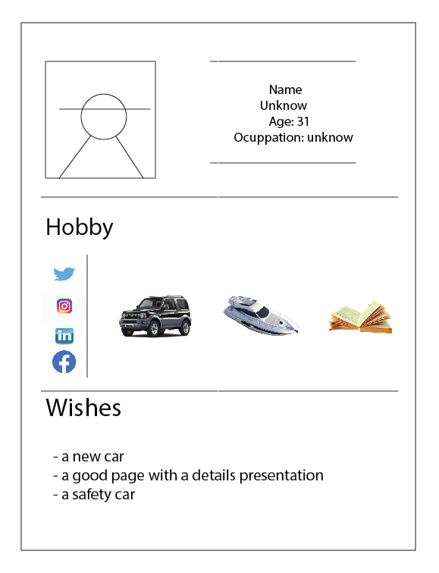

* 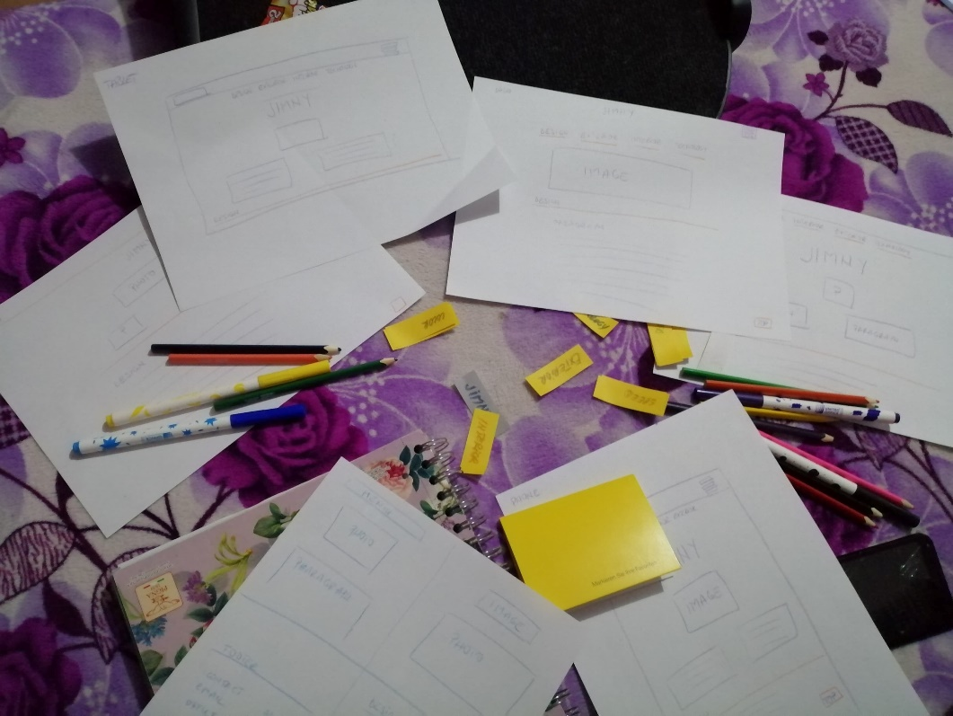

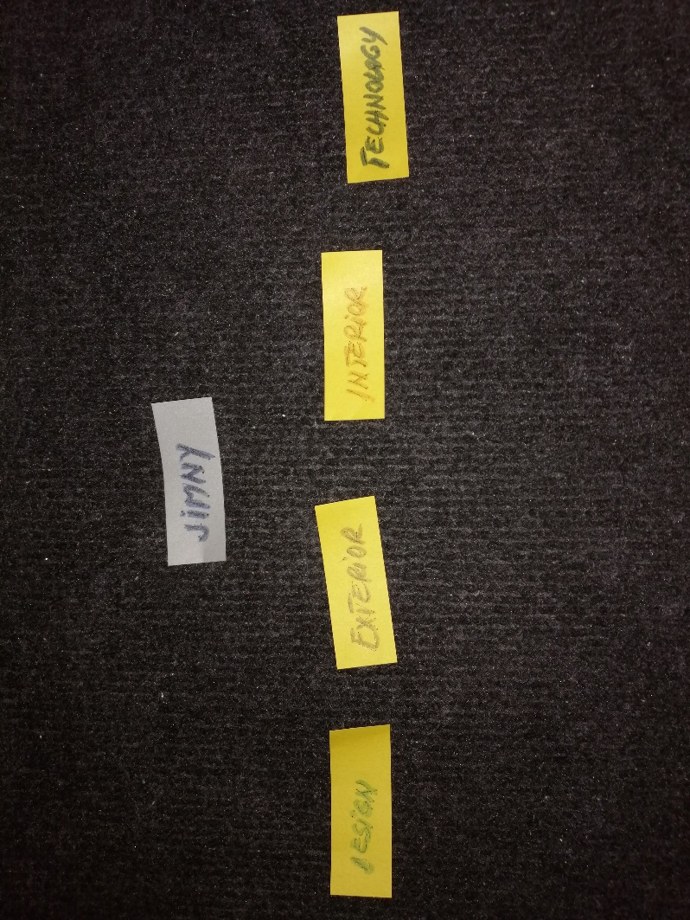

* 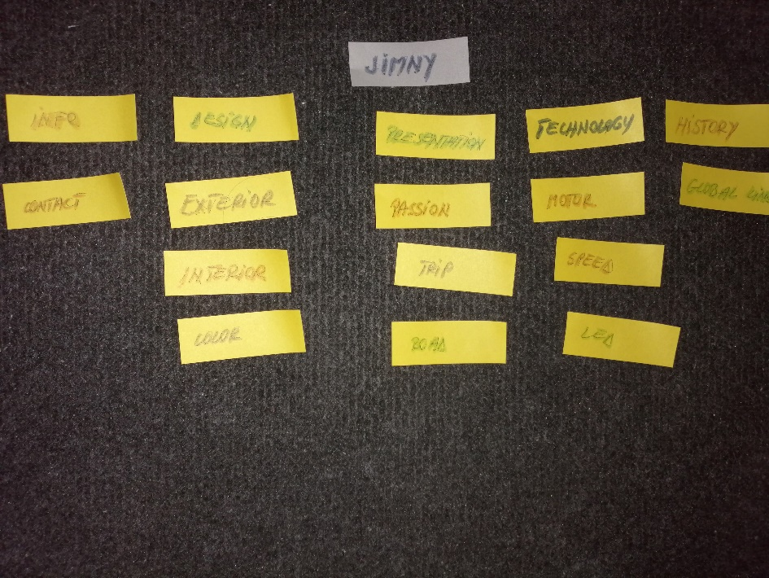
* 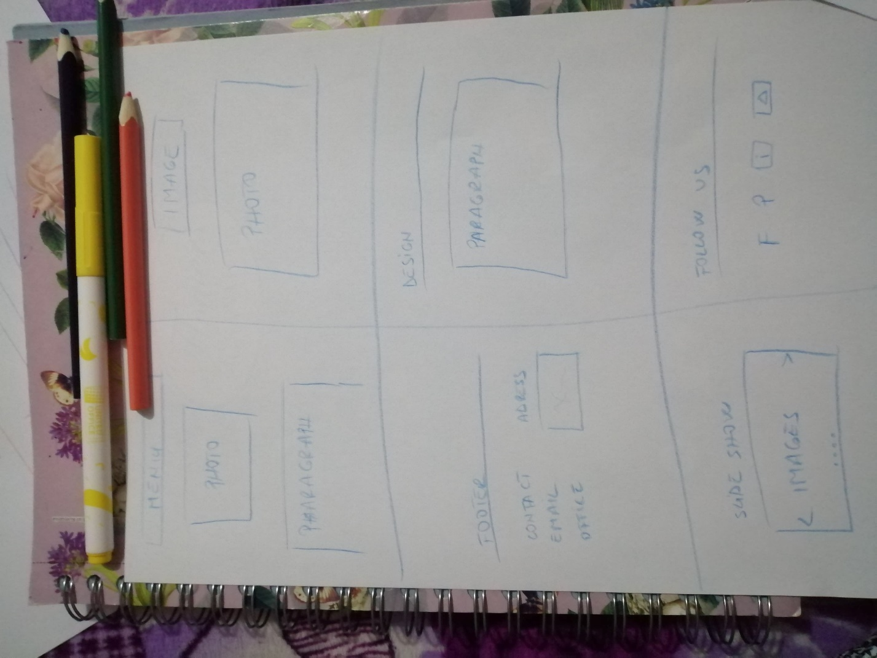
* 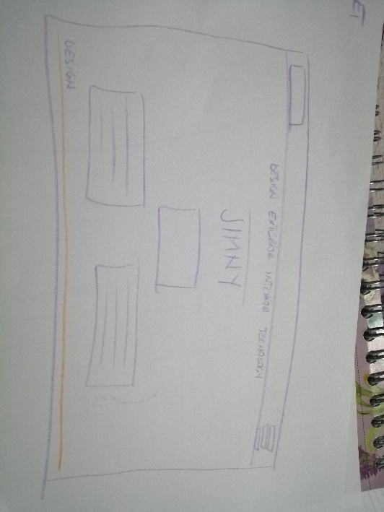

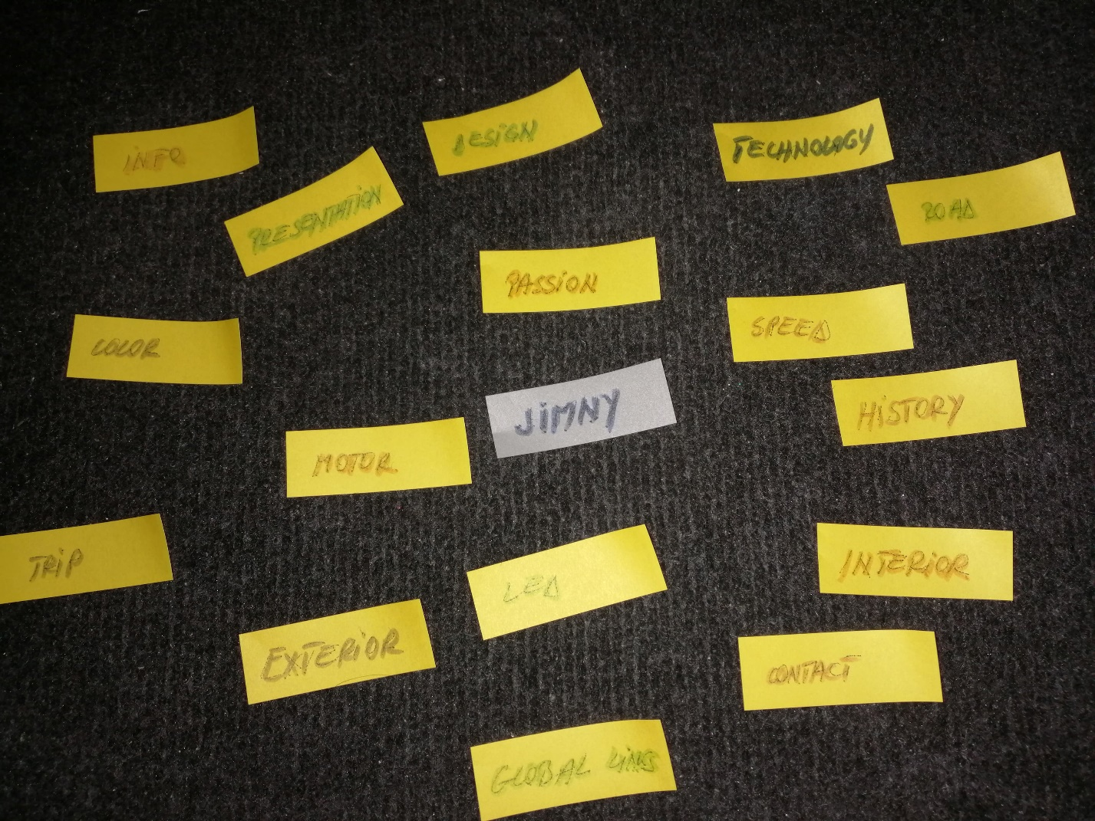

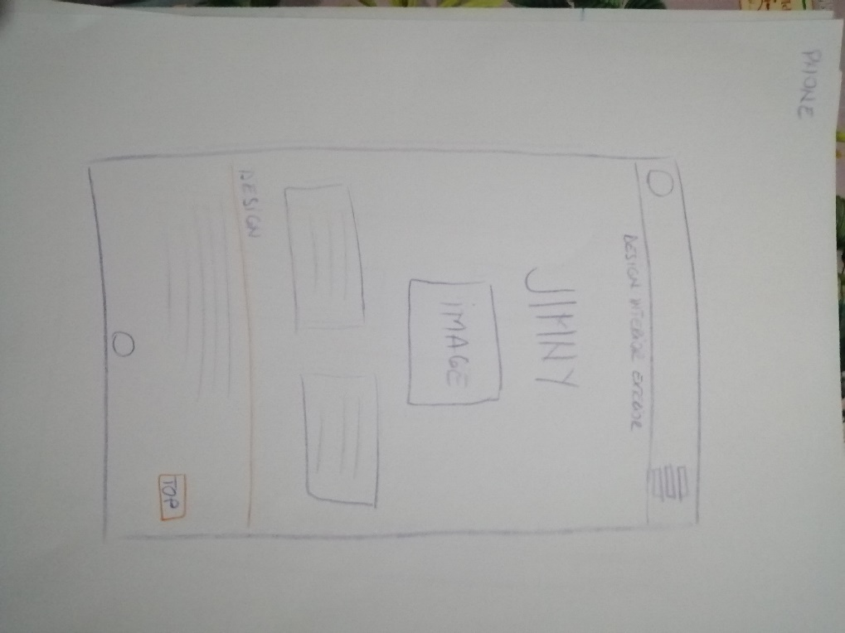

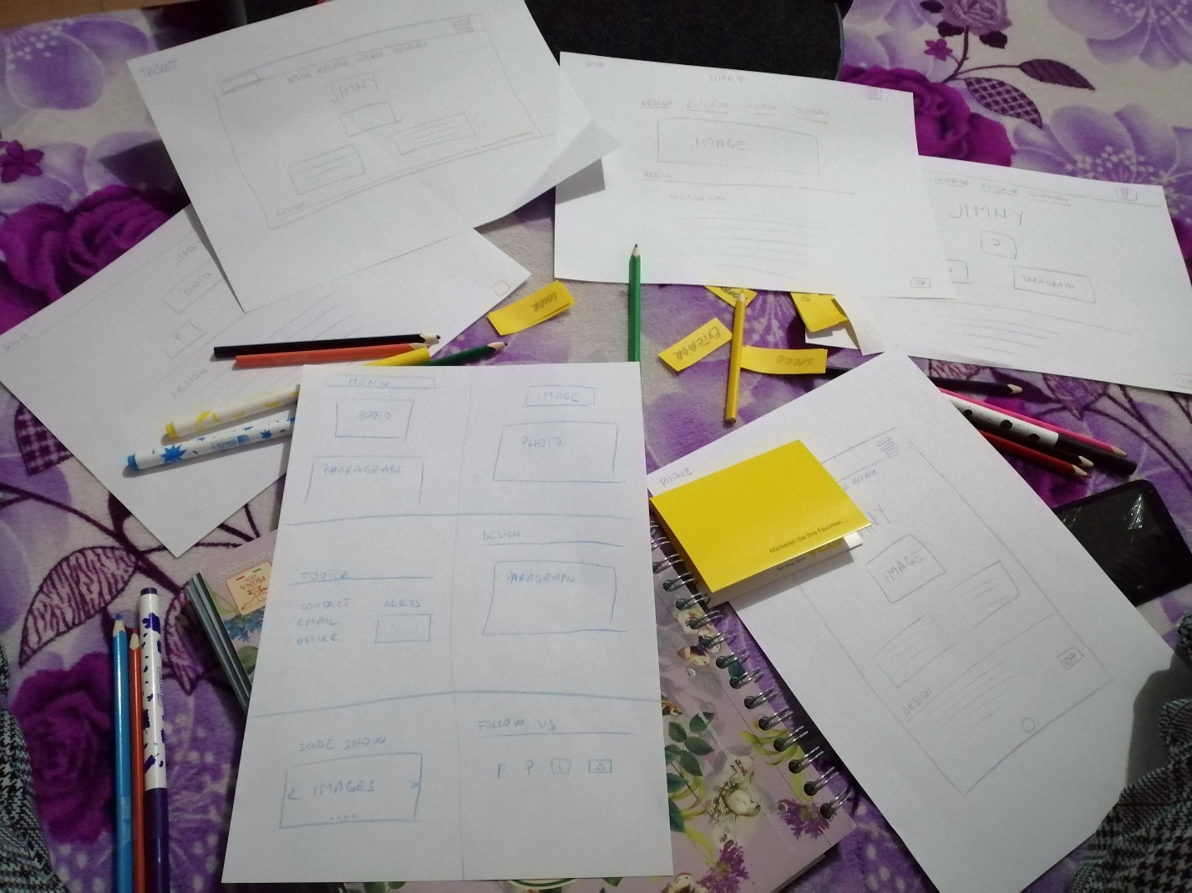

Bibliography

*#01 Tutorial HTML & CSS [ROMANA] - Introducere*. 2016. [online]DM TV Mady Available at: <https://www.youtube.com/watch?v=5cTQ6i-KmZc&list=PLRlcs-KgbzEcAnDpKq7zYBsXx8_qkJ9ME> [Accessed 28 Oct. 2019].

Anon 2019. *Formulare Google: creați și analizați sondaje gratuit.* [online] Available at: <https://www.google.com/intl/ro_ro/forms/about/> [Accessed 13 Dec. 2019].

Anon 2019. *Samsung Galaxy Fold*. [online] The Official Samsung Galaxy Site. Available at: <https://www.samsung.com/global/galaxy/galaxy-fold/> [Accessed 6 Jan. 2020].

Anon 2019. Suzuki Jimny. In: *Wikipedia*. [online] Available at: <https://en.wikipedia.org/w/index.php?title=Suzuki_Jimny&oldid=929380953> [Accessed 13 Dec. 2019].

Anon 2020. *Animista*. [online] Animista CSS animations on demand. Available at: <http://animista.net/> [Accessed 9 Jan. 2020].

*New Jimny | Promotional Video 2018 ‘Nobody But Jimny’ | Suzuki*. 2018. Suzuki, Jimny Available at: <https://www.youtube.com/watch?v=kkd8WxoPnBQ&feature=emb_title> [Accessed 9 Jan. 2020].

Parkers, 2019. *Suzuki Jimny Review (2019) | Parkers*. [online] Available at: <https://www.parkers.co.uk/suzuki/jimny/review/> [Accessed 13 Dec. 2019].

*Suzuki Jimny review | A replacement for the Land Rover Defender?*. 2018. Directed by D. James. Available at: <https://www.youtube.com/watch?time_continue=66&v=A2jyEpze6vM&feature=emb_title> [Accessed 13 Dec. 2019].

Tim, P., 2018. *Suzuki Jimmy toughens up with pick-up and explorer concepts*. [online] CAR Magazine. Available at: <https://www.carmagazine.co.uk/car-news/first-official-pictures/suzuki/jimny-2018-news-pictures-prices-specs/> [Accessed 13 Dec. 2019].

w3schools, 2020. *HTML Basic*. [online] w3schools. Available at: <https://www.w3schools.com/html/html_basic.asp> [Accessed 6 Jan. 2020].

<https://codrean.github.io/exam/>