8. Experimental Section:

Data Collection and Visualization:

* We collected data for all 5 activities – Laundry, Eating, Hair drying, Vacuuming, Typing using the USB Microphone interfaced with the Raspberry pi
* We collected 50 audio samples of each activity for a duration of 10s. Below table represents the various type of data collected for each activity.

|  |  |
| --- | --- |
| ACTIVITY | DATA COLLECTED |
| Hair Drying | Data was collected on all 3 speed and heat settings |
| Laundry | Data was collected on washer and Dryer, when they were running on varying speeds. (i.e – when the machine switched on vs when the machine is running at full speed) |
| Eating | Data was collected on all kinds of food- soft and hard. Particularly we collected data when the subject was eating Chips, Bread, Apple, Grapes, Chocolate, Cookie, Chewing Gum. |
| Vacuuming | Data was collected on all setting on the vacuum cleaner- low to high. |
| Typing | Data was collected when the subject was typing rigorously, when the subject was typing slowly and when the subject is typing and using mouse simultaneously. |

* We then visualized data by plotting them using Python to see if they were actually different and if we can run a classifier to classify them accurately. Below are the plots for each activity.
  + 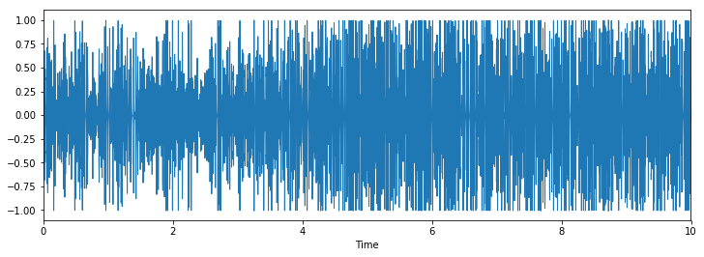HairDrying
  + Typing

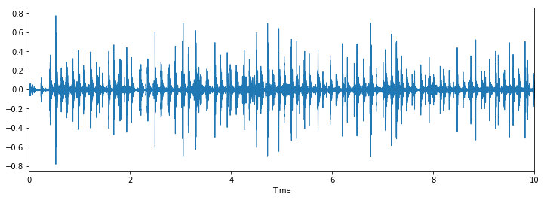

* + 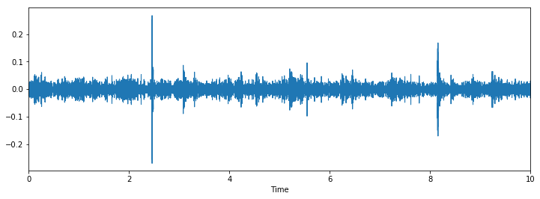Laundry
  + Vacuuming

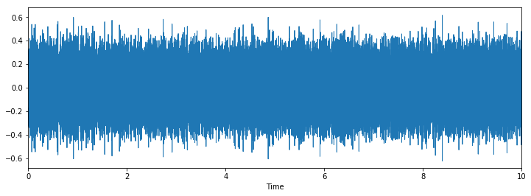

* + Eating

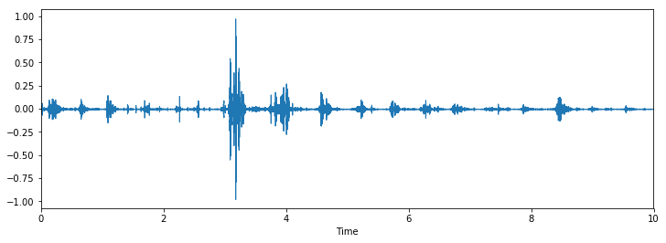

It can be seen from the above plots that the audio signals have different principle components and can be classified with a classifier.

Feature extraction and building Feature Vector:

Machine Learning Algorithms:

*Non- Real Time-based prediction:*

* Now that we have the feature vector, we split the data in ratio of 8:2 for train and test respectively.
* We first implemented the Non-Real Time version of the prediction – i.e. We recorded the entire audio first, extracted the feature vector and ran the ML algorithm to predict the activity. The reason this is not real time is because it does not predict as the activity comes in.
* Since we are running the algorithms on Raspberry Pi, we wanted to use the classification algorithm that gives us the maximum accuracy and with least execution time.
* In order to find this out we ran all the classification algorithms and noted their execution time and accuracy and took an average of 5 runs for different combinations of the three key features – MFCC, Delta, DDelta.
* The below table shows the results:

**Feature: MFCC**

|  |  |  |
| --- | --- | --- |
| ML Algorithm | Accuracy | Execution Time (in seconds) |
| Logistic Regression | 73.01% | 95.17 |
| SVM – Linear Kernel | 66.67% | 7.58 |
| SVM -RBF Kernel | 66.67% | 110 |
| K- Nearest Neighbors | 79.36% | 3.192 |
| Decision Tree | 100% | 7.6 |
| Multilayer Perceptron Classification | 47% | 23.28 |
| Random Forest | 100% | 0.6 |
| Boosting- Ada Boost | 99.92% | 185 |

**Feature: MFCC and Delta**

|  |  |  |
| --- | --- | --- |
| ML Algorithm | Accuracy | Execution Time (in seconds) |
| Logistic Regression | 87.3% | 218 |
| SVM – Linear Kernel | 77.77% | 235 |
| SVM -RBF Kernel | 84.12% | 14.7 |
| K- Nearest Neighbors | 77.77% | 6.4 |
| Decision Tree | 100% | 13.7 |
| Multilayer Perceptron Classification | 42% | 46.53 |
| Random Forest | 100% | 0.95 |
| Boosting- Ada Boost | 99.92% | 365.9 |

**Feature: MFCC, Delta and DDelta**

|  |  |  |
| --- | --- | --- |
| ML Algorithm | Accuracy | Execution Time (in seconds) |
| Logistic Regression | 94.1% | 325 |
| SVM – Linear Kernel | 88.1% | 235 |
| SVM -RBF Kernel | 84.12 | 14.7 |
| K- Nearest Neighbors | 77.77 | 6.4 |
| Decision Tree | 100% | 13.7 |
| Multilayer Perceptron Classification | 42 | 46.53 |
| Random Forest | 100% | 0.95 |
| Boosting- Ada Boost | 99.92% | 365.9 |

From the table, Random forest with one feature gives the best accuracy and execution time. We implemented the Non-real time-based activity prediction with one feature -MFCC and with Random Forest as our classifier algorithm.

* All the above steps were done in Jupyter Notebook and iPython Notebooks. To make the project more interactive, we developed a GUI using Python’s Tkinter library.
* The GUI has three buttons for the following purposes:
  + Record – signals the Microphone interface to start recording for a duration of 10sec
  + Process – Opens the recorded audio file, builds MFCC feature vector by following the steps in Section 7 and stores the feature vector in a text file.
  + Find activity – Opens the text file, runs the Random forest algorithm to predict the label. Based on the label, it prints out the type of activity that was recorded.
* Below is a picture of the GUI detecting Typing

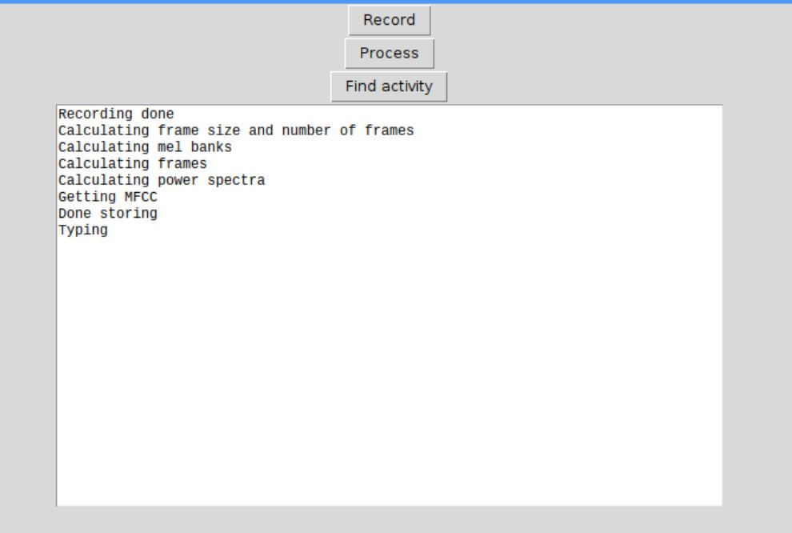

* During demo, we were not able to show the working of activities such as Laundry and Vacuum. Hence, we recorded a video and below are the links:
  + Laundry- <https://youtu.be/0m3kBEFjWR4>
  + Vacuum- <https://youtu.be/f9YrJ3E30Mk>

*Real Time-based Prediction*:

* We implemented the real-time based prediction using multithreading by running two threads in parallel, one thread to record audio and one thread to run the Machine algorithm to predict the activity.
* We have a common queue which is shared between the two threads. The data that is being recorded is put in the queue by the Thread_One. Thread_Two consumes the data in the queue builds the MFCC feature vector.
* The built feature vector is then used to predict the activity by running Random Forest algorithm.
* Our main issue with this approach was that the algorithm was not predicting correctly and latency. The audio is 10s long and it is simultaneously calculating the feature vector as the audio comes in, because of this there was latency involved.
* To increase the probability of predicting correctly, we considered three features (MFCC, Delta, DDelta) for the real-time implementation as it will have more principle components for each label. This improved the prediction and our model was able to correctly classify the activities, but the latency issue persisted.
* All the above steps were done using Threading library in Python using Jupyter’s Ipython notebook.
* The GUI has only one button:
  + Start – Starts the process by executing Thread_One and Thread_Two
* Below is a picture of GUI for a series of activities- Typing and Eating

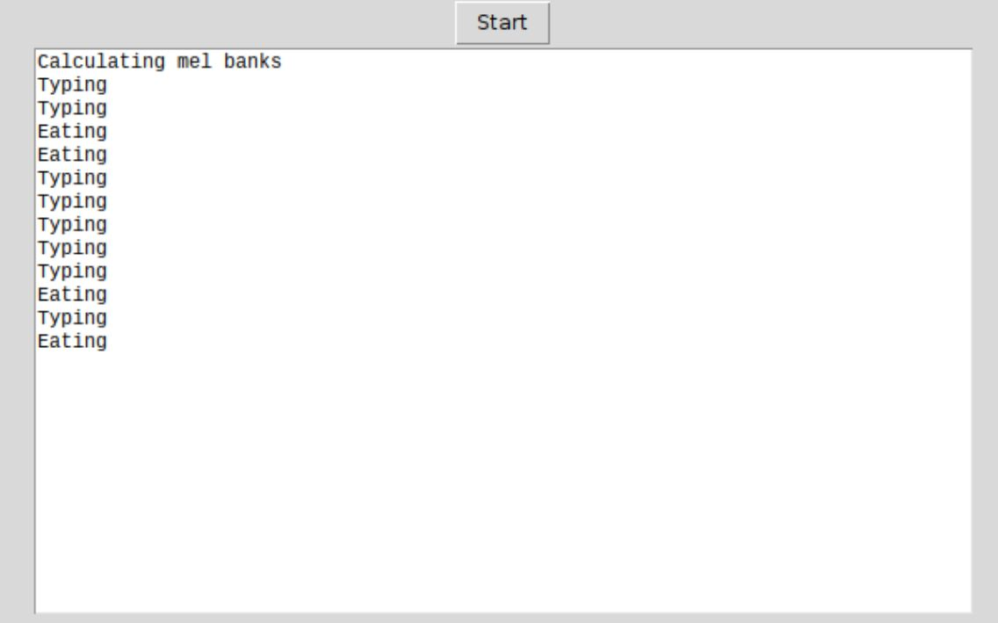

* During demo, we were not able to show the working of activities such as Laundry and Vacuum. Hence, we recorded a video and below are the links:
  + Laundry- <https://youtu.be/Ud1WwnJU2n0>
  + Vacuum- <https://youtu.be/93BD09TxFtk>

*Issues Faced:*

* The main issue we had was in reducing the latency in real-time implementation.
* We implemented an approach of having a sliding window kind which samples signals in blocks- i.e for a 9s audio signal, it samples first 3 seconds and builds the feature vector, then samples the next 3 seconds but it retains 1 second of the last frame and gets 2 seconds of the new frame inorder to retain continuity.
* The above approach did not increase or decrease the latency , but it greatly affected the prediction as none of the activities were predicted correctly.